Order:- Diptera

Sub order:-Branchycera
Family:- Tabanidae
Common name :- horse fly
Genus:- Chrysops, Tabanus.

Tabanids are large biting flies generally called horse flie, Tabanids are medium to very large flies (6–30mm long). The colouration of tabanids varies from very dark brown or black to lighter reddish brown yellow or greenish; frequently the abdomen and thorax have stripes or patches of contrasting colours The head is large and, viewed from above, is more or less semicircular.
Adults are sexed by examining their eyes. In the female there is a distinct space on top of the head separating the eyes: this is known as a dichoptic
. In males the eyes are so large that they occupy almost all of the head and either touch each other on top of the head or are very narrowly separated, this being known as a holoptic.
The antennae are relatively small but stout. They consist of three segments;
the last is subdivided into usually three or four small divisions .
Unlike the Muscidae, Glossinidae and Calliphoridae, there is no antennal arista. The size and shape of the antennae serve to distinguish the genera Chrysops, and Tabanus.
`
The stout thorax bears a pair of wings which have two submarginal and five posterior cells and a completely closed discal cell in approximately the centre of the wing .Adults at rest have the wings placed either like a pair of open scissors over the abdomen. The presence or absence of coloured areas on the wings and how they are held over the body provides useful additional characters for distinguishing between Chrysops, and Tabanus

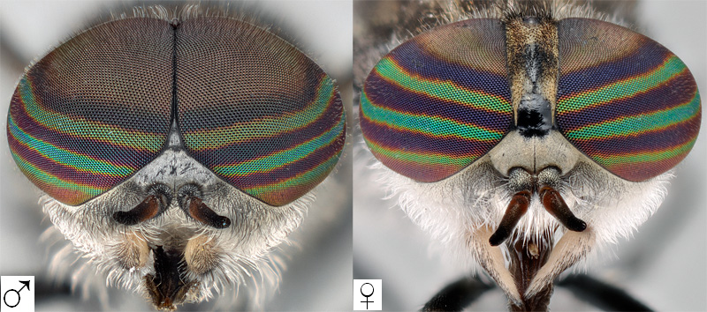
- 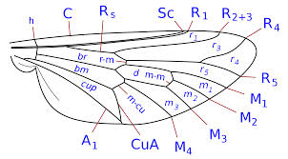
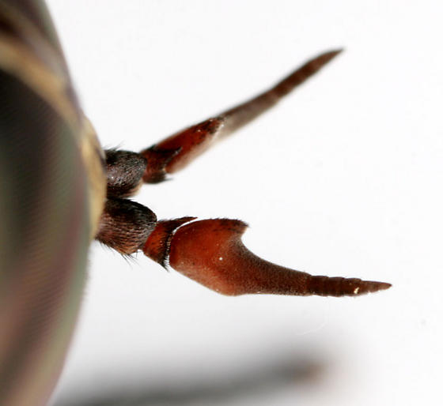

Life cycle
Eggs are whitish when laid but soon darken to a greyish or blackish colour;
they are 1–3mm long, and curved or approximately cigar-shaped. They usually hatch after 5–14 days, the time depending on temperature
Larvae are cylindrical and rather pointed at both ends .They are creamy white, brown or even greenish but often have darkish pigmentation near the borders of the segments. The very small black head can be retracted into the thorax. There are 11–12 well-differentiated body segments.
Larvae are readily recognized by the prominent raised tyre-like rings which encircle most body segments. The first seven abdominal segments have one pair of lateral and two pairs of ventral (a total of six)
conspicuous roundish protuberances called pseudopods. The presence of
prominent rings and these pseudopods readily identify larvae of tabanids.
The last abdominal segment has dorsally a short siphon which can be
retracted into the abdomen, and a pear-shaped structure known as Graber’s organ, which is composed of 15 or fewer black globular bodies. The exact function of this organ is unclear.

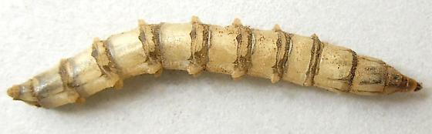.
siphon
Graber organ

pupa

The head and thorax are combined to form a distinct cephalothorax

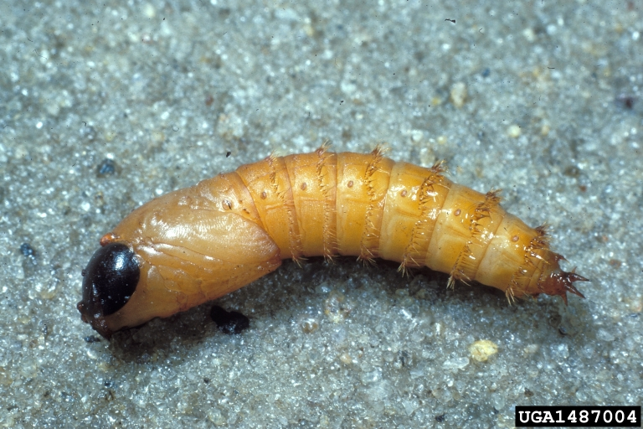

Medical importance
They can also mechanically transmit Trypanosoma vivax, causing trypanosomiasis in cattle in Africa and Latin America
Tabanids transmit viruses, bacteria, protozoa and filarial worms and therefore are of veterinary importance
tabanids transmit, to humans nematode Loa loa and causing , loiasis

Order :-Siphonaptera
Family : Pulicidae
Common name:- Fleas

Adult fleas are more or less oval in shape and relatively small (1–6 mm); they are compressed laterally and vary from light to dark brown .
Wings are absent, but there are three pairs of powerful legs, with the hind
legs specialized for jumping. The legs, and much of the body, are covered
with bristles and small spines. The head is approximately triangular, bears a pair of conspicuous eyes (a few species are eyeless), and short three-segmented more or less clubshaped antennae which lie in depressions behind the eyes. In some species a row of coarse, well-developed toothlike spines, collectively known as the genal comb or genal ctenidium, is present along the bottom margin of the head
The thorax has three distinct segments: the pro-, meso- and metathorax.
The posterior margin of the pronotum (i.e. dorsal part of the prothorax)
may have a rowof tooth-like spines forming the pronotal comb or pronotal
ctenidium .
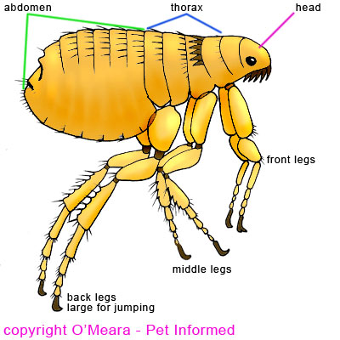
Fleas in some genera lack both pronotal and genal combs and are referred to as combless fleas .In some genera fleas have both combs, while in other species the pronotal comb is present and the genal comb absent, but never the reverse . In several genera including Xenopsylla, which contains important plague vectors, this sternite is clearly divided into two parts by a thick vertical rod-like structure called the meral rod, pleural rod, mesopleural suture or just rod. The presence of this rod, combined with the absence of both genal and pronotal combs,indicates the genus Xenopsylla .
In female fleas the tip of the abdomen is more rounded than in males and
is not upturned as in males.

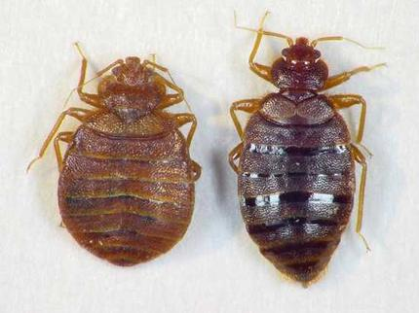

Ctenocephalides felis برغوث القطط , Ctenocephalides canis برغوث الكلاب
the genus is recognized for bearing genal and pronotal combs.
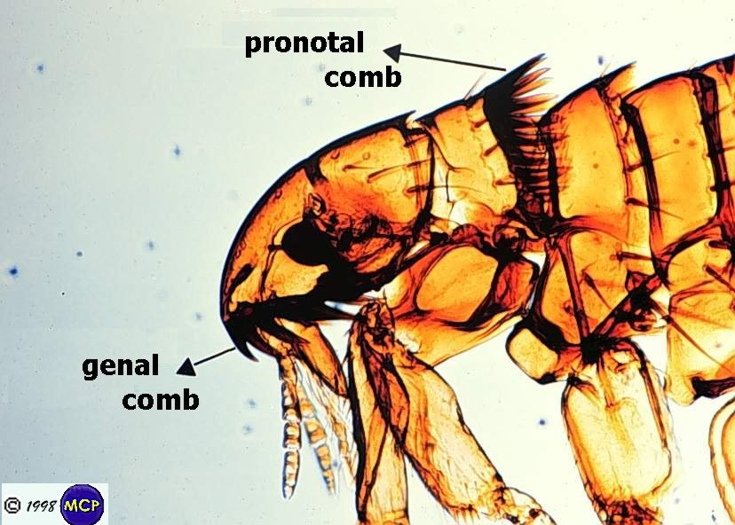

Neither genal nor pronotal combs are present, which serves to distinguish Pulex and Xenopsylla from all species. Meral rod thickening reinforces the mesopleuron of Xenopsylla but this structure is absent in Pulex irritans. Ocular bristle inserted below eye Pulex irritans but in Xenopsylla . Ocular bristle inserted in front of eye

