College of Science Al-Mustanseryea University Dep.: Biology
Academic year: 2015-2016 Subject: Plant Physiology Class: Fourth Grade
By: Dr. Alaa Jabar & Dr. Rana Azeez
Lecture: 1
**Plant Cells and Water:
Without water, life as we know it could not exist. Water is the most abundant constituent of most organisms. The actual water content will vary according to tissue and cell type and it is dependent to some extent on environmental and physiological conditions, but water typically accounts for more than 70 percent by weight of non-woody plant parts. The water content of plants is in continual state of flux, depending on the level of metabolic activity, the water status of the surrounding air and soil, and a host of other factors. Although certain desiccation -tolerant plants may experience water contents of only 20 percent and dry seeds may contain as little as 5 percent water, both are metabolically inactive, and resumption of significant metabolic activity is possible only after the water content has been restored to normal levels.
Water fills a number of important roles in the physiology of plants, roles for which it is uniquely suited because of its physical and chemical properties.
1/ Water physical and chemical properties:
The key to understanding many of the unique properties of water is found in the structure of the water molecule and the strong intermolecular attractions that result from that structure. Water consists of an oxygen atom covalently bonded to two hydrogen atoms. The oxygen atom is strongly electronegative, which means that it has a tendency to attract electrons. So in water molecule the oxygen tends to draw electrons away from the hydrogen. The shared electrons that make up the O-H bond are, on the average, closer to the oxygen nucleus than to hydrogen. This asymmetric electron distribution makes water a polar molecule. Overall, water remains a neutral molecule, but the separation of partial negative and positive charges generates a strong mutual (electrical) attraction between adjacent water molecules or between water and other polar molecules. This attraction is called hydrogen bonding. The energy of the hydrogen bond is about 20 kJ mol^{_1}. Thus the hydrogen bond is weaker than the covalent and ionic bonds, but it is stronger than the Van der Waals forces (about 4 kJ mol^{_1}).

**What is the important of hydrogen bond in water molecule?
- Hydrogen bonding is largely responsible for the many unique properties of water, compared with other molecules of similar molecular size.
- Hydrogen bonding is the basis for hydration shells that form around biologically important macromolecules such as proteins, nucleic acids, and carbohydrates. These layers of tightly bound and highly oriented water molecules are often referred to as bound water. It has been estimated that bound water may account for as much as 30 percent by weight of hydrated protein molecules. Bound water is important to the stability of protein molecules. Bound water “cushions” protein, preventing the molecules from approaching close enough to form aggregates large enough to precipitate.
- Hydrogen bonding, although characteristic of water, is not limited to water. It arises wherever hydrogen is found between electronegative centers. This includes alcohols, which can form hydrogen bonds because of the _OH group, and macromolecules such as proteins and nucleic acids where hydrogen bonds between amino (_NH₂) and carbonyl (C=O) groups help to stabilize structure.

2/ The Thermal properties of Water:
Perhaps the single most important property of water is that it is liquid over the range of temperatures most compatible with life. Boiling and melting points are generally related to molecular size, however, both the melting and boiling points of water are higher than expected when compared with other molecules of similar size, especially ammonia (NH₃) and methane (CH₄).

3/ Water exhibits a unique Thermal Capacity:
The term specific heat is used to describe the thermal capacity of a substance or the amount of energy that can be absorbed for a given temperature rise. The specific heat of water is 4.184 Jg^{_1}ᵒC^{_1}, higher than that of any other substance except liquid ammonia.
Because of its highly ordered structure, liquid water also has a high thermal conductivity. This means that it rapidly conducts heat away from the point of application. The combination of high specific heat and thermal conductivity enables water to absorb and redistribute large amounts of heat energy without correspondingly large increase in temperature. For plant tissues that consist largely of water, this property provides for an exceptionally high degree of temperature stability. Localized overheating in a cell due to the heat of biochemical reactions is largely prevented because the heat may be quickly dissipated throughout the cell. In addition, large amounts of heat can be exchanged between cells and their environment without extreme variation in the internal temperature of the cell.

4/ Water exhibits a high heat of fusion and heat of vaporization:
Energy is required to cause changes in the state of any substance, such as from solid to liquid or liquid to gas, without a change in temperature. The energy required to convert a substance from the solid to the liquid state is known as the heat of fusion.
The density of ice is another important property. At 0ᵒC, the density of ice is less than that of liquid water. Thus water, unlike other substances, reaches its maximum density in the liquid state (near 4ᵒC), rather than as a solid. This occurs because molecules in the liquid state are able to pack more tightly than in the highly ordered crystalline state of ice. Consequently, ice floats on the surface of lakes and ponds rather than sinking to the bottom where it might remain year-round. This is extremely important to the survival of aquatic organisms of all kinds.
Just as hydrogen bonding increase the amount of energy required to melt ice, it also increase the energy required to evaporate water.
Evaporation from moist surface cools the surface because the most energetic molecules escape the surface, leaving behind the lower-energy (hence, cooler) molecules. As a result, plants may undergo substantial heat loss as water evaporates from the surfaces of leaf cells. Such heat loss is an important mechanism for temperature regulation in the leaves of terrestrial plants that are often exposed to intense sunlight.

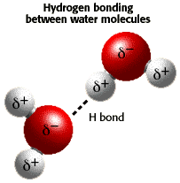

5/ Water is the universal solvent:
The excellent solvent properties of water are due to the highly polar character of the water molecule. Water has the ability to partially neutralize electrical attractions between charged solute molecules or ions by surrounding the ion or molecule with one or more layers of oriented water molecules, called a hydration shell.
Hydrogen shells encourage solvation by reducing the probability that ions can recombine and form crystal structures.
The polarity of molecules can be measured by a quantity known as the dielectric constant. Water has one of the highest known dielectric constants. The dielectric constants of alcohols are somewhat lower, and those of nonpolar organic liquids such as benzene and hexane are very low. Water is thus an excellent solvent for charged ions or molecules, which dissolve very poorly in nonpolar organic liquids. Many of the solutes of importance to plants are charged. On the other hand, the low dielectric constants of nonpolar molecules helps to explain why charged solutes do not readily cross the predominantly nonpolar, hydrophobic liquid regions of cellular membranes.

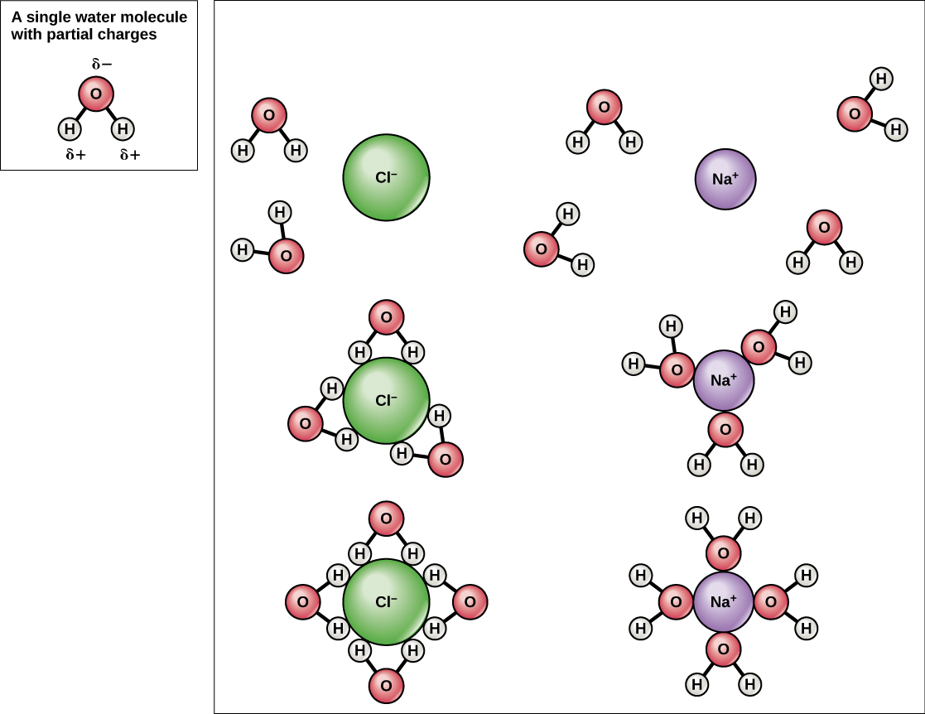
Solvent properties of water, the orientation of water molecules around the sodium and chloride ions screens the local electrical fields around each ion.

6/ Polarity of water molecules results in cohesion and adhesion:
The strong mutual attraction between water molecules resulting from hydrogen bonding is also known as cohesion. One consequence of cohesion is that water has an exceptionally high surface tension, which is most evident at interface between water and air. Surface tension arises because the cohesive force between water molecules is much stronger than interactions between water and air. The result is that water molecules at the surface are constantly being pulled into the bulk water. The surface thus tends to contract and behaves mush in the manner of an elastic membrane. A high surface tension is the reason water drops tend to be spherical or that a water surface will support the weight of small insects.
Cohesion is directly responsible for the unusually high tensile strength of water. Tensile strength is the maximum tension that an uninterrupted column of any material can withstand without breaking. The same forces that attract water molecules to each other will also attract water to solid surfaces, a process known as adhesion. Adhesion is an important factor in the capillary rise of water in small-diameter conduits. The combined properties of cohesion, adhesion, and tensile strength help to explain why water rises in capillary tubes and are exceptionally important in maintaining the continuity of water columns in plants.

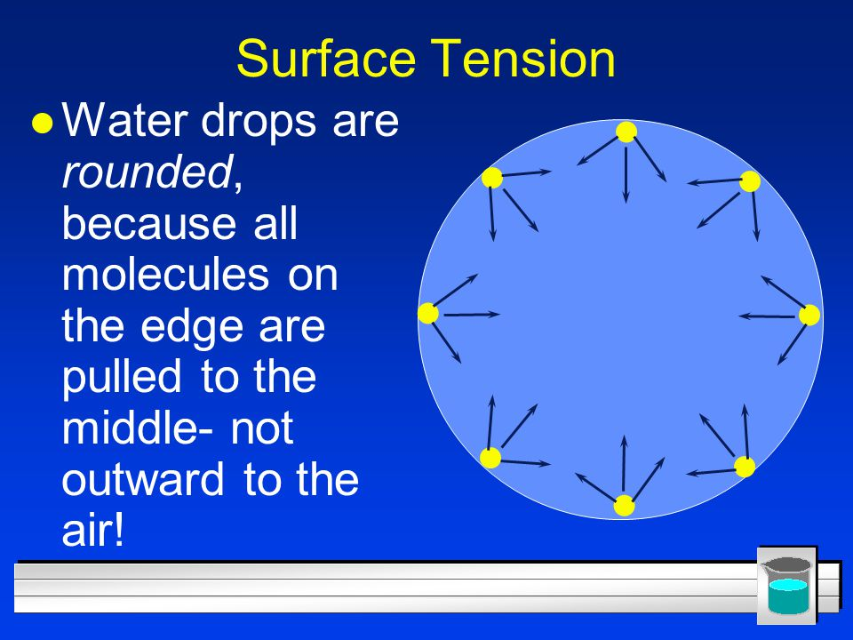

Summary:
Water has numerous chemical and physical properties that make it particularly suitable as a medium in which life can occur. Most of these properties are the result of the tendency of water molecules to form hydrogen bonds.

