College of Science Al-Mustanseryea University Dep.: Biology
Academic year: 2015-2016 Subject: Plant Physiology Class: Fourth Grade
By: Dr. Alaa Jabar & Dr. Rana Azeez
Lecture:7
****plant hormones****
****Cytokinins***
Are plant hormones, they are derivatives of the nitrogenous base adenine, and consist of purine ring. Cytokinine were previously named as kinin.
Cytokinins were discovered when scientists found that some compounds containing adenine have the ability to induce cell division. At that time the first compound discovered by the scientists were named kinin. However animal physiologists used the term kinin to include hormones related to polypeptides group, there for scientists used the term phytokinin and later replaced it to cytokinin.
Thirteen out of eighteen cytokinins have been extracted and purified from higher plants. Some of these compounds bound with 5 carbon sugar and sometimes with phosphate to form nucleotides and nucleosides. Zeatine is one of the most important cytokinin compounds in plants.
Several types of the isolated cytokinins have been synthesized outside the plant and named as synthetic cytokinins. These compound have the same physiological effect as natural cytokinins.
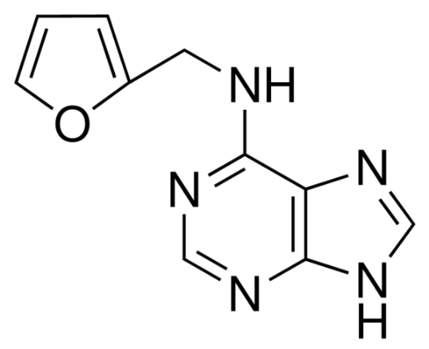Cytokinin structure
***Physiological effect of cytokinins:
cytokinins were found to synthesize in roots and translocate to other part of the plant by xylem. Rate of movement of cytokinins is slower than the auxins and Gas.
The most important physiological effects are :
1-cell division: cytokinins are found to be essential for cell division in plant tissue culture. However, the continuity of growth of tissue required the presence of IAA with cytokinins. It was found that IAA is necessary for nucleus division, while cytokinin is required for cytoplasm division.
2-cell enlargement: it was found that cytokinins stimulate cell enlargement as IAA and GA.
3-Root initiation and growth: it was found that cytokinins in presence of IAA stimulate the formation of roots in callus tissues.
4-Shoot initiation and growth: it was known that the parenchyma cells of callus do not differentiate into organs or tissues when there is a balance between IAA and cytokinin, but when the ratio of cytokinin/ IAA increased, the differentiation of parenchyma cells started to form buds and shoots.
5-Breaking dormancy: scientists revealed that growth of lateral buds breaking the dormancy of apical dominance could not be controlled by IAA alone but in combination with cytokinin in certain ratio.
6-prevention of aging and senescence: cytokinins are found to inhibit aging and senescence due to the following reasons:
A/ prevents the formation of hydrolytic enzymes such as nucleases, proteases which cause senescence and aging.
B/ withdraw of nutrient from the surrounding tissues to the region in which the cytokinin accumulates.
7- Enzyme formation: scientists believe that cytokinins stimulate the metabolic reactions which lead to synthesis of enzymes and not to the effect on the genes responsible for the synthesis of the enzymes as was happened in case of IAA and GA.
***Abscisic acid(ABA)***
This hormone is isolated in 1965 from fruit of cotton crop and named Abscission II. In subsequent years several types of this hormones have been isolated from plants and it is considered as growth inhibitor hormone.
ABA is synthesized in mature leaves and translocated to shoot apex through leaf petiole.
***physiological effects of ABA:

- It was found that one of the most important phenomenon in ABA is the drastic increase in its concentration shortly following expose of plants to flooding, drought, mechanical injuries and deficiency in mineral nutrients. The concentration of the ABA subside down very quickly in plants exposed to drought stress to normal level after irrigation.
- Regulation of stomatal opening and closing: it was observed that when the plant leaves is treated with ABA, the stomata close after 10-15 minutes. The reason is that ABA causes leakage in K⁺ from guard cells and thus the guard cells lose its turgidity and the aperture closed.
- Abscission and senescence of leaves and fruits: it was observed that higher concentration of ABA stimulates juvenile leaves and fruit dropping. Concentration of ABA in mature leaves was 200% more than that in juvenile leaves. Senescence is also accelerated due to the inhibition of GA by ABA.
- Bud dormancy: most of plant species form buds which grow later to leaves or flowers. Buds of most plant species may enter dormancy under unfavorable condition such as drought, high and low temperature and salinity. The dormancy regulated by endogenous hormonal levels.

***Mechanism of action for ABA:
- Causes changes in electrical potential across the plasma membrane which lead to afflux or influx of K⁺ across the membrane.
- Inhibition of RNA and protein synthesis.
- Inhibits the action of IAA, GA and cytokinin.
**Biosynthesis of ABA :
1-The biosynthesis is occurred in plastids.
2-the precursor of ABA synthesis is acetyl CoA.
3-The pathway is similar to GA3 biosynthesis but ended in farnesyl pyrophosphate (15 c).

***Ethylene****
1-it is a growth retardant hormone.
2-gas under natural condition.
3-simple chemical structure compared to other hormones.
4-found in a very low concentration in plants.
5-it affects essential physiological process alone or in combination with auxins.
6-Ethylene is produced from the 5-amino methionine.
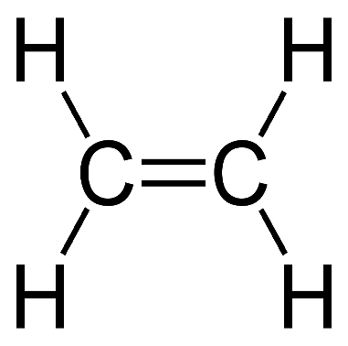 ( Ethylene structure)

**factors affecting the activity of ethylene:
1-high CO₂ concentration.
2-decrease in temperature.
****physiological effects:
- Fruit ripening : respiration was found to increase rapidly in most of the fruit then decreased the end of fruit maturation, this type of respiration is called climacteric respiration. It was found that ethylene is increased 100 times during climacteric respiration than during immature fruits.
- Apical dominance: it was revealed that ethylene is strongly inhibited the lateral buds and this result due to translocation of auxin from young leaves and apical meristems to the nodes. The higher accumulation of auxins in the nodes stimulates ethylene production in the buds which inhibits their growth.
- Geotropism: previously we mentioned that geotropism is taken place due to accumulation of auxin (IAA) in the lower part of the roots causing inhibition of growth in this region recently it was found that the effect was not related directly to IAA but to ethylene which is stimulated by the presence of IAA.

