College of Science Al-Mustanseiriyah University Dep.: Biology
Academic year: 2014-2015 Subject: Plant taxonomy Class: Third Grade
Lecturer:Dr.Hadeel R.,Dr.Rana A.,Dr.Aseel M.,Dr.Zena K.
Lecture: 6
***Fruits:
Fruits are the mature ovaries or pistils of flowering plants plus any associated accessory parts.
**Accessory parts: are organs attached to a fruit but not derived directly from the ovary, including the bracts, axes, receptacle.
**Pericarp: is the fruit wall, derived from the mature ovary, sometimes pericarp divided into layers: 1- endocarp
2- mesocarp
3- exocarp
****Fruit types: are based first on fruit developed :
- Simple fruit: derived from a single pistil of one flower.
- Aggregate fruit: derived from multiple pistil of a single flowers, thus having an apocarpous gynoecium.
- Multiple fruit: derived from many coalescent flowers.

***Simple fruits:
- Achene: is a one-seeded, dry, indehiscent fruit with seed attached to the pericarp at one point only as in sunflower.
- Grain (or caryopsis): is a one-seeded, dry, indehiscent fruit with the seed coat adnate to pericarp wall as in poaceae family.(like wheat).
- Nut: is a one seeded, dry, indehiscent fruit with a hard pericarp.
- Samara: is a winged, dry, usually indehiscent fruit as in Acer.
- Urticle: is a small, bladdery or inflated, one-seeded, dry fruit, utricles are essentially achenes in which the pericarp is significantly larger than the mature seed as in Atriplex (salt bush).
- Capsules: are generally dry, dehiscent fruits derived from compound ovaries, several types of capsule can be recognized based on the type or location of dehiscence:-
A/ Loculicidal capsules: have longitudinal lines of dehiscence radially aligned with the locules or between the placenta if septa are absent it splits into valves.
B/ Septicidal capsules: have longitudinal lines of dehiscence radially aligned with the ovary septa( or with placenta if septa are absent). Its splits into valves.
**Valves: apportion of the pericarp wall that splits off, but does not enclose the seed, valves may remain attached to the fruit or may fall off.
C/ Circumscissile capsules: (also called a pyxis) has a transvers (as opposed to longitudinal) line of dehiscence, typically forming a terminal lid as in Plantago.
D/ Septifragal or valvular capsules: is one in which the valves break off from the septa, as in Lpomoea (morning glory).
E/ Poricidal capsules: have dehiscence occurring by means of pores as in Papaver.
- Follicle: is a dry, dehiscent fruit derived from one carpel that splits along one suture, such as in unit fruit of Magnolia.
- Legume: is a dry, dehiscent fruit derived from one carpel that splits along two longitudinal sutures as in fabaceae.
11- Silicles and siliques: are dry, dehiscent fruits derived from a two carpeled ovary that dehisces along two sutures but that has an outer rim.
12- Scizocarp: is a dry, dehiscent fruit type derived from a two or more loculed compound ovary in which the locules separate at maturity.
13- Berry: is the unspecialized term for a fruit with asucculent pericarp as in Vitis (grape).
14- Drupe : is a fruit with a hard, stony endocarp and a fleshy mesocarp, as in Prunus.
15- Hesperidium: is a septate fleshy fruit with a thick – skinned, leathery outer pericarp wall and fleshy modified trichomes (juice sacs)arising from the inner walls, as in Citrus(orange, lemon, etc.).
16- Pepo: is a non –septate fleshy fruit with parietal placentation and leathery exocarp derived from an inferior ovary, as in cucurbtaceae.
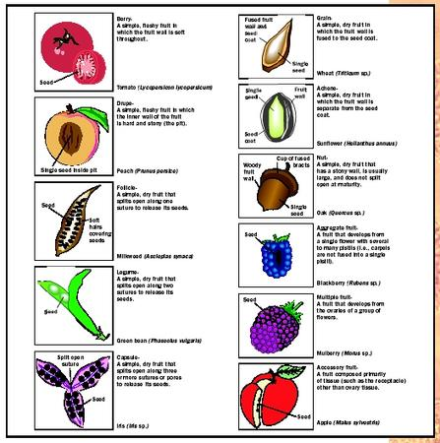

***Aggregate fruits: is one derived from two or more pistils (ovaries) of one flower:-
A/ Achenecetum: is an aggregate fruit of achenes. A common example is Fragaria( strawberry), in which the achenes are on the surface of accessory tissue, an enlarged, fleshy receptacle.
B/ Drupecetum: is an aggregate fruit is an aggregate fruit of follicles as in Magnolia.
C/ Syncarp: is an aggregate fruit, typically of berries , in which the fruits fuse together , as in Annona (note that syncarps may form at the floral stage or later during fruit development , if the latter , the fruit is sometimes called a pseudosyncarp.

*****Multiple fruits: is one derived from two or more flowers that coalesce. Types of multiple fruits:-
- Sorosis: is a multiple fruit in which the unit fruits are fleshy berries and are laterally fused along a central axis as in Ananas( pineapple).
- Syconium : is a multiple fruit in which the unit fruits are small achenes covering the surface of a fleshy , inverted composed receptacle (derived from a hypanthodium) as in Ficus.
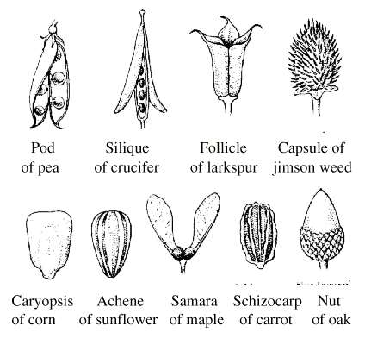

****Seeds:
Aspects of seed morphology can be important systematic characters used in plant classification and identification. Parts of ssed is:
- Seed coat: the outer protective covering of seed derived from the integument. Seed coat consist of two fused layers: a/ testa
b/ tegmen
***sarcotesta: a seed coat that is fleshy at maturity .
- Hilum : the scar of attachment of the funiculus on the seed coat.
- Raphe: a ridge on the seed coat formed from an adnate funiculus.
**Embryo: is the immature sporophyte, it consist of:
A/ Epicotyl : the immature shoot.
B/ Radical: the immature root.
C/ Hypocotyl: the transition region between the root and epicotyl.
D/ Cotyledon: the first leaf/leaves of the embryo, often functioning in storage of food reserves.

