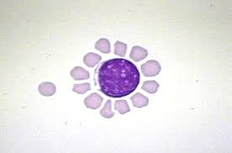
T and B Rosette Forming Tests
Lab. 11

Using rosette formation tests it is possible to differentiate between T and B lymphocytes in a lymphocyte suspension. Certain lymphocytes are capable of binding in vitro to sheep erythrocytes (SRBCs) forming rosettes (so-called E rosettes). Although the immunological basis of this bind- ing is not fully understood). In suitable conditions up to 80 % of lymphocytes react in this way.
Other lymphocytes (B lymphocytes) have receptors for antigen-antibody complexes and
for complement components and in suitable conditions can form rosettes with human
erythrocytes coated with antibody and complement (so-called HEAC rosettes). These lymphocytes comprise up to 20 per cent of the total.
T-rosette forming test:
- 0.5 ml. of the lymphocyte suspension( prepared in Lab. 10) was mixed with an equal volume of the(sheep RBC) SRBC suspension .
- Centrifuged at 180G/ 5 min at room temperature.
- The mixture then stood for 30 min. at 4°C.
- Stain a dry preparation with leishman stain and count rosette forming cells .
The result consider positive if 3 and more SRBC found on the surface of T- cell.
B-rosette forming test:
Material required:
- Mouse complement
- Rabbit antiserum (prepared by injecting rabbit with 5% suspension of SRBC, after 1 week blood collected from rabbit by heart puncture to get rabbit antiserum).
- Sheep RBC 5% suspension
Procedure:
- Mix equal quantities of Sheep RBC (Ag) + 1:200 of rabbit seum (Ab).
- Incubate the mixture at 37 for 30 min then centrifuge 200 g for 5 min.
- Prepare 5% of the sediment in step 2 in HBSS .
- Mix suspension in step 3 with mouse complement , incubate the mixture at 37 for 30 min then centrifuge for 5 min /200 g ,three times.
- Prepare a suspension of the sediment in step 4 in HBSS the suspension now called (EAC) Erythrocyte Antigen Complement.
- Mix equal volumes of EAC = lymphocytes suspension ( prepared in Lab. 10) and leave for I hr in 4 C, then centrifuge 200g/1min.
- The same steps 3,4 in T- rosette formation test.
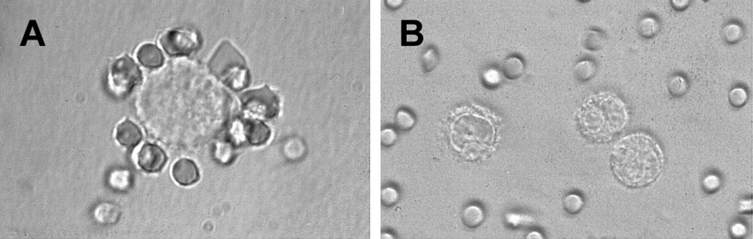
The result consider positive if 3 and more SRBC found on the surface of B- cell.

Quiz: without knowing the procedure, can you tell by looking to the above slide if these cells are T or B lymphocytes?
B: Negative result
A: Positive result

