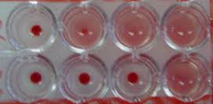
Complement Fixation Test
Lab. 9
(CFT)
The complement fixation test is an immunological medical test that can be used to detect the presence of either specific antibody or specific antigen in a patient's serum. It was widely used to diagnose infections, particularly with microbes that are not easily detected by culture methods, and in rheumatic diseases. However, in clinical diagnostics labs it has been largely replaced by other serological methods such as ELISA and by DNA-based methods of pathogen detection, particularly PCR.
The complement fixation test (CFT) was extensively used in syphilis serology after being introduced by Wasserman in 1909. It took a number of decades before the CFT was adapted for routine use in virology.

CFT meet the following criteria
􀁺 it is convenient and rapid to perform
􀁺 the demand on equipment and reagents is small
􀁺 a large variety of test antigens are readily available.

Complement, a protein constituent of normal blood serum, is consumed (fixed) during the interaction of antigens and antibodies. The phenomenon forms the basis for the complement fixation test, which is sensitive test that can be used to detect and quantitate antigens and antibodies.

CFT consists of two steps:

The primary reacting ingredients are known antigen, antiserum, and guinea pigs complement.

1. Complement Fixation Step: In the first step a known antigen and inactivated patient’s serum (serum which is heated to 56ºC to inactive native complement) are incubated with a standardized, limited amount of complement. If the serum contains specific, complement activating antibody the complement will be activated or fixed by the antigen-antibody complex. However, if there is no antibody in the patient’s serum, there will be no formation of antigen-antibody complex, and therefore complement will not be fixed. But will remain free.This initial reaction, however, cannot be seen.

2. Indicator Stage: In a second step, an indicator system( hemolysin) consisting of sheep red blood cell (SRBC) plus antibody specific for SRBC, is added to test for the presence of free complement. Interpretation of the test is based on the presence of hemolysis.

- If all the complement has been fixed, none will be free to lyse the SRBCs, which constitutes a positive complement fixation test.
- If no antibody is present in the patient's serum, then the complement is not fixed and is free to interact in the indicator system and lyse the SRBCs, which constitutes a negative complement fixation test.

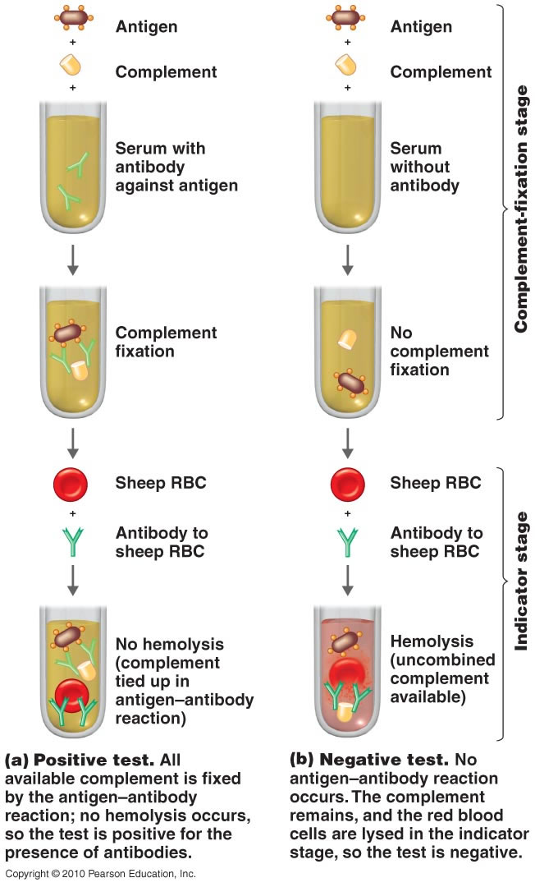
- Properly conducted complement fixation tests require the incorporation of appropriate controls of ensure that the result are not adversely affected by the presence of anticomplementary ingredients. The antigen or the serum itself may have anti-complementary properties (e.g., denatured or aggregated immunoglobulin, heparin, chelating agents, microbial contaminants), may fix all the complement in the system, or may remove calcium or magnesium ions (both of which are essential for complement-mediated lysis).

Advantages of CFT
1. Ability to screen against a large number of viral and bacterial infections at the same time.
2. Economical.

Disadvantages of CFT
1. Not sensitive - cannot be used for immunity screening
2. Time consuming and labor intensive
3. Often non-specific e.g. cross-reactivity
Quiz…
The results of CFT shown in a microtitration plate where the test is done, Identify the positive and negative results in this picture???

