Handling of laboratory animals
Animal inoculation Techniques using different routes

Introduction:
Selection of an animal model is one of the most important step in any of the experimental studies. Animal model preferred for the study must be producing similar disease profile as in the human.

Animal model selected should follow three main objectives:
- Use of an animal phylogenetically closer to man.
- Use of an animal in which the process under investigation is as close as possible to that in man.
- The Anatomy, Physiology and Biochemistry are considered to be similar .

Classification of experimental animals:
- RODENTS (Mice, Rats, Guinea pigs, Hamster… etc.)
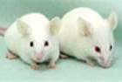
- NON-RODENTS (Rabbit, Dog, Cat, Monkey…..etc.)
MOUSE :
Smallest laboratory animal Easy to keep, handle and require small place for housing, uniformly breed. Common strain Swiss albino mice, Sensitive to small doses of drugs.

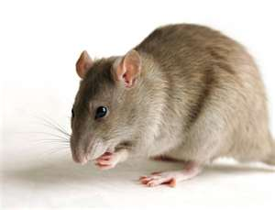
RAT:
Rat is commonly used for the assay of different hormones and for the study of the oestrous cycle, mating behavior and fertility.

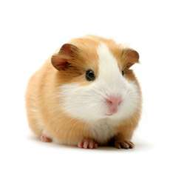
Guinea pig :
Herbivorous and eats green foods seed and roots. Guinea pig are not able to synthesize required daily vit C. Highly sensitive to histamine,Highly sensitive to penicillin Serum contains an enzyme asparaginase, which shows anti- leukemic action, very susceptible to tuberculosis and anaphylactic shock .

Hamster :
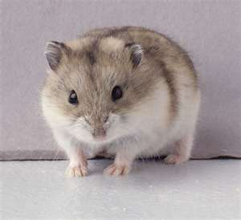
Third commonly used laboratory animal. Two species are commonly used : Golden or Syrian Hamster -Chinese Hamster.Hamsters are used extensively in onco virus, influenza virus, respiratory syncitical virus (RSV) studies and vaccine production Cheek pouches do not have lymphatic drainage and hence they are ideal site for tissue transplants such as tumors and crafts European hamster is a more suitable model for highly concentrated and prolonged smoke inhalation studies.

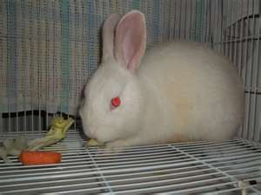
Rabbit:
Very docile animals, Used for testing of large volume parenterals and for the screening and bioassay of insulin, antidiabetic and curaremimetic drugs.New Zealand white rabbits have been used in the screening of different drugs for diseases like diabetes, diphtheria, tuberculosis, cancer and heart diseases. Employed in screening of antifertility drugs and for teratogenic studies. Skin is sensitive to irritation. Hence used for irritancy tests. Good model for the production of antibodies and antiserums.

ANIMAL HANDLING:
Before restrain, first pet or sooth the animal by slow deliberate movements in the body, overcrowding near the animal cage should be , noise should be kept as minimum, don’t hold animal too hard, never agitate the animal, it may become violent for self protection.

MOUSE:One can handle it with the help of blunt forceps by grasping the skin behind the neck or body. (to transfer from one cage to another) Grasp the base of the tail with one hand and with the other grasp the loose skin behind its neck Hold the complete body by grabbing back of neck by using all fingers

RAT:Lift rat out of the cage by grasping the base of the tail and place on a soft surface Place your index and middle fingers alongside the rat’s head and your thumb and ring fingers under its forelegs. Use your index and middle fingers to secure its head and remaining fingers to support the body Hold the complete body by grabbing the back using complete palm

GUINEA PIG:By using both hands, calmly grasp it with one hand under the chest and use your other hand to support its hindquarters Handle guinea pig with one hand, by holding its hindquarter

HAMSTER : Hold the complete body by grabbing at the nap of the neck by thumb and index finger and grasp the complete body by using rest of fingers Hold the complete body by grabbing back by using complete palm

RABBIT : By using single hand, hold the pelvic region. This is to transfer rabbits from one cage to another By using both the hands, hold the complete hindquarter. By using both hands, calmly grasp it with one hand supporting back of neck and the other hand supporting its hindquarters.

ROUTES OF ADMINISTRATION:
- FEEDING OR ORAL CAVAGES:
Feeding or oral gavages Hold the rodent in hand carefully Measure the tube length from nose to the last rib of the rodent and mark it Give a gentle tight grip at back of the neck, so that it opens its mouth widely. Push the rodent head slightly upward and back to straighten esophagus and then either from right or left side of the teeth, insert the tube by gentle rotation to avoid the resistance

- INTRAPERITONEAL :
- INTRAVENOUS :
- INTRAMUSCULAR :
- SUBCUTANEOUS :
- INTRACARDIAC INJECTION:

BLOOD COLLECTION FROM EXPERIMENTAL ANIMALS:
- Terminal blood collection --whole blood withdrawal.
- Non terminal blood collection (Single blood removal -- Multiple blood withdrawals).

TERMINAL BLOOD COLLECTION:
Done either after exsanguinations of the animal by physical stunning or after submitting the animal to general anesthesia The blood from such animals can be collected by:

Withdrawal of blood from venacava or aorta after performing laparatomy Animals are subjected to exanguination after decapitation, the jugular vein or carotid artery is exposed given an incision and blood is directly collected using a syringe Blood can also be collected by retro-orbital bleeding of smaller animal like mice rats and hamsters.

NON TERMINAL COLLECTION OF BLOOD:
Required for single or multiple withdrawals. Different peripheral veins of different animals may be used for collection of blood For multiple withdrawals, the amount of blood sample should not exceed 1% of total blood volume every 24 hours.
For single withdrawal of blood, up to 15% of total blood volume does not adversely affect animal. Withdrawal of more than 15%may lead to cardiac failure. A single withdrawal of up to 15%of total blood volume can be repeated after 3-4 weeks from the normal healthy animal.

TECHNICAL ASPECTS OF BLOOD REMOVAL:

- BLOOD COLLECTION FROM TIP OF TAIL:
Common method used in rats and mice for collecting 0.1ml from the capillary blood is to cut sharply the tip of tail Adequate for multiple collection of blood samples for the determination of biochemical parameters like blood glucose, radio labelled drugs etc.. In tail less animals cardiac puncture is used for collection of blood.

- BLOOD FROM SUPERFICIAL VEINS:
In larger animals superficial veins are used for blood collection The bore of the needle should as large as possible for ensuring rapid withdrawal of blood A check is made afterwards to ensure that no after bleeding occurs from this point

- PERMANENT VENOUS CANNULATION:
Used for chronic experiments which necessitate multiple blood collection at regular intervals The catheters are made to exit at the back of animal for only 2cms and capped with steel needles and at the time of blood collection a longer catheter is attached Thrombi formation due to clotting can be prevented by repeatedly filling the catheter with saline containing heparin

- RETRO-ORBITAL BLEEDING:
This technique for collection of blood should be used as the last resort ,by a well trained staff and be confirmed only to one of the eyes Employed in small animals like rat and mice when larger amount of blood is required which cannot be collected from tail vein or in tail less animals Should ideally be performed in anaesthetized animals

- CARDIAC PUNCTURE:
Generally employed in guinea pig, hamsters and gerbils. It is ideal to perform cardiac puncture in anaesthetized animal in order to reduce stress and facilitate smooth handling of animals Premedication with atropine helps to prevent cardiac arrhythmias

