Phylum : Platyhelminthes (Flatworms)
Platyhelminthes are an ancient phylum, but practically nothing is known of their evolutionary history because they have very soft bodies which do not preserve well as fossils. Scientists believe that the first turbellarians evolved around 550 MYA (million years ago).
Platyhelminthes are mostly worm like creatures that are dorsoventrally flattened, meaning they look like a ribbon, this is why they are called names such as Tapeworm, Flatworm, Fluke and Planarian.
Characteristics:-
1) Bilaterally symmetrical.
2) Body having 3 layers of tissues with organs and organelles.
3) Body contains no internal cavity.
4) Possesses a blind gut (i.e. it has a mouth but no anus)
5)Has Protonephridial excretory organs instead of an anus.
6) Has normally a nervous system of longitudinal fibres rather than a net.
7) Generally dorsoventrally flattened.
8) Reproduction mostly sexual as hermaphrodites.
9) Mostly they feed on animals and other smaller life forms.
10) Some species occur in all major habitats, including many as parasites of other animals.
- Class:Trematoda
The parasitic flatworms of class Trematoda, also called flukes, have oral suckers, sometimes supplemented by hooks, with which they attach to their vertebrate hosts. Trematodes have retained the same body form and digestive cavity as the turbellarians. However, practically the entire interior is occupied by the reproductive system; the organism is capable of producing huge numbers of offspring. Trematodes of the order Digenea have complex life cycles involving two or more hosts. The larval worms occupy small animals, typically snails and fish, and the adult worms are internal parasites of vertebrates. Many species, such as the liver fluke Clonorchis sinensis and the blood fluke (Schistosoma), cause serious diseases in humans.
Trematodes normally inhabit the digestive system and/or liver. Some trematodes seek out the lungs, or may wander to the heart, brain or skin. In the digestive system or liver, they disrupt digestion and nutrient absorption. Symptoms include chronic diarrhea and abdominal pain. Other symptoms occur from long-standing infections. These symptoms include ulcers, hemorrage and abscessess of the intestinal wall, and liver damage. Sometimes severe toxemia results when the host's body absorbs the worm's metabolites.
Trematode infections are usually acquired after ingesting one of the infective forms. Most fluke infections are acquired by
(1) drinking infected water, (2) swallowing infected water while swimming; transmission from wet hands to mouth or nose, etc., (3) eating infected aquatic vegetation, or (4) eating infected raw meat or raw intermediate hosts (snails, shellfish, crustaceans, fish). One can kill trematodes by thoroughly cooking meats and vegetable taken from suspect waters. Salting, pickling, drying, and smoking does not always kill the parasites in meat.
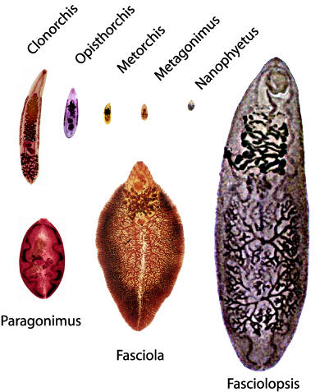
2-Class:Cestoda
The body of the cestodes, also known as tapeworms, has lost the typical turbellarian form. Although there are a few unsegmented species, the bulk of a typical cestode body consists of a series of linearly arranged reproductive segments called proglottids. There is no mouth or digestive system; food is absorbed through the cuticle. Adults live in the digestive tract of vertebrates, and larval forms encyst in the flesh of various vertebrates and invertebrates.
The body of an adult tapeworm is virtually a reproductive factory. Behind a small securing knob, called a scolex, which bears a circle of hooks or other attachment organs, the proglottids constantly bud off and gradually enlarge. As they mature they become filled with male and female reproductive organs. Cross-fertilization takes place with adjacent worms or neighboring proglottids; in some cases self-fertilization occurs. In some species the ripe proglottids, filled with eggs, are shed. In others the fertilized eggs leave the adult host in the feces. If the eggs are consumed by the intermediate host, the life cycle continues. Tapeworm species that infest human intestines as adults include Taenia saginata, T. solium, the dwarf tapeworm, Hymenolepsis nana, and the fish tapeworm, Diphyllobothrium latum, which can reach lengths of up to 50 ft (15 m).
General Characteristics of Tapeworms Proglottids (segment):
-body of adult worm is subdivided into segments; a segment usually corresponds to one segment which has male and female reproductive organs, nervous and excretory system.
-There is no intestine; nutrients are absorbed through the integument.
- New segment are produced near the anterior end, and are shunted posteriorly as they mature. Mature, gravid segments detach from the strobila.
Scolex (head): Anterior segment of the worm modified for attachment to host's digestive tract.
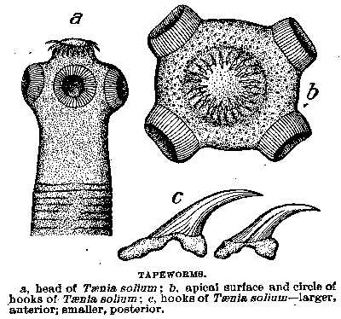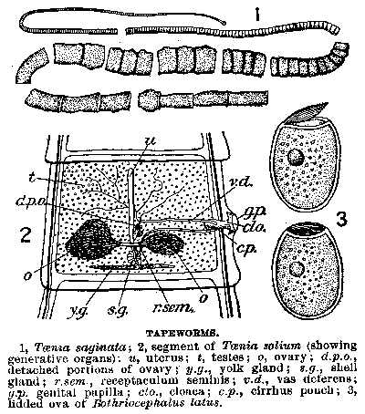
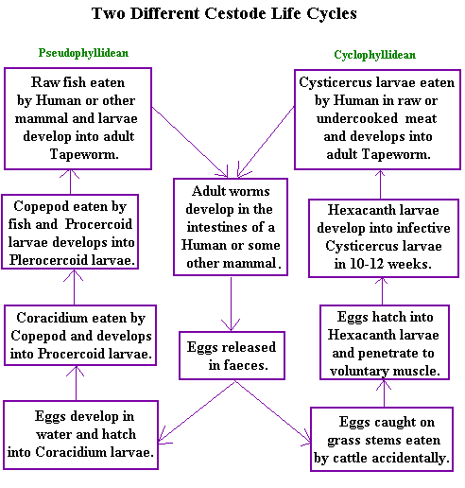

Order:-Cyclophyllidea
Tapeworms of the order Cyclophyllidea (the cyclophyllid cestodes) are the most important cestode parasites of humans and domesticated animals. All have multiple proglottid "segments," and all have four suckers on their scolex ("head"), though some may have other structures as well. Proglottids of this order have genital openings on one side (except in the family Dilepididae, which has genital openings on both sides),
Families include:
- Dipylidiidae (formerly Dilepididae), the most important member of which is Dipylidium caninum, also called the "cucumber tapeworm" or the "double-pore tapeworm"
- Hymenolepididae, with the most important genus being Hymenolepis.
- Taeniidae, which consists of livestock parasites in the genus Taenia and parasites that encyst in humans of the genus Echinococcus.

Order:-Pseudophyllidea
Pseudophyllid cestodes (order pseudophyllidea) are a kind of flatworm with multiple "segments" (proglottids) and two bothria or "sucking grooves" as adults. Proglottids are identifiably pseudophyllid as the genital pore and uterine pore are located on the mid-ventral surface, and the ovary is bilobed ("dumbbell-shaped").
Eggs have one flat end (the operculum). All pseudophyllid cestodes have a procercoid stage in their life cycle, and most also have a plerocercoid stage.
The most important family of pseudophyllid cestodes is Diphyllobothriidae, which infect mammals as their definitive hosts and use either copepods (a group of small crustaceans found in the sea and nearly every freshwater habitat, e.g. Spirometra) or both copepods and fish as in the broadfish tapeworm as intermediate hosts.
Class : Trematoda
Trematoda class or "trematodes" are commonly known as flukes. Flukes are flat worms. Parasitic flukes live in the intestine, tissue or in the blood.
Their life cycle begins when molluscs such as snails get infected with fluke larvae. The first stage larvae are called miracidia. They have tail-like structures, cilia, for moving and finding molluscs. Depending on the fluke species the larva goes through different developmental stages which are:
- miracidium
- sporocyst
- redia
- cercaria
- mesocercaria
- metacercaria.
Adulthood is reached inside the final host, humans. Adults reproduce either sexually or asexually. Eggs exit the body with the feces and infect new molluscs.
Flukes cause diarrhea, inflammation, ulcers, allergic and inflammation reactions among other symptoms.
- Fasciola Hepatica - Liver Fluke
Fasciola hepatica is a flat worm that eats your blood and liver. Find information such as parasite life cycle, symptoms, diagnosis and treatment as well as pictures and videos.
- Fasciolopsis Buski - Intestinal Fluke
Fasciolopsis buski is a parasitic fluke that lives in your small intestine causing fasciolopsiasis (disease). Pictures, videos, symptoms, diagnosis and treatment.
- Paragonimus Westermani - Lung Fluke
Paragonimus westermani is a lung fluke. It causes a parasitic disease called paragonimiasis. Symptoms, diagnosis, treatment and pictures.
- Schistosoma - Blood Flukes
Find information such as Schistosoma life cycle, symptoms, diagnosis and treatment as well as pictures and videos. Schistosoma (blood flukes) cause schistosomiasis (snail fever) in humans.
1-Lung flukes
Paragonimus westermani
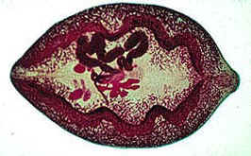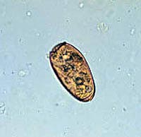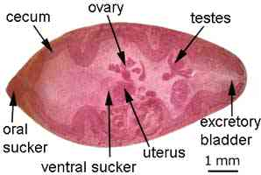
Paragonimiasis is a food-borne parasitic infection caused by the lung fluke which can cause a sub-acute to chronic inflammatory disease of the lung. It’s one of the more recognized lung flukes with the widest geographical range.

Morphology
Size, shape, and color resemble a coffee bean when alive. The skin of the worm (tegument) is heavily covered with scale like spines. The oral and ventral suckers are similar in size. The excretory bladder extends from the posterior end to the pharynx. The lobed testes are adjacent from each other located at the posterior end, and the lobed ovaries are off-centered near the center of the worm (slightly postacetabular).
• Eggs: Paragonimus westermani eggs They are yellow-brown, ovoid or elongate, with a thick shell, and often asymmetrical with one end slightly flattened. At the large end, the operculum is clearly visible. The opposite (abopercular) end is thickened. The eggs are unembryonated when passed in sputum or feces .
• Cercaria (not shown): Cercariae are often indistinguishable between species. There is a large posterior sucker, and the exterior is spined.
• Metacercaria: Metacercariae are usually encysted in tissue. The exterior is spined and has two suckers
• Adults: Adult flukes are typically reddish brown and ovoid, measuring 7 to 16 mm by 4 to 8 mm, similar in size and appearance to a coffee bean.They are hermaphroditic, with a lobed ovary located anterior to two branching testes. Like all members of the Trematoda, they possess oral and ventral suckers.
Life cycle The eggs are excreted unembryonated in the sputum, or alternately they are swallowed and passed with stool . In the external environment, the eggs become embryonated , and miracidia hatch and seek the first intermediate host, a snail, and penetrate its soft tissues . Miracidia go through several developmental stages inside the snail : sporocysts , rediae , with the latter giving rise to many cercariae , which emerge from the snail. The cercariae invade the second intermediate host, a crustacean such as a crab or crayfish, where they encyst and become metacercariae. This is the infective stage for the mammalian host . Human infection with P. westermani occurs by eating inadequately cooked or pickled crab or crayfish that harbor metacercariae of the parasite . The metacercariae excyst in the duodenum , penetrate through the intestinal wall into the peritoneal cavity, then through the abdominal wall and diaphragm into the lungs, where they become encapsulated and develop into adults The metacercariae excyst in the duodenum, penetrate through the intestinal wall into the peritoneal cavity, then through the abdominal wall and diaphragm into the lungs, where they become encapsulated and develop into adults. The worms can also reach other organs and tissues, such as the brain and striated muscles, respectively. However, when this takes place completion of the life cycles is not achieved, because the eggs laid cannot exit these sites.
- (7.5 to 12 mm by 4 to 6 mm). The worms can also reach other organs and tissues, such as the brain and striated muscles, respectively. However, when this takes place completion of the life cycles is not achieved, because the eggs laid cannot exit these sites. Time from infection to oviposition is 65 to 90 days. Infections may persist for 20 years in humans. Animals such as pigs, dogs, and a variety of feline species can also harbor P. westermani .
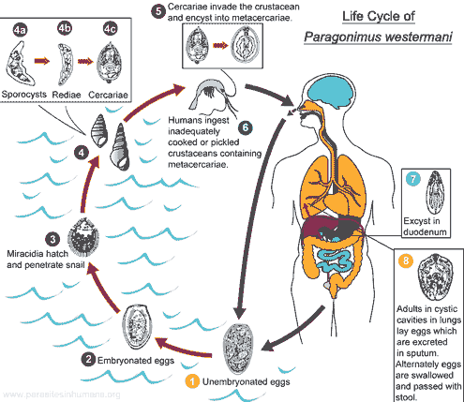

Epidemiology
Reservoir hosts of Paragonumus spp. include numerous species of carnivores including felids, canids, , some rodents and pigs. Humans only become infected after eating raw fresh water crabs that have been encysted with the metacerciaria. Southeast Asia is more predominately more infected because of lifestyles.. This parasite is easily spread because it is able to infect other animals (zoonosis).
Symptoms
The fluke provokes the development of a fibrous tissue capsule with bloody purulent material containing eggs. There is inflammatory infiltrate around the capsule. The symptoms include a dry cough, followed by production of blood stained rusty brown sputum. Pulmonary pain and pleurisy may develop. Worms may migrate to the brain where they lay eggs and cause a granulomatous abscess resulting in symptoms similar to epilepsy.
Pathology
Once in the lung or ectopic site, the worm stimulates an inflammatory response that allows it to cover its self in granulation tissue forming a capsule. These capsules can ulcerate and heal over time. The eggs in the surrounding tissue become pseudotubercles. If the worm becomes disseminated and gets into the spinal chord, it can cause paralysis; capsules in the heart can cause death. The symptoms are localized in the pulmonary system, which include a bad cough, bronchitis, and blood in sputum

Diagnosis

Diagnosis is based on history and symptomsThe way to properly diagnose this parasite infection is by looking at the sputum and finding the eggs. Eggs are found in rust colored sputum, often being examined for tuberculosis. Sometimes eggs are shed in the feces. Radiological methods can be used to X-ray the chest cavity and look for worms. This method is easily misdiagnosed, because pulmonary infections look like tuberculosis, pneumonia,. A lung biopsy can also be used to diagnose this parasite. An assay that detects worm antigens using monoclonal antibody can also be used for diagnosis.
Control
Adequate cooking of crustaceans is a preventive measure. Improved sanitary conditions have lowered the infection rate in endemic areas.

2-Blood flukes

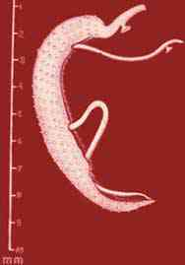
Schistosomiasis is a parasitic disease caused by several species of fluke of the genus Schistosoma.
Species of Schistosoma that can infect humans:
- Schistosoma mansoni cause intestinal schistosomiasis
- Schistosoma haematobium causes urinary schistosomiasis
- Schistosoma japonicum cause Asian intestinal schistosomiasis
Although it has a low mortality rate, schistosomiasis often is a chronic illness that can damage internal organs and, in children, impair growth and cognitive development. The urinary form of schistosomiasis is associated with increased risks for bladder cancer in adults. Schistosomiasis is the second most socioeconomically devastating parasitic disease after malaria. The disease affects many people in developing countries, particularly children who may acquire the disease by swimming or playing in infected water.

Life cycle
Eggs are eliminated with feces or urine . Under optimal conditions the eggs hatch and release miracidia , which swim and penetrate specific snail intermediate hosts . The stages in the snail include 2 generations of sporocysts and the production of cercariae . Upon release from the snail, the infective cercariae swim, penetrate the skin of the human host , and shed their forked tail, becoming schistosomulae . The schistosomulae migrate through several tissues and stages to their residence in the veins (, ). Adult worms in humans reside in the mesenteric venules in various locations, which at times seem to be specific for each species . For instance, S. japonicum is more frequently found in the superior mesenteric veins draining the small intestine , and S. mansoni occurs more often in the superior mesenteric veins draining the large intestine . However, both species can occupy either location, and they are capable of moving between sites, so it is not possible to state unequivocally that one species only occurs in one location. S. haematobium most often occurs in the venous plexus of bladder , but it can also be found in the rectal venules. The females (size 7 to 20 mm; males slightly smaller) deposit eggs in the small venules of the portal and perivesical systems. The eggs are moved progressively toward the lumen of the intestine (S. mansoni and S. japonicum) and of the bladder and ureters (S. haematobium), and are eliminated with feces or urine, respectively .
In snails
The life cycles of all three human schistosomes are broadly similar: parasite eggs are released into the environment from infected individuals, hatching on contact with fresh water to release the free-swimming miracidium. Miracidia infect fresh-water snails by penetrating the snail's foot. After infection, close to the site of penetration, the miracidium transforms into a primary (mother) sporocyst. Germ cells within the primary sporocyst will then begin dividing to produce secondary (daughter) sporocysts, which migrate to the snail's hepatopancreas. Once at the hepatopancreas, germ cells within the secondary sporocyst begin to divide again, this time producing thousands of new parasites, known as cercariae, which are the larvae capable of infecting mammals.

In humans
Penetration of the human skin occurs after the cercaria have attached to and explored the skin. The parasite secretes enzymes that break down the skin's protein to enable penetration of the cercarial head through the skin. As the cercaria penetrates the skin it transforms into a migrating schistosomulum stage.
The newly transformed schistosomulum may remain in the skin for 2 days before locating a post-capillary venule; from here the schistosomulum travels to the lungs where it undergoes further developmental changes necessary for subsequent migration to the liver. Eight to ten days after penetration of the skin, the parasite migrates to the liver sinusoids. S. japonicum migrates more quickly than S. mansoni, and usually reaches the liver within 8 days of penetration. Juvenile S. mansoni and S. japonicum worms develop an oral sucker after arriving at the liver, and it is during this period that the parasite begins to feed on red blood cells.
The nearly-mature worms pair, with the longer female worm residing in the gynaecophoric channel of the shorter male. Adult worms are about 10 mm long. Worm pairs of S. mansoni and S. japonicum relocate to the mesenteric or rectal veins. S. haematobium schistosomula ultimately migrate from the liver to the perivesical venous plexus of the bladder, ureters, and kidneys through the hemorrhoidal plexus.
Adult S. mansoni and S. japonicum Many of the eggs pass through the walls of the blood vessels, and through the intestinal wall, to be passed out of the body in faeces. S. haematobium eggs pass through the ureteral or bladder wall and into the urine. Up to half the eggs released by the worm pairs become trapped in the mesenteric veins, or will be washed back into the liver, where they will become lodged. Worm pairs can live in the body for an average of four and a half years, but may persist up to 20 years.
The eggs themselves do not damage the body. Rather it is the cellular infiltration resultant from the immune response that causes the pathology classically associated with schistosomiasis.

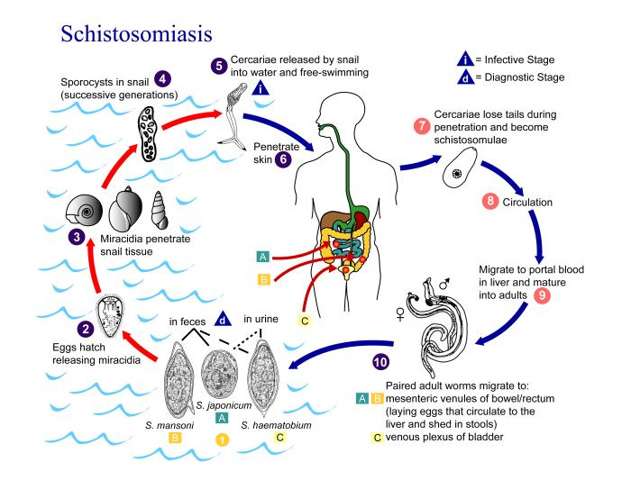
Symptoms
Penetration of cercariae causes transient dermatitis (swimmers' itch). The symptoms of schistosomiasis are primarily due to a reaction against the eggs and include splenomegaly, lymphadenopathy and diarrhea. In the bladder, they produce granulomatous lesions, hematuria and sometimes urethral occlusion. Most bladder cancers in endemic areas are associated with chronic infection. In the intestine, they cause polyp formation which, in severe cases, may result in life threatening dysentery. In the liver, the eggs cause periportal fibrosis and portal hypertension resulting in hepatomegaly, splenomegaly and ascites. A gross enlargement of the esophageal and gastric veins may result in their rupture. S. japonicum eggs are sometimes carried to the central nervous system and cause headache, disorientation, amnesia and coma. Eggs carried to the heart produce arteriolitis and fibrosis resulting in enlargement and failure of the right ventricle .

Clinical features
Pathology of S. mansoni and S. japonicum schistosomiasis includes: Katayama fever, presinusoidal egg granulomas, Symmers’ pipe stem periportal fibrosis, portal hypertension, and occasional embolic egg granulomas in brain or spinal cord. Pathology of S. haematobium schistosomiasis includes: hematuria, scarring, calcification, squamous cell carcinoma, and occasional embolic egg granulomas in brain or spinal cord. Human contact with water is thus necessary for infection by schistosomes. Various animals, such as dogs, cats, rodents, pigs, hourse and goats, serve as reservoirs for S. japonicum.
Pathology and Immunology
The 'swimmers' itch is due to physical damage to the skin by proteases and other toxic substances secreted by the cercaria. The host develops both type I and type IV hypersensitivity reactions to schistomal secretions and egg constituents. Embryonated eggs cause collagenase-mediated damage to the vascular endothelium. Host immune responses, both humoral and cell mediated, have been shown to be of some protective value. IgE and eosinophil mediated cytotoxicity has been suggested as a mechanism of killing the adult worm. Above all, schistosomiasis is a chronic disease. Many infections are subclinically symptomatic, with mild anemia and malnutrition being common in endemic areas. Acute schistosomiasis (Katayama's fever) may occur weeks after the initial infection, especially by S. mansoni and S. japonicum. Manifestations include:
- Abdominal pain
- Cough
- Diarrhea
- Eosinophilia — extremely high eosinophil granulocyte (white blood cell) count.
- Fever
- Fatigue
- Hepatosplenomegaly — the enlargement of both the liver and the spleen.
- Genital sores
- Cystitis and ureteritis (S. haematobium) with hematuria, which can progress to bladder cancer; Bladder Cancer diagnosis and mortality are generally elevated in affected areas.

Laboratory diagnosis
Microscopic identification of eggs in stool or urine is the most practical method for diagnosis. Stool examination should be performed when infection with S. mansoni or S. japonicum is suspected, and urine examination should be performed if S. haematobium is suspected.
Investigation of S. haematobium should also include a pelvic x-ray as bladder wall calcificaition is highly characteristic of chronic infection. Photomicrography of bladder in S. hematobium infection, showing clusters of the parasite eggs with intense eosinophilia,
Tissue biopsy (rectal biopsy for all species and biopsy of the bladder for S. haematobium) may demonstrate eggs when stool or urine examinations are negative.
The eggs of S. haematobium are ellipsoidal with a terminal spine, S. mansoni eggs are also ellipsoidal but with a lateral spine, S. japonicum eggs are spheroidal with a small knob.
Antibody detection can be useful in both clinical management and for epidemiologic surveys.

Prevention

1- Eliminating or avoiding the snails

2- Prevention through good design,Irrigation schemes can be designed to make it hard for the snails to colonize the water, and to reduce the contact with the local population. Control measures include sanitary disposal of sewage and destruction of snails.
3-Contaminated water should be avoided.
4-No vaccine is available.
3-Intistinal fluks

Fasciolopsis buski (Fasciolopsis)

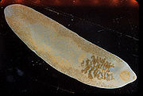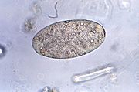
Fasciolopsis buski is a commonly called the giant intestinal fluke. It is a common parasite of humans and pigs and is most prevalent in Asia, mainly central and southeast Asia. It is in the class Trematoda, family Fasciolidae. The reason for its common name is due to the fact that it is one of the largest flukes to infect humans. The worm inhabits the upper region of the small intestine and, when abundantغزير, can also be found in the lower areas of the intestine and the stomach. Fasciolopsis buski is the cause of Fasciolopsiasis

Morphology
F. buski is a large leaf-shaped worm that is characterized by a blunt غير حادanterior end, undulating, unbranched ceca (sac-like cavity with a single opening), dendritic testes, branched ovaries, and ventral suckers to attach itself to the host. The ventral sucker is larger than the oral sucker. It has extensive vitelline follicles. It can be distinguished from other fasciolids by a lack of cephalic cone or "shoulders" and the unbranched ceca. The size of an adult worm can reach up to 3 inches in length and 1 inch in width. and lives in the small intestine of man

Life Cycle
Adults produce over 25,000 eggs every day which take up to seven weeks to mature.
Immature eggs are discharged into the intestine and stool . Eggs become embryonated in water , eggs release miracidia , which invade a suitable snail intermediate host . In the snail the parasites undergo several developmental stages (sporocysts , rediae , and cercariae ). The cercariae are released from the snail and encyst as metacercariae on aquatic plants . The mammalian hosts become infected by ingesting metacercariae on the aquatic plants. After ingestion, the metacercariae excyst in the duodenum and attach to the intestinal wall. There they develop into adult flukes (20 to 75 mm by 8 to 20 mm) in approximately 3 months, attached to the intestinal wall of the mammalian hosts (humans and pigs) . , attached to the intestinal wall of the mammalian hosts (humans and pigs). The adults have a life span of about one year.
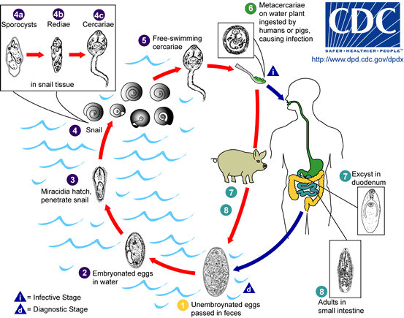

Symptoms
Most infections are light and asymptomatic. In heavy infections, symptons can include: Abdominal pain, chronic diarrhea, anemia, toxemia, allergic responses, sensitization caused by the absorption of the worms allergenic metabolites (may eventually cause death of patient), and intestinal obstruction. Erosion into the intestinal wall can lead to mucosal ulceration, GI hemorrhage, and/or abscess formation. Absorption of toxic metabolites may lead to the development of, potentially fatal, systemic symptoms.
Laboratory Diagnosis Microscopic identification of eggs, or more rarely of the adult flukes, in the stool or vomitus is the basis of specific diagnosis. The eggs are indistinguishable from those of Fasciola hepatica.

Prevention
Prevention can be easily achieved by immersion of vegetables in boiling water for a few seconds to kill the infective metacercariae, avoiding the use of nightsoil as a fertilizer, and maintenance of proper sanitation. Additionally, snail control should be attempted. Water chestnuts from contaminated waters should be avoided. Sewage should be treated before disposal.
Heterophyes heterophyes
(Intestinal Fluke) is caused by the infection with a trematode.This type of parasite belongs to the genus of Heterophyes, being the most common of the twelve species that compose the actual genus.This is a small fluke due to its dimensions.It measures only 0.5 to 0.8 millimeters in width and 0.8 to 2 millimeters in length and has a broadly rounded posterior ending.It has an oral sucker that is subterminal and represents one third of the size that the ventral sucker has.
life cycle
Adults release embryonated eggs each with a fully-developed miracidium, and eggs are passed in the host's feces . After ingestion by a suitable snail (first intermediate host), the eggs hatch and release miracidia which penetrate the snail’s intestine . Genera Cerithidia and Pironella are important snail hosts in Asia and the Middle East respectively. The miracidia undergo several developmental stages in the snail, i.e. sporocysts , rediae , and cercariae . Many cercariae are produced from each redia. The cercariae are released from the snail and encyst as metacercariae in the tissues of a suitable fresh/brackish water fish (second intermediate host) . Humans become infected by eating raw, pickled مخللor insufficiently cooked contaminated fish. The metacercariae excyst in the intestinal tract, become attached to its wall and reach maturity within 1–2 weeks. . The definitive host becomes infected by ingesting undercooked or salted fish containing metacercariae . After ingestion, the metacercariae excyst, attach to the mucosa of the small intestine and mature into adults (measuring 1.0 to 1.7 mm by 0.3 to 0.4 mm) . In addition to humans, various fish-eating mammals (e.g., cats and dogs) and birds can be infected by Heterophyes heterophyes . Inside the human body, the worms attach to the small bowel, causing mild inflammation, shallow ulcers and superficial necrosis. Because the eggs are very small, they easily enter into the blood vessels and embolize the brain.
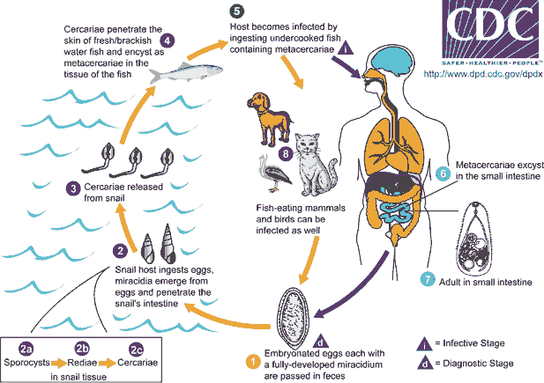
Clinical manifestations: Adult worm in the jejunum of the host causes
inflammation and ulcer, resulting in abdominal pain and diarrhea. In a few cases penetration of the worm into the tissue of the intestine results in liberation of the eggs in lymph nodes from where they may migrate to the heart and brain causing sever cardiac and nervous symptoms.
Diagnosis: is made by finding eggs in the feaces.
Prevention :is possible by avoiding consumption of not properly ed
fish.
Epidemiology: The life span of the worm is normally short and is about 6to 8 weeks. ****cercaria can live in the body of salted fish as long as
seven days.The number of Heterophyes worm is very high in the body of the host reaching sometimes to 4000.
4-Liver flukes

Fasciola hepatica
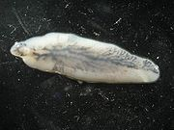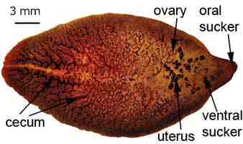
Fasciola hepatica is a parasitic fluke that lives in the liver. In addition to humans it infects cows and sheep. It is known as the sheep or common liver fluke and causes a disease called fascioliasis. Fasciola hepatica is found in areas where cattle and sheep are raised. Adults reach a length of 3 cm and 1 cm width.
Life cycle
The life cycle of Fasciola hepatica starts when a female lays eggs in the liver of an infected human. Immature eggs are discharged in the biliary ducts and taken out in the feces. If landed in water, the eggs become embryonated and develop larvae called miracidia. A miracidium invades an aquatic snail and develops into cercaria, a larva that is capable of swimming with its large tail. The cercaria exits and finds aquatic vegetation where it forms a cyst called metacercaria. A human eats the raw freshwater plant containing the cyst. The metacercaria excysts in the first part of the small intestine, duodenum. It then penetrates the intestinal wall and gets into the peritoneal cavity. It finds the liver and starts eating liver cells. This happens only a few days after the initial contact with the parasite. Usually the larva spends a few weeks just browsing and eating the liver. Then it relocates to the bile duct where it begins its final stage and becomes an adult. It takes about three months for the metacercaria to develop into an adult. Adult females can produce up to 25000 eggs per day.
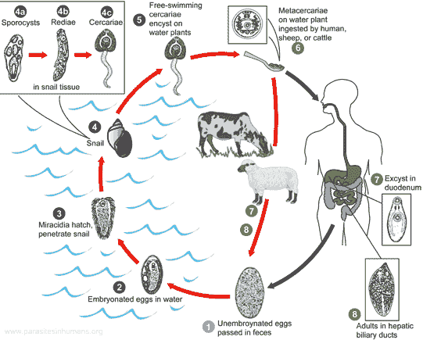
Clinical manifestations:
The effects of liver fluke are referred to as fascioliasis, and include anaemia, weight loss and sub-mandibular oedema. Diarrhea is only an occasional consequence of liver fluke.In the chronic phase of fascioliasis adults in the large biliary ducts cause liver inflammation and obstruction of the biliary fluid. During the migration of the larvae (this acute phase of the disease lasts many weeks) symptoms include:
- diarrhea
- eosinophilia (high number of white blood cells)
- fever
- nausea
- stomach ache
- vomiting.
- Diagnosis:
Liver fluke is diagnosed by yellow-brown eggs in the faeces. Adult Fasciola hepatica is identified from eggs in a stool sample. The eggs are very similar to those of Fasciolopsis buski. Early stage of the infection can be diagnosed from a blood sample, if antibodies are found.

Clonorchis sinensis

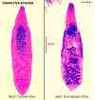
The Clonorchis sinensis is a human liver fluke in the class Trematoda, Phylum Platyhelminthes. This parasite lives in the liver of humans, and is found mainly in the common bile duct and gall bladder, feeding on bile. These are spindloid flukes measuring about 16x4 mm. The eggs measure 29 x 16 µm.
Life cycle
Embryonated eggs are discharged in the biliary ducts and in the stool . Eggs are ingested by a suitable snail intermediate host ; there are more than 100 species of snails that can serve as intermediate hosts. Each egg releases a miracidia , which go through several developmental stages (sporocysts , rediae , and cercariae ). The cercariae are released from the snail and after a short period of free-swimming time in water, they come in contact and penetrate the flesh of freshwater fish, where they encyst as metacercariae . Infection of humans occurs by ingestion of undercooked, salted, pickled, or smoked freshwater fish . After ingestion, the metacercariae excyst in the duodenum and ascend the biliary tract through the ampulla of Vater . Maturation takes approximately 1 month. The adult flukes (measuring 10 to 25 mm by 3 to 5 mm) reside in small and medium sized biliary ducts. In addition to humans, carnivorous animals can serve as reservoir hosts

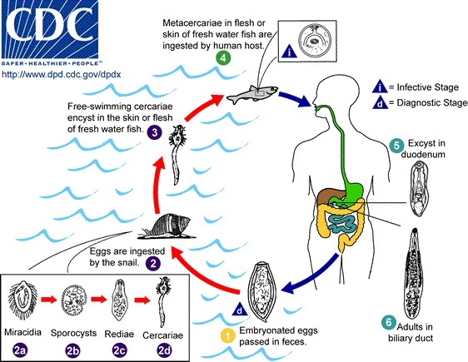

Effects on human health
Dwelling in the bile ducts, Clonorchis induces an inflammatory reaction, epithelial hyperplasia and sometimes even cholangiocarcinoma, the incidence of which is raised in fluke-infested areas.One adverse effect of Clonorchis is the possibility for the adult metacercaria to consume all bile created in the liver, which would inhibit the host human from digesting, especially fats. Another possibility is obstruction of the bile duct by the parasite or its eggs, leading to biliary obstruction.
Symptoms
The worm causes irritation of the bile ducts that become dilated and deviated. The liver may become enlarged (hepatomegaly), necrotic and tender and liver function may be impaired. Modest infections result in indigestion, epigastric discomfort, weakness and loss of weight. Heavier infections produce anemia, hepatomegaly, slight jaundice, edema, ascites and diarrhea.
Diagnosis
Diagnosis is based on symptoms and presence of endemic infection in the area. Definitive diagnosis is dependent on finding the characteristic yellow-brown eggs in the feces or biliary drainage.
Control Fish should be cooked well before consumption. Sewage must be treated before disposal.
احد السجناء في عصر لويس الرابع عشر محكوم عليه بالإعدام ومسجون في جناح قلعه
هذا السجين لم يبق على موعد إعدامه سوى ليله واحده.. ويروى عن لويس الرابع عشر ابتكاره لحيل وتصرفات غريبة ..
وفي تلك الليلة فوجئ السجين بباب الزنزانة يفتح ولويس يدخل عليه مع حرسه ليقول له :
أعطيك فرصه إن نجحت في استغلالها فبإمكانك إن تنجوا ....هناك مخرج موجود في جناحك بدون حراسه إن تمكنت من العثور عليه يمكنك الخروج وان لم تتمكن فان الحراس سيأتون غدا مع شروق الشمس لأخذك لحكم الإعدام.....
غادر الحراس الزنزانة مع الإمبراطور بعد إن فكوا سلاسله
وبدأت المحاولات وبدا يفتش في الجناح الذي سجن فيه والذي يحتوى على عده غرف وزوايا
ولاح له الأمل عندما اكتشف غطاء فتحه مغطاة بسجاده باليه على الأرض
وما إن فتحها حتى وجدها تؤدى إلى سلم ينزل إلى سرداب سفلي ويليه درج أخر يصعد مره أخرى وظل يصعد إلى أن بدأ يحس بتسلل نسيم الهواء الخارجي مما بث في نفسه الأمل إلى أن وجد نفسه في النهاية في برج القلعة الشاهق والأرض لايكاد يراها . عاد إدراجه حزينا منهكا و لكنه واثق إن الإمبراطور لايخدعه
وبينما هو ملقى على الأرض مهموم ومنهك ضرب بقدمه الحائط وإذا به يحس بالحجر الذي يضع عليه قدمه يتزحزح
فقفز وبدأ يختبر الحجر فوجد بالإمكان تحريكه وما إن أزاحه وإذا به يجد سردابا ضيقا لايكاد يتسع للزحف فبدأ يزحف وكلما زحف كلما استمر يزحف بدأ يسمع صوت خرير مياه وأحس بالأمل لعلمه إن القلعة تطل على نهر لكنه في النهاية وجد نافذة مغلقة بالحديد أمكنه أن يرى النهر من خلالها .....
عاد يختبر كل حجر وبقعه في السجن ربما كان فيه مفتاح حجر آخر لكن كل محاولاته ضاعت بلا سدى والليل يمضى
واستمر يحاول...... ويفتش..... وفي كل مره يكتشف أملا جديدا... فمره ينتهي إلى نافذة حديديه ومره إلى سرداب طويل ذو تعرجات لانهاية لها ليجد السرداب أعاده لنفس الزنزانة
وهكذا ظل طوال الليل يلهث في محاولات وبوادر أمل تلوح له مره من هنا ومره من هناك وكلها توحي له بالأمل في أول الأمر لكنها في النهاية تبوء بالفشل
وأخيرا انقضت ليله السجين كلها
ولاحت له الشمس من خلال النافذة ووجد وجه الإمبراطور يطل عليه من الباب ويقول له : أراك لازلت هنا ...
قال السجين كنت أتوقع انك صادق معي أيها الإمبراطور..... قال له الإمبراطور ... لقد كنت صادقا... سأله السجين.... لم اترك بقعه في الجناح لم أحاول فيها فأين المخرج الذي قلت لي : -----------------------
قال له الإمبراطور
لقد كان باب الزنزانة مفتوحا وغير مغلق.
Class: Cestoda
The body of the cestodes, also known as tapeworms, has lost the typical turbellarian form. Although there are a few unsegmented species, the bulk of a typical cestode body consists of a series of linearly arranged reproductive segments called proglottids. There is no mouth or digestive system; food is absorbed through the cuticle. Adults live in the digestive tract of vertebrates, and larval forms encyst in the flesh of various vertebrates and invertebrates.
The body of an adult tapeworm is virtually a reproductive factory. Behind a small securing knob, called a scolex, which bears a circle of hooks or other attachment organs, the proglottids constantly bud off and gradually enlarge. As they mature they become filled with male and female reproductive organs. Cross-fertilization takes place with adjacent worms or neighboring proglottids; in some cases self-fertilization occurs. In some species the ripe proglottids, filled with eggs, are shed. In others the fertilized eggs leave the adult host in the feces. If the eggs are consumed by the intermediate host, the life cycle continues. Tapeworm species that infest human intestines as adults include Taenia saginata, T. solium, the dwarf tapeworm, Hymenolepsis nana, and the fish tapeworm, Diphyllobothrium latum, which can reach lengths of up to 50 ft (15 m).
Cestodes or tapeworms are the most specialised of the Platyhelminthe parasites. All cestodes have at least one, and sometimes more than one, secondary or intermediate host as well as their primary host. While the intermediate hosts are often invertebrates of some sort, the primary host is normally a vertebrate. Having said this, in some cases both hosts are vertebrates, as in the common Beef Tapeworm Taenia saginatus, and in a few species their may be only a single host. A number of tapeworms include mankind in their life cycles but infection is not normally a serious health problem and can be cured. There are more than 1,000 species of tapeworms known to science, and nearly every species of vertebrate is liable to infection from at least one species of tapeworm.
- Order: Pseudophylidea
Diphyllobothrium latum
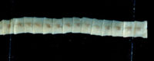
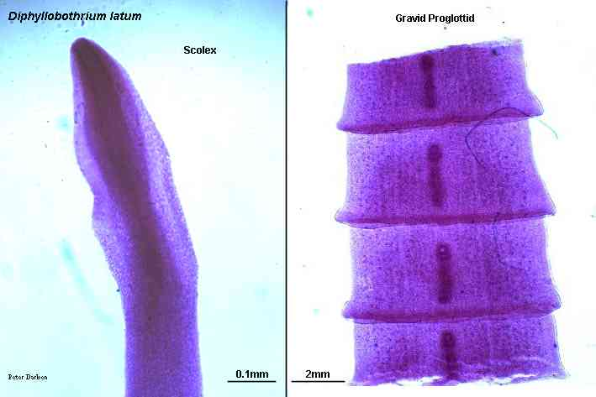
Diphyllobothrium is a genus of tapeworm which can cause Diphyllobothriasis in humans through consumption of raw or noncooked fish. The principal species causing diphyllobothriosis is Diphyllobothrium latum, known as the broad or fish tapeworm, or broad fish tapeworm. D. latum is a pseudophyllid cestode that infects fish and mammals.
This is the longest tapeworm found in man, ranging from 3-10 meters with more than 3000 proglottids. The scolex resembles two almond-shaped leaves and the proglottids are broader than they are long, a morphology reflected in the organism's name. Eggs are 30 x 50 micrometers in size and contain an embryo with 3 pairs of hooklets.The adult worm is comprised of three fairly distinct morphological segments; the scolex, the neck and the lower body. The scolex is the head portion of the worm, and is equipped with a slit-like groove (the bothrium) for attachment to the intestine. The scolex attaches to the neck, or proliferative region. From the neck, grows many proglottid segments which contain the reproductive organs of the worm. D. latum is the longest tapeworm in humans, averaging ten meters long. Adults can shed up to a million eggs a day. In adults, proglottids are wider than they are long (hence the name broad tapeworm). As in all pseudophyllid cestodes, the genital pores open midventrally.
Life cycle
Immature eggs are passed in feces . Under appropriate conditions, the eggs mature (approximately 18 to 20 days) and yield oncospheres which develop into a coracidia . After ingestion by a suitable freshwater crustacean (the copepod first intermediate host) the coracidia develop into procercoid larvae . Following ingestion of the copepod by a suitable second intermediate host, typically minnows and other small freshwater fish, the procercoid larvae are released from the crustacean and migrate into the fish flesh where they develop into a plerocercoid larvae (sparganum) . The plerocercoid larvae are the infective stage for humans. Because humans do not generally eat undercooked minnows and similar small freshwater fish, these do not represent an important source of infection. Nevertheless, these small second intermediate hosts can be eaten by larger predator species, e.g., trout, perch, walleyed pike . In this case, the sparganum can migrate to the musculature of the larger predator fish and humans can acquire the disease by eating these later intermediate infected host fish raw or undercooked . After ingestion of the infected fish, the plerocercoid develop into immature adults and then into mature adult tapeworms which will reside in the small intestine. The adults of D. latum attach to the intestinal mucosa by means of the two bilateral groves (bothria) of their scolex . The adults can reach more than 10 m in length, with more than 3,000 proglottids. Immature eggs are discharged from the proglottids (up to 1,000,000 eggs per day per worm) and are passed in the feces . Eggs appear in the feces 5 to 6 weeks after infection. In addition to humans, many other mammals can also serve as definitive hosts for D. latum.
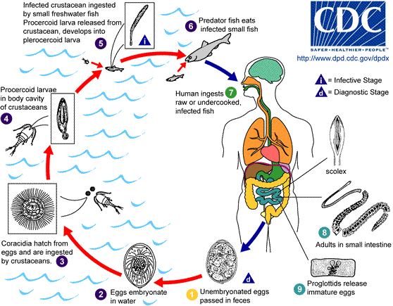
The plerocercoid larvae are the infective stage for the definitive host (including humans).
Because humans do not generally eat undercooked minnows and similar small freshwater fish, these do not represent an important source of infection.
These small second intermediate hosts can be eaten by larger predator مفترسspecies, for example, trout, perch, and walleyed pike. In this case, the sparganum can migrate to the musculature of the larger predator fish and mammals can acquire the disease by eating these later intermediate infected host fish raw or undercooked.
After ingestion of the infected fish, the plerocercoids develop into immature adults and then into mature adult tapeworms which will resideيسكن in the small intestine.
The adults attach to the intestinal mucosa by means of the two bilateral grooves (bothria) of their scolex. The adults can reach more than 10 m (up to 30 ft) in length in some species such as D. latum, with more than 3,000 proglottids. One or several of the tape-like proglottid segments (hence the name tape-worm) regularly detach from the main body of the worm and release immature eggs in fresh water to start the cycle over again.
Immature eggs are discharged from the proglottids (up to 1,000,000 eggs per day per worm) and are passed in the feces. The incubation period in humans, after which eggs begin to appear in the feces is typically 4-6 weeks, but can vary from as short as 2 weeks to as long as 2 years. The tapeworm can live up to 20 years.
Clinical symptoms
Including occasional parasite-induced B12 deficiency.Symptoms of diphyllobothriasis are generally mild, and can include diarrhea, abdominal pain, vomiting, weight loss, fatigue, constipation and discomfort. Approximately four out of five cases are asymptomatic and may go many years without being detected. In a small number of cases, this leads to severe vitamin B12 deficiency due to the parasite absorbing 80% or more of the host’s B12 intake. Symptoms
Clinical symptoms may be mild, depending on the number of worms. They include abdominal discomfort, loss of weight, loss of appetite and some malnutrition. Anemia and neurological problems associated with vitamin B12 deficiency are seen in heavily infected individuals.
Epidemiology People at high risk for infection have traditionally been those who regularly consume raw fish, including fishermen who eat the raw liver or roeأنثى الضبي أو الأرنب of their catches and women preparing and tasting foods that contain raw fish. Many regional cuisinesأسلوب الطبخ include raw or undercooked food
Diagnosis is based on finding many typical eggs and empty proglottids in feces . A history of raw fish consumption and residence in an endemic locality is helpful.

Prevention
Freezing for 24 hours, thorough cooking or pickling of fish kills the larvae. Fish reservoirs should be kept free of raw sewage.
- Order:Cyclophylidea
Taenia solium
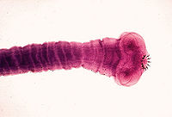
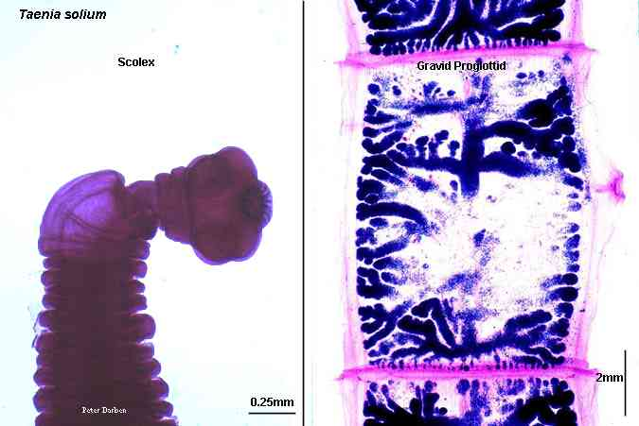
Taenia solium, also called the pork tapeworm, is a cyclophyllid cestode in the family Taeniidae. It infects pigs and humans. Like all cyclophyllid cestodes, T. solium has four suckers on its scolex ("head"). T. solium also has two rows of hooks. T. solium is slightly smaller than T. saginata. It has a globular scolex with four suckers and a circular row of hooks (rostellum) that gives it a solar appearance. There is a neck and it has a long flat body (0.1 meter in length). The proglottids are 5 x 10 mm with a 7-12 branch uterus. The eggs of T. solium and T. saginata are indistinguishable .T. solium has a very similar life cycle to Taenia saginata,. Cysticerci have three morphologically distinct types. The common one is the ordinary "cellulose" cysticercus which has a fluid filled bladder that is 0.5 cm to 1.5 cm in length and an invaginated scolex. Though humans usually serve as a definitive host, eating infected meat, fostering adult tapeworms in the intestine, and passing eggs through feces, sometimes a cysticercus (a larva sometimes called a "bladder worm") develops in the human and the human acts like an intermediate host. This happens if eggs get to the stomach, usually as a result of contaminated hands, but also of vomiting.
Clinical symptoms Cysticerci often occur in the central nervous system, which can cause major neurological problems like epilepsy and even death. The condition of having cysticerci in one's body is called Cysticercosis,
Diagnosis Eggs can be diagnosed only to the family (biology) level, but if a proglottid's uterus is stained with India ink, the number of visible uterine branches can help identify the species: unlike the Taenia saginata uteri, T. solium uteri have only five to ten uterine branches on each side.
Prevention Infection may be prevented with proper disposal of human feces around pigs, cooking meat thoroughly, and/or freezing the meat at -10ºC for 5 days. Most cases occur because infected food handlers contaminate the food.
Distribution Taenia solium is found worldwide. Because pigs are intermediate hosts of the parasite, completion of the life cycle occurs in regions where humans live in close contact with pigs and eat undercooked pork. Cysticercosis is often seen in areas where poor hygiene علم صحةallows for contamination of food, soil or water supplies. It is important to note that human cysticercosis is acquired by ingesting T. solium eggs shed in the feces of a human T. solium tapeworm carrier, and thus can occur in populations that neither eat pork nor share environments with pigs.

Taenia saginata
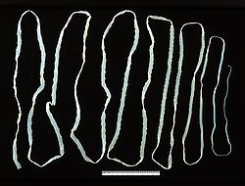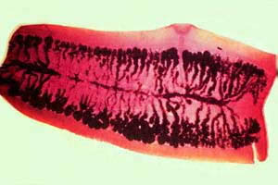
It has a pear-shaped head (scolex) with four suckers but no hooks or neck. It has a long flat body with several hundred segments (proglottids). Each segment is about 18 x 6 mm with a branched uterus (15-30 branches). The egg is 35 x 45 micrometers, roundish and yellow-brown. It has peripheral radial striations and contains an embryo with 3 hooklets .The pore on the side identifies T. saginata as a cyclophyllid cestode. Taenia saginata, also known as the Beef tapeworm, is a parasite of both cattle and humans, but which can only reproduce asexually in humans. Taenia saginata occurs where cattle are raised by infected humans maintaining poor hygiene, human feces is improperly disposed of, meat inspection programs are poor, and where meat is eaten without proper cooking. Taenia saginata are normally 3m to 5m in length, but it can become very large, over 20m in some situations. It does not have a rostellum or scolex armature. The scolex is composed of 4 powerful suckers. The segments are made up of mature and gravid proglottid. The mature proglottid contains the uterus (unbranched), ovary, genital pore, testes, and vitelline gland. In the gravid proglottid the uterus is branched and is filled with eggs. The gravid segments detach and are passed in the feces. Each of these segments can act like a worm. When they dry up the proglottid ruptures and the eggs are released. The egg can only infect cattle, the intermediate host.Inside the cow's duodenum the oncosphere hatch with the help of the gastric and intestinal secretions and migrates through the blood to the muscle. There it develops into infective cysticerci. Humans become infected when they eat beef that is not cooked fully.
Symptoms Tapeworms are usually asymptomatic, as implausible as that may sound. Some symptoms include dizziness, abdominal pain, diarrhea, headaches, nausea, and loss of appetite الشهية. There can be intestinal obstruction in humans and this can be alleviated by surgery.
Prevention is easy. Cook beef until it is no longer pink inside because cysticerci die at 56 degrees Celsius. Also, if beef is frozen at -5 degrees Celsius it is considered to be safe to consume. This parasite is found anywhere where beef is eaten.
Diagnosis The eggs look like other eggs from the family Taeniidae, so it is only possible to identify the eggs to the family, not to the species level. Since it is difficult to diagnose using eggs alone, looking at the scolex or the gravid proglottids can help identify if it is Taenia saginata. Proglottids sometimes trickle down the thighs of infected humans and are visible with unaided eye and aid with identification. When the uterus is injected with India ink, its branches become visible. Counting the uterine branches enables some identification (Taenia saginata uteri have twelve or more branches on each side, while other species like Taenia solium only have five to ten).
Life cycle
Life cycle of Taenia saginata and Taenia solium , Humans are the only definitive hosts for Taenia saginata and Taenia solium. Eggs or gravid proglottids are passed with feces ; the eggs can survive for days to months in the environment. Cattle (T. saginata) and pigs (T. solium) become infected by ingesting vegetation contaminated with eggs or gravid proglottids . In the animal's intestine, the oncospheres hatch , invade the intestinal wall, and migrate to the striated muscles, where they develop into cysticerci. A cysticercus can survive for several years in the animal. Humans become infected by ingesting raw or undercooked infected meat . In the human intestine, the cysticercus develops over 2 months into an adult tapeworm, which can survive for years. The adult tapeworms attach to the small intestine by their scolex and reside in the small intestine . Length of adult worms is usually 5 m or less for T. saginata (however it may reach up to 25 m) and 2 to 7 m for T. solium. The adults produce proglottids which mature, become gravid, detach from the tapeworm, and migrate to the anus or are passed in the stool (approximately 6 per day). T. saginata adults usually have 1,000 to 2,000 proglottids, while T. solium adults have an average of 1,000 proglottids. The eggs contained in the gravid proglottids are released after the proglottids are passed with the feces. T. saginata may produce up to 100,000 and T. solium may produce 50,000 eggs per proglottid respectively.
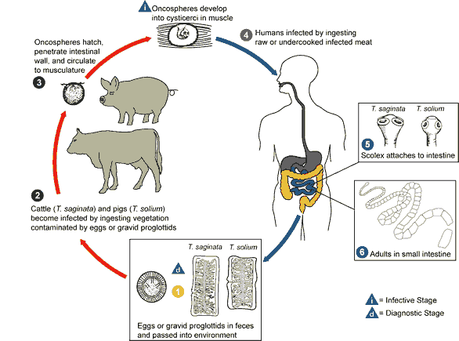

Echinococcus granulosus

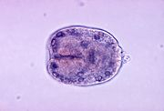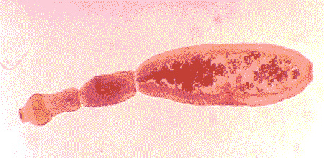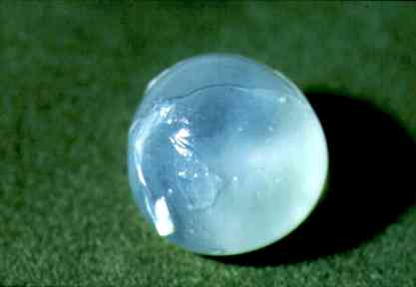

It is also called the Hydatid worm or Hyper Tape-worm, is a cyclophyllid cestode that parasitizes the small intestine of canids العائلة الكلبيةas an adult, but which has important intermediate hosts such as livestock and humans, where it causes hydatid disease.
Morphology
The adult tapeworm is about 5 mm long and has three proglottids ("segments") when intact. Like all cyclophyllideans, E. granulosus has four suckers on its scolex ("head"), and E. granulosus also has a rostellum with hooks.
Life Cycle
The adult Echinococcus granulosus (3 to 6 mm long) (1) resides in the small bowel of the definitive hosts, dogs or other canids. Gravid proglottids release eggs (2) that are passed in the feces. After ingestion by a suitable intermediate host (under natural conditions: sheep, goat, swine, cattle, horses, camel), the egg hatches in the small bowel and releases an oncosphere (3) that penetrates the intestinal wall and migrates through the circulatory system into various organs, especially the liver and lungs. Inthese organs, the oncosphere develops into a cyst (4) that enlarges gradually, producing protoscolices and daughter cysts that fill the cyst interior. The definitive host becomes infected by ingesting the cyst-containing organs of the infected intermediate host. After ingestion, the protoscolices (5) evaginate, attach to the intestinal mucosa (6), and develop into adult stages (1) in 32 to 80 days. Humans become infected by ingesting eggs (2), with resulting release of oncospheres (3) in the intestine and the development of cysts (4) in various organs
-In canids, E. granulosus causes a typical tapeworm infection, and produces eggs that are passed with the dog's feces. Intermediate hosts include herbivores such as sheep, deer, moose, kangaroos, and any other organism (including humans) that ingests dog feces.
- In the intermediate host, eggs hatch into oncosphere larvae that travel through the blood and form hydatid cysts in the host's tissues. These cysts can grow to be the size of a softball or basketball, and may contain several smaller "balloons" inside the main cyst.
-Hydatid cysts occur in organs like the liver, brain and lungs, not in subcutaneous tissue.
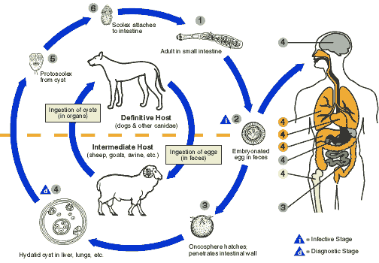

Symptoms can include liver enlargement, and possible anaphylactic shock when the immune system reacts to ruptured cysts.
Diagnosis in the definitive host, the dog, is difficult by ordinary microscopy as it cannot differentiate between Taenia and Echinococcus eggs. Detection of antigens in feces by ELISA is currently the best available technique. A cyst diagnosis with ultrasound, MRI, or immunoelectrophoresis.
Symptoms comparable to those of a slowly growing tumor, depend upon the location of the cyst. Large abdominal cysts produce increasing discomfort. Liver cysts cause obstructive jaundice. Peribronchial cysts may produce pulmonary abscesses. Brain cysts produce intracranial pressure and Jacksonian epilepsy. Kidney cysts cause renal dysfunction. The contents of a cyst may produce anaphylactic responses.
Diagnosis Clinical symptoms of a slow-growing tumor accompanied by eosinophilia are suggestive. Intradermal (Casoni) test with hydatid fluid is useful. Pulmonary cysts and calcified cysts can be visualized using x-rays. Antibodies against hydatid fluid antigens have been detected in a sizable population of infected individuals by ELISA or indirect hemagglutination test.
Control &Tretment Treatment involves surgical removal of cyst or inactivation of hydatid sand by injecting the cyst with 10% formalin and its removal within few (4-5) minutes. Prazequantel has been shown to be effective in many cases. Albendazole, in high doses, is an alternative. Preventive measures involve avoiding contact with infected dogs and cats and elimination of their infection.
Hydatid disease is treated with surgery, taking special care to leave the cyst intact so new cysts do not form, and mebendazole over a long period of time at low dosages.
The best way to keep dogs from being infected is to prevent them from eating infected offal. The best way to avoid human infection is to avoid ingesting food or other substances contaminated with dog feces.

Hymenolepis nana

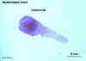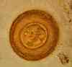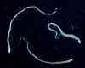
Commonly called the dwarf tapeworm, is a cosmopolitanعالمي species that is one of the most common cestodes of humans in the world, especially among children. It can be found throughout the world, but is usually most common in temperate zones. When it becomes an adult, it will attach to the intestinal walls with its suckers and toothed rostellum and have its segments reaching out into the intestinal space to absorb food.
This is a small tapeworm (20 x 0.7 mm) which infects children. Rodents are the reservoir. Infection is by the oro-fecal mode and, hence, cross infection and auto infection by eggs in feces in normal .The worm develops from ingested eggs into an adult in the small intestine and resides there for several weeks . Light infections produce vague abdominal disturbances but heavier infections may cause enteritis. Diagnosis is based on finding eggs in the feces. Hygiene is the best control.
Morphology As its name implies (Gr. nanos=dwarf), it is a small species, seldom exceeding 40 mm long and 1 mm wide. The scolex bears a retractable rostellum armed with a single circle of 20 to 30 hooks. The scolex also has four suckers, or a tetrad. The neck is long and slender, and the segments are wider than long. Genital pores are unilateral, and each mature segment contains three testes. gravid segments disintegrate, releasing eggs, which measure 30 µm to 47 µm in diameter. The oncosphere is covered with a thin, hyaline, outer membrane and an inner, thick membrane with polar thickenings that bear several filaments. Hymenolepis nana, like all tapeworms, contains both male and female reproductive structures in each proglottid. This means that the dwarf tapeworm like other tapeworms is hermaphroditic. Each segment contains 3 testes and a single ovary.

life cycle Eggs of Hymenolepis nana are immediately infective when passed with the stool and cannot survive more than 10 days in the external environment by contaminated fingers, or in sewage-contaminated drinking water. . Hymenolepis nana is the only cestode that does not require an intermediate host to develop into its infective stage. When eaten by a person or rodent, eggs hatch in the duodenum, releasing or sometime When eggs are ingested by an arthropod intermediate host (various species of beetles and fleas may serve as intermediate hosts), they develop into cysticercoids, which can infect humans or rodents upon ingestion and develop into adults in the small intestine. A morphologically identical variant, H. nana var. fraterna, infects rodents and uses arthropods as intermediate hosts. When eggs are ingested (in contaminated food or water or from hands contaminated with feces), the oncospheres contained in the eggs are released. The oncospheres (hexacanth larvae) penetrate the intestinal villus and develop into cysticercoid larvae . Upon rupture of the villus, the cysticercoids return to the intestinal lumen, evaginate their scoleces , attach to the intestinal mucosa and develop into adults that reside in the ileal portion of the small intestine producing gravid proglottids . Eggs are passed in the stool when released from proglottids through its genital atrium or when proglottids disintegrate in the small intestine . An alternate mode of infection consists of internal autoinfection, where the eggs release their hexacanth embryo, which penetrates the villus continuing the infective cycle without passage through the external environment . The life span of adult worms is 4 to 6 weeks, but internal autoinfection allows the infection to persist for years.
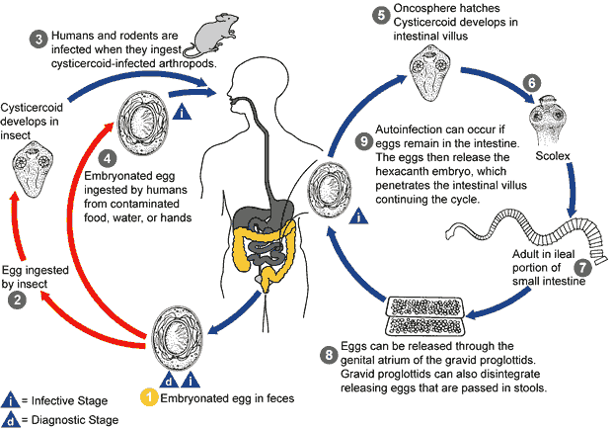

Clinical Manifestations of Hymenolepiasis
Hymenolepis nana lodges itself in the intestines and absorbs nutrients from the intestinal lumen. In human adults, the tapeworm is more of a nuisance شيء مزعجthan a health problem, but in small children, many H. nana can be dangerous. Usually it is the larva of this tapeworm that causes the most problem in children. The larva will burrow جحرinto the walls of the intestine, if there are enough tapeworms in the child, severe damage can be inflictedيسبب. This is done by absorbing all the nutrition from the food the child eats. Usually a single tapeworm will not cause any danger, but in small children, many tapeworms can become a problem. Hymenolepis nana usually will not cause deaths unless in extreme circumstances and usually in young children or in people who have weakened immune systems. Symptoms are due to allergic responses or systematic toxaemia caused by waste products of the tapeworm. Light infections are usually symptom less. Infection with more than 2000 worms can cause enteritis, abdominal pain, diarrhea,. vomiting, nausea, bloody diarrhea,.
Epidemology
Rates of infection run from 1% in The dwarf tapeworm like all other tapeworms lacks a digestive system and feeds by absorption on nutrients in the intestinal lumen. the Southern United States to 9% in Argentina and to 97.3% in Moscow.
Diagnosis 1- Detection The egg or gravid segment in feces.2-Detection of antigens in feces by ELISA is currently the best available technique.

Dipylidium caninum

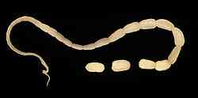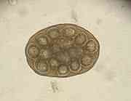

Also called the cucumber tapeworm or the double-pore tapeworm, is a cyclophyllid cestode that infects organisms afflicted with fleas, including canids, and pet-ownersمربي حيوان,especially children.Adult worms are about 18 inches long. Eggs (or “egg clusters” or “egg balls”) are passed in the host's feces and ingested by fleas, which are in turn ingested by another mammal after the tapeworm larvae partially develop.

As in all members of family Dipylidiidae, proglottids of the adult have genital pores on both sides (hence the name double-pore tapeworm). Each side has a set of male and female reproductive organs. The scolex has a rostellum with four rows of hooks, along with the four suckers that all cyclophyllid cestodes have. In cats, sometimes proglottids are visible hanging out of a cat's anus. Inside fleas, eggs hatch and form oncosphere larvae that move through the wall of the flea intestine into the body cavity where they become cysticercoid larvae, which are infective to mammal hosts.

Morphology
A Dipylidium caninum adult is a long flat worm, around 40 to 50 cm. The body is made up of the head or scolex, the neck, and a segmented section called the strobilus. The scolex has hooks for attachment. Each segment contains two proglottids. A proglottid is one set of reproductive organs. Dipylidium caninum is often identified by examing segments passed in feces. Dipylidium caninum has two genital pores located laterally on each segment, with two proglottids per segment.. Larvae are called oncospheres generally, but specifically for D. caninum. Larvae of Eucestoda are termed "hexacanth" because of the six hooks on the posterior end. Dogs are the principal definite hosts; other hosts are foxes and cats. Humans are accidental hosts and may be infected, especially children, by ingesting an infected flea, when playing with dogs and cats.
The infection is acquired by the ingestion of the infective stage of D.caninum, the cysticercoid, harboured by the dog or cat flea or by the dog lice (Trichodectes canis) the intermediate hosts.

Clinical Manifestations In children, infection causes diarrhea and restlessness.
Diagnosis :1- Detection The egg or gravid segment in feces

2-Detection of antigens in feces by ELISA is currently the best available technique.
Life cycle the adult worm lives in the small intestine of the definite host; the worm produces proglottids. The gravid proglottids detach and migrate to the anus or are passed in the stool. Each proglottids contains eggs packets enveloped by an outer embryonic membrane; each packet contains about 20 embryonated eggs (25-30 m m in diameter). Larval fleas become infected by ingesting the eggs; following ingestion an hexacanth embryo is releases and cysticercoid develops in the body cavity of the flea.When the dog (or human) ingests an infected flea, after the evertion of the scolex the parasite attaches to the small intestine and develop to the adult worm forming proglottids in about 1 month. The parasite develops to adult (measuring 15 to 70 cm in lenght) in 20-30 days.Mild gastrointestinal symptoms and eosinophilia are the common findings.
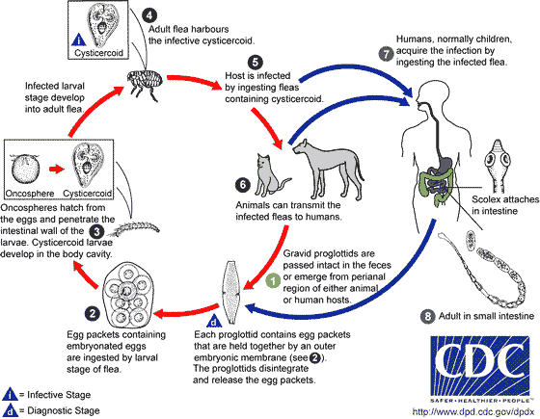

Multiceps multiceps
It is a cestode of cosmopolitan distribution and causes coenuriasis in man. The dog is the common definitive host in the USA and UK. With the intermediate stages developing in many ungulates, especially sheep.
Multiceps sp, a rare cause of human infection, is acquired by accidental ingestion of dog feces. Canines are the definitive hosts for adult Multiceps tapeworms; sheep and other herbivorous animals are intermediate hosts. Unwitting غير مقصودingestion of dog feces causes human disease. The larva, termed a coenurus, forms a cyst in human tissues.
Symptoms Symptoms require several years to develop and depend on the organ infected. Involvement of the brain causes increased intracranial pressure, seizuresنوبة , and focal neurologic deficits.

Life cycle the adult worm is found in dogs and other canidae. The intermediate hosts comprise of a number of herbivorous animals, where the cysts develop in the brain and spinal cord causing a disease called ‘staggers’, which affects the balancing powers of the animals. Man becomes infected by the accidental ingestion of eggs. The oncosphere hatches and penetrates the intestinal wall and the embryo is carried by the blood stream to various parts of the body including the central nervous system where it lodges and the cyst or coenurus develops. (Fig. 7) Multiple scolices burst from the inner surface of the cyst wall. The cyst resembles that of a cysticercus (Cysticercus cerebralis). It is filled with fliud, semi-transparent and glistening white. The cysticercus possesses unusual asexual multiplication, forming a bladder (or coenurus) which gives rise to hundreds of daughter protoscoleces directly from its inner wall. It therefore differs from a hydatid cyst.
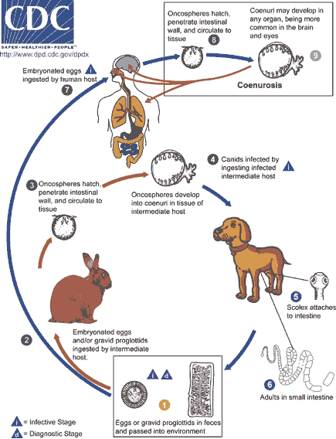

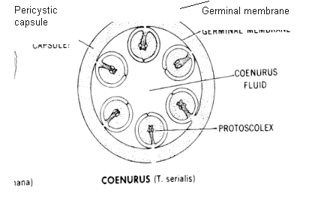
Diagrammatic representation of a Multiceps multiceps coenurus cyst. Hundred of daughter protoscoleces are released from the cyst, therefore differing from a hydtatid cyst.

Clinical Disease In humans, coenuri are most frequently found in the brain and spinal cord but also in the subcutaneous tissue. Symptoms include headache, vomiting, paraplegia seizures and eye problems. The coenurus may cause serious damage or even death, but only a few have ever been reported.

Diagnosis There are no serological tests available.
There was a man who worked for the Post Office whose job was to process all the mail that had illegible addresses.
One day, a letter came addressed in a shaky handwriting to God with no actual address. He thought he should open it to see what it was about.
The letter read:
Dear God,
I am an 83 year old widow, living on a very small pension.
Yesterday someone stole my purse. It had "$100" in it, which was all the money I had until my next pension payment.
Next Sunday is Christmas, and I had invited two of my friends over for dinner. Without that money, I have nothing to buy food with, have no family to turn to, and you are my only hope. Can you please help me?
Sincerely, Edna
The postal worker was touched. He showed the letter to all the other workers. Each one dug into his or her wallet and came up with a few dollars.
By the time he made the rounds, he had collected $96, which they put into an envelope and sent to the woman.
The rest of the day, all the workers felt a warm glow thinking of Edna and the dinner she would be able to share with her friends.
Christmas came and went.
A few days later, another letter came from the same old lady to God.
All the workers gathered around while the letter was opened.
It read:
Dear God,
How can I ever thank you enough for what you did for me?
Because of your gift of love, I was able to fix a glorious dinner for my friends. We had a very nice day and I told my friends of your wonderful gift.
By the way, there was $4 missing.
I think it might have been those bastards at the post office.
Sincerely, Edna

