Lab Six :.
Minimum Bacteriocidal Concentration (MBC):
The minimal bactericidal concentration (MBC) or the minimum lethal concentration (MLC) can be determined by sub culturing all tubes showing no visible turbidity, of an antibacterial, which is defined as the maximum dilution of the product that will kill a test, organism can be determined by sub culturing last clear MIC tube onto growth medium and examining for bacterial growth. Serial dilutions are made of the products in bacterial growth media.
The tube with the highest dilution that fails to yield growth on the subculture plate contains the MBC of antibiotic for the test strain.
The MBC was measured by inoculating the broths used for MIC determinations onto drug-free medium. The MBC is the first dilution at which no growth was observed.
Procedure:
- The same steps of determination MIC, after we got the result fellow this
- We culture all clear tubes in MIC and start from the first dilution at which no growth was observed, the culture by taken (0.1mL) from all clear tubes and streaking on MHA and incubate 16-18 hrs.
- After incubation period, we observed the plate, which do not contain growth, so this plate or concentration is MBC, which kill growth of bacteria, the MIC is much lower than the MBC or maybe equal this MBC value

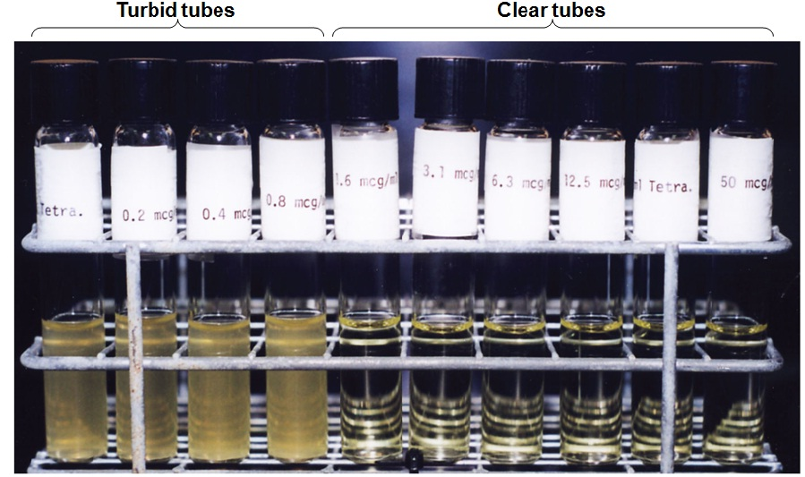Minimum inhibitory concentration (MIC) test in test tubes
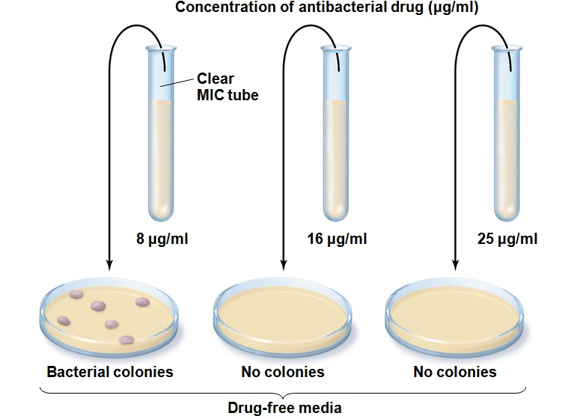A minimum bactericidal concentration (MBC) test
