Gene Therapy And Nanoparticles
Gene therapy is an experimental technique that uses genes to treat or prevent disease. In the future, this technique may allow doctors to treat a disorder by inserting a gene into a patient’s cells instead of using drugs or surgery. Researchers are testing several approaches to gene therapy, including:
- Replacing a mutated gene that causes disease with a healthy copy of the gene.
- Inactivating a mutated gene that is functioning improperly.
- Introducing a new gene into the body to help fight a disease.
Nanoparticles
The urgent requirement for the discovery of innovative strategies to develop the next drug or agents from natural and inorganic substances to control microbial infections. Prior to the extensive use of chemotherapeutics in modern health care system, inorganic antimicrobials such as silver and copper were used since ancient times to treat microbial infections. The antimicrobial activity of nanoparticles known to be a function of surface area in contact microscopic living organisms. Small size and high surface to volume ratio, a large surface area of nanoparticles interact with bacteria to improve or perform a wide variety of potential antimicrobial activities. Metal nanoparticles with antimicrobial activity can find tremendous applications in water treatment, industrial textiles, medical vitality and surgical instruments as well as, in food industry and packaging. Moreover, the composites prepared using metal nanoparticles and polymers can find better utilization due to the enhanced antimicrobial activity

Nanoparticles preparation :
The preparation of copper oxide and oxalate nanoparticles via soft chemistry approach based on the thermal decomposition of oxalic precursors with a well-controlled morphology and particle size.
Copper oxalate nanoparticles:
An alcoholic oxalic acid solution was very slowly added under efficient magnetic stirring to a solution of copper nitrate in alcohol-water at a temperature below 20°C. Addition rate was such a way. It takes between 60 to 90 minutes. The color of copper nitrate solution was faded during the progress of the addition and fine suspension of pale blue copper oxalate was observed. The mixture was left in refrigerator overnight to allow some of the suspension to settle. The mixture was separated from the mother liquor by centrifugation at 3000 rpm for 60 minutes in 10 mL capped plastic tubes. The precipitate was collected in one tube and then washed twice with 95% alcohol with the aid of the centrifugation at similar rotation speed. After the second washing centrifugation cycle, the particles require more time to sediment. The collected solid (1.53 gm) was much less than the theoretical yield, and this could be due to the very small size of resulted copper oxalate. The solid was dried in an oven at 70ºC for 3 hour, to give dry solid (1.23 gm).
Determination of antimicrobial activity by well diffusion and broth dilution methods
The antibacterial activity of synthesized copper oxide and oxalate nanoparticles were tested against pathogenic bacterial strains of P.aeruginosa that was resistant to all kinds of antibiotics applied.
The antibacterial activity were performed by agar well diffusion method
Antimicrobial activity of the synthesized copper oxide and oxalate nanoparticles were determined by following a modified Kirby-Bauer disc diffusion method. In brief, A lawn of bacterial culture was prepared by spreading 100 µL of bacterial suspension, having 106 CFU/mL of each test organism on solid nutrient agar plates. The plates were allowed to

stand for 10-15 minute to allow for culture absorption. The 8 mm size wells were punched into the agar with the head of sterile micropipette tips. Using micropipette, the wells in each plate were loaded with 100 µL of different concentrations 200, 400, 800, 1600 and 3200 µg/mL of nanoparticles suspension. After incubation at 37 °C for 24 hour, the size of the inhibition zone was measured.

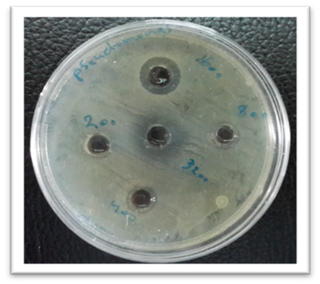
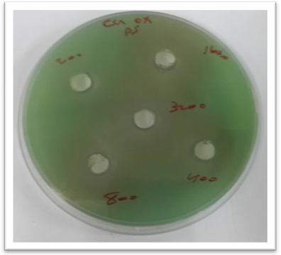
Figure: The antibacterial activity (a) copper oxide nanoparticles against P. aeruginosa and (b) copper oxalate nanoparticles against P. aeruginosa.

