RESTRACTION ENZYME
One way that bacterial cell protect themselves from bacteriophages, is by using special proteins called (restriction enzyme)or (end nucleases).these restriction enzyme can cut the viral DNA at specific locations ,thereby by destroying it activity.
There are a great variety of different restriction enzymes and each one cuts
only at specific position along a DNA molecule. They are essential tools for
recombinant DNA technology. Many of these enzymes recognize and cut palindromic sequences of
DNA.
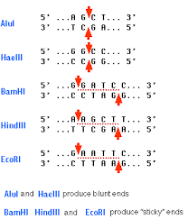
Since the digestive enzymes cut the DNA is an asymmetric manner ,they create single-stranded portions called sticky ends.

Biochemical can extract and clone (These restriction enzymes for a variety of purpose:
1.Analying DNA molecules
2. Determining the nucleotide sequence of long DNA molecules
3. Creating DNA molecules
4.Cloning and amplifying DNA
Mechanism of action
.Restriction enzyme one proteins that can cleave phosphor diester bonds on double stranded DNA molecules at specific palindromic sequences.

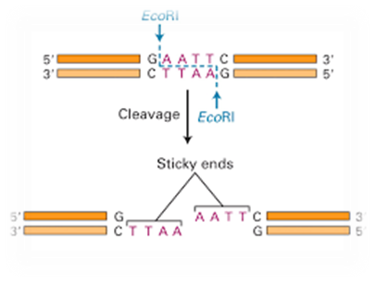
Notice
That the restriction enzyme cuts at palindromic sequence chain in blue. The cut sites one symmetrically positioned along the two strand of DNA.

Hybridization
Southern and northern blotting.
Restriction enzyme can be used to cut DNA molecules into smaller restriction fragment these fragment can then be visualurd and separated via southern blotting.
1. Expose the DNA molecule to restriction enzyme
2. Run gel electrophoresis to separate the fragments based on size transfer the result on to a polymers sheet
3. Specific restriction fragment of interest can be detected by creating and adding a radioactivity-labeled
Complementary DNA strand to the sheet since is complementary it will hybridize with the fragment of interest.

++++++=single strand DNA fragment of interest to be detected

----------=Radioactively-labeled DNA probe that contains a nucleotide sequence complementary to the restriction fragment above

*Autoradiography can now be used to detect the position of the DNA probe restriction fragment complex.
.In the same analogous way ,we can conduct the same step to separate and locate RNA fragments. This process is called Northern blotting.
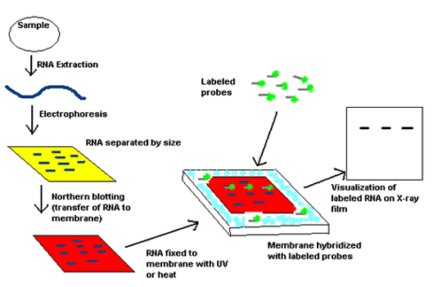
Restriction fragment polymorphism (RFLP)
Polymorphism is any different in the DNA sequence between individuals since are all genetically differ from each other, we all polymorphic. this difference is exploit RFLP analysis.
RFLP required a large sample of DNA .the whole genome is required a segment of DNA is not enough.
RFLP is often called genetic finger printing and is often used by law enforcement to link evidence left at a crime scene with the DNA a suspect
How does it work?
Step1
A large sample of DNA is extracted form a living sample. The DNA is (cut up) by one or more restriction enzyme this results in DNA fragments of various size which are run on gel (gel electrophoresis) to produce (invisible at this point).
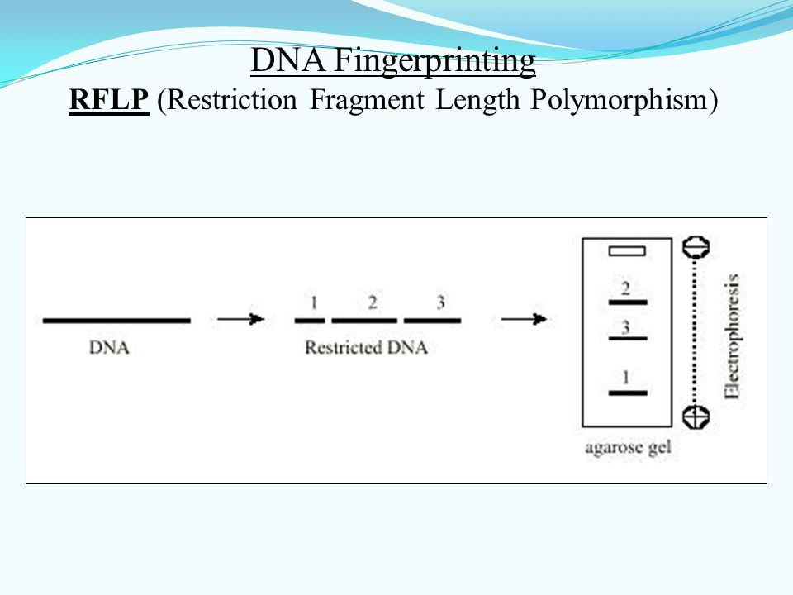

Step2
Southern blotting is performed a chemical is added to gel to separate the double strand DNA.
Chemical separates strands
The resulting single-strand DNA is then transferred (blotted)onto anylon membrane using an electrical charge.
Step 3:
The nylon membrane is then immersed in a solution containing radioactive complimentary nucleotide probes which bind to specific of DNA fragments this is called
Step4:
The nylon membrane is then placed against x-ray film over a period of 2-3 weeks the radioactive probes expose the film in areas of hybridization.
