The Rock Cycle: One of Earth’s Subsystems

Rock is the most common and abundant material on Earth. When a rock is examined closely, we find that it consists of smaller crystals or grains called minerals. Minerals are chemical compounds (or sometimes single elements), each with its own composition and physical properties. The grains or crystals may be microscopically small or easily seen with the unaided eye.The nature and appearance of a rock is strongly influenced by the minerals that compose it.
Geologists divide rocks into three major groups: igneous, sedimentary, and metamorphic.
In this lecture you learned that Earth is a system. This means that our planet consists of many interacting parts that form a complex whole. Nowhere is this idea better illustrated than when we examine the rock cycle (see FIGURE below). The rock cycle allows us to view many of the interrelationships among different parts of the Earth system. Knowledge of the rock cycle will help you more clearly understand the idea that each rock group is linked to the others by the processes that act upon and within the planet. You can consider the rock cycle to be a simplified but useful overview of physical geology.

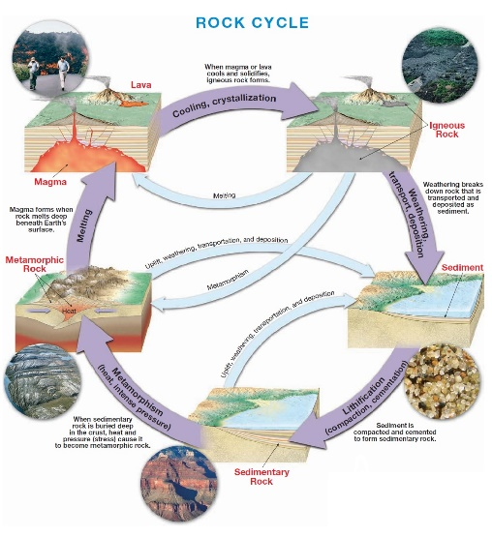

The Basic Cycle
We begin at the top of Figure Magma is molten material that forms inside Earth. Eventually magma cools and solidifies. This process, called crystallization, may occur either beneath the surface or, following a volcanic eruption, at the surface. In either situation, the resulting rocks are called igneous rocks (ignis = fire). If igneous rocks are exposed at the surface, they will undergo weathering, in which the day-in and day-out influences of the atmosphere slowly disintegrate and decompose rocks. The materials that result are often moved downslope by gravity before being picked up and transported by any of a number of erosional agents, such as
running water, glaciers, wind, or waves. Eventually these particles and dissolved substances, called sediment, are deposited. Although most sediment ultimately comes to rest in the ocean, other sites of deposition include river floodplains, desert basins, swamps, and sand dunes.
Next the sediments undergo lithification, a term meaning “conversion into rock.” Sediment is usually lithified into sedimentary rock when compacted by the weight of overlying layers or when cemented as percolating groundwater fills the pores with mineral matter. If the resulting sedimentary rock is buried deep within Earth and involved in the dynamics of mountain building or intruded by a mass of magma, it will be subjected to great pressures and/or intense heat. The sedimentary rock will react to the changing environment and turn into the third rock type, metamorphic rock. When metamorphic rock is subjected to additional pressure changes or to still higher temperatures, it will melt, creating magma,which will eventually crystallize into igneous rock, starting the cycle all over again. Although rocks may seem to be unchanging masses, the rock cycle shows that they are not. The changes, however, take time—great amounts of time. The rock cycle is operating all over the world, but in different stages.

