Genetics and Cell Biology
Genetics has been central to the development of our understanding of bacterial metabolism and physiology. The techniques are important for understanding the function of the genes concerned in relation to the overall behaviour of the cell.
1.Metabolic pathways
The initial impetus (الحافز) for the use of genetic analysis to investigate metabolic pathways came from the work of Beadle and Tatum in the 1940s. Although their work was with the fungus Neurospora, many of the principles were applied subsequently to bacteria. The concepts will be illustrated in relation to an hypothetical pathway leading to the formation of an essential product P (see Figure 1). Auxotrophic mutants that are unable to grow unless P is provided should be of three types corresponding to the three steps involved and can be assigned to three groups by complementation analysis.
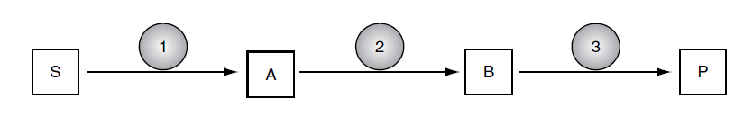
1.1 Complementation
A mixed infection with two mutant bacteriophages could result in complementation between the two mutants if the two phage strains carry mutations in different genes, so that between them they have a full set of functional genes. If complementation analysis is applied to mutants of a pathway such as that in (Figure1) the mutants could be assigned to three groups corresponding to the step in which they are deficient, assuming each enzyme contains a single polypeptide. For example, mutants defective in gene 1 would not be able to complement one another, but they would be able to complement mutants defective in either of the other two genes. Complementation analysis of this sort is easier to undertake in Neurospora than in bacterial systems .
In bacteria complementation is encountered more commonly in connection with plasmids. Introducing a plasmid can create a partial diploid with one version of a gene on the chromosome and another version on the plasmid. If the chromosomal gene is defective, it can be complemented by the plasmid.
When two mutations occur in different genes, they are said to be complementary, because the heterozygote condition rescues the function otherwise lost in the homozygous recessive state. Hence, the term complementation test is used to describe the process to test for gene function in recessive allelism. The alternative name cis-trans test describes the two central components of the test. The terms cis and trans refer to the relationship of the two mutations, with cis used to describe mutations occurring on the same chromosome and trans used to describe mutations occurring on different chromosomes. The cis portion of the complementation test essentially acts as a control and involves creating heterozygotes (one mutated chromosome and one wild-type, or normal, chromosome) such that one parent bears both mutations. In the cis test, a functional protein is always produced regardless of whether both mutations are on the same gene or on different genes. The trans test involves creating heterozygotes with different mutations from different parents. In this case a functional protein is produced only if the mutations are on different genes.
1.2 Cross-feeding
Complementation analysis does not identify the steps involved nor the order in which they occur. Additional information is obtained by a procedure known as cross-feeding, as illustrated in (Figure 2) None of these mutants is able to grow on a medium that lacks the essential nutrient P. However if the plate is inoculated with each mutant in the pattern shown, then intermediates accumulated by a mutant may stimulate the growth of the neighbouring mutant. For example mutant I is unable to produce the intermediate A, but this is produced by mutant II. So the growth of mutant A is stimulated where it is near to mutant II. Similarly, growth of mutant II is stimulated by mutant III. A cross-feeding experiment can therefore categorize mutants in a way that corresponds to the steps in the biochemical pathway.
Neither of these procedures identifies the steps involved or the nature of the intermediates. However, an hypothetical pathway can be tested by examining the ability of the predicted intermediates to stimulate the growth of each mutant.
Such an analysis was used to confirm the role of ornithine and citrulline as intermediates in the pathway of arginine biosynthesis. One class of mutants responded only to arginine, a second class responded to either arginine or citrulline, while the third group responded to arginine, ornithine or citrulline. This established that the synthetic sequence went from ornithine to citrulline to arginine.
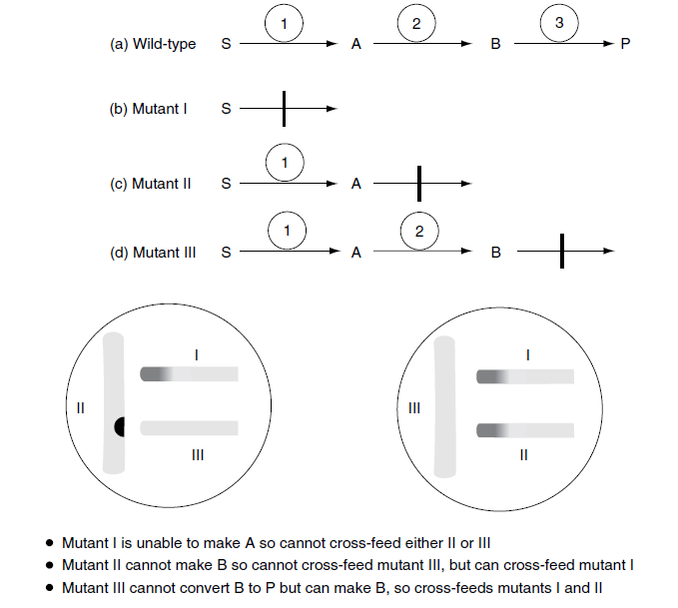
The order of a biosynthetic pathway with diffusible intermediates can often be determined by crossfeeding experiments. Consider the following biosynthetic pathway:
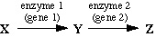
A mutation in either gene 1 or gene 2 can prevent synthesis of Z. In cells with a mutation in gene 2 intermediate Y may accumulate and ultimately be excreted into the surrounding medium (because Y is not being consumed to make Z in this mutant). In cells with a mutation in gene 1 cannot make Y, since gene 2 is functional they can convert exogenous Y into Z. That is, the Y excreted by gene 2 mutants can crossfeed the gene 1 mutants.
For example, the following cartoon shows the growth of tryptophan auxotrophs on a minimal medium plate supplemented with a tiny amount of tryptophan.
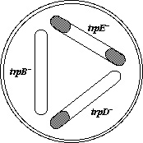
All three mutants grow until the tryptophan is exhausted, resulting in faint growth where the cells had been streaked. However, in the area where the trpB and trpD cells were close to each other, the trpD mutants grew much better, indicating that the trpB mutants excrete a product that the trpD mutant can convert to tryptophan. Hence, the metabolic block in the trpB mutant must be at a later step than in the trpD mutant. Likewise, the metabolic block in the trpD mutant must be at a later step than in the trpE mutant. Thus, the conclusion is that the three gene products act in the following order:
If the intermediates are available, it is also possible to simply test to see which of the mutants can use which intermediates. This can be done in liquid medium containing the intermediates or on agar plates containing the intermediates. A very simple way of checking for growth on different intermediates is called a crystal test. The mutant is spread on a minimal agar plate lacking the auxotrophic requirement, and a few crystals of each intermediate are added near the edge of the plate -- growth near the crystals indicates that the mutant can use that intermediate.
The crossfeeding results were confirmed by testing growth with specific biochemical intermediates as shown in the table below.
Mutation | Growth on minimal medium plus: |  |  |  | Intermediate  Accumulated
 | None | Anthranilate | Indole | Tryptophan
trp+ | + | + | + | + | None
trpE | - | + | + | + | None
trpD | - | - | + | + | Anthranilate
trpB | - | - | - | + | Indole
These growth tests confirm the crossfeeding results, indicating that the genes act in the following order:

2. Microbial physiology
In the above examples of simple metabolic pathways, the genetic approach is essentially complementary to biochemical investigations. Genetics is useful, but is not absolutely essential to the investigation. However, a bacterial cell consists of much more than a series of straightforward biochemical pathways. There are complex structures, such as flagella, ribosomes and bacterial cell envelopes, as well as sophisticated systems such as the control of replication and cell division or the control of lysogeny in temperate bacteriophages. Although in some cases a reductionist approach can be applied – ribosomes for example can be disassembled and reassembled in vitro – very often this is extremely difficult or even impossible.
Genetics therefore plays a central role in the investigation of such systems. Some of the ways of analysing the genetic basis of physiological characteristics are summarized in (Figure 3). The starting point in this case is the isolation of a series of mutants that are altered in a specific characteristic (such as sporulation for example). These mutants can be classified according to the precise nature of their phenotype, as well as by complementation analysis. The genes involved can then be mapped (i.e. their positions on the chromosome can be determined). This information can be used to identify the genes in a library. The identity of the clone can be confirmed by its ability to complement the original mutation.
The gene can then be sequenced and its function predicted from analysis of the sequence . Probes can also be made, using the sequence data, to analyse the expression of the gene under different conditions, which may yield information as to its role. Furthermore the cloned gene can be expressed at a high level and thus obtained in pure form and antibodies to the purified protein can be produced to locate the position of the protein in the cell.
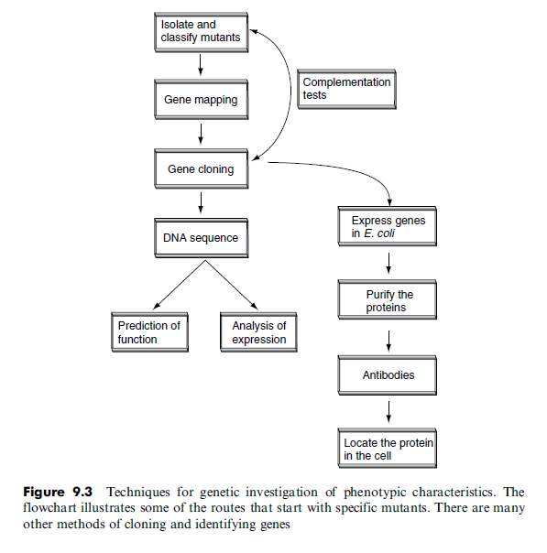
2.1 Reporter genes
Instead of producing mutants, the expression of various genes under different conditions can be examined using the assumption (أفتراض) that genes that are specifically needed for those conditions will be selectively expressed at that time. A convenient and widely used method of doing this is to employ reporter genes. This involves attaching the regulatory region of the gene concerned to another gene that is more easily detected so that the regulation by proxy can be followed by observing the expression of the reporter .
For example, if a b-galactosidase reporter and a medium containing the chromogenic substrate X-gal is used, the colonies will only turn blue when the promoter in question becomes activated and the reporter gene starts to be expressed.
One use of reporter genes is to identify unknown genes whose expression is activated in response to a given stimulus.
In this case, random fragments of DNA, some of which will contain promoter regions, are fused to the reporter gene to generate a library of promoter fusions. The library is then plated onto a medium containing X-gal (assuming that b-galactosidase is the reporter). The colonies of interest are those which are white initially but turn blue when the conditions are changed – for example if the plate is transferred to an anaerobic incubator.
This indicates that the promoter is responsive to the new environment which in this case is growth under anaerobic conditions. From this we can infer (نخمن) that the gene which is normally expressed from that promoter is one that is needed for anaerobic growth in the original host. Whilst this approach has been largely replaced by the advent of microarrays which enable global gene expression to be analysed more easily , it has been widely used to identify genes which are expressed in response to heat, starvation, osmotic shock and during sporulation for example.
- Apart from b-galactosidase, two other reporter genes are worth a specific mention
- The expression of luciferase results in the production of blue-green light and this allows the expression of a gene to be monitored simply by measuring light production. It also makes the host organism bioluminescent and by using sensitive imaging systems it is possible to trace the luciferase-labelled bacterium in complex environments and ecosystems, including tracking a pathogen in a living animal.
- Another reporter gene that has additional utility is Green Fluorescent Protein (GFP), a protein (originating from the jellyfish Aequorea victoria) that is intrinsically fluorescent and emits a green light when exposed to ultraviolet irradiation. This has the advantage of being readily detected in situ, without the need for an enzymic substrate. In addition to its use as a reporter of gene expression, it can also be expressed as a translational fusion, so that the target protein is labelled with GFP. This enables the location of the target protein within the cell to be determined.
