The design of primers for PCR
Oligonucleotide primers are available from many commercial sources and can be synthesised to order in a few days. In primer design, there are several aspects that have to be considered. Perhaps most obvious is the sequence of the primer -- more specifically, where does the sequence information come from? It may be derived from amino acid sequence data, in which case the genetic code degeneracy has to be considered, as shown in Fig. 7.3. In synthesising the primer, two approaches can be taken. By incorporating a mixture of bases at the wobble position, a mixed primer can be made, with the ‘correct’ sequence represented as a small proportion of the mixture.
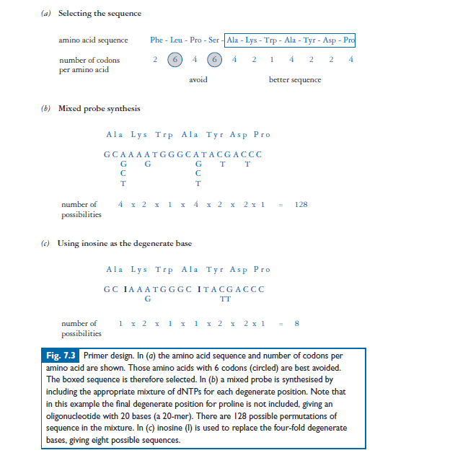
Alternatively, the base inosine (which pairs equally well with any of the other bases) can be incorporated as the third base in degenerate codons.
If the primer sequence is taken from an already-determined DNA sequence, it may be from the same gene from a different organism or may be from a cloned DNA that has been sequenced during previous
experimental work.
Regardless of the source of the sequence information for the primers, there are some general considerations that should be addressed.
The primer length is important; it should be long enough to ensure stable hybridisation to the target sequence at the required temperature. Although calculation of the melting temperature (Tm) can be used to provide information about annealing temperatures, this is often best determined empirically. The primer must also be long enough to ensure that it is a unique sequence in the genome,from which the target DNA is taken. Primer lengths of around 20—30 nucleotides are usually sufficient for most applications. With regard to the base composition and sequence of primers, repetitive sequences should be avoided, and also regions of single-base sequence. Primers should obviously not contain regions of internal complementary sequence or regions of sequence overlap with other primers. Because extension of PCR products occurs from the 3_ termini of the primer, it is this region that is critical with respect to fidelity and stability of pairing with the target sequence. Some ‘looseness’ of primer design can be accommodated at the 5_ end, and this can sometimes be used to incorporate design features such as restriction sites at the 5_ end of the primer.
Characteristics of Good PCR Primers
Sequence
• Typical primers are 18-28 nucleotides in length
• 50-60% GC compositon
• Have a balanced distribution of G/C and A/T domains
• No long strings of a single base (<4)
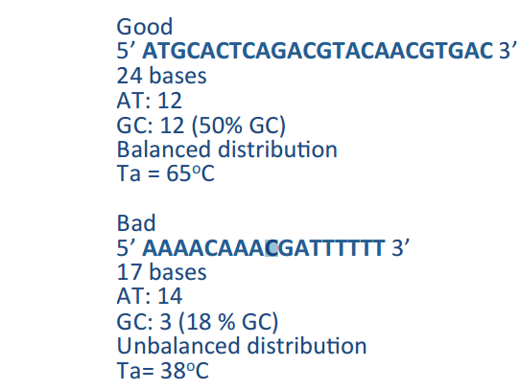
Unique
Unique (Lack of secondary priming sites). Only one target site in the template DNA where the primer binds, which means the primer sequence shall be unique in the template DNA. Uniqueness can be determined by BLAST (BioinformaCcs)
Primers Length
• Primer length has effects on uniqueness and melting/ annealing temperature.
• The longer the primer, the more chance that it’s unique; the longer the primer, the higher melting/annealing temperature. • The length of primer has to be at least 18 bases to ensure uniqueness.
• Usually primers of 18-28 bases long are used for PCR.
Melting Temperature
Melting Temperature, Tm – the temperature at which half the DNA strands are single stranded and half are doublestranded.
Tm is characteristics of the DNA composition; Higher G+C content DNA has a higher Tm due to more H bonds.
Calculation
Shorter than 13: Tm= (A+T) X 2 + (G+C) X 4
Longer than 13: Tm= 64.9 +41(G+C-16.4) / (A+T+G+C)
(Formulae are from hTp://www.basic.northwestern.edu/biotools/oligocalc.html)
Annealing Temperature
Annealing Temperature, Ta is the temperature at which primers anneal to the template DNA. It can be calculated from Tm.
Annealing Temperature Ta = Tm+/- 5°C
Primers with Tm between 55-70ºC are preferred Ta is usually within 5ºC of the Tm
Secondary structures
If primers can anneal to themselves, or anneal to each other rather than Internal Structure anneal to the template, the PCR efficiency will be decreased dramatically. They shall be avoided.
However, sometimes these 2° structures are harmless when the annealing temperature does not allow them to take form. For example, some dimers or hairpins form at 30°C while during PCR cycle, the lowest temperature only drops to 60°C.

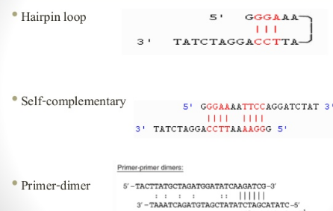

Quality control for primer
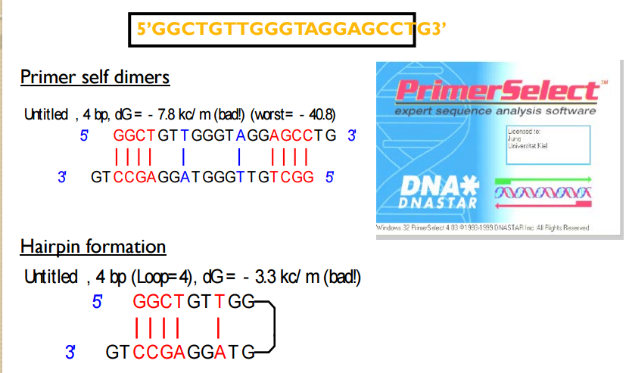
Primer compatibility
• Primers work in pairs – forward primer and reverse primer.
• Since they are used in the same PCR reaction, the PCR conditions should be suitable for both.
• One critical feature is their annealing temperatures, which shall be compatible with each other.
• You should aim for a maximum difference of 3 °C. The closer their Ta are, the better.

Primer desigin program
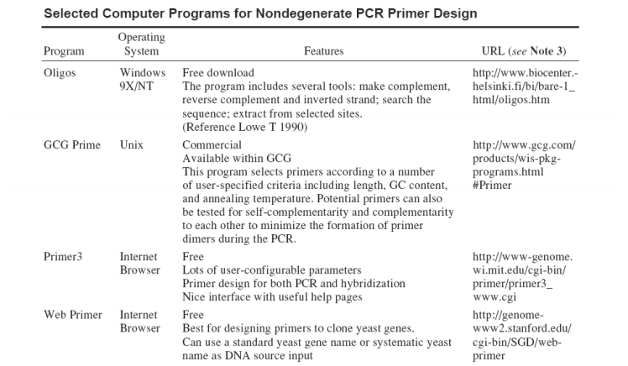
Primer Stock Preperation
