Main marker technologies
MORPHOLOGICAL MARKERS
Few simple Mendelian morphological characters have been discovered that could be used as genetic markers. Many of the identified morphological markers are mutations observed in seedlings such as albino needles, dwarfing and other aberrations. These markers, however, have limited application because morphological mutants occur rarely and often are highly detrimental or even lethal to the organisim.
BIOCHEMICAL MARKERS
Protein Markers
Proteins are the products of gene expression. Different alleles encode different amino acid sequences, giving proteins different sizes or biochemical characteristics that can be observed by electrophoresis and thus used as molecular markers. Isozymes are an example. Isozymes are useful molecular markers because they can be distinguished from each other based on differences in charge or size, despite having the same enzymatic activity. Although proteins cannot usually be seen by the naked eye, isozymes can be easily detected by separating via gel electrophoresis then adding the substrate of the enzyme. The isozyme produces color from the substrate, producing a band on the gel. Isozyme markers have a few drawbacks that greatly reduce their utility. In addition to having a very limited number of possible markers (only a few dozen have been developed), they are not distributed evenly on the chromosome, and often the enzyme activity depends on the plant’s age or tissue type. Even so, isozyme analysis is very cheap and simple and was used for studies of maize, wheat, and barley decades before DNA markers were developed.
Monoterpenes
Monoterpenes are a subgroup of the terpenoid substances found in resins and essential oils of plants. Although the metabolic functions of monoterpenes are not fully understood, they probably play an important role in resistance to attack by diseases and insects. The concentrations of different monoterpenes, such as alpha-pinene, beta-pinene, myrcene, 3-carene and limonene are determined by gas chromotography and are useful as genetic markers. Monoterpene genetic markers have been applied primarily to taxonomic and evolutionary studies . However, they have also been used to a limited extent to estimate genetic patterns of geographic variation within species. In addition, there are relatively few monoterpene marker loci available and most express some form of dominance in their phenotypes. Dominant genetic markers have the disadvantage that dominant homozygous genotypes cannot be distinguished from heterozygotes carrying the dominant allele. Monoterpenes were gradually replaced by allozyme genetic markers because allozymes are less expensive to apply, are codominant in expression, and many more marker loci can be assayed.
Allozymes
Allozymes have been the most important type of genetic marker and are used in many species for many different applications. Allozymes are allelic variants of enzymes encoded by structural genes. Enzymes are proteins consisting of amino acids, some of which are electrically charged. As a result, enzymes have a net electric charge, depending on the stretch of amino acids comprising the protein. When a mutation in the DNA results in an amino acid being replaced, the net electric charge of the protein may be modified, and the overall shape (conformation) of the molecule can change. Because changes in electric charge and conformation can affect the migration rate of proteins in an electric field, allelic variation can be detected by gel electrophoresis and subsequent enzyme-specific stains that contain substrate for the enzyme, cofactors and an oxidized salt (e.g. nitro-blue tetrazolium). Usually two, or sometimes even more loci can be distinguished for an enzyme and these are termed isoloci. Therefore, allozyme variation is often also referred to as isozyme variation .
Allozyme analysis is fairly easy to apply and standard protocols for its use in trees are available. Crude protein extracts are isolated from almost any tissue type and then are separated on starch gels by applying an electrical current (i.e. electrophoresis). Isozymes in the protein extract migrate to different positions on the gel depending on the electrical charge and size of the isozyme. Isozymes with different amino acid composition generally have a different charge and/or size, so it is these genetic differences that are revealed as mobility differences on the gel. The location of an isozyme on a gel following electrophoresis is visualized by placing the gel in a solution that contains the enzyme substrate, appropriate cofactors and a dye. The colored bands on the gel are the products of the enzymatic reactions linked to the dye.
Applications:
Allozymes have been applied in many population genetics studies
- (sub)population structure and population divergence .
- Allozymes are particularly useful at the level of conspecific populations and closely related species, and are therefore useful to study diversity in crops and their relatives .
- The mode of genetic inheritance and allelic frequencies in germplasm collections over serial increase cycles in germplasm banks
- To identify parents in hybrids
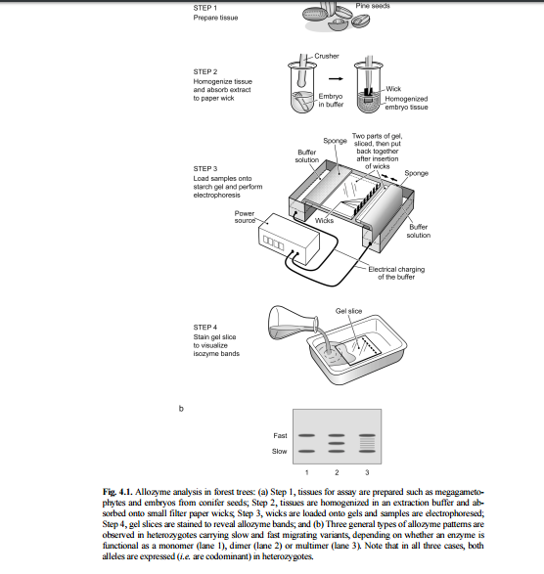

Other Protein Markers
Another type of protein-based genetic marker utilizes two-dimensional polyacrylamide gel electrophoresis (2-D PAGE). Unlike allozymes where single known enzymes are assayed individually, the 2-D PAGE technique simultaneously reveals all enzymes and other proteins present in the sample preparation. The proteins are revealed as spots on gels and marker polymorphisms are detected as presence or absence of spots. This technique has been used most extensively for linkage mapping in Pinus pinaster where protein polymorphisms have been assayed from both seed and needle tissues. difficult than in allozyme analyses, and the markers are often dominant in their expression.Separates protien according isoelectric point and molecular mass.
