Molecular markers Non-PCR based techniques
- Restriction Fragment Length Polymorphisms
- Minisatellites or Variable Number of Tandem Repeats

Restriction Fragment Length Polymorphism (RFLP)
Description: RFLPs are bands that correspond to DNA fragments, usually within the range of 2–10 kb, that have resulted from the digestion of genomic DNA with restriction enzymes. DNA fragments are separated by agarose gel electrophoresis and are detected by subsequent Southern blot hybridization to a labelled DNA probe. Labelling of the probe may be performed with a radioactive isotope or with alternative non-radioactive stains, such as digoxigenin or fluorescein. The locus specific RFLP probes consist of a homologous sequence of a specific chromosomal region. Probes are generated through the construction of genomic or complementary DNA (cDNA) libraries and therefore may be composed of a specific sequence of unknown identity (genomic DNA) or part of the sequence of a functional gene (exons only, cDNA). RFLP probes are maintained as clones in suitable bacterial vectors that conveniently allow the isolation of the DNA fragments they hold. Probes from related species may be used (heterologous probes). DNA sequence variation affecting the absence or presence of recognition sites of restriction enzymes, and insertions and deletions within two adjacent restriction sites, form the basis of length polymorphisms.
Strengths: RFLPs are generally found to be moderately polymorphic. In addition to their high genomic abundance and their random distribution, RFLPs have the advantages of showing codominant alleles and having high reproducibility.
Weaknesses: The main drawbacks of RFLPs are the requirement of laborious and technically demanding methodological procedures, and high expense. In general, if research is conducted with poorly studied groups of wild species or poorly studied crops (orphan crops) suitable probes may not yet be available, so considerable investments are needed for development. Moreover, large quantities (1–10 µg) of purified, high molecular weight DNA are required for each DNA digestion. Larger quantities are needed for species with larger genomes, and for the greater number of times needed to probe each blot. RFLPs are not amenable to automation and collaboration among research teams requires distribution of probes. Applications: RFLPs can be applied in diversity and phylogenetic studies ranging from individuals within populations or species, to closely related species. RFLPs have been widely used in gene mapping studies because of their high genomic abundance due to the ample availability of different restriction enzymes and random distribution throughout the genome . They also have been used to investigate relationships of closely related taxa ,as fingerprinting tools , for diversity studies , Molecular markers for genebank management 7 and for studies of hybridization and introgression, including studies of gene flow between crops and weeds .
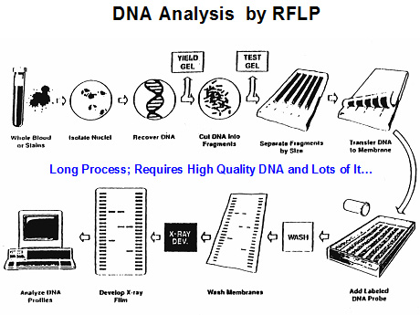
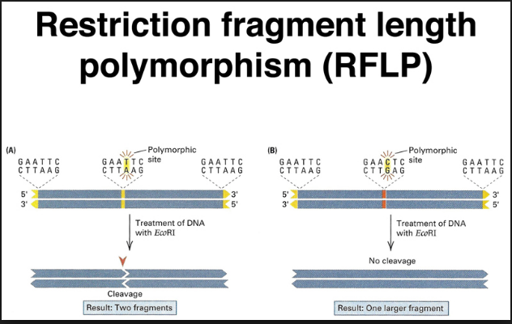
Minisatellites or Variable Number of Tandem Repeats
Description: Minisatellite analysis, like RFLPs, also involves digestion of genomic DNA with restriction endonucleases, but minisatellites are a conceptually very different class of marker. They consist of chromosomal regions containing tandem repeat units of a 10–50 base motif, flanked by conserved DNA restriction sites. A minisatellite profile consisting of many bands, usually within a 4–20 kb size range, is generated by using common multilocus probes that are able to hybridize to minisatellite sequences in different species. Locus specific probes can be developed by molecular cloning of DNA restriction fragments, subsequent screening with a multilocus minisatellite probe and isolation of specific fragments. Variation in the number of repeat units, due to unequal crossing over or gene conversion, is considered to be the main cause of length polymorphisms. Due to the high mutation rate of minisatellites, the level of polymorphism is substantial, generally resulting in unique multilocus profiles for different individuals within a population. Minisatellite loci are also often referred to as Variable Number of Tandem Repeats (VNTR) loci. Strengths: The main advantages of minisatellites are their high level of polymorphism and high reproducibility.
Weaknesses: Disadvantages of minisatellites are similar to RFLPs due to the high similarity in methodological procedures. If multilocus probes are used, highly informative profiles are generally observed due to the generation of many informative bands per reaction. In that case, band profiles can not be interpreted in terms of loci and alleles and similar sized fragments may be non-homologous.
Applications: The term DNA fingerprinting was introduced for minisatellites, though DNA fingerprinting is now used in a more general way to refer to a DNA-based assay to uniquely identify individuals. Minisatellites are particularly useful in studies involving genetic identity, parentage, clonal growth and structure, and identification of varieties and cultivars , and for population-level studies .

