Cell disintegration and extract

Cell disruption is an essential part of biotechnology and the downstream processes related to the manufacturing of biological products.
Several types of cell disruption methods exist, as biological products may be extracellular, intracellular or periplasmic.Cell disruption methods can be categorised into mechanical methods and non-mechanical methods.
Non-mechanical methods can be divided into physical methods, chemical methods and enzymatic methods, Mechanical methods are divided into solid shear methods and liquid shear methods.
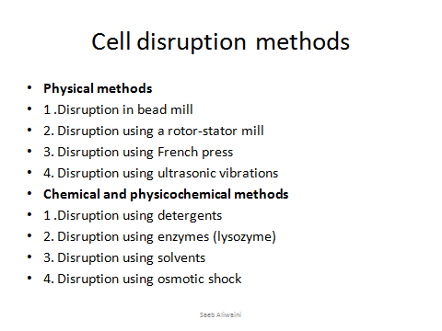
Factors that influence the selection of disruption method include:
1-The susceptibility of the cells to disruption.
2-Pproduct stability.
3-The ease of extraction from the cell debris.
4-The speed of the method and the cost of the method.
- Cell walls act as additional disruption deterrents, with yeast cells being particularly difficult to disrupt, as the cell wall limits the solvents access to the desired products.
- Different cells have different structures; hence they require different methods for disruption.
- Other types of cells requiring disruption are bacterial cells, moulds, plant cells, mammalian cells and ground tissue.
- Mechanical methods produce heat during the process, so additional cooling systems are required when using mechanical cell disruption methods.
- The drying of the cell mass enhances disruption methods and may help bring down the costs.

There are many methods of cellular disruption because there are many types of cells.
- Bacterial cells may have different disruption methods, depending on whether they are gram positive or gram negative, as the amount of peptidoglycan and the presence of an envelope affect the overall process. Bacteria vary by different type of disintegration(digestive enzymes like lysozymes, osmotic shocks, chemical or mechanical treatment.
- Mammalian cells are the easiest to disrupt as they lack a cell wall.
3-Plant cells: are more difficult to disrupt than animal cells because of the cellulosic walls.
There are three simplest types for disruption of bacterial cells like:
- Bead mill
All bead devices open the cells or homogenize tissues by throwing the beads (also called “grinding media”) against the cells/tissue. Also the accelerated beads generate strong shear in the liquid buffer surrounding the cells/tissues, which also pulls then apart.
Two methods to accelerate the grinding media (beads) are
(1) by shaking the entire container or
(2) by a spinning agitator within a container

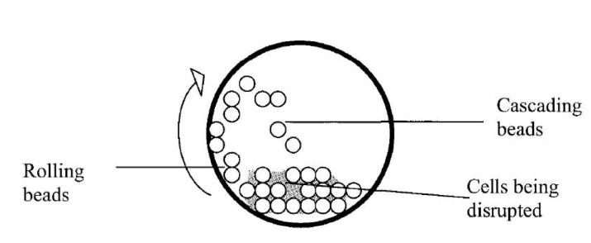
The basic principle of a bead mill

- Commonly used for disrupting yeast cells and for grinding animal tissue.
- The choice of bead size and weight is greatly dependent on the type of cells.
- The diameter can affect the efficiency of cell disruption in relation of the location of the desired enzyme in the cell.

An optimal condition for bead load is considered between 80 and 85% of the free volume. The discs run at a speed of 1500-2250 rpm.
Glass beads with a diameter greater than 0.5 mm are considered best for yeast cells, and diameter lesser than 0.5 mm is optimal for bacterial cells.
The process variables are: agitator speed, proportion of the beads, beads size, cell suspension concentration, cell suspension flow rate, and agitator disc design.
The increased number of beads increases the degree of disruption, due to the increased bead-to-bead interaction. The increased number of beads, however, also affects the heating and power consumption.

1- Disintegration of bacterial cells by glass beads:
1-Suspend bacterial cells in the extraction buffer and mix them with sterilized glass beads then vortex the mixture for 20 min in cold condition.
2- Remove the suspension by Pasteur pipette then centrifuge it at 8000 r/min for 15 min in cooling centrifuge.
3- discard the pellet and collect the supernatant and measure the activity of product in order to do other steps of extraction and purification of our desired product.

Nonmechanical methods:use chemicals to solubilise the components in the cell walls to release the product.
Chemical requirements:
1.Products are insensitive to the used chemicals.
2.The chemicals must be easily separable.
Types of chemicals:
Surfactants (solubilising lipids): sodium sulfonate,sodium dodecylsulfate.
Alkali: sodium hydroxide, harsh.
Organic solvents: penetrating the lipids and swelling the cells. e.g. toluene.
e.g. Bacteria were treated with acetone followed by sodium dodecyl sulfate extraction of cellular proteins.
Nonmechanical to lyse cell walls to release the product. gentle, but high cost i.e. lysozyme (carbohydrase) to lyse the cell walls of bacteria.

Triton X-100
Undiluted Triton X-100 is a clear fluid (but less viscous than undiluted glycerol) owing to the hydrogen bonding of its hydrophilic polyethylene oxide parts. Triton X-100 is soluble at 25 °C in water, toluene, xylene, ethyl ether, ethyl alcohol, isopropyl alcohol,but insoluble in kerosene, mineral spirits, and naphtha
Triton X-100 is a commonly used detergent in laboratories. Triton X-100 is widely used to lyse cells to extract protein or organelles, or to permeabilize the membranes of living cells.
Some applications include:
- Industrial purpose (plating of metal)
- Ingredient in influenza vaccine (Fluzone)
- Permeabilizing unfixed (or lightly fixed) eukaryotic cell membranes
- Solubilizing membrane proteins in their native state in conjunction with zwitterionic detergents such as CHAPS
- Part of the lysis buffer (usually in a 5% solution in alkaline lysis buffer) in DNA extraction.
- Reducing surface tension of aqueous solutions .
- Removing SDS from SDS-PAGE gels prior to renaturing the proteins within the gel
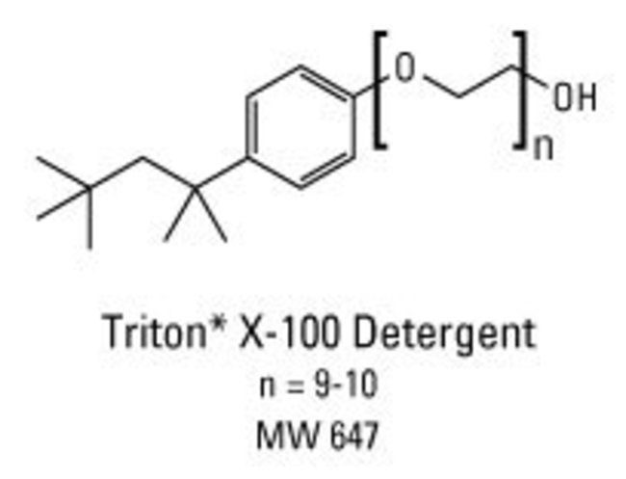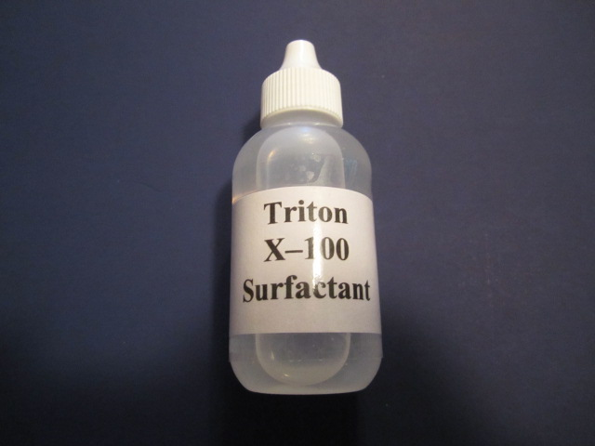

2- TritonX-100 and K₂HPO₄
1- Add (12.5%) of K₂HPO₄ and 2% of Triton x-100 to the suspension of bacterial cells and incubate them at 25ºC for 30 min.
2- centrifuge the suspension at 8000 r/min for 30 minute in cooling centrifuge.
3- discard the pellet and collect the supernatant and measure the activity of product in order to do other steps of extraction and purification of our desired product.

K₂HPO₄
Potassium hydrogenphosphate
Potassium hydrogen(tetraoxidophosphate)(2−)
Other names
Potassium monohydrogen phosphate
Phosphoric acid dipotassium salt
Potassium phosphate dibasic
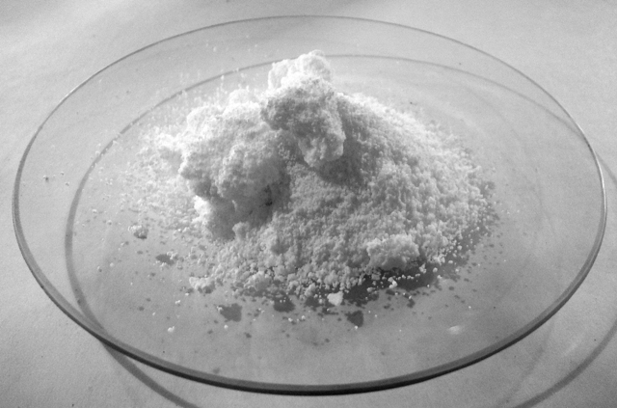

3- Disintegration of bacterial cells by Lysozyme enzyme .

1- Suspend bacterial cells in 100ml DW.
2- Add 0.2mg/ml and 200 µg/ml of lysozyme then incubate them for 20 min. at 37ºC.
2- Centrifuged the suspension at 8000 r/min for 15 min in cooling centrifuge.
3- discard the pellet and collect the supernatant and measure the activity of product in order to do other steps of extraction and purification of our desired product.

