RadioButton

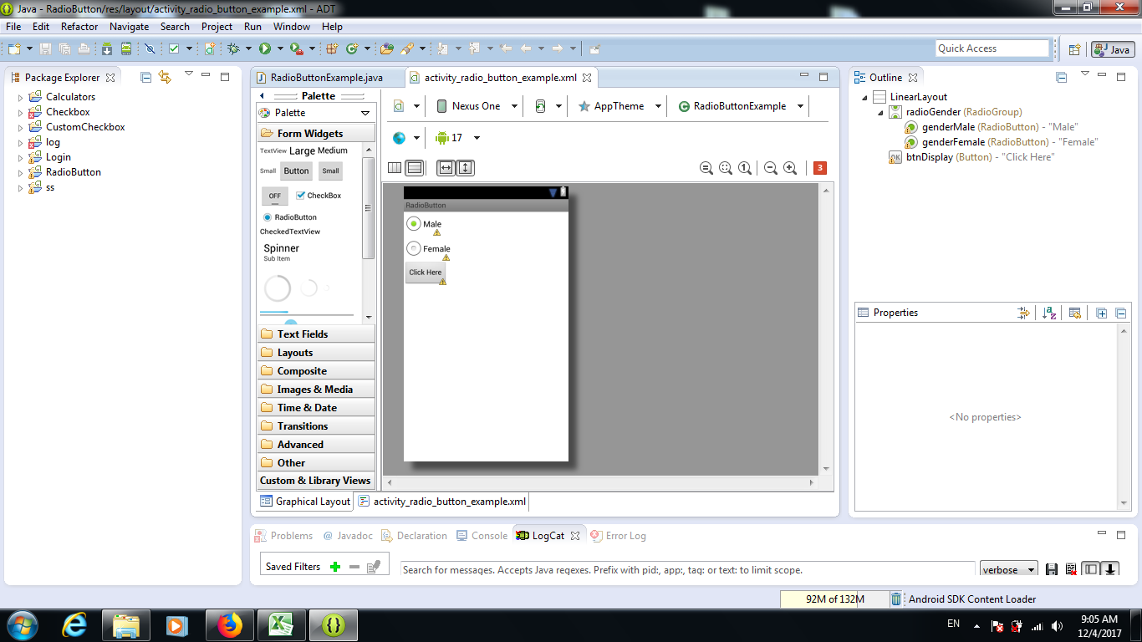

<?xml version="1.0" encoding="utf-8"?>
<LinearLayout xmlns:android="http://schemas.android.com/apk/res/android"
android:layout_width="fill_parent"
android:layout_height="fill_parent"
android:orientation="vertical" >

<RadioGroup
android:id="@+id/radioGender"
android:layout_width="wrap_content"
android:layout_height="wrap_content" >

<RadioButton
android:id="@+id/genderMale"
android:layout_width="wrap_content"
android:layout_height="wrap_content"
android:checked="true"
android:text="Male" />

<RadioButton
android:id="@+id/genderFemale"
android:layout_width="wrap_content"
android:layout_height="wrap_content"
android:text="Female" />
</RadioGroup>

<Button
android:id="@+id/btnDisplay"
android:layout_width="wrap_content"
android:layout_height="wrap_content"
android:text="Click Here" />

</LinearLayout>
<?xml version="1.0" encoding="utf-8"?>
<resources>

<string name="app_name">RadioButton</string>
<string name="menu_settings">Settings</string>
<string name="hello_world">Hello world!</string>

</resources>

package com.androidexample.radiobutton;
import android.app.Activity;
import android.os.Bundle;
import android.view.View;
import android.view.View.OnClickListener;
import android.widget.Button;
import android.widget.RadioButton;
import android.widget.RadioGroup;
import android.widget.Toast;
public class RadioButtonExample extends Activity {
private RadioGroup radioSexGroup;
private RadioButton radioSexButton;
private Button btnDisplay;
@Override
public void onCreate(Bundle savedInstanceState) {
super.onCreate(savedInstanceState);
setContentView(R.layout.activity_radio_button_example);
addListenerOnButton();
}
public void addListenerOnButton() {
radioSexGroup = (RadioGroup) findViewById(R.id.radioGender);
btnDisplay = (Button) findViewById(R.id.btnDisplay);
btnDisplay.setOnClickListener(new OnClickListener() {
@Override
public void onClick(View v) {
// get selected radio button from radioGroup
int selectedId = radioSexGroup.getCheckedRadioButtonId();
// find the radiobutton by returned id
radioSexButton = (RadioButton) findViewById(selectedId);
Toast.makeText(RadioButtonExample.this, radioSexButton.getText(), Toast.LENGTH_SHORT).show();
}
});
}
}

