Biotechnology department LAB: Genetic engineering
Collage of science Al-Mustansiriyah University
Lab 7

Gene Sequencing
The term DNA sequencing refers to methods for determining the order of the nucleotides bases adenine, guanine, cytosine and thymine in a molecule of DNA.
Methods of sequencing
- Sanger dideoxy (primer extension/chain-termination) method: most popular protocol for sequencing, very adaptable, scalable to large sequencing projects
- Maxam-Gilbert chemical cleavage method: DNA is labelled and then chemically cleaved in a sequence-dependent manner. This method is not easily scaled and is rather tedious
For Sanger dideoxy sequencing you need:

- Single stranded DNA template
- A primer for DNA synthesis
- DNA polymerase
- Deoxynucleoside triphosphates and dideoxynucleotide triphosphates
DNA templates for sequencing
- Single stranded DNA isolated from recombinant M13
- bacteriophage containing DNA of interest
- Double-stranded DNA that has been denatured
- Non-denatured double stranded DNA (cycle sequencing(
Reagents for sequencing: DNA polymerases
- Should be highly processive, and incorporate ddNTPs efficiently
- Should lack exonuclease activity
- Thermostability required for “cycle sequencing”

Sanger DNA Sequencing method:
The chain terminator method is more efficient and uses fewer toxic chemicals and lower amount of radioactivity than the method of Maxam and Gilbert. The key principle of the Sanger method is the use of dideoxynucleotide triphosphates (ddNTPs) as DNA chain terminators. The chain termination method requires a single-stranded DNA template, a DNA primer, a DNA polymerase, radioactively or fluorescently labelled nucleotides, and modified nucleotides that terminate DNA strand elongation. The DNA sample is divided into four separate sequencing reactions, containing all four of the standard deoxynucleotides (dATP, dGTP, dCTP, dTTP) and the DNA polymerase. To each reaction is added only one of the four dideoxynucleotide (ddATP, ddGTP, ddCTP, ddTTP) which are the chain terminating nucleotides, lacking a 3’-OH group required for the formation of a phosphodiester bond between two nucleotides, thus terminating DNA strand extension and resulting in DNA fragments of varying length. The newly synthesized and labelled DNA fragments are heat denatured, and separated by size by gel electrophoresis on a denaturing polyacrylamide-urea gel with each of the four reactions run in one of the four individual lanes (lanes A, T, G, C), the DNA bands are then visualized by autoradiography or UV light, and the DNA sequence can be directly read off the X-ray film or gel image. A dark band in a lane indicates a DNA fragment that is result of chain termination after incorporation of a dideoxynucleotide (ddATP, ddGTP, ddCTP, or ddTTP). The relative position of the different bands among the four lanes are then used to read (from bottom to top) the DNA sequence. The technical variations of chain termination sequencing include tagging with nucleotides containing radioactive phosphorus for labelling, or using a primer labelled at the 5’ end with a fluorescent dye. Dye- primer sequencing facilitates reading in an optical system for faster and more economical analysis and automation. Chain termination methods have greatly simplified DNA sequencing. Limitations include non-specific binding of the primer to the DNA, affecting accurate read-out of the DNA sequence, and DNA secondary structures affecting the fidelity of the sequence.
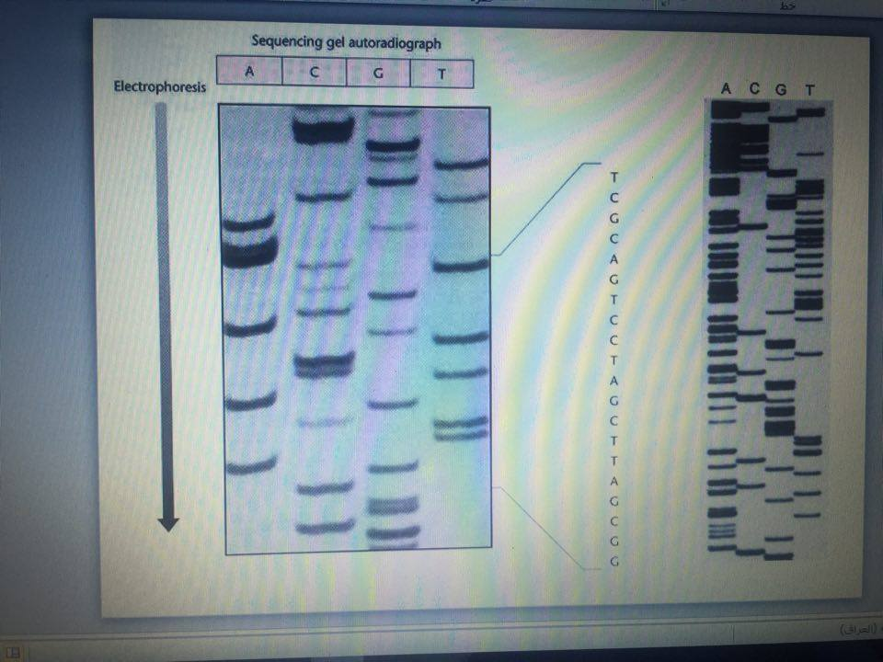

Sanger dideoxy sequencing--basic method
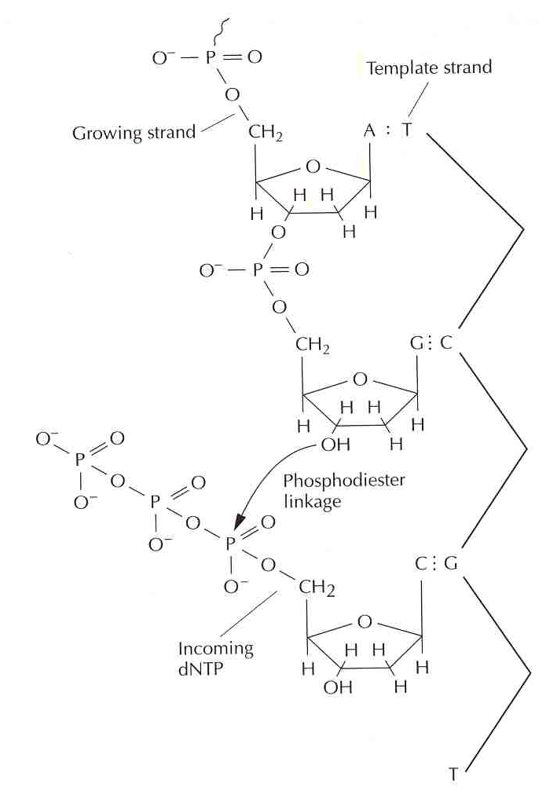
Extend the primer with DNA polymerase in the presence of all four dNTPs, with a limited amount of a dideoxy NTP (ddNTP)

