Biotechnology department LAB: Genetic engineering
Collage of science Al-Mustansiriyah University

Lab:4

Enzymes used in recombinant DNA technology

DNA manipulative enzymes can be grouped into four broad classes, depending on the type of reaction that they catalyse:

1-Nucleases
Enzymes that attack and degrade DNA from the end known as exonucleases
enzymes that cut DNA at internal site called endonucleases

2- DNA ligase
Enzymes that join or stick two duplexes together

3-DNA polymerases
Enzymes that synthesize DNA, but also have exonucleae function too.

4-DNA Modifying Enzymes, remove or add chemical groups.

Nucleases
We will principally focus on endonucleases that cut specific DNA sequence within DNA molecules.
Endonucleases used for cloning DNA are known as restriction enzymes. They discovered for first time in the early of 1950, when it was shown that some strains of bacteria are immune to bacteriophage infection, Restriction occurs because the bacterium produces an enzyme that degrades the phage DNA before it has time to replicate and direct synthesis of new phage particles. The bacterium’s own DNA is protected from attack because it carries additional methyl groups that block the degradative enzyme action.

Restriction enzyme nomenclature

A restriction enzyme is simply named by three italic letters that identify the host bacterium, and then a capital letter and roman number to identify the strain or serotype and the order of identification
e.g.
BamHI denotes a restriction enzymes from Bacillus amyloliquefaciens
Strain or serotype H and was first identified in this Bacillus sp.
HindIII Haemophilus influenzae

Restriction enzymes mechanism

Restriction enzymes recognise the sequence, attach and cut through the DNA by catalysing the hydrolysis of the bond between adjacent nucleotides. These enzymes cut specific sequence called recognition site and its palindromic sequence.

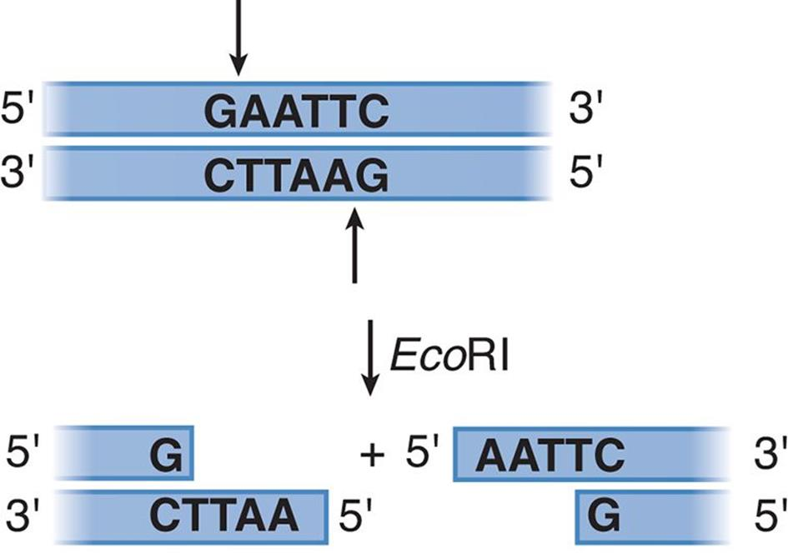

Types of enzymes:-

- Type I enzymes cut DNA at random far from their recognition sequences. They are multifunctional protein with both restriction and methylase activities

- Type II restriction endonucleases cut DNA at specific nucleotide sequences. Restriction and methylase activities are separate.

- Type III enzymes cleave outside of their recognition sequences. They cut DNA about 20-30 base pairs after the recognition site.They are multifunctional protein with both restriction and methylase activities

- Type IV enzymes target methylated DNA.

Blunt ends and sticky ends

Many restriction endonucleases make a simple double-stranded cut in the middle of the recognition sequence, resulting in a blunt end or flush end.

Other restriction endonucleases, the two DNA strands are not cut at exactly the same position. Instead the cleavage is staggered, usually by two or four nucleotides, so that the resulting DNA fragments have short single-stranded overhangs at each end. These are called sticky or cohesive ends, as base pairing between them can stick the DNA molecule back together again

One important feature of sticky end enzymes is that restriction endonucleases with different recognition sequences may produce the same sticky ends.
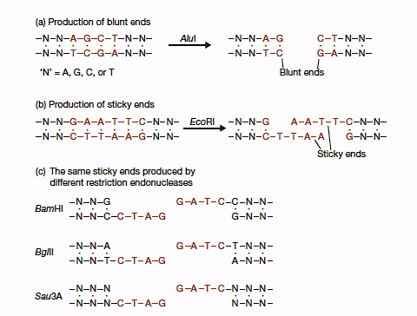

DNA ligase

These enzymes catalyse the final step in creating recombinant DNA molecule. The main role of DNA ligases in the cells is in DNA replication and repair. However, it is now used to generate recombinant DNA molecules.
Main ligase used in cloning is that of the viral T4 DNA ligase.

Application of restriction enzymes

- They are used to assist insertion of genes into plasmid vectors during gene cloning and protein expression experiments.
- Restriction enzymes can also be used to distinguish gene alleles by specifically recognizing single base changes in DNA known as Single Nucleotide Polymorphisms (SNPs)

- Map DNA molecules and many other applications

Procedure:

A typical restriction digestion reaction:
- Up to 1 µg DNA (5-10 µL)
- 1 µL of Restriction Enzyme*
- 2 µL 10x Buffer (1x final concentration)
- 1 µL 20x BSA** (if recommended)
- x µL dH₂O (to bring total volume to 20µL)
- Mix gently by pipetting.
- Incubate tube at appropriate temperature (usually 37 °C and some enzymes require a different temp.) for 1-2 hours. Always follow the manufacturer’s instructions.
- After that you can check the digestion of your plasmid by running on agarose gel alongside uncut plasmid (control).
* always add restriction enzyme last thing.
**Bovine serum albumin (also known as BSA or "Fraction V") is a serum albumin protein derived from cows. It is often used as a protein concentration
standard in lab experiments.

