Biotechnology department LAB: Genetic engineering
Collage of science Mustansiriyah University

Lab: 4
Gel Electrophoresis for DNA analysis

Gel electrophoresis is the standard lab procedure for separating DNA by size (e.g. length in base pairs) for visualization and purification. Electrophoresis uses an electrical field to move the negatively charged DNA toward a positive electrode through an agarose gel matrix. The gel matrix allows shorter DNA fragments to migrate more quickly than larger ones. Thus, you can accurately determine the length of a DNA segment by running it on an agarose gel alongside a DNA ladder (a collection of DNA fragments of known lengths).

The materials and components are using in electrophoresis:.
- Buffer TBE (Tris/Borate/EDTA) or TAE (Tris-acetate-EDTA) (or TPE Tris-Phosphate EDTA).
- Agarose
- Loading dye buffer (6X):
4- Fluorescent dye: Ethidium bromide or gel red, gel green.
5-Power supply
6-Cell
7-Tray or gel bed
8-Comb
9- Ultraviolet cabinet

Several additional factors have important effects on mobility of DNA fragments in agarose gels:
- Agarose concentration, 1% gels are common for many applications. (Agarose gel electrophoresis can be used for the separation of DNA fragments ranging from 50 base pair to several megabases (millions of bases) using specialized apparatus. Increasing the agarose concentration of a gel reduces the migration speed and enables separation of smaller DNA molecules)

- Voltage (The higher the voltage, the faster the DNA moves. But voltage is limited by the fact that it heats and ultimately causes the gel to melt
High voltages also decrease the resolution (above about 5 to 8 V/cm)
.
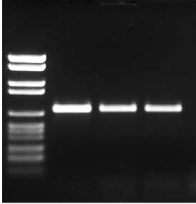
examples for the effect of using high voltage

- Electrophoresis Buffer
The two most popular types of buffers for running agarose gels are Tris-acetate with EDTA (TAE) and Tris-borate with EDTA (TBE). Because both buffers have a near-neutral pH, the DNA in the buffers has a net negative charge and migrates toward the anode (+) end of the gel apparatus.

- Effects of Ethidium Bromide.

Procedure :.
  - Prepare 1% agraose gel by adding 1 gm of agarose to 100 ml of 1x TBE buffer, heat until the agarose completely dissolved then allow the gel to cool to 45-50 °C.
  - The next step, add 5μl of ethidium bromide (final concentration 0.5 μg/mL), mix well and pour carefully in the tray (always avoid air bubbles formation between the teeth of the comb). Allow the gel to set at room temperature for 30-40 minutes.
  - Remove the comb carefully from the gel and place the tray in the gel tank, after that add a sufficient 1xTBE buffer to the tray (should cover the gel).
  - The gel is ready to load samples (e.g amplified PCR products) and run your gel for 1 hour and a half (7 Volts/ cm) .

  - DNA ladder is used to determine samples size (e.g PCR product size) then PCR products were visualized by UV light at 336 nm, and were photographs by using digital camera.

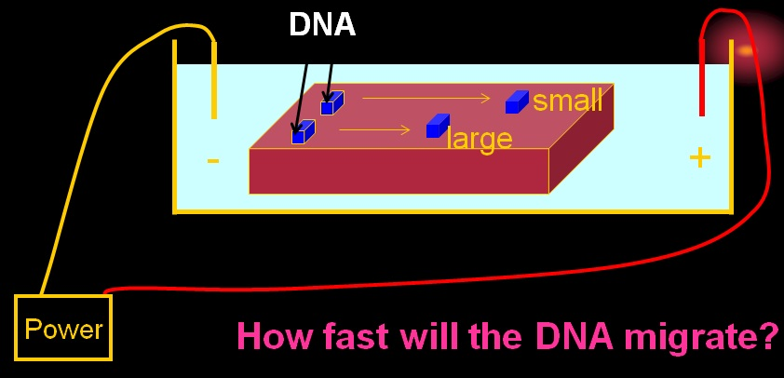

Polymerase Chain Reaction ( PCR )

The polymerase chain reaction (PCR) is a scientific technique in molecular biology to amplify a single or a few copies of a piece of DNA across several orders of magnitude, generating thousands to millions of copies of a particular DNA sequence.
Procedure:
Typically, PCR consists of a series of 25-40 repeated temperature changes, called cycles, each cycle of PCR includes steps for template denaturation, primer annealing and primer extension:
- Initialization step: This step consists of heating the reaction to a temperature of 94–96 °C which is held for 1–9 minutes.

- Denaturation step: This step is the first regular cycling event and consists of heating the reaction to 94–98 °C for 30 sec- 1min.
- Annealing step: The reaction temperature is lowered to 50–65 °C for 30 sec-1min.
- Extension/elongation step: The temperature at this step depends on the DNA polymerase used; Taq polymerase has its optimum activity temperature at 75–80 °C, and commonly a temperature of 72 °C is used with this enzyme.
- Final elongation: This single step is occasionally performed at a temperature of 70–74 °C for 5–15 minutes after the last PCR cycle to ensure that any remaining single-stranded DNA is fully extended
Applications of PCR:

  - Medicine: The PCR technique enables early diagnosis of malignant diseases.
  - Classification of organisms.
  - Mutation detection.
  - Detection of pathogens.
  - Gene therapy.
  - Finger print.
  - Forensic science: PCR is very important for the identification of criminal
  - It is also used in diagnosis of retroviral infection, bacterial infections, cancers, sex determination of embryos.
  - Evolutionary studies: It plays an important role in phylogenetic analysis.

