Microbiology Departmant, laboratory
College of Science,
Al-Mustansirya University Genetic engineering

Lab1:
Genetic engineering:
also called genetic modification, is the direct manipulation of an organism's genome It is a set of technologies used to change the genetic makeup of cells, including the transfer of genes within and across species boundaries to produce improved or novel organisms. New DNA may be inserted in the host genome by first isolating and copying the genetic material of interest using molecular cloning methods to generate a DNA sequence, or by synthesizing the DNA, and then inserting this construct into the host organism. Genetic engineering techniques have been applied in numerous fields including research, agriculture, industrial biotechnology, and medicine. Enzymes used in laundry detergent and medicines such as insulin and human growth hormone are now manufactured in GM cells, experimental GM cell lines and GM animals such as mice or zebrafish are being used for research purposes, andgenetically modified crops have been commercialized .
equipments in Genetic engineering lab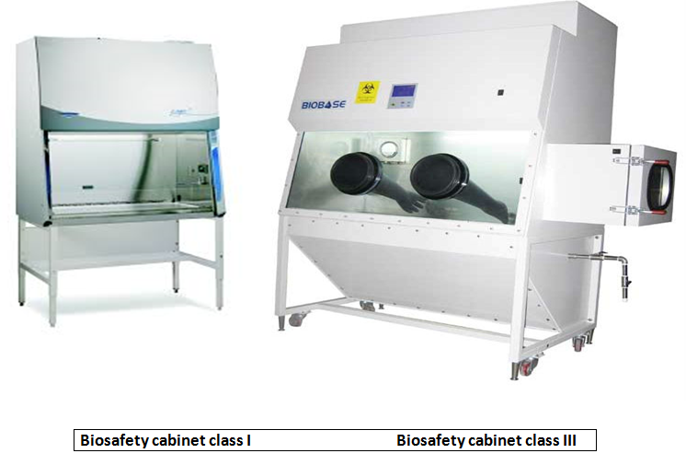
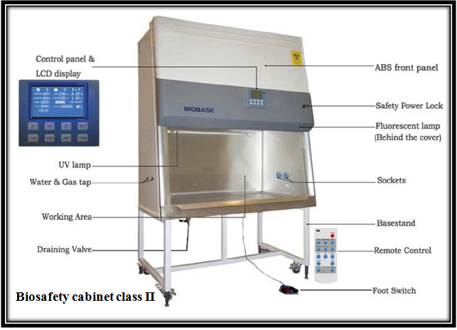
Picture | description | Instrument
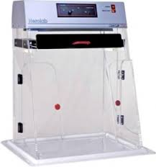 | enclosed, sterilized space work. | PCR work station
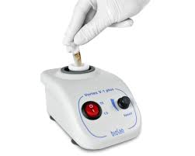 | To mix the reaction continent | Vortex shaker
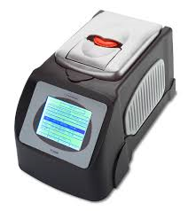 | To amplified DNA molecules (quality identification) | Conventional PCR
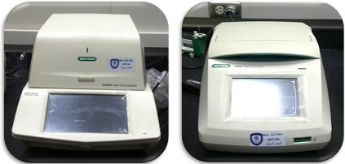 | Quantitatively measure the amplification of DNA using fluorescent probes | Real-Time PCR detection system and Thermal Cycler
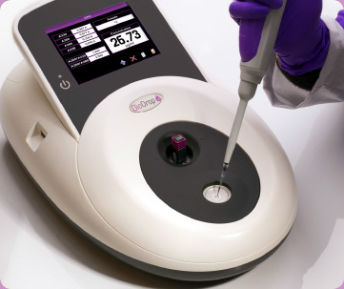 | To measuring nucleic acid concentration and purity | Nanodrop
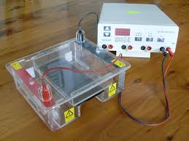 | To separate nucleic acid and protein with molecular weigh less than 10000 bp | Gel electrophoresis
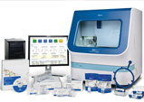 | To determine sequence of nucleotide in DNA strand | DNA sequencer
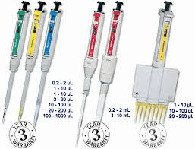 | To transfer the appropriate amount of volumes | Micropipettes in different size
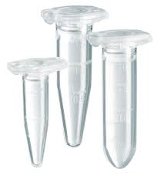 | To keep and holder samples in experiment | Different size of eppendorf tubes
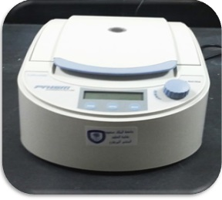 | Centrifuge Eppendorf tubes to a maximum of 15000 RPM | Micro centrifuge
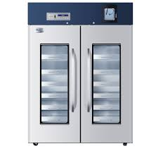 | Long time storage of cells (mammalian/bacterial) at -80ºC as glycerol stocks | Deep freezer (-80ºC)
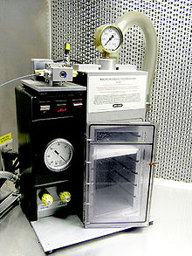 | originally designed for plant transformation This device is able to transform almost any type of cell, including plants, and is not limited to genetic material of the nucleus: it can also transform organelles, including plastids | gene gun or a biolistic particle delivery system
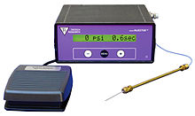 | used to penetrate the cell membrane and/or the nuclear envelope. Microinjection can also be used in the cloning of organisms, | Microinjection

Microbiology Departmant, laboratory
College of Science,
Al-Mustansirya University Genetic engineering

Lab2:
Gel Electrophoresis:
The materials and Components (of) Gel Electrophoresis (system) used in electrophoresis:.
- Buffer TBE or TAE (or TPE).
- Agarose
- Loading buffer (6X):
4- Fluoresces dye : Ethedium bromide or other dye.
5-Power supply
6-Cell
7-Tray or gel bed
8-Comb 9- Ultraviolet cabinet
Several additional factors have important effects on mobility of DNA fragments in agarose gels:
- Agarose Concentration
- Voltage
- Electrophoresis Buffer
- Effects of Ethidium Bromide.
Procedure :.
- The agarose(1%) has already been prepared by adding 1 gm of agarose to 100 ml of 1x TBE buffer , heated until the agarose completely dissolved then the gel was allowed to cool to 45-50 °C.
- After cooling, 5μl of ethidium bromide (final concentration 0.5 μg/mL) was added, mixed well and poured carefully in the tray, with avoiding air bubbles formation between the teeth of the comb. The gel allowed setting at room temperature for 30-40 minutes.
- The comb was carefully removed from the gel and the tray was placed in the gel tank then a sufficient 1xTBE buffer was added.
- The amplified PCR products then submitted to electrophoresis using loading buffer for 1 hour and a half (7 Volts/ cm²) .
- DNA ladder was used to assess PCR product size, then PCR products were visualized by UV light at 336 nm, and were photographs by using digital camera.

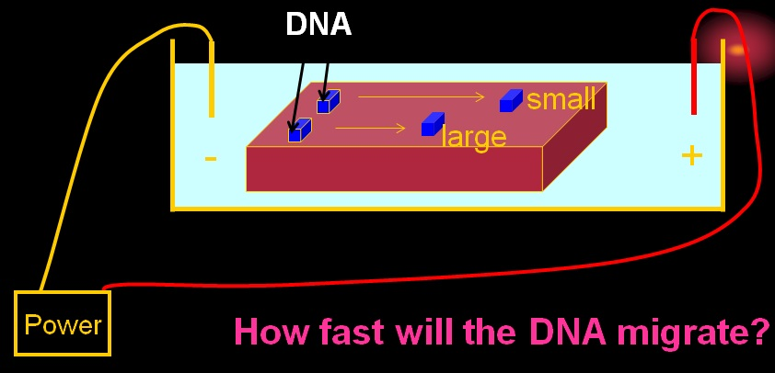

Polymerase Chain Reaction ( PCR )

Procedure:
Typically, PCR consists of a series of 25-40 repeated temperature changes, called cycles, each cycle of PCR includes steps for template denaturation, primer annealing and primer extension:
- Initialization step: This step consists of heating the reaction to a temperature of 94–96 °C which is held for 1–9 minutes.
- Denaturation step: This step is the first regular cycling event and consists of heating the reaction to 94–98 °C for 30 sec- 1min..
- Annealing step: The reaction temperature is lowered to 50–65 °C for 30 sec-1min .
- Extension/elongation step: The temperature at this step depends on the DNA polymerase used; Taq polymerase has its optimum activity temperature at 75–80 °C, and commonly a temperature of 72 °C is used with this enzyme.
- Final elongation: This single step is occasionally performed at a temperature of 70–74 °C for 5–15 minutes after the last PCR cycle to ensure that any remaining single-stranded DNA is fully extended.
Applications of PCR:
  - Medicine: The PCR technique enables early diagnosis of malignant diseases.
  - Classification of organisms .
  - Mutation detection .
  - Detection of pathogens .
  - Gene therapy.
  - Finger print .
  - Forensic science: PCR is very important for the identification of criminal
  - It is also used in diagnosis of retroviral infection, bacterial infections, cancers, sex determination of embryos.
  - Evolutionary studies: It plays an important role in phylogenetic analysis.

Microbiology Departmant, laboratory
College of Science,
Al-Mustansirya University Genetic engineering

Lab3:
Gen cloning
Cloning include insert foreign DNA to a living organism that does not contain of this piece exceeded the species barrier and is the main axis in the genetic engineering technique

Steps in cloning[
In standard molecular cloning experiments, the cloning of any DNA fragment essentially involves seven steps:
- Choice of host organism and cloning vector,
- Preparation of vector DNA,
- Preparation of DNA to be cloned,
- Creation of recombinant DNA,
- Introduction of recombinant DNA into host organism,
- Selection of organisms containing recombinant DNA,
7-Screening for clones with desired DNA inserts and biological properties

Types of cloning[
- Gen cloning
- Cell cloning
- Reproductive cloning
- Therapeutic cloning

Characteristics vectors cloning prokaryotic
1-The ability to self-replicate independently of the bacterial chromosome (containing ori replication origan)
2-Ease isolated(Small size)
- Non-toxic to the host cell
- It has places cut insert DNA fragment
- Contain genes can be detected all the way to the elected details (antibiotic resistance genes)
- It has a private places by restriction enzyme
- The large number of copies
Types of cloning vectors
- Plasmids:
Plasmid is an autonomously replicating circular extra-chromosomal DNA. They are the standard cloning vectors and the most commonly used. Most general plasmids may be used to clone DNA insert of up to 15 kb in size. Function carrying the genes of( antibiotic resistance genes or the production of toxins).
It is classified into two types:
- Natural Plasmid ex: COL E1
Three examples of Natural Plasmid
Plasmid | Size (kb) | Relaxed (amplified) | Single sites for restriction enzymes | Marker genes for selecting transformant | Additional marker genes showing insetional inactivation
Psc101 | 6.5 | No | Xhol,EcorR1,  Pvull,Hincll | Tetracycline resistance | -
 |  |  | HindIII, BamHI,Sall | - | Tetracycline resistance
ColE1 | 8 |  | EcoRI | Immunity to colicin E1 | colicin E1 production
RSF2124 | 11 |  | EcoRI, BamHI | Ampicillin resistance | colicin E1 production
Note: There is no perfect plasmid in nature
- Artificial Plasmid ex: pBR322
pBR322 is a plasmid and was one of the first widely used E. coli cloning vectors . The p stands for "plasmid," and BR for "Bolivar" and "Rodriguez. It is 4361 base pairs

Construction of an artificial cloning plasmid pBR322
Tetracycline resistance gene from pSC 101
ORI from PMB1 (a ColE1-type plasmid)
Ampicillin resistance gene from RSF 2124

O

Combined

PMB 9 Combined
(Asmall useable plasmid)

PBR 312 (too large)

Unnecessary
DNA deleted

PBR 313 (too large)
Unnecessary
DNA deleted

PBR 322(4.36 kb)
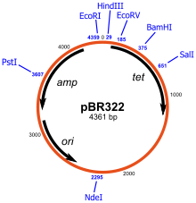
- Bacteriophage

The bacteriophages used for cloning are the phage λ and M13 phage.
phage λ : phag Infects E.coli
And a linear DNA containing the ends of the adhesive, when entering the phage into the host cell endings you will be linked with each lens you shall take the form of a circular molecule . Genes in hand, be left off the map for this chromosomal phage proteins coded for the head and tail of phage . The centrist genes responsible for the re-engagement and the right of the map genes are responsible for gene regulation work .
Genome of wild type phage λ

cos cos
Head , Tail Lysogeny Regulation

It was observed that the genes of the central region is essential for the growth of the phage and so can be removed without affecting the phage and this was an important point in the construction of vectors which are derived from cloning phage .

How is the use of phage λ in experiments :
- Isolated DNA phage λ from molecule of phage λ .
- Cutting DNA phage λ and foreign DNA by restriction enzyme (removed the central region )
- Link foreign DNA with DNA phage λ (Instead of the central region) by DNA ligase .
- Insert recombinant molecule to the head phage λ .
- Infects E.coli with phage λ and Begins replicate .
- Isolated the plaques formed which contains cloning phage λ.
- The selection of the container cells on the phage λ, it is Carrier recombinant molecule by DNA hybridization.
- Multiplication the cells .
Cosmid
A recombinant molecule composed of a plasmid containing end site (cos) derived from phage λ and DNA from the plasmid does not cause lysis of the host cell It is normally used to clone large DNA fragments between 28 to 45 Kb , but this vector is not stable .
How is the use of Cosmid in experiments
- Cosmid cutting and open from the ends of the adhesive to phage λ by enzyme .
- foreign DNA cutting by the same enzyme cutter.
- Connecting pieces of foreign DNA with open cosmid by DNA ligase.
- Phage Formation by in –vitro package , Phage formation immature add-head proteins and tail.
- Infection E.coli.
- Selection colonies resistance Amp^{r} as Character appearance.

