**كلية العلوم**

**قسم علوم الحياة**

**المرحلة الاولى**

**علم الحيوان العام العملي**

**(Zoology)**

**الست اصال غازي الشمري**

**Lab :1**

**The microscope**

**- Compound microscope**

**- Dissecting microscope**

**- Scanning electron microscope**

- **Transmission electron microscope**

**The Compound Microscope**

**A microscop**: It is a tool that is used to study things that can not be seen with the naked eye.

**Microscope parts**

1- **Eye piece (ocular lens)** : contains the magnifying lens you look through, and may be provide with pointer to point on indicated parts from the body we need to exam.

2- **Body tube** : It holds the eye piece.

3- **Arm** : Supports the body tube & it holds the microscope.

4- **Revolving nose piece** : Holds high & low power objectives ; can be rotated to change magnification .

5**- Objective lens :** we can divided it to :

a) Low power objective (L.P.) :- Provides the least magnification, usually it power is (4.5 X) and (10 X).

b) High power objective (H.P.) :- Provides the most magnification, usually it power is (40 X).

c) Immersion oil :- magnification usually (100 X), it is used only with oil drop.

6**- Coarse adjustment** : moves the body up & down for focus, it is used with (L.P.) objective.

7- **Fine adjustment :** used to sharpen the image, moves the body tube slightly , it is used with (H.P.) objective.

8**- Condenser:-** It condense the light.

9- **Stage**:- Supports the microscope slide.

10- **Stage clips**:- Holds the microscope slide in place.

11- **Diaphragm** :- Regulates the amount light which enter the body.

12- **Mirror** :- Reflects the light upward through the diaphragm to the objective & the eye piece.

13- **Base** :- Supports the microscope.

**How to keep your microscope**

**(Use of the microscope)**

1. Always carry the microscope with both hands , holds the arm with one hands & place the other hand under the base.
2. Place the microscope on the table gently with the arm towards you and the stage facing a light source.
3. Turn on the light from the swich.
4. Look through the eye piece & adjust the diaphragm so that the greatest amount of light comes through the opening in the stage. The circle of light is called the field of view.
5. Turn the revolving nose piece so that the low power objective lens clicks in to place.
6. Always focus first with the coarse adjustment & the low power objective lens.
7. Turn the revolving nosepiece until the high power objective (H.P.) clicks into place. Use only the Fine adjustment knob with this lens.
8. Use only special lens paper to clean lenses.
9. Before putting the microscope away, always turn the low power into place over the stage.
10. Be sure that the distance between the low power & the stage is about tow or three centimeters.
11. Turner off the swich.

**The partical part**

How to see your field:

1. Gently scrape the inside of your mouth with the flat side of a toothpick .
2. Place the sampil in the middle of slide.
3. Stain the sampil with methylene blue or iodine.
4. Hold a cover slip at a 45 degree angle to the slide and lower the cover slip onto the sampil.
5. Place the slide on the microscope stage.Use the stage clips to hold the slide in place.
6. Use the mirror or light to send light upward through the slide.
7. View the microscope from the slide and the low power objective with the coarse adjustment knob until it is closed to the cover slip.
8. Look through the eye piece until you can see the cell,then focus with the fine adjustment knob.

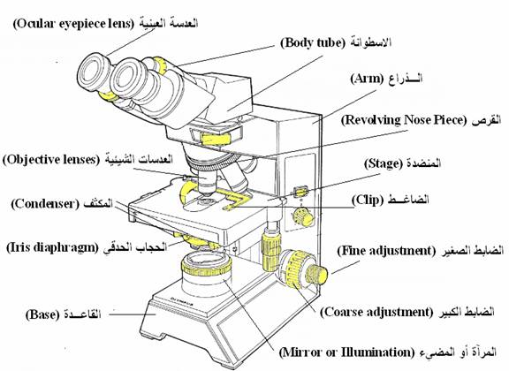

**The compound microscop**

|  |  |  |  |  |  |  |  |
| --- | --- | --- | --- | --- | --- | --- | --- |
| **Total** **Magnification:** | | |  | | | |  |
|  | To figure the total magnification of an image that you are viewing through the microscope is really quite simple. To get the total magnification take the power of the objective (4X, 10X, 40x) and multiply by the power of the eyepiece, usually 10X. | | | |  | | | |  |
|  | | http://www.cas.muohio.edu/mbi-ws/microscopes/images/Magnification.JPG | |  |  |  |  |  |  |
|  |  |  |  |  |  |

**Lab :2**

**The animal cell**

**Cell**: It is the basic unit of structure & function in an organism.

**Cell theory**: Every living organism is composed of cell and every cell in an organism produced by another cell.

The main parts of cell (cell structure) :

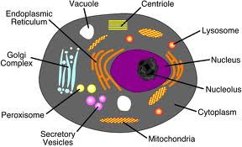

**Living &non living component in cell**

1. **Living component**

1-**Cell membrane** : surrounds the part of a cell together ,it controls the movement of material into and out of a cell.

2- **Cytoplasm** : is protoplasm inside the (cell membrane ). It makes

up most of the mass of many cells, different cell materials are

produced in the cytoplasm.

**Function** : produces variety of cell materials.

3- **Nucleus** : It controls cell activities, it is often in or near the center of a cell material .That nucleus is separated from the cytoplasm by a thin membrane is called (nuclear membrane).

**Function** : Controls cell activities.

4- **Mitochondria** : Are rod- shaped in the cytoplasm .

**Function :** Release energy & it is called (power house of cell) 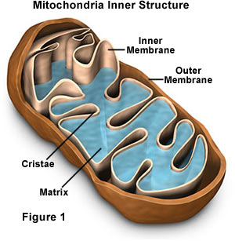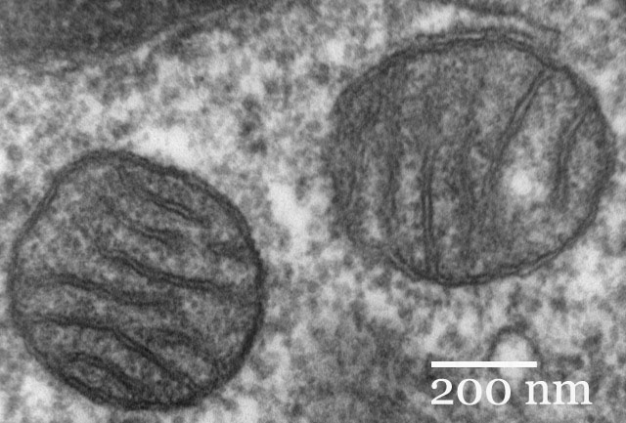

5- **Ribosomes** : Are tiny- particles, so small . They can seen only with an electron microscope.

**Function :** Parts of cells where proteins are made.

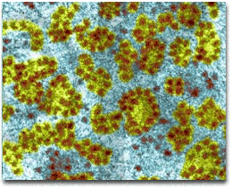

6- **Endoplasmic reticulum** : Structures like tubes in the cytoplasm of the cell.

**Function** : Moves materials within cells.

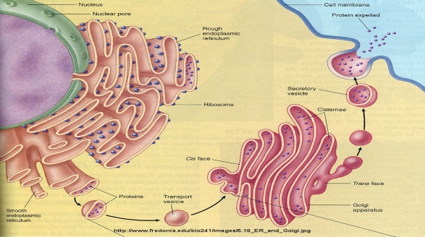

**7-Lysosome:**round organelles surrounded by a membrane and containing digestive enzymes.

**B- Non Living component**

**Vacuoles** : is a liquid- filled sphere surrounded by a membrane.

**Function** : stores water &dissolved materials.

Note: You can see these types of structures in Amoeba or Paramecium

* **Organisms are divided according to number of cells:**

1- **Unicellular Organisms**: some Organisms are single cells are called unicellular e.x. : Bacteria , Amoeba , Euglena .

2- **Multicellular Organisms**: some Organisms have many cells are called multicellular e.x. : Animal tissue & Plant tissue .

**We can divide the organisms to:**

**1-Eukaryotic**

**2-Prokaryotic**

|  |  |  |
| --- | --- | --- |
|  | **Eukaryotic** | **Prokaryotic** |
| **1-**nucleus | present | absent |
| **2-**number of  chromosomes | More than one | one |
| **3-**number of cells | multicellular | unicellular |
| 4-nucleous membrane | present | absent |
| 5-mitochondria | present | absent |
| 6-ribosomes | larger | smaller |
| 7-ex: | Animal, plant | Bacteria |

**Lab:3**

**Cell shape**

1. Squamous shape / Irregular – shaped cell forming a continuous surface with small nuclei.

[ ex. Squamous epithelial tissue in Skin , mouth ].

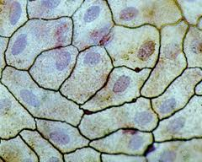

2- Cuboidal shape / The cells appear square & the nuclei is in the middle of cell .

[ ex. Cuboidal epithelial tissue in c.s in Kidney , Urinary bladder & pancreas ].

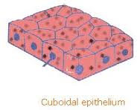

3- Columnor shape / is similar to Cuboidal epithelialium except that the cell are taller & appear columnar in section, the nuclei may be located towards the base .

[ ex. Columnor epithelial tissue in Stomach , Trachea ]

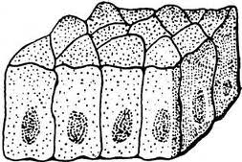

4- Spindle cell / The cell elongated spindle shaped with pointed end .

[ ex. Smooth muscle ]

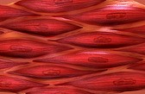

5- Stellate ( Asteriodal shape ) [ ex. Neuron ]

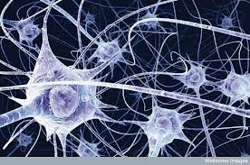

6- Circular (Discoid shape )

[ ex. Red blood cell(R.B.C) in Human blood ]

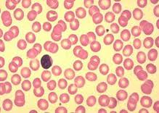

7- Sperm shape [ ex. Rabbit sperm ]

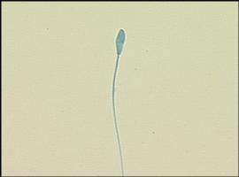

8- Amoeboid shape [ ex. Amoeba ]

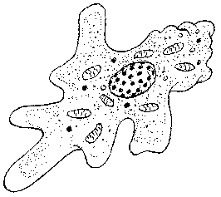

**Lab:4**

**Cell Division**

**Cell division**: Is the process in which a cell reproduces.

* During cell division a cell divides to form two cells.
* Cell division produces new cells as an organism grows in size.
* Also cell division replaces cells that wear out die.

Ex. : Cells in your skin divide to replaces the dead skin cells.

The name is given to the process in which a cell divides to form two cells, that is called Mitosis.

**Interphase**: is this phase the cell spends the majority of its time and performs the majority of its purposes including preparation for [cell division](http://en.wikipedia.org/wiki/Cell_division). In preparation for cell division, it increases its size and makes a copy of its [DNA](http://en.wikipedia.org/wiki/DNA). Interphase is also considered to be the 'living' phase of the cell, in which the cell obtains nutrients, grows, and conducts other "normal" cell functions. The majority of [eukaryotic cells](http://en.wikipedia.org/wiki/Eukaryotic_cells) spend most of their time in interphase. Interphase does not describe a cell that is merely resting but is rather an active preparation for cell division.

**Mitosis or Karyokinesis**

During mitosis the cell material passes through four stages:

1. **Prophase**: A stage of mitosis which the chromosomes first

become visible in the nucleus, chromates become shorter &

thicker by process of coiling. The tow chromates of each chromosome are joined by a small region called" Centro mere" . As mitosis progresses, the nuclear envelope & the nucleus being to disappear.

1. **Metaphase**:A stage of mitosis during which the chromosomes come to lie in a centrally located plane in spindle. The spindle composed of microtubules & has tow distinct poles. The orientation and shape of the spindle is responsible for the later movement of chromosomes to the poles .
2. **Anaphase**: A stage of mitosis in which the chromatids of each chromosome separate &move to opposite poles.
3. **Telophase** : A stage of mitosis in which the chromatides (now called chromosomes) reach the poles of the spindle The spindle dissolve & the nuclear envelop nucleolus reform.

A cell membrane begins to form the center of the cell. The membrane divides the cytoplasm between the two nuclei which is called (cytokinesis).

Now the chromosomes are no longer visible when the cell membrane is completed, two cells have been formed from one cell.

*In the animal cell constricting the cell membrane to form a [cleavage furrow](http://en.wikipedia.org/wiki/Cleavage_furrow).

* Mitosis normally results in tow cells with the same number & kinds of chromosomes.

* Mitosis can last five minutes to several hours depending on the species.
* The chromosomes inside the nucleus contain the cell life code.
* Mitosis is copies of the cell from which they were formed.

**Mitosis in Animal cell**

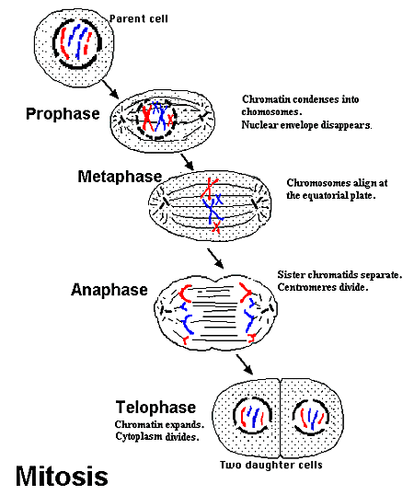

**Lab:5**

**Tissues**

**Tissue:** It is a group of cells similar in shape and function .

There are four main chief tissues in the body.

1. **Epithelial tissue**
2. **Connective tissue**
3. **Muscular tissue**
4. **Nervous tissue**

**Epithelial tissue**

Epithelium is divided into two types:

* + - * 1. **Simple epithelium:**

One cell layer thick

All cells rest on the basement membrane (basal surface) and all cells face the free surface.

Types of simple epithelium are: Squamous, Cuboidal, Columnar, Pseudostratified .

* + - * 1. **Stratified epithelium:**

1. More than one cell layer thick
2. Only the deepest layer of cells contacts the basement membrane and only the superficial-most cells have a free surface.
3. Types of stratified epithelium are: Squamous, Cuboidal, Columnar, Transitional.

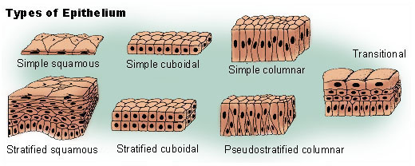

**Connective tissue**

The connective tissue have an important function include connecting, supporting and protection.

**Classification of connective tissue:**

**Proper connective tissue**

**1-Loose connective tissue: areolar**, **reticular** and **adepose.**

**2-Dense connective tissue: regular** and **Irregular**

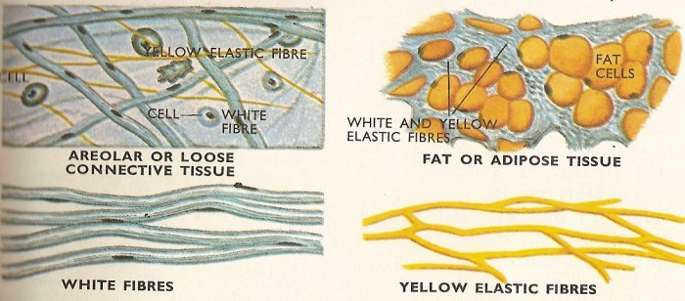

**Special Connective tissue**

**1-Cartilage:** There are three types of cartilage: **hyaline**, **fibro** and **elastic**.

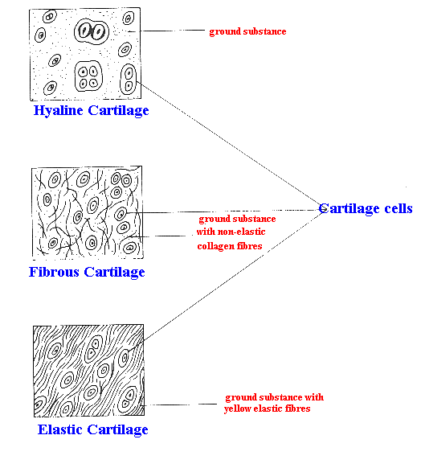

**2-Bone:** There are two types of bone**:compact** and **spongy**

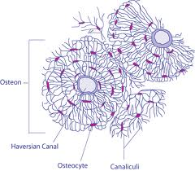

**3- Blood:** Consists of formed elements (cells) Are erythrocytes (RBCs) ,leukocytes (WBCs)& platelets suspended & carried in plasma (fluid part)



**Erythrocytes**

RBCs are flattened biconcave discs, Lack nuclei & mitochondria



**Leukocytes**

1. **Granular leukocytes**.

Include: eosinophils, basophils & neutrophils

**2.Agranular leukocytes**.

Include: lymphocytes & monocytes

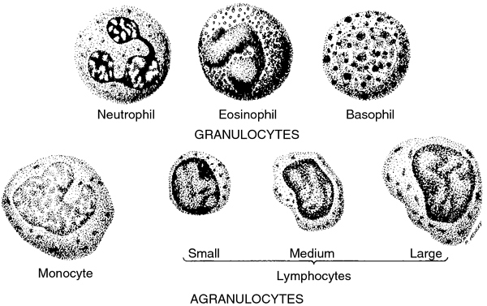

**Platelets (thrombocytes):** Are smallest of formed elements, lack nucleus



**Lab: 6**

**Muscle tissue**

Classification of Muscle tissues

* + 1. **Skeletal muscle**
       1. Striated and voluntary
       2. Found mostly attached to the skeleton

3)Nuclei are peripherally located

* + 1. **Cardiac muscle**
       1. Striated and involuntary
       2. Composes the majority of the heart wall (myocardium)

3) one central nucleus

* + 1. **Smooth muscle**
       1. Nonstriated and involuntary
       2. Found mostly in the walls of hollow organs and vessels

3)one central nucleus

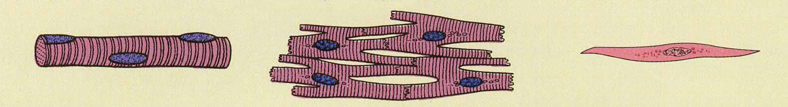

Skeletal muscle Cardiac muscle Smooth muscle

**Nervous tissue**

Is a tissue that are specialized for receiving different types of stimuli.

Neuron Consists of:

* **Cell Body** : contains nucleus, mitochondria,nissl bodies
* **Dendrites**: highly branched extensions of the cell body. Conduct impulses towards the cell body
* **Axon**: a single long process. Conducts impulses away from the cell body.

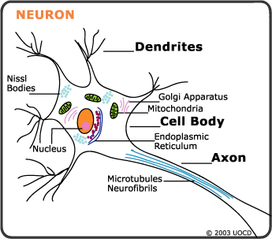

Structural of Neurons:

1. **multipolar neurons**: more than two processes one is the axon and the rest are denderites

2. **bipolar neurons**: have two processes one is axon and other one is denderites

3. **pseudounipolar neurons** : have a single process close to the perikaryon.

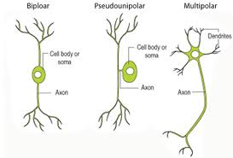

**Lab: 7**

**Biology**: The science that deals with life.

Characteristics of life:

Living things show 4 Characteristics that the non living do not display.

1- Metabolic processes: The total of all chemical reaction within an organism. For example Nutrient up take, processing, and waste elimination.

2- Generative processes: Action that increase the size of an individual organism (growth), or increase the number of individual in population (reproduction).

3- Responsive processes: Those abilities to react to external and internal change in the environment, for example irritability individual adaptation , and evolution.

4- Control processes : Mechanisms that ensure that an organism will carry out all metabolic activities in the proper sequences (coordination) and the proper amount.

**Scientific Name**

* It Started with a system developed by Carlous Linnaeus.
* Linnaeus developed a two – part name system.
* Each known plant or animal is given with two parts.

First part: Genus name.

Last part: Species name.

* Linnaeus used Latin when he named plant & animal.
* The genus name is spelled is with a Capital letter.
* The species name is spelled is with a Small letter.
* When imprint both name are in italics.
* When written a scientific name under lined.

Ex. Fasciola hepatica

**Classification**

Classification : Means to put things into group.

*Classifying organisms makes it easier to study & learn about them.

* The groups are classified according to the similar & different from each other.

* life characteristics are used to divide all things into two groups non living & living things.

*living things are classified into five main groups. Each main group is called a Kingdom.

The 5 Kingdom are:

1-Monera Kingdom

2-Protista Kingdom

3- Fungi kingdom

4- Plant Kingdom

5- Animal Kingdom

**Kingdom: Monera**

1. These organisms have cell walls.
2. They do not have true nucleus & the nuclear material in the cells is not surrounded by a nuclear membrane.
3. Chlorophyll may be present in the cells but there are no chloroplasts.
4. The Monera kingdom is divided into two phylum:
   1. Blue- Green Algae.(e.x: Nostoc , Oscillatoria )

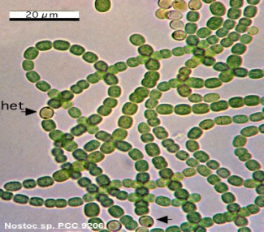

* 1. **Bacteria.( Bacteria )**

Bacteria

One- celled, most of them have no chlorophyll ,it have three basic shape ( Coccus, Spherical, Bacillus)

* Bacteria are found deep in Oceans & high in the atmosphere.

* Some bacteria cause disease in the plant & animal. And some bacteria are useful.

* Most bacteria need oxygen, warmth & food & water to grow.

* Bacteria that have chlorophyll can make their food by (photosynthesis) but other bacteria did not have chlorophyll so they obtain food by growth on living thing & called Parasites or by dead organic and called Saprophytes.

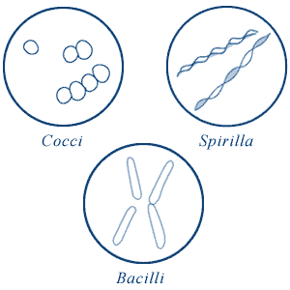

**Kingdom: Protista**

1- Most of the protista are unicellular .

2- Some of protista make their own food & others obtain their food from plants, animals, or dead organic matter.

3- They have a true nucleus. (Eukaryotic) .

4- The protista kingdom is divided into eight phylum. Three of these phylum are simple algae, four are different groups of Protozoa, one phylum consist of species of slim molds.

**The phylum of Protista Kingdom:**

1. Euglenophyta → Euglena
2. Chrysophyta (golden algae) → Diatoms
3. Pyrophyta →Ceratium
4. Sarcodina → Amoeba
5. Ciliophora (Ciliates) → Paramecium
6. Mastoigophora → Trichomonas , Trypansoma
7. Sporozoa → Plasmodium
8. Myxomycota (Slime Molds) → Physarum

Some examples about Protista:

**Euglena:**

1. Are unicellular, live in water
2. When present in large amount they may color the water green.
3. Euglena have tail called a flagellum
4. The shape of Euglena may change sometimes as it swims
5. Euglena responds to light by swimming towards it because it has the stigma.
6. Euglena has chloroplast and can make its own food.
7. Euglena reproduces a sexually through cell division.
8. Euglena lack cell wall and can move about.

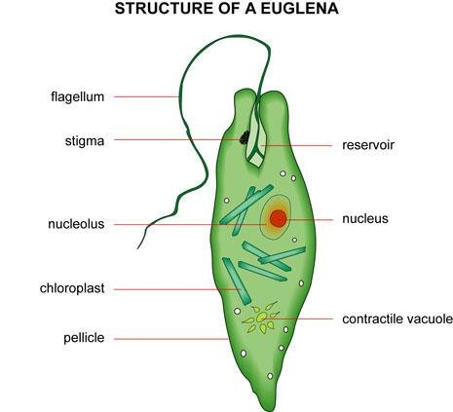 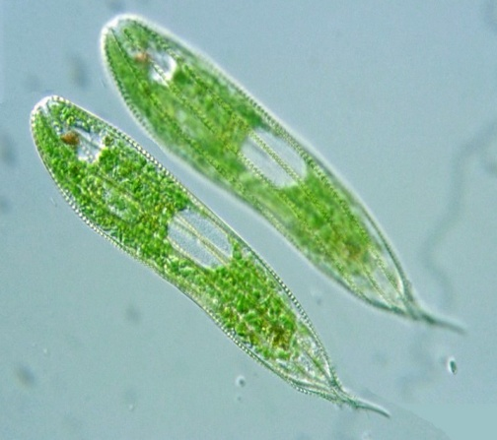

**Paramecium:**

1. Paramecium is a Sporozoa with two nucleuses, large nucleus controls cell activities and small nucleus is involved in reproduction.
2. Ciliated do not have cell wall, but they have cell membrane.
3. Cilia of Paramecium are short, hair like parts on the out side of the cell.
4. Cilia are useful for swimming & in obtaining food.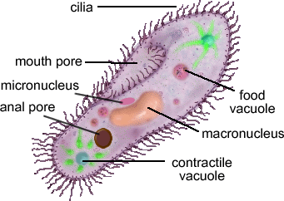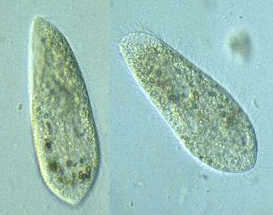

**Lab:8**

**Kingdom: Animal**

1. Animals can not make their own food, so they eat other organisms for food.
2. Most animals can move about.
3. Multicellular
4. Animals with backbones are called vertebrates but the animals without backbones are called invertebrates.
5. Animals reproduction can be a sexual or Asexual , ex: Hydra

It can reproductive with both ways.

1. Animal Kingdom is classified into nine phylum, Vertebrates animal belong to one phylum & invertebrates belong to eight phylum.

**The phylum of Animal Kingdom**:

1. **Porifera (Sponges)** →(ex. Sponge)

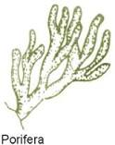also named sponges:means animal that contains

holes,are sessile feeders(struck to the ground eating what comes near them).

Body symmetry: asymmetric

Ex: yellow Tube spongy.

1. **Cnidaria**→(ex. Hydra)

Contains cnidocyte or Venomous cells that helps collect and

transmit sensory information .

body symmetry: radial

ex :Jelly fishes

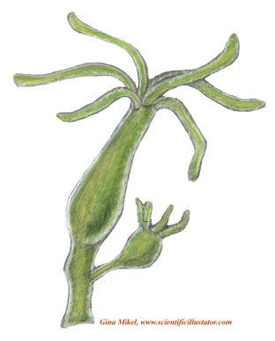

1. **Platy helminthes** **(flat worms)** →(ex. Liver fluke)

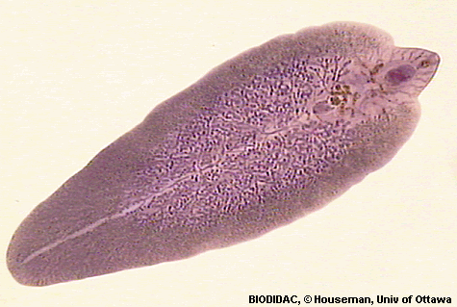also named flat worms lack a coelom and other body cavities, can be found in

marine of fresh water.

Body symmetry: bilateral

Ex: tapeworms .

4- **Nematoda** **(round worms)** →(ex. Ascaris )

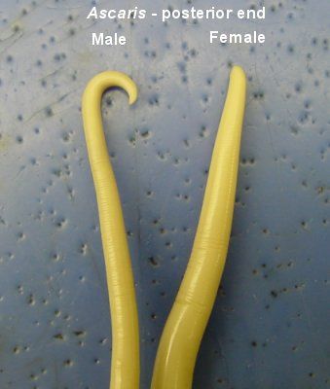also named round worms, very long

and narrow.

Body symmetry: bilateral

Ex: Ascaris .   
5-**Annelida** →(ex. Earth worm)

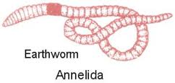have long bodies that have

segments divided externally

by shallow rings.

Body symmetry: bilateral

Ex: earthworms   
6- **Mollusca** →(ex. Octopus & Snail)

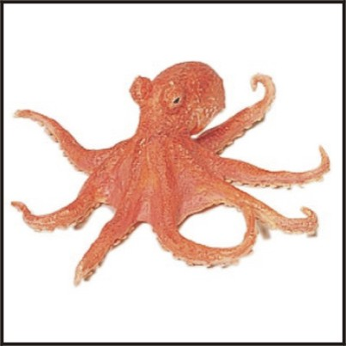 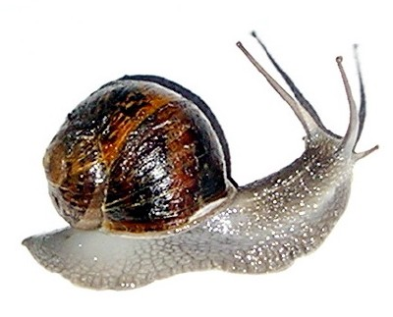

One of the largest phylum composed of many diverse organisms, all have a soft body, body structure composed of three parts.

Body symmetry: bilateral

Ex: snails , octopus

7-**Arthropoda** →(ex. Butterfly, Spider,Scorpion & Cockroach)

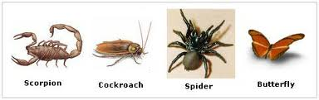

Have jointed appendages (body extensions that give them a wide range of controlled motion) , most successful because they are the most divers, living in a great range of habitats.

Body symmetry : bilateral.

8-**Echinodermata** →(ex. Sea cucumber , Sea urchin & Sea star)

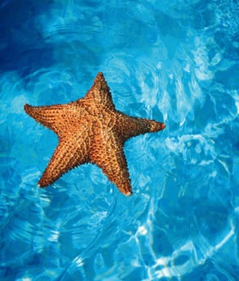means spiky skin, dwells at the bottom of

the ocean floor.

Body symmetry: radial

1. **Chordate** → Vertebrate (ex. Fish, Frog & Birds)

Has internal skeletal rod , acomplete digestive

System, a ventral heart, a closed blood system and a tail

Body symmetry: bilateral.

