Bacterial Physiology Lec -3
Uptake of nutrients by the cell
The first step in nutrient use is uptake of the required nutrients by the microbial cell,uptake mechanism must be specific-that is the necessary substances,and not others,must be acquired.Nutrients must pass through a selectively permeable plasma membrane that will not permit the free passage of most substances.
The most important transport mechanisms are :
1-Passive diffusion : the process in which molecules move from a region of higher concentration to one of lower concentration because of random thermal agitation.The rate of passive diffusion is dependent on the size of the concentration gradient between a cell’s exterior and it’s interior,very small molecules (H2O,O2 & CO2) often move across membranes by passive diffusion. 2-Facilitated diffusion : the rate of diffusion across selectively permeable membranes is greatly increased by using carrier proteins, called permeases, which are embedded in the plasma membrane. Because carrier aids the diffusion process,it is called facilitated diffusion .The rate of transport increases with the concentration gradient much more rapidly and at lower concentrations of the diffusing molecule than that of passive diffusion.The curve below resembles an enzyme – substrate and is different from the linear response seen with passive diffusion .Carrier proteins also resemble enzymes in their specificity for the substance to be transported ;each carrier is selective and will transport only closely related solutes.
3 -Active transport : M.O often live in habitats with very dilute nutrient sources,must be able to transport and concentrate these nutrients, thus facilitated diffusion mechanisms are not always adequate ,and other approaches must be used ,the two most important transport mechanisms in such situations are ; active transport & group translocation , both energy –dependent processes .
Active transport; is the transport of solute molecules to higher concentrations,or against concentration gradient,with the use of metabolic energy.The carrier proteins or permeases bind particular solutes with great specificity,it is also characterized by the carrier saturation effect at high solute concentration.
4- Group translocation ; Many bacteria take up molecules by group translocation,a process in which a molecule is transported into the cell while being chemically altered. It is energy –dependent transport because metabolic energy is used. In the 1,2,3 types the solute molecules move across a membrane without modification.
The best –known group translocation system is the phosphoenolpyruvate;
Sugar phosphotransferase system (PTS).It is transports a variety of sugars into cells while phosphorylating them using phosphoenolpyruvate (PEP) as the phosphate donor.

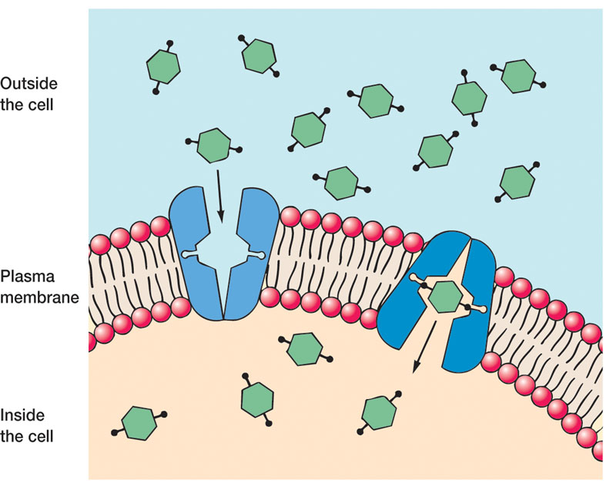
Figure -1 A model of facilitated diffusion the membrane can carrier change conformation after binding an external molecule and subsequently release

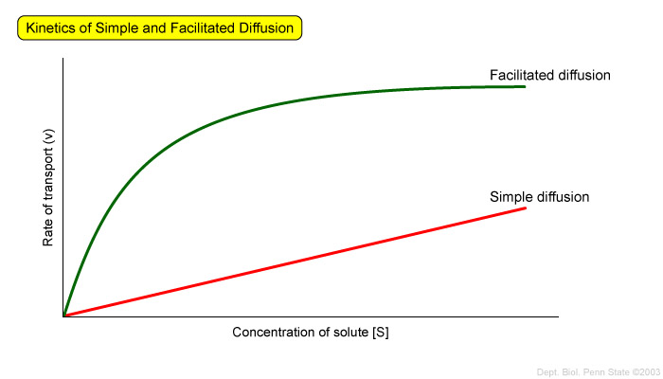
Figure -2 The kinetics of simple diffusion and facilitated diffusion. The rate of transport (v) is plotted against the concentration of solute ([S]) for simple diffusion of a solute (shown in red) and facilitated diffusion of a solute by a carrier protein (shown in green). Transport by a carrier protein is much more rapid than transport by simple diffusion. Facilitated diffusion becomes saturated at high solute concentrations, and higher solute concentrations do not significantly increase the rate of transport.

.

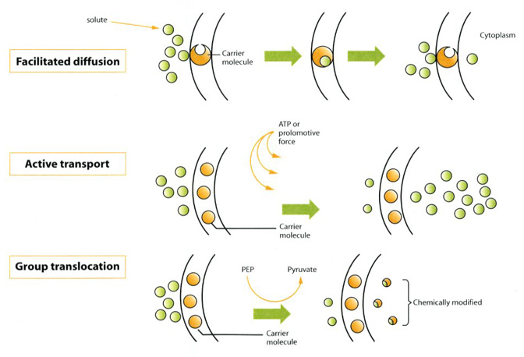

Figure -3 Operation of bacterial transport systems. Bacterial transport systems are operated by transport proteins (sometimes called carriers, porters or permeases) in the plasma membrane. Facilitated diffusion is a carrier-mediated system that does not require energy and does not concentrate solutes against a gradient. Active transport systems such as Ion-driven transport and Binding protein-dependent transport, use energy and concentrate molecules against a concentration gradient. Group translocation systems, such as the phosphotransferase (pts) system in Escherichcoli,use energy during transport and modify the solute during its passage across the membrane

