Lab. 1

Comparative anatomy is the study of similarities and differences in the anatomy of different species. It indicates that various organisms share a common ancestor. Also, it helps scientists in classifying organisms based on similar characteristics of their anatomical structures. Two major facts of comparative anatomy are:
1. Homologous structures - structures which are similar in different species because the species have common origin. They may or may not play the same function. An example is the forelimb structure shared by cats and whales.
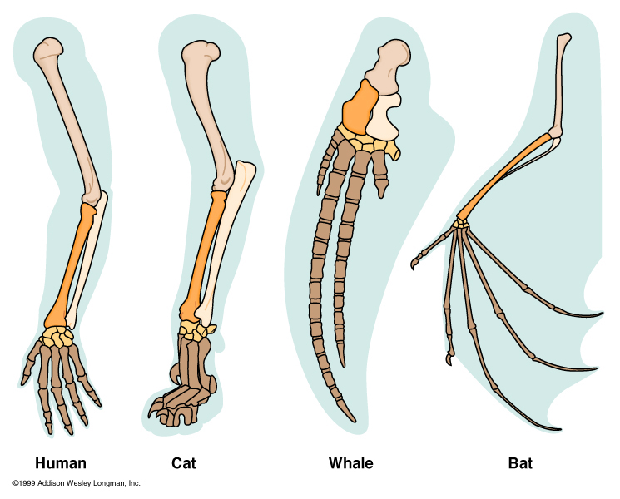

2. Analogous structures - It shows that the basic structures of wings of butterfly, bird and bat are different. In other words, they are anatomically different, although externally they look alike. Wings in these animals are used for similar function (flying) but they are differing anatomically and in embryonic origin.
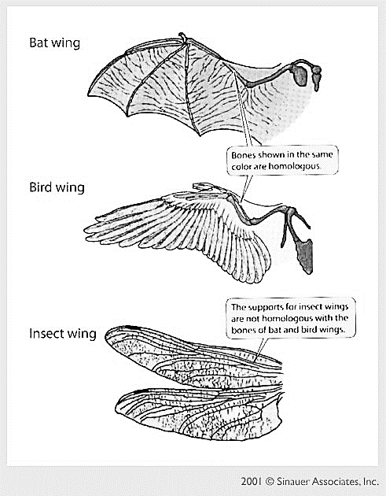
Phylum Chordate
Chordate: phylum of animals having a notochord, as the main internal skeletal support at some stage of their development. Most chordates are vertebrates (animals with backbones), but the phylum also includes some small marine invertebrate animals.

Major Characteristics of Phylum Chordate
1. A single, hollow nerve cord runs just under the dorsal surface of the animal.
In vertebrates, the dorsal nerve cord differentiates into the brain and spinal cord.
2. Notochord is a flexible rod present at some developmental stage in all chordates. The notochord is located just below the nerve cord. The notochord may continue throughout the life cycle of some chordates or be replaced during embryonic development.
3. Pharyngeal slits connect the pharynx and the esophagus, with the outside.
4. Chordates have a post anal tail that extends behind the anus, at least during
their embryonic development.

Minor Characteristics of Phylum Chordata
- Chordates are bilaterally symmetrical, which means there is a line of symmetry that divides their body into similar halves.
- Segmentation results from repetition of body parts, allowing further specialization and differentiation.
- Cephalization means that the concentration of sensory organs, feeding organs, and neural centers near the anterior end of the animal.
- They have a true body cavity or coelom.
Sub phylum: Hemichordata
The name "hemichordate" means "half chordate”. There is a primitive structure in the collar region that is similar to a notochord.
* Body cavity a true coelom.
* Bilaterally symmetrical.
* Body divided into three sections, a proboscis, a collar and a trunk.
* There are branchial openings, or "gill slits," that open into the pharynx.
* There is a dorsal nerve cord, in addition to a smaller ventral nerve cord.
Example: Balanoglssus
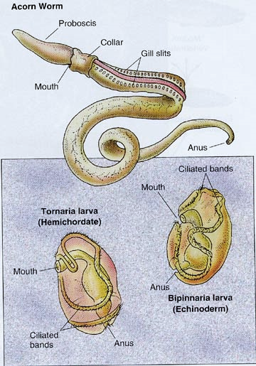

Sub phylum: Urochordata
- Small marine animals with larvae that swim freely and adults that connect themselves to the ocean floor.
- Larva has notochord in the tail. It disappears during development.
- Respiratory system contains gills in the pharyngeal wall.
- Nervous system is represented by a single dorsal ganglion in the adult.
- Coelom is absent. Example: Acedia

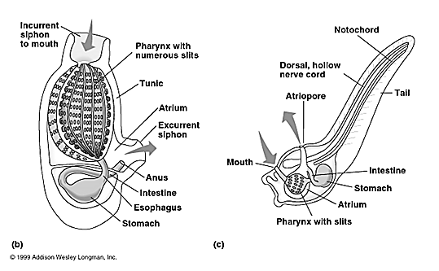

Sub phylum: Cephalochordata
- Body is fish -like and is useful for drilling and swimming.
- Notochord extends from the anterior end to posterior end.
- coelom is present.
- Respiration by gills.
- A single, dorsal, hollow nerve cord, usually with an enlarged anterior end (brain). Example: Amphioxus.

Lab. 2
Sub phylum: Vertebrata
Superclass: Pisces
Class: Cyclostomata (Agnatha)
Example: Lamprey
- Has a long body .
2- Has a round mouth that is surrounded by suckers with horny teeth. Its tongue is covered with teeth as well.
3- A lamprey's skull and spinal cord are made of cartilage.
4- Lamprey has a notochord - a flexible rod supporting its body.
5- Lampreys do not have scales. Their skins are covered with mucus.
6- It has seven gills on each side of its body.
- A lamprey does not have paired fins, but it has two dorsal fins (back fins) and a caudal fin (tail fin).
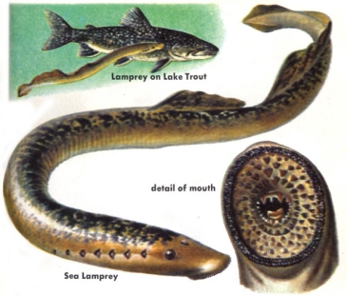

Class: Chondrichthyes
- Fishes with cartilaginous endoskeleton.
- Body is covered with placoid scales.
- Gills are five - seven pairs with no operculum.
4-Tail heterocercal means, tail lobes are unequal in shape. 5- Air bladder or lungs absent.

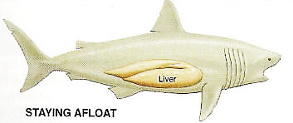

Class: Osteichthyes

- Fishes with bony endoskeleton.
- Body is covered with cycloid and ctenoid scales.
- Gills four pairs with operculum.
- Tail homocercal, means tail lobes are equal in shape.
- Air bladder is present and in some fishes lungs are also seen.

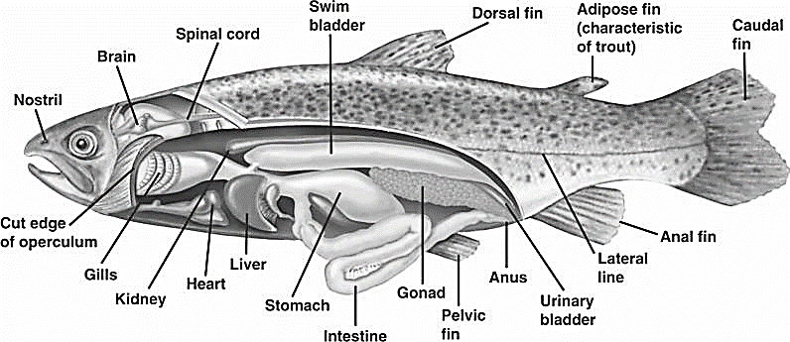

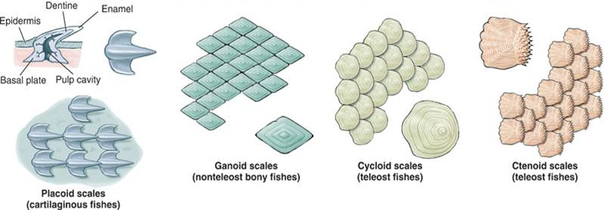

Types of scales

Superclass: Tetrapod
- Tetrapod have four limbs
- Various adaptations of the skeleton and muscles that enable special support and movement on land
- Adaptations to the cranial bones that allows the head to remain fixed while the animal moves
- An olfactory organ that plays a role in taste and smell
- An absence of internal gills.

Class: Amphibia
1) Amphibians spend part of their lives on water and another part on land.
3) The skin is smooth, thin, hairless and contains mucus glands and poison glands.
4) A bone endoskeleton with varying numbers of vertebrae.
5) Four limbs which may vary in size with the forelimbs much smaller than the hind limbs, some are legless.
6) The mouth is usually large with small teeth in upper or both jaws; two nostrils open into the anterior part of the mouth cavity.

Class: Reptilia
1- Reptiles have backbone and spines.
2-Reptiles have scales on their bodies and have a dry skin.
3-Reptiles have lungs and need air to breathe.
4-Reptiles either have four legs or have no legs at all.
5-Reptiles have ear holes instead of ears.

Class: Aves
1) Body usually spindle shaped, with four divisions: head, neck, trunk, and tail.
2) Limbs paired; forelimbs usually modified for flying; posterior pair variously adapted for perching, walking, and swimming; foot with four toes.
3) Epidermal covering of feathers and leg scales.
4) Fully bony skeleton with air cavities.
5) Each jaw covered with a keratin, forming a beak.

Class: Mammalia
1) Body covered with hair which is made of keratin.
2) Mammary glands are used to produce milk to feed their young.
3) The diaphragm that separates the thoracic cavity from the abdominal cavity.
4) Teeth are imbedded in the jaw bone and come in a variety of forms.
5) Well developed brain.
6) The mouth has a false palate as a roof, meaning that the nostrils do not lead directly into his mouth.

Lab. 3
Amphioxus

Phylum : Chordata
Subphylum : Cephalochordata
Genus : Branchiostomata lanceolatum

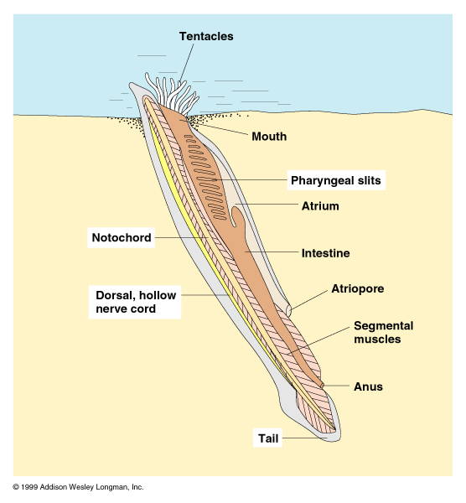

Amphioxus, also called lancelet, it is the closest living relatives of the vertebrates. Amphioxus is a small slender fishlike marine animal without eyes or specific heads found widely in the coastal waters of the warmer parts of the world and less commonly in moderate waters, it generally less than 5 cm in length, although some reach 6 to 9 cm. Amphioxus spend much of its time buried in stone or mud on the ocean bottom, although they are able to swim.

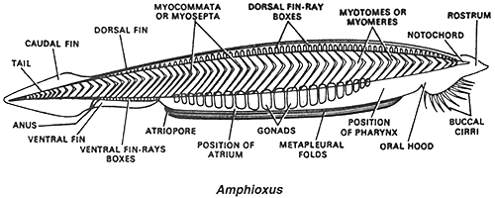
The notochord extends almost the entire length of the body and provides much of its support. It has a solid sheath made up of a single series of cells that contains muscle fibers. These fibers probably maintain the hardness of the notochord.
Nervous system is simple, the main nerve cord, which is single and hollow starts at the head and ends at the base of the tail. As in all chordates, has a slight swelling at the front that hardly considered as a brain. There are small eyelike organs (eye spot) in the nerve cord that can detect the direction of light and changes in its intensity.
Amphioxus fins: A dorsal fin extends along the upper surface of the body and continues as a caudal fin around a tail and as a ventral fin to an atrium on the lower surface. Paired fins are absent, but metapleural folds along the sides of the body considered as the origin of paired fins.
Body's openings: The animal has several openings on its body:
1- The mouth: at the anterior end the mouth is opening with several cirri that act as filters for food and as sensory parts. The openings also include pharyngeal slits on both lateral sides of the animal that are used when the animal is feeding.
2- The anus, which is used for the excretion of waste, is located on the ventral surface of the animal toward the posterior end.
3- The atriopore is located on the ventral side of the animal and a little more anterior than the anus,it is used to release water from the amphioxus' body.
Body's muscles: Amphioxus can swim both forward and backward and can move rapidly through the gravel in which they live. The body, like those of fishes and other vertebrates, is largely made up of serially repeated units (segments) that include V-shaped blocks of muscles called metameres or myotomes that run from end to end on each side of the body and a barrier of thin connective tissue known as muscular myoseptum barrier separates each of the two pieces of muscles.
Reproductive system
Amphioxus have separate sexes,male and female are identical in outward appearance and differ internally only in the nature of the gonads, or reproductive glands, which form in rows on the wall of the atrial cavity, gonads containing eggs or sperm. The fertilization is external with females releasing eggs of and males releasing simple spermatozoa. When the sperm and eggs meet a larva is produced.
Respiratory system
Water is driven into the mouth and pharynx and out through the pharyngeal gill slits into the surrounding atrium and exits the body through the ventral atriopore. The pharyngeal slits are lined by filaments that carry blood vessels. The blood runs through these filaments, and it then exchanges gases with the environment.
Digestive system
The oral cavity of amphioxus is covered by a hood whose edges are lined with buccal cirri, these are fringelike structures that form a filter to screen out particles too large to be swallowed. The buccal cavity is the gut lumen within the oral hood.

The posterior wall of the buccal cavity is the transverse muscular velum work as valve and filter. On the posterior side of the velum, the mouth is surrounded by slender sensory velar tentacles which prevent undesirable objects from entering the digestive cavity. Anterior to the velum, the walls of the buccal cavity bear a series of thick ciliated grooves which make up the wheel organ; the cilia in these grooves trap food particles in mucus for digestion at the posterior part of gut. On the dorsal midline of the buccal cavity is a deep ciliated cavity called Hatschek's pit, this is like an unpaired kidney whose duct opens into the anterior pharynx. The pharynx begins just behind to the velum and is a large section of the gut, extending about two-thirds the length of the body. Posterior to the pharynx the gut narrows to form a short esophagus which connects the pharynx with the stomach. The stomach bears a finger like part which is called hepatic cecum, which extends into the atrium on the right side of the pharynx. Hepatic cecum been compared to the liver and pancreas of vertebrates.

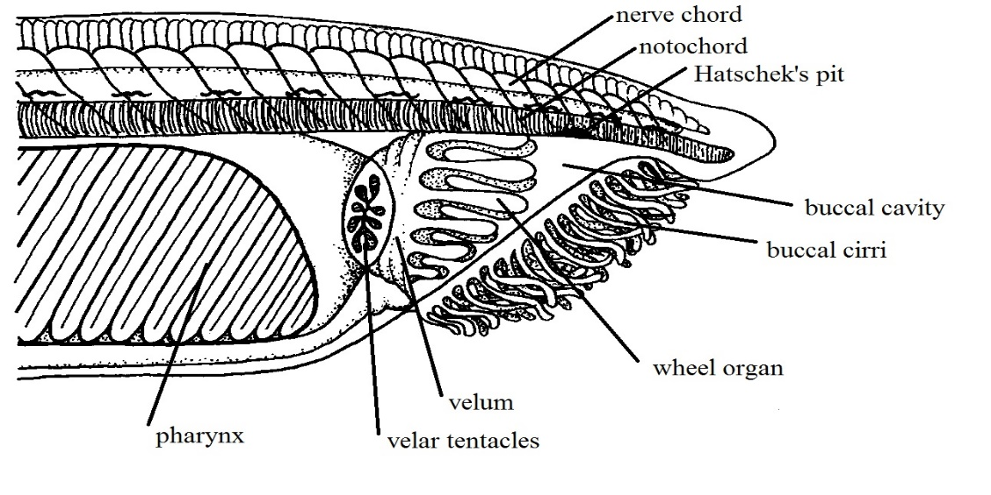

The stomach narrows posteriorly to become the darker iliocolon region. This region of the gut tube bears a ring of ciliated epithelium that rotates the food mass and mixes it with enzymes. Posterior to the ring the gut continues as the intestine, ultimately ending at the anus.

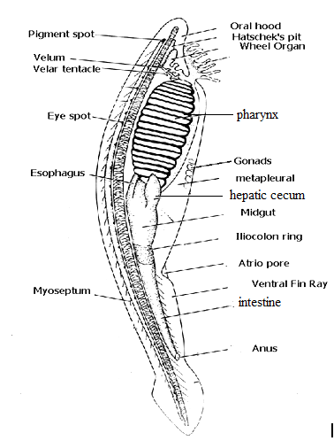

Lab 4
(Dogfish) Shark

Phylum : Chordata
Sub phylum : Vertebrata
Super class : Piesces
Class : Chondrichthyes
Sub class : Elasmobranchii
Order : Selachii
Genus : Squalus acanthias

The Dogfish or shark is belong to phylum Chordata meaning it has a notochord. It is a jawed vertebra in the class chondrichthyes; meaning it has a flexible skeleton made of cartilage. The shark has a graceful and streamlined body shape built for fast, long distance swimming. The body is divided into the head, trunk, and tail. Placoid scales (dermal denticles) are covering the skin of sharks. The snout is at the anterior end. The opening to the mouth of sharks is always on the underside. The external nostrils are located on each side of the head and leads to larger internal nostrils. Eyes are large in sharks and are located at both sides of head. The shark's body is dark gray above and almost white below. Sharks have 5-7 pairs of gill slits located on the sides of their heads. Unlike bony fish, they do not have gill covers. Some sharks have spiracles, which are special gill slits appear like small openings located just behind the eyes. These openings allow water to pass through the gills even when the shark’s mouth is closed.

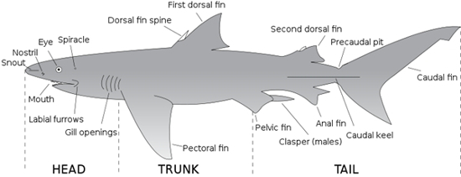

Shark's fins
Most sharks have five different types of fins, while some sharks only have four. These types of fins include:
- Pectoral Fins
At the front of the shark behind its head, are the pectoral fins. Sharks use these fins to lift and steer them while they swim.
- Pelvic Fins
Behind the pectoral fins, are the pelvic fins, also found on either side of the cloaca. In male sharks, the posterior parts of pelvic fins are modified into tube-like copulatory organs called claspers which are necessary for the reproduction process.
- Dorsal Fins
Dorsal fins are the ones that most people are familiar with; these fins are often seen when a shark is at the water’s surface. Anterior dorsal fin is larger than the posterior dorsal fin. There are two spines, one immediately in front of each dorsal fin. The spines carry poisons secreted by glands at their base and are mainly used in defense.
- Anal Fins
For some sharks, these fins are not enough to completely stabilize them. Therefore, the anal fin is present to provide additional stability to the sharks that possess them. The anal fin is located between the pelvic and caudal fins on the bottom, or ventral, part of the shark.
- Caudal Fins
The shark having the ability to propel itself through the water, they utilize what is called the caudal fin. This fin, also known as the tail fin. The caudal fin is divided into two lobes: a larger dorsal lobe and a smaller ventral lobe. This type of tail is known as a heterocercal tail.
Shark's senses
- Smell
Sharks have an acute sense of smell. Paired external nostrils with internal and external openings lead to ventral olfactory organs. Sharks have ability to detect minute quantities of substances such as blood in the water; also can detect a concentration as low as one part per billion of some chemicals.
- Hearing
Shark external ears are hard to see, they are just two small openings behind and above the eyes. The ears may be small, but they’re powerful. Inside, there are cells that can sense even the tiniest vibration in the surrounding water. Sharks may track sounds over many miles.
- Eyesight
Sharks have good eyesight for being in the water, so they can see well during the day or the night. Upper and lower eyelids also protect the eye. Sharks that live deeper in the oceans usually have larger eyes than those that live nearer the surface.
- Taste
Many sharks rely heavily on their sense of taste. Before these sharks eat something, they will give it a "test bite" first. The sensitive taste buds clustered in the mouth analyze the potential meal to see if it's palatable. Sharks will often reject prey that is outside their ordinary diet, after this first bite.
- Lateral line
The lateral line system is a series of fluid-filled canals just below the skin of the head and along the sides of the body. The canal is open to the surrounding water through tiny pores. The lateral line canals contain a number of sensory cells called neuromasts. Tiny hair-like structures on the neuromasts project out into the canal. Water movement created by turbulence, currents, or vibrations displaces these hair-like projections and stimulates the neuromasts. This stimulation triggers a nerve impulse to the brain. The lateral line senses low-frequency vibrations. It functions mainly in distance perception and detecting low-frequency vibrations and directional water flow.

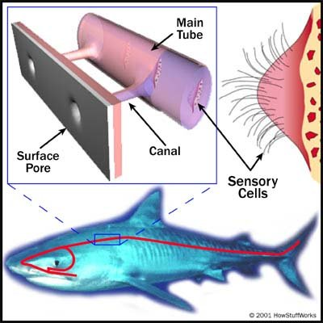
Lateral line

- Ampullae of Lorenzini
The ampullae of Lorenzini form a complex and extensive sensory system around a shark's head. External pores cover the surface of a shark's head. Each pore leads to a jelly-filled canal that leads to a membranous sac called an ampulla.
In the wall of the ampulla are sensory cells innervated by several nerve fibers. The ampullae detect weak electrical fields at short ranges. All living organisms produce electrical fields. ampullae of Lorenzini may also detect temperature, changes in water pressure, mechanical stimuli, and magnetic fields.
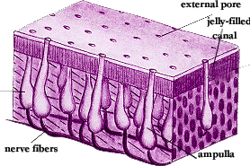
Ampullae of Lorenzini
The digestive system
The digestive tract is begins at the mouth behind which is the oral Cavity, and ends either at a cloaca or anus. In mouth on the jaws there are many sharp teeth which are similar in shape. Sharks have many rows of sharp teeth and its shape depends on the shark’s diet. The teeth are actually modified placoid scales, and are replaced regularly. On the floor of the mouth is the immovable tongue, Posterior to the mouth is the pharynx, which connect the oral cavity to the esophagus, the posterior end of the pharynx is the esophagus, a short tube lined by many papillae. The esophagus leads into the "J"-shaped stomach. The upper portion, the cardiac region, lining with numerous glands which produce acids and enzymes that digest food. The shark does not chew its food, but swallows large pieces, which may remain in the stomach for some time. The caudal section of the stomach is the pyloric region that breaks the food down further. This ends in a muscular pyloric valve, which regulates the passage of food into the intestine.
The small intestine is beginning at the pyloric valve. The first portion of the intestine is the short duodenum.

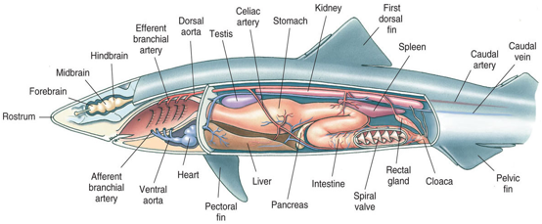
The larger and longer portion is the ileum. Opening the ileum reveals the spiral valve, a unique adaptation of sharks that greatly increases the surface area available for absorption of nutrients. The large intestine or colon is very short; the rectal gland is a slender, blind-ended, finger-like structure with duct into the colon. It excretes salt (NaCI) in high concentrations; to regulate the shark's salt balance. Colon connects with the short rectum, which leads to the cloaca. The cloaca is the common chamber for the digestive, excretory, and reproductive systems. The cloacal opening is the common opening for these systems.
Glandular organs in digestive system
1- The liver
Is the largest organ in the abdominal cavity, it is composed of three lobes. The right and left lobes are large; the medial lobe is much smaller. The gall bladder is located within the smaller lobe. Gall bladder is small sac stores bile and releases it into the small intestine through the common bile duct.
- The pancreas
The pancreas has two lobes located on the duodenum and the lower stomach. The secretions of the pancreas enter the duodenum by way of the pancreatic duct.
Respiratory system
Sharks have 5-7 pairs of gill slits located on the sides of their heads. There is also a modified slit, called the spiracle, which lies immediately behind the eye on the shark’s head. Unlike bony fish, they do not have gill covers, water must continually flow across these slits in order for the shark to breathe. . Each gill is supported by a gill arch and protected by gill rakers, which filter the respiratory water and direct food toward the esophagus. Each gill arch supports one set of paired gill filaments, which help increase their surface area for oxygen exchange. Water enters through the mouth and the spiracle, into the pharynx, over the gills and exits through the gill slits. Respiratory gas exchange takes place on the surface of the gill filaments as the water passes over and out the gills.
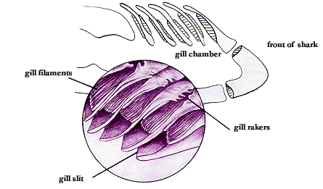
Urogenital system
The kidneys are flattened, ribbon-like, darkly colored structures lying dorsally on either side of the midline. Small collecting tubules from the kidneys collect and transport urine from the kidneys lead into the accessory urinary ducts along their lengths then open into cloaca. The kidneys of the male are the same as those of the female, the posterior portion is involved in the manufacture and transport of urine, the main difference lies in the anterior portion of the kidney, which in females is degenerate and functionless, but in males is an active part of the reproductive system.

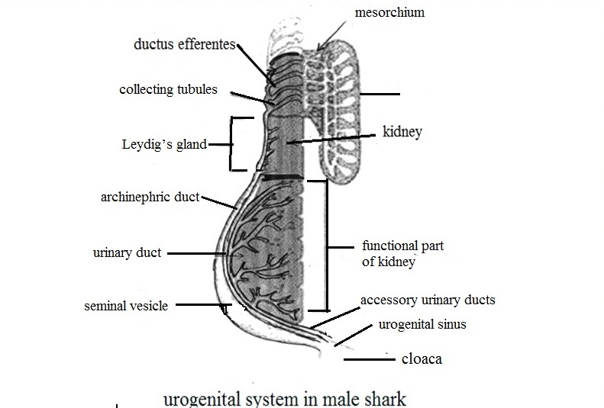
The male testes are suspended in the cavity by the mesorchium. In the mesorchium, several small tubules called the ductus efferentes carry the sperms from the testes to the archinephric duct. The archinephric duct is a highly coiled tube that carries sperm to the seminal vesicle. The Leydig’s gland, secretes fluid into the archinephric duct to protect the sperm. The posterior portion of the archinephric duct enlarges and forms the seminal vesicle, the posterior ends of the seminal vesicles transform to sperm sac. The joining of sperm sac end and the accessory urinary duct produce the urogenital sinus which open into cloaca. The male also have external structures called claspers. The claspers are rod like copulatory organs present on the inner borders of the pelvic fins. Each clasper has a groove on its dorsal side. The groove is opened at both the ends. The male deposits his sperm into the female's cloaca via claspers’ grooves.

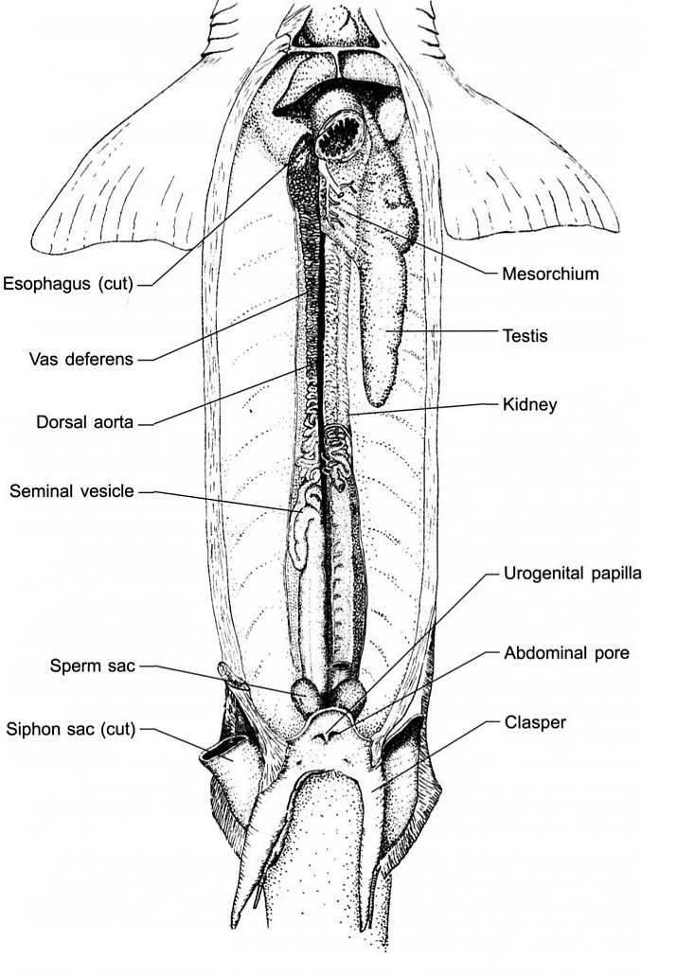

The female ovaries are suspended by a mesovarium, which contains eggs in different stages of maturity. Once the eggs reach maturity, they are released from the ovary and mesovarium and travel to the oviducts. Oviduct is elongated tubes that lay dorsal and lateral along the body cavity .At the beginning of oviduct there is shell duct. This gland secretes a thin shell around a group of eggs and is a reservoir for sperm storage. Eggs are fertilized in this gland as they pass through.at the end of ovidut the uterus.
Uterus is enlarged caudal end of the oviduct; it is here that eggs develop. The two oviducts join in the dorsal portion of the cloaca.
Fertilization is internal, usually taking place within the shell gland of the oviduct. The fertilized eggs continue to move posteriorly to the uterus.

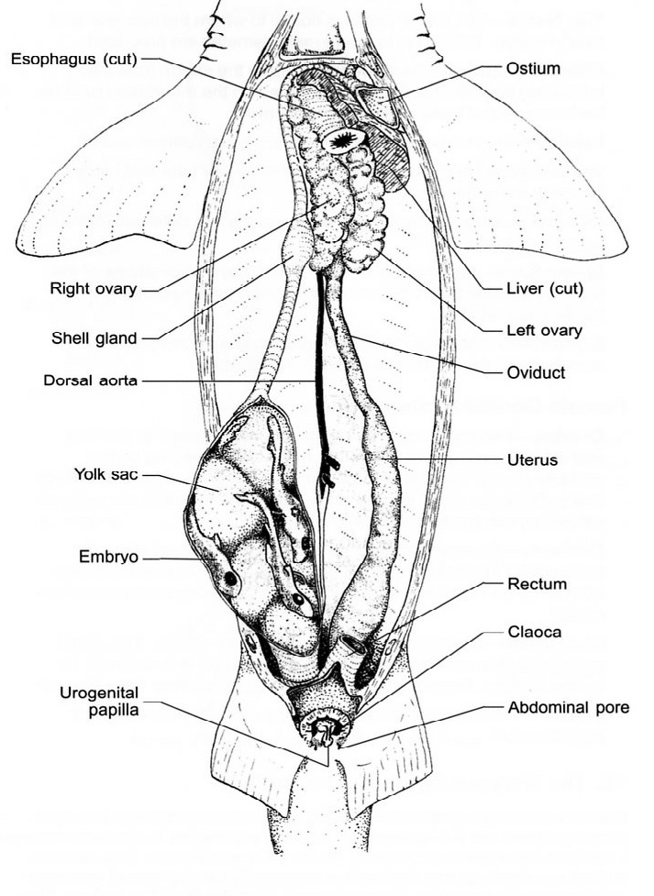

Lab 5
Amphibia
Phylum: Chordata
Sub phylum: Vertebrata
Super class: Tetrapoda
Class: Amphibia
Order: Anura
Genus: Rana ridibunda
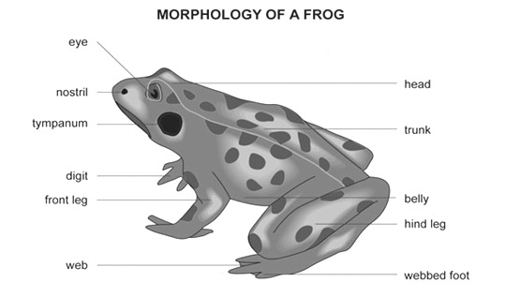
Frogs belong to a group of animals called amphibians. Amphibian means two-lives. Frogs begin their lives in the water as eggs and then tadpoles and when they are fully developed they live on land. Frogs are found all over the world, they can be found near any fresh water, lakes, and marshes. The body of a frog can be divided into a head, a short neck, and a trunk. Frogs have very powerful back legs and webbed feet that help them jump great distances, as well as, swim. Frog eyes are present on the side of their heads allowing them to see all directions and can even see behind them without moving their heads. Each eye has three eyelids: an upper and lower lid and a transparent lid that protects the frog's eyes. Frog ears are behind their eyes, frogs can hear using big round ears on the sides of their head called a tympanum which transfers sound vibrations to the inner ear. Frogs breathe through their nostrils while also absorbing about half the air they need through their skin. A frog’s skin is usually moist and thin, it does not have scales, hair, or other protective features. Instead of drinking water, they absorb it through their skin. Glands in the skin secrete mucus to help keep the skin moist. Frogs also have glands that produce poison to help them escape from predators.
Digestive system
Alimentary canal: - it is long, coiled tube which starts from mouth to anus. It consists of following organs:
Bucco-pharyngeal cavity: The buccal cavity and pharynx together is called bucco-pharyngeal cavity, it lies between upper jaw and lower jaws. Upper jaw is immovable but lower jaw is movable.
There are two types of teeth. Maxillary teeth- they are found in upper jaw, all these teeth are very small and similar in size. Vomerine teeth are present on either side of roof buccopharyngeal cavity, they help to capture prey from slipping out.

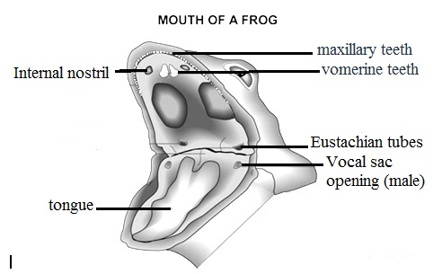

Tongue: It is thick, fleshy, and muscular; it can be thrown out and return in. It arises from in front of lower jaw. The tongue secrets a kind of sticky substance so that insects or prey coming and sticks in tongue.
Vocal sac: In male frog on either side of the tongue on the lower jaw there are two pores called vocal sacs, which produce croaking sound.
Pharynx: Posterior part of buccopharyngeal cavity is called pharynx, which opens into oesophagus.
Oesophagus: It is wide, short muscular tube which opens into stomach.
Stomach: The stomach is large, thick walled muscular. Anterior part of stomach is called cardiac part and posterior part is called pyloric part.
Intestine: It is long, coiled part which starts from pyloric constriction. Intestine is divided into two parts:
a- Small intestine: it consists of:
Duodenum: Duodenum is the anterior part of Small intestine; it is U-shaped structure which joined the stomach to the coiled ileum.
Ileum: Is coiled part, it is internally highly folded; foldings is called villi, which increase absorptive surface.
b- Large intestine: Also called rectum, is short and opens outside through cloaca and the opening is called cloacal aperture.
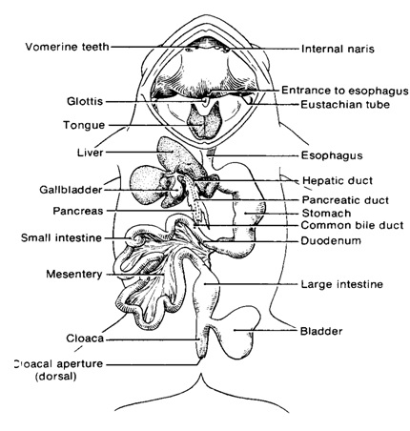

Digestive glands
1. Gastric glands: They are present on the stomach wall. They secret HCL and enzyme pepsinogen.
2. Liver: It is large gland. It has two lobe-right lobe and left lobe. Left lobe is again divided into two lobes. There is a small sac like thin walled bladder present on right lobe called gall bladder which stores bile. Liver secrets bile through bile-duct which opens into the duodenum.
3. Pancreas, and an important digestive gland that secretes pancreatic juice into the duodenum.
Respiratory system
The respiration through the lungs is called pulmonary respiration. There is a pair of lungs. The lungs are thin walled elastic sacs. They are present within thoracic cavity on either side of heart. Numerous small air sacs are present in the lungs called alveoli.
The alveoli are very thin walled and supplied by blood vessels. The air enters into the external nares, internal nares, buccopharyngel cavity, glottis, trachea, lung and alveoli where the gas exchange takes place.
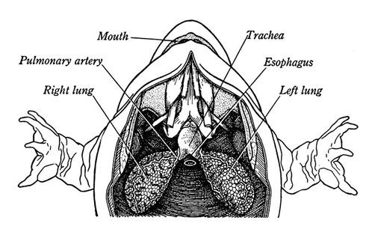
Urinary system
The frog's urinary system organs include the kidneys, ureter, bladder and cloaca. The kidneys are reddish-brown and located on either side of the backbone. The bladder, a thin membranous sac, is usually deflated unless filled with urine.
Urine is produced in the kidneys and passed through tubes called ureters directly to the cloaca for excretion, or to the urinary bladder for storage before moving to the cloaca.
Reproductive system
In frog sexes are separate. Male and female frogs can be morphologically distinguished. The male frog has vocal cords which enable them to make a croaking noise to attract the females during breeding season. Male reproductive organs consist of a pair of yellowish ovoid testes, which are found adhered to the upper part of kidneys by a double fold of peritoneum called mesorchium. Each testis opens into the kidneys by numerous fine ducts called vasa efferentia. Sperms produced by the testis are carried through the ureters which in the male are called urinogenital ducts. This duct opens into the cloaca. The cloaca is a small, median chamber that is used to pass faecal matter, urine and sperms to out the body.
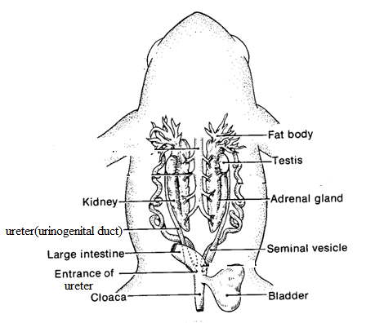
The female reproductive system consists of a pair of ovaries and a pair of oviducts. Each ovary like testes adhered to the kidneys by a double fold of peritoneum called mesovarium. Ovary is lobulated sac like structures composed of ovarian follicles consists of countless ova; the colour of the ovary is yellowish with small black spots. The ovoiducal funnel or ostium is located on the dorsal side of the lung. The oviducal funnel leads into the oviduct. This oviduct is straight and thin-walled for a short distance, then it becomes highly coiled and thick-walled which runs behind the kidney. The posterior portion of the oviduct becomes very thin walled. It is sac-like and is called ovisac where the ova are stored. The ovisac opens into the cloaca by its apertures lying anteriorly to the openings of ureters. The cloaca opens to the exterior by a cloacal aperture.
The fat bodies in frogs are yellowish to orange in color. They have a finger-like shape. The fat bodies are needed for hibernating and for mating. They are located near the testes in males and near the ovaries in females.
Egg fertilization happens outside the female's body instead of inside. The female releases her eggs and the male releases his sperm at the same time. The eggs are immediately fertilized before dropping into the water. A jellylike substance surrounds the egg when dropped into the water, and it swells on contact to protect the eggs from predators and harmful bacteria.
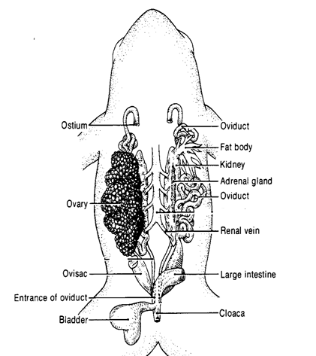
Lab 6
Reptilia
Phylum: Chordata
Sub phylum: Vertebrata
Super class: Tetrapoda
Class: Reptilia
Order: Squamata
Class Reptilia, is divided into four orders - Crocodilia, Rhynchocephalia, Squamata and Testudines. Most of the reptiles are tetrapods they are four-legged animals with 5 fingers, but there are exceptions like snakes which are legless reptiles, they move along the ground by flexing their body and can move very quickly. Reptiles are considered as the first animals with the ability to live and multiply on land. Reptiles have a dry skin covered with small; thin horny scales develop from the epidermis of the skin (or) bony structures scutes that form from the dermis. Snakes have scales, whereas turtles and crocodiles have scutes. These structures prevent water loss.
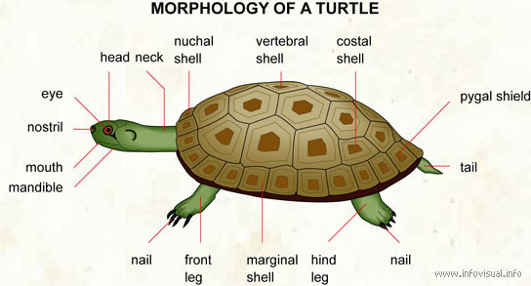
In the case of snakes, the complete outer layer of skin is shed in one layer. Snake scales are not discrete but extensions of the epidermis hence they are not shed separately, but are ejected as a complete contiguous outer layer of skin during each moult.The old skin breaks near the mouth and the snake wriggles out, aided by rubbing against rough surfaces. Turtle have a shell which is made up of 60 different bones all connected together, the shell is covered with plates (scutes) that are derivatives of skin and offer additional strength and protection. Glands are absent in the skin of Reptiles.
The reptile's senses of sight, smell, and hearing are similar to those of other vertebrates, though the levels of development of these senses vary among reptile groups. Snakes lack ears and can detect only ground vibrations or airborne vibrations of low frequency. Snakes and lizards have a specialized, chemically sensitive organ, called Jacobson's organ, located in the roof of their mouths. These animals can detect the presence of chemicals in their surroundings by flicking their tongues out and in rapidly.
Digestive system
The mouths of reptiles are large. Snakes have a very flexible lower jaw, the two halves of which are not tough attached, and numerous other joints in their skull. These modifications allow them to open their mouths wide enough to swallow their prey whole, even if it is wider than they are.
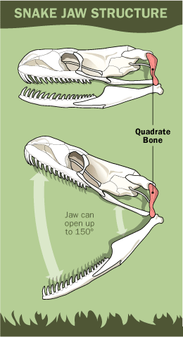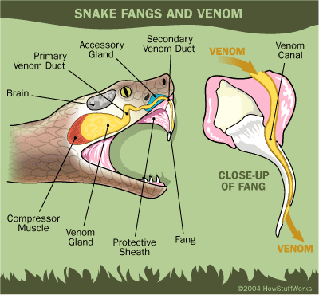

The tongues of reptiles are as varied as the species. The tongue has many functions including the capture of prey, transport the food to the back of the mouth and providing taste. All turtles lack teeth. Snakes, lizards and crocodilians all have teeth. Oral glands include the premaxillary, sublingual, lingual, and mandibular glands, not all of the oral glands are found in all reptile species. In snake the venom gland lies along the lower jaw and empties near grooved, multiple teeth within the mouth.
Directly inside the mouth is the buccal cavity, this leads to the esophagus. The esophagus of snakes has more internal folds than other reptiles, which allows for the swallowing of large, whole prey. The stomach is a j-shaped organ, stomach secrete digestive enzymes and gastric juices that breakdown proteins. The food then passes through the pyloric valve into the small intestine. The small intestine is a long narrow coiled tube where absorbance of nutrients takes place. The small intestine is divided into three regions: the duodenum, the ileum, and jejunum. The liver, producing bile and excretes digestive enzymes into the duodenum. Also, the pancreas produces insulin and digestive enzymes secrete them into the duodenum.
At the junction of the small intestines and large intestines is the caecum. The large intestine absorbs the water from the food before moving to the cloaca chamber.
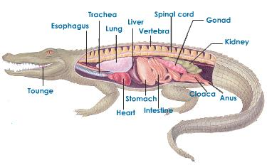

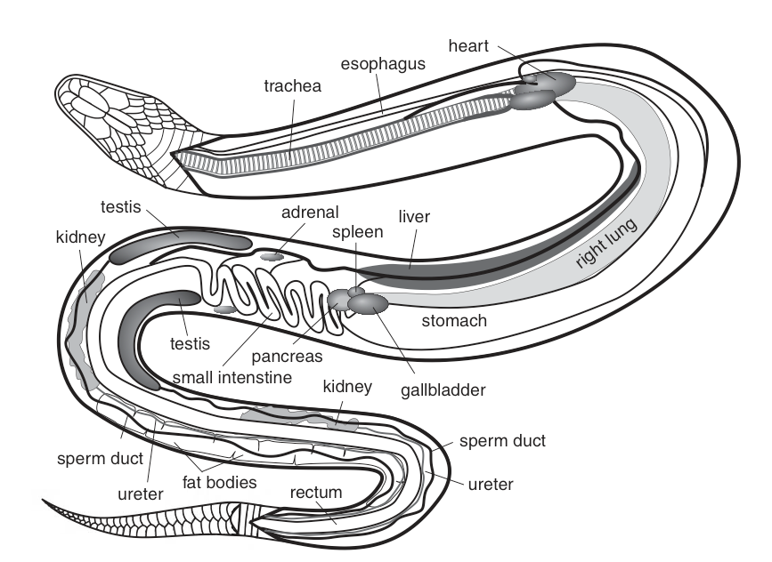
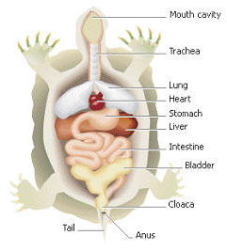

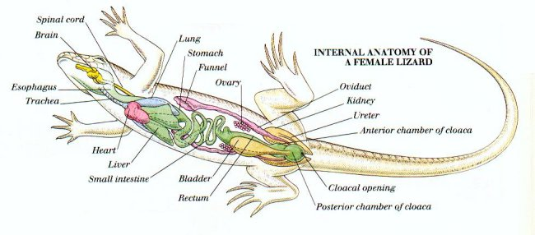
Respiratory system
The lungs of reptiles are large, and they are often divided internally into several chambers. The lining of the lungs may be folded into numerous small sacs called alveoli. Alveoli greatly increase the internal surface area of the lungs, thus increasing the amount of oxygen that can be absorbed. In most snakes, only the right lung actively functions. The left lung is either reduced to a small nonfunctional sac or absent entirely. A reptile fills its lungs by expanding its rib cage. This expansion reduces the pressure within the thorax and draws air into the lungs. When the ribs return to their resting position, pressure within the thorax increases, and air is forced out of the lungs.
Excretory system
The excretory system is made up of the paired elongated dark red and irregular in shape kidneys composed of glomerular nephrons. Each kidney has two lobes Anterior and posterior lobe. Ureters carry the urine (fluid in turtles and crocodiles; semisolid with insoluble urates in the other) to a thin walled urinary bladder which opens on the ventral side of cloaca. In males the ureters join at its posterior end with its corresponding vas deferens and both open by a common urino-genital aperture. A thin walled urinary bladder opens on the ventral side of cloaca.

Reproductive system

The male reproductive system consists of paired white elongated testes. Testes lie in the abdominal cavity in front of kidneys. Each testis is attached to the dorsal body wall by a double fold of peritoneum the mesorchium. Right testis is a little ahead of the left one. From the inner end of each testis arises a much convoluted tube-epididymis. Epididymis is continued behind as long, narrow, coiled and delicate vas deferens. It passes backwards along the ventral surface of the kidney of its side and joins with the ureter to form urino-genital sinus which opens into the cloaca.
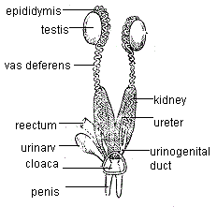

The female system is made up of large paired ovaries. Ovaries are irregular bodies situated assymetrically and hanging from the dorsal wall of the body cavity by mesovaria. Right ovaiy is a little anterior to the left one. Oviducts are paired with funnel-shaped ostia . Oviducts extend in front of the overies. The oviduct is divided into four regions: infundibulum; magnus (secretes albumin); uterus (secretes shells) and vagina. The oviduct opens at the end into the cloaca near the opening of the ureter. Most reptiles are oviparous after the eggs are fertilized internally; they are deposited outside of the mother’s body to complete their development.
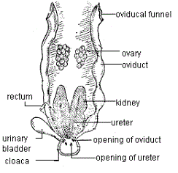
Lab 7
AVES
Phylum: Chordata
Sub phylum: Vertebrata
Super class: Tetrapoda
Class: Aves
Sub class: Neornithae
Super order: Neognathae
Order: Columbiformes
Genus: Pigeon

The body is usually spindle shaped, with four divisions: head, neck, trunk, and tail , forelimbs (wings) usually modified for flying; posterior pair adapted for perching, walking, and swimming; legs are covered with scales, the foot have three toes forwards and one backwards with claws at the end. Body covered with Feathers made of keratin. Birds have beaks, made of a bony core surrounded by a thin layer of keratin. The bird’s nostrils are at the junction between the beak and the head. The sense of smell is the least developed sense for most birds. The eyes are positioned further apart on the head, giving them a wider field of view, Pigeons have excellent eyesight and they can see all colors. The ears are located slightly behind the eyes, and they are covered with soft feathers Birds, hear a smaller frequency range than humans.
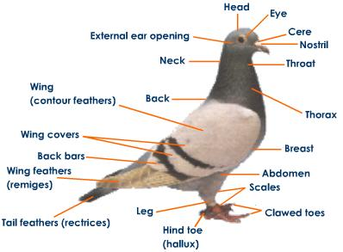

Digestive system
The mouth of birds distinctly different from mammals. They have no teeth and their jaws are covered by a beak which vary in shape, size, length and function according to the type of diet consumed. The tongue of birds is short, hard and practically lacks muscles and lateral lingual swellings. Digestion begins when the bird picks up food with its beak; the food is pushed down the esophagus with help from the tongue. Esophagus is a thin walled tube-like structure that runs from the mouth to the Stomach. Many species of birds have an enlarged area of the esophagus known as a crop which serves as a temporary storage location for food. The crop also allows food to be softened before it enters the stomach. Pigeons produce "crop milk" that they feed to their young for the first two weeks after hatching. Food is slowly passed into the first part of the stomach; Birds have a two part stomach, a glandular portion known as the proventriculus and a muscular portion known as the gizzard. Hydrochloric acid, mucus and a digestive enzyme, pepsin, are secreted by specialized cells in the proventriculus and start the process of breaking down the structure of the food material. The food then passes to the second part of the stomach, the gizzard. The gizzard is a highly muscular organ which grinds the food up into small pieces to be more easily digested. The gizzard may contain small stones to help grind the food.

Once the food is broken down in the gizzard it passes through the pyloric sphincter into the small intestine. The first part of the small intestine is called the duodenum which receives bile from the liver and digestive enzymes from the pancreas. The rest of the small intestine is divided into two parts called the jejunum and the ileum. The small intestine is where food is digested and absorbed. Finally the food is passed through the large intestine which is relatively short and mainly acts as a connection between the small intestine and the cloaca where waste is excreted.
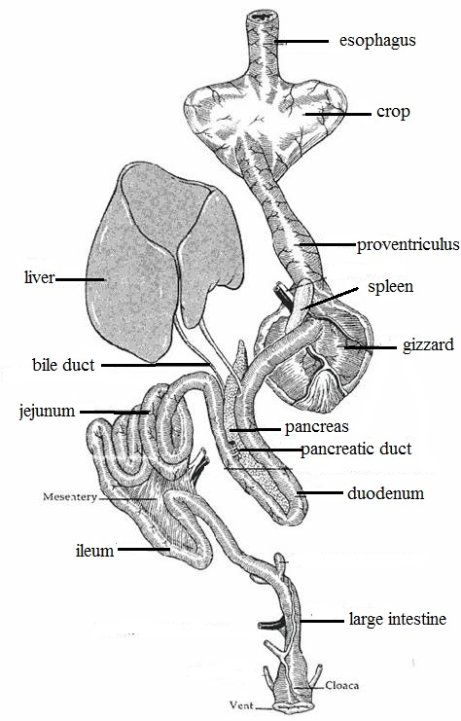
Respiratory system
Inspiration, beginning with the nostrils openings which are situated at the base of the beak. The openings are surrounded by soft sensitive membranous called cere. Air moves through the nostrils into the nasal cavity then to the larynx which is found at the anterior margin of trachea. From there it passes through the larynx and into the trachea. Air moves through the trachea to the syrinx, which is located at the point just before the trachea divides in two bronchi. Syrinx is the sound producing organ of pigeon called sound box. It is a wide cavity supported by tracheal rings. The two bronchi continued running for a short distance enters into the lungs.
Each bronchus made up of cartilaginous rings. Lungs are small, spongy organs; the gas exchange occurs in the walls of microscopic tubules, called 'air capillaries.
There are large, thin walled air sacs present around the lungs of pigeon. Their volume is several times more than the volume of lungs and they fill up much of the body cavity making the body light. There are nine air sacs which are of following types.
(a) Inter Clavicular sac (single)
(b) Cervical air sacs
(c) Anterior thoracic air sacs
(d) Posterior thoracic air sacs
(e) Abdominal air sacs
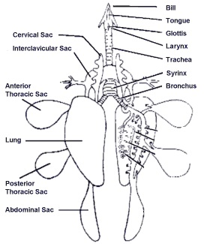
Excretory system
The two kidneys are reddish-brown with three lobes each and are found behind the lungs on each side of the vertebral column. A relatively straight, narrow tube called the ureter, leaves the medial border of each kidney and opens into the cloaca, the ureters do not join with the vas deferens and both open separately into the cloaca. Urinary bladder is absent. Urine is excreted in a semisolid state.
Reproductive system
Male have two functional bean-shaped testes located within the body, just above the kidneys. Each testis is attached to the kidney of its side by mesorchium. In a mature pigeon, the testes can vary in size and greatly enlarge during the breeding season. The left testis is often larger than the right. On the inside of each testes there is a small, flattened area that is called epididymis, where the deferent duct starts at this flattened area. The deferent duct continues from the epididymis as highly coiled tubes running lateral to the ureters. The Posterior end of each deferent duct enlarges to form seminal vesicle, and then opens into the cloaca.
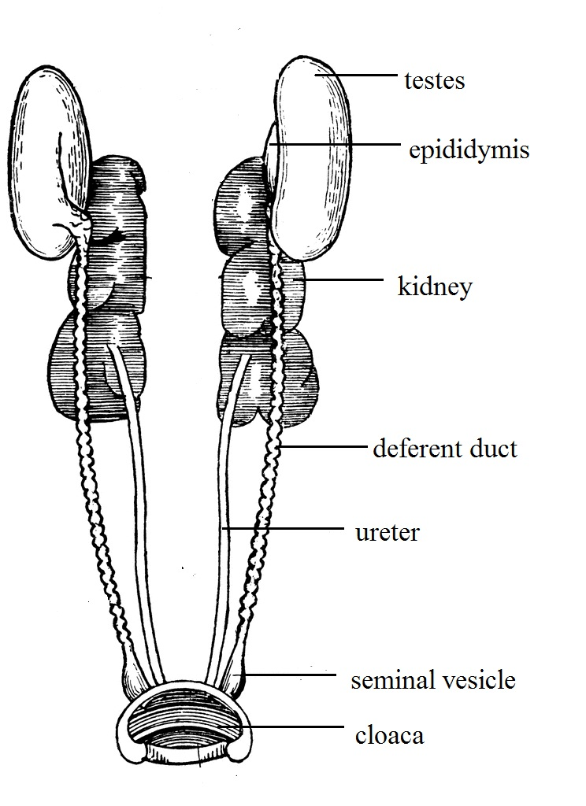

Female reproductive system consists of two ovaries and the oviduct, the left ovary and oviduct grow more rapidly to become functional while the right ovary usually does not develop., the left ovary is located in front of the kidneys and attached to anterior lobe of the left kidney by mesovarium. Ovary containing immature and mature follicles. The mature follicles consist of the egg "yolk" and the unfertilized ovum, matured yolk egg will released into the oviduct.
The oviduct is a long tube with many glands found in its walls. It is divided into five major portions each having different functions:
- Infundibulum (or funnel): Located adjacent to the ovary and with long segments enclosing the ovary, the infundibulum collects the yolk after its release from the follicle as a funnel and directs it into the oviduct. Fertilization of the ovum by the male sperm occurs here.
- Magnum: This is the longest and most coiled portion of the oviduct. It is very thick-walled and contains many tubular glands which secrete albumen.
- Isthmus: Is a short portion of the oviduct. In this portion the inner and outer shell membranes which line the shell are formed.
- Uterus or shell gland: The shell of the egg is secreted here by the shell gland.
5. Vagina: It secretes the egg’s outer cuticle and possibly the shell pigment. The vagina is important in the laying of the egg, it is made of muscle that helps push the egg out of the hen's body.

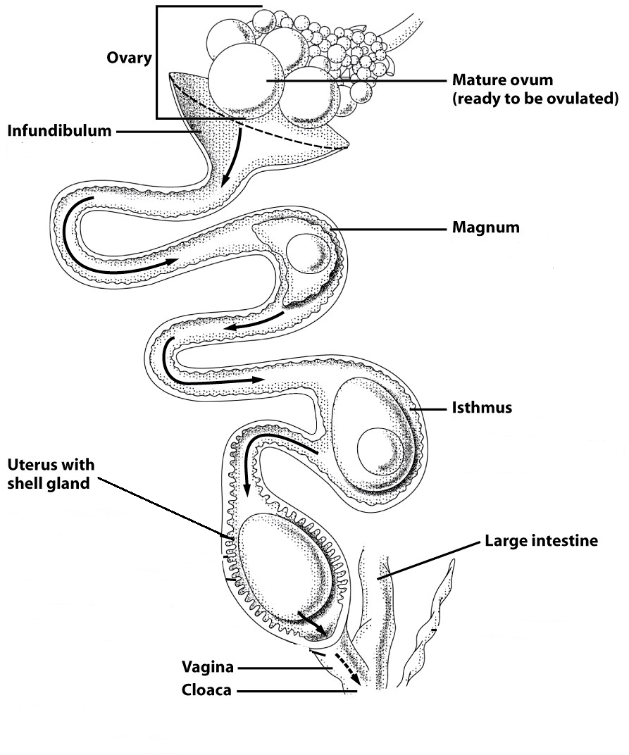

Lab 8
Mammalia

Phylum: Chordate
Subphylum: Vertebrata
Superclass: Tetrapoda
Class: Mammalia
Subclass: Eutheria
Order: Lagomorpha
Genus: Rabbits

Rabbits are small mammals found in several parts of the world. Skin is covered thickly with hairs. The body is divided into head, neck, trunk and tail. Trunk is further divided into thorax and abdomen. Hind limbs and fore limbs are present in the trunk. The fore limb has5 clawed fingers and the hind limb has 4 fingers with claws. In between upper lip and nostrils hair like vibrissae are present. The upper lip has a gap and the teeth can be seen from this gap. He has large eyes that are located on the sides and upper part of the head, enabling each eye to see more than one half of a circle. Together, they can see in every direction. The nose of the rabbit is relatively small, but the sense of smell is quite good. Rabbit ears are long can be moved to any direction. Hearing is a the most vital sense within the rabbit anatomy The shape of a rabbits ears allow them to pick up sounds over 2 miles away.
The rabbit has taste buds situated in the mouth and pharynx.
Female has 2-5 pairs of nipples of mammary glands are present in ventral thorax, no nipples in the male. Urethra opens to the floor of the genital tract.

Digestive system
The first part of a rabbit's digestive system is the mouth. The mouth is terminal and relatively small, bounded by two movable lips. The rabbit uses its lips to grab food and pass it back to the teeth to cut and crush the plant material.
Mouth leads into a large cavity called Bucco - pharyngeal cavity. There is a partition or barrier separating buccal cavity and nasal cavity, it is called palate. The anterior half of the palate is called hard palate, while the posterior half is smooth and fleshy and is called soft palate.
Tongue is situated on the floor of the mouth. It is a muscular organ and helps mixing the food with saliva. There are three kinds of papillae, which are small projections, on which taste-buds are situated.
The teeth of the rabbit are very well adapted to its normal foods. The teeth consist of two pairs of incisors (or cutting 'teeth) on the upper jaw and one pair on the lower. In mouth several kinds of mucus and salivary glands are present, these are:
- Sub orbital gland: situated below the eye.
- Parotids are at the base of external ears.
- Sub lingual glands are situated under the tongue.
- Submaxillary glands lie on the inner side of the angles of lower jaws.
Esophagus
Once food is swallowed, it passes through the esophagus. It is a long, narrow straight muscular tube that transfers food from the mouth to the stomach. The opening of the oesophagus into the stomach is provided with a valve called cardiac valve.

Stomach
It is a large, curved sac lying behind the diaphragm. The stomach of the rabbit consists of two parts. The larger left part called cardiac and the smaller right part is called pyloric. Once food is in the stomach, it begins to be broken down through hydrolytic and enzymatic digestion.
Small intestine
The passes into the small intestine from the stomach is regulated by the pyloric sphincter. The small intestine is the place where the majority of digestion and absorption of nutrients occurs. The small intestine can be divided into three sections – duodenum, jejunum, and ileum.
In duodenum a variety of enzymes are secreted into the small intestine to break down the food. Bile is carried into the duodenum by a large bile duct, which is formed by gallbladder from the liver. Pancreas also produce an alkaline secretion called pancreatic juice whicn is poured into the duodenum by the pancreatic duct.
The jejunum is the middle section of the small intestine. Many nutrients, are absorbed here.
The last section is the ileum. The internal lining of the ileum is raised into numerous finger like projections called villi, which increase the absorptive surface.
Cecum
The cecum is a blind sac located at the junction of the small and large intestines. The cecum may be the most important part of the digestive system of the rabbit. Visible on the external surface is a spiral constriction around the caecum. This is related to the folding of the mucosa internally. There is an appendix at its distal end containing lymphoid tissue.

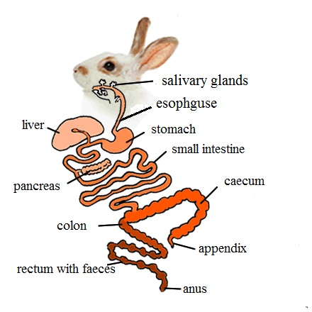
Large intestine
It proceeds from the caecum and consists of two parts: a proximal colon, which is a wide tube. Second part is distal, narrow rectum, long having beaded appearance due to the presence of faeces and opens to the outside through the anus.
Anus
It is situated on the underside of the tail and is provided with a sphincter muscle.
Respiratory system
The respiratory organs in rabbit are a pair of lungs. The respiratory system starts with a pair of external nostrils present at the anterior end of the snout. The nostrils open into nasal passage that is situated above the buccal cavity.
The nasal passage is separated from the buccal cavity by a palate. The nasal passage opens posteriorly into the pharynx by internal nostrils. The pharynx in rabbit has two openings namely the gullet and the glottis.
The gullet leads into oesophagus while the glottis leads into the trachea. The glottis is guarded by a cartilaginous flap like structure called Epiglottis. The epiglottis prevents the entry of food into trachea by closing the glottis. The anterior part of trachea consists of larynx or voice box. The larynx opens into trachea that runs along the length of neck, ventral to the oesophagus. The trachea enters into the thoracic cavity and divided into two branches called Bronchi. Each bronchus enters into the lung of its side. The bronchus is further divided into small branches called bronchioles within the lung. Each bronchiole divides into number of alveolar ducts. The alveolar ducts closed to form air sacs which contain many alveoli. The alveoli are highly vascularised with blood capillaries.
The lungs in rabbit are spongy pinkish bags, lying in thoracic cavity. The left lung consists of two lobes; the right lung consists of four lobes. Inside each lung the bronchiole ends in a cluster of air sacs or alveoli. Gaseous exchange occurs within the alveoli.
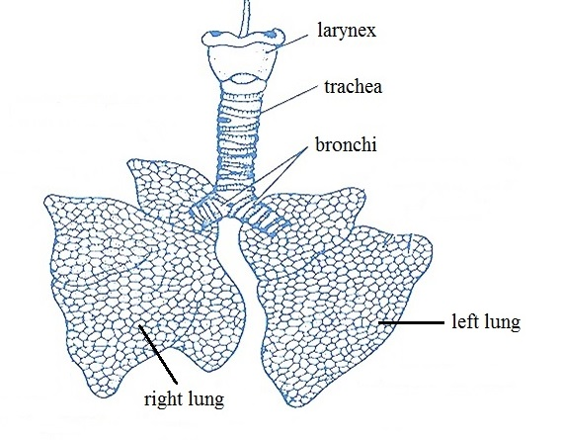

Excretory system
The kidneys are two dark red bodies present on either side of vertebral column. The kidney of the right side is placed slightly anterior than the left kidney. Each kidney is bean-shaped with a median notch or groove called hilus on the inner side. An elongated ureter originates from the hilus that runs posterioly and opens into urinary bladder. The urinary bladder in female rabbit opens into urinogenital canal which opens out by vulva. The urinary bladder in male opens into urethra present in penis. The urinogenital canal both in male and female transmits the germ cells and urine Rabbit urine always contains a certain amount of sediments. This is absolutely normal, the system of rabbits works this way to excrete the too much of calcium in their body.
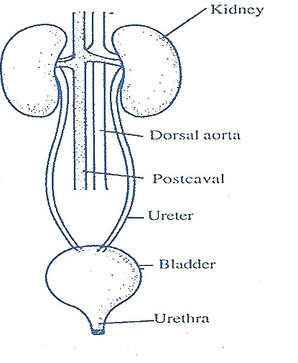

Reproductive system
The male reproductive system consists of paired of testes, testes are small, ovoid bodies. Each testes lies in a special thin-walled sac outside the abdominal cavity, called the scrotum. The epididymis is an irregular, narrow and highly convoluted tubule of great length. It forms a compact ridge - like mass all along the inner surface of the testis. The basal end of epididymis leads into a yellowish-white, straight, and muscular tube, the sperm duct or vas deferens. It runs forward along the inner side of the scrotal sac, to enter the abdominal cavity.
It loops ventrally under the ureter and opens dorsally into urethra immediately in front of the opening of the ureter. The neck of the urinary bladder and the vasa deferentia open into a thick-walled muscular duct, the urethra. Urethra is the common passage for both urine and semen and called the urinogenital duct. It traverses and opens at the tip of the penis as the male urinogenital opening.

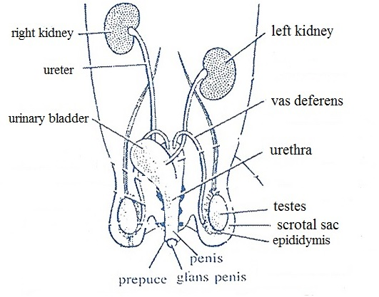
The female reproductive organs include a pair of ovaries, a pair of oviducts, a pair of uteri, vagina. The two ovaries are small, whitish, oval bodies. They are found behind the kidneys, each ovary attached to the dorsal abdominal wall by a double fold of peritoneum called mesovarium. From the surface of ovaries project several small, rounded, semitransparent projections, called ovarian or Graafian follicles, each containing a developing ovum. Each oviduct opens anteriorly, close to the ovary of its side, by a wide funnel called fallopian or oviducal funnel. The opening of funnel is provided with many cilia to receive the minute ova released from the ovary.
Funnel leads into the upper part of oviduct. It is a short, narrow, coiled and internally ciliated duct called fallopian tube. Ova pass through this tube by ciliary action and fertilization also occurs here. The fallopian tube is followed by a much wider, longer convoluted, thick walled muscular tube the uterus. Fertilized ova get fixed on the uterine wall to develop into embryos. The uterus of both the sides meet into a long wide, median duct, the vagina, lying behind the urinary bladder. It opens posteriorly into the neck of bladder to join the urethra forming a short narrow common urinogenital canal It runs backwards ventral to the rectum and opens out by a slit-like opening, the vulva.
