Basics of DNA Cloning /part 2
Molecular cloning using a plasmid vector involves five major steps .

Step 1: Isolation of DNA (gene of interest and vector):
The first initial step in cloning a DNA fragment is to isolate foreign DNA containing gene of interest and bacterial plasmid. If the sequence of the gene of interest is known it is isolated by PCR amplification using gene specific primers which include restriction sites selected from the multiple cloning site of the plasmid selected for cloning. When the sequence of the gene is not known degenerate primers are used for PCR amplification. Most of the time people generate genomic DNA library and screen for the gene using southern hybridization technique. According to the result of southern hybridization, the DNA is sequenced and the gene was confirmed by BLAST analysis. Now the gene is amplified by PCR and cloned. There are many plasmids available commercially for cloning.

Step 2: Treatment of plasmid and foreign DNA with the same restriction enzyme and ligation:
The gene of interest and the plasmid are modified using same restriction enzymes. Plasmid vectors are engineered to contain a specific antibiotic resistance gene and a multiple cloning site (also called the polylinker region) which contain many unique target sites for restriction endonucleases (Figure1).
When the circular plasmid is cut with one of the restriction enzyme whose restriction site is present in the plasmid, it results the linearization of plasmid. A fragment of DNA molecule, referred to as the “insert,” is treated with the same restriction enzyme, and then can be joined to the plasmid DNA in a ligation reaction. The chance for recombinant clones in ligations of the insert to vector will not be 100% as there is more possibility of self-ligation of two ends of the plasmid. To decrease the degree of self-ligation, enzyme phosphatase is used which removes the terminal 5′-phosphate and prevents self-ligation. Another strategy to overcome self-ligation is by using two different restriction enzymes cutting sites with non- complementary sticky ends. In this way self-ligation is inhibited and also promotes correct orientation of the insert DNA within the plasmid. The ligation of the digested insert and the plasmid is performed by pooling both in a single reaction tube and adding DNA ligase enzyme which catalyses the formation of phosphodiester bond between insert and plasmid DNAs, there by forming the recombinant DNA molecule (Figure 2).

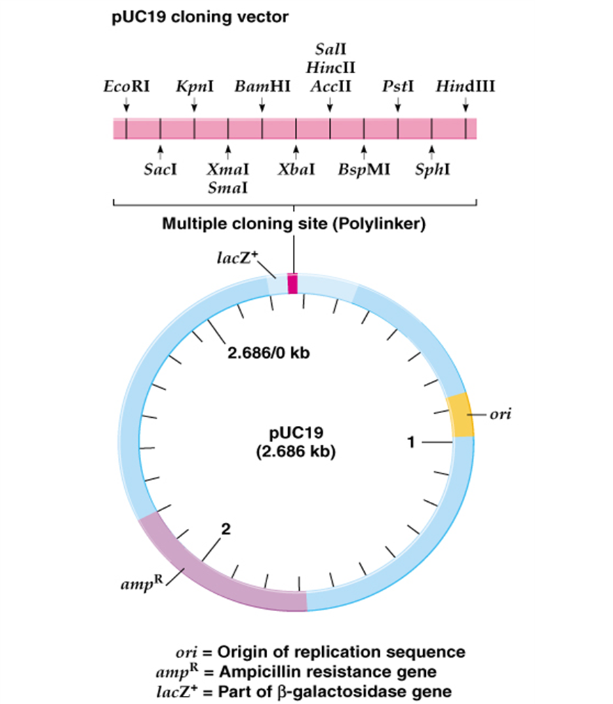

Figure 1: Plasmid pUC 19, The commonly used plasmid pUC19 (“puck 19”) is a small plasmid with the essential elements for a vector: An origin of DNA replication A dominant selectable marked (resistance to an antibiotic, ampicillin) And a cloning site, usually a polylinker with recognition sites for numerous restriction enzymes.

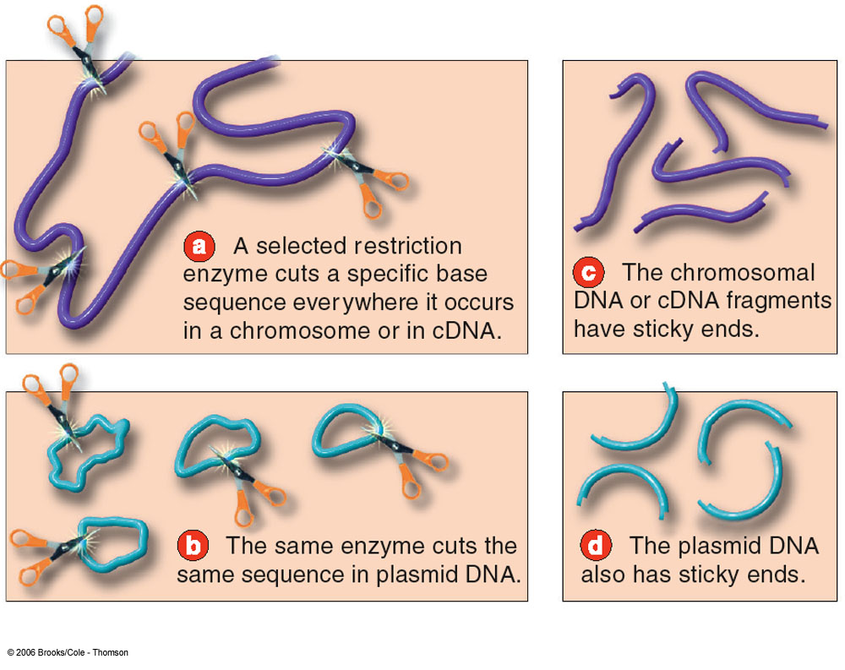
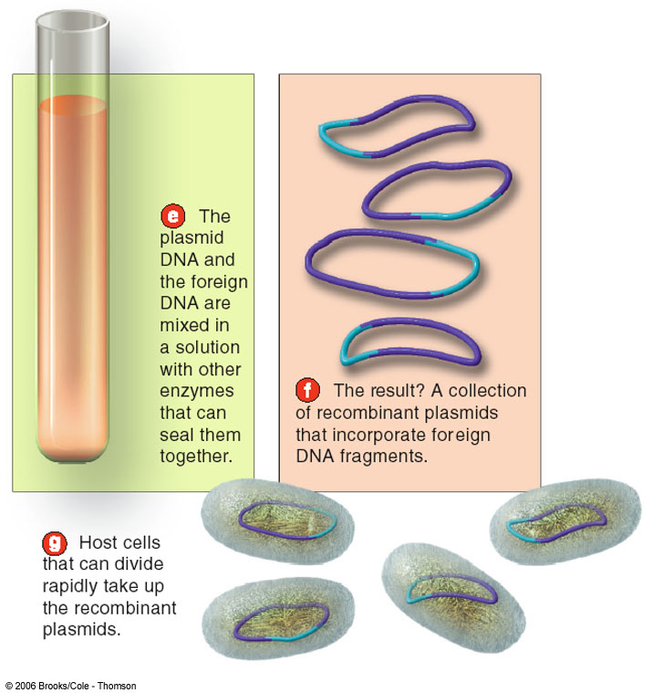

Figure 2: Treatment of plasmid and foreign DNA with the same restriction enzyme and ligation.

Step 3: Transformation: transfer of recombinant plasmid DNA to a suitable host:
The ligation reaction mixture of recombinant DNA described in the step 2 is introduced into bacterial cells in a process called transformation (The process of transferring exogenous DNA into cells)
There are basically two general methods for transforming bacteria:
The first is a chemical method utilizing CaCl2 and heat shock to promote DNA entry into cells.The traditional method to prepare cells for transformation process is to incubate the cells in a concentrated calcium salt solution to neutralize the negative charge of membrane (due to salicylic acid), so that the negatively charged DNA molecules can come close to bacterial membrane and during heat shock can easily enter in the cells. These “competent” cells are then mixed with ligation product to allow entry of the DNA into the bacterial cell (Figure 3).

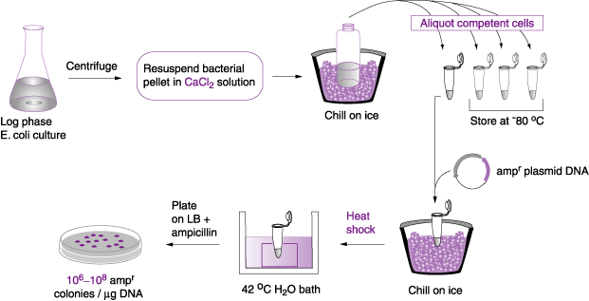

Figure 3: Chemical transformation with calcium chloride .

A second method is called electroporation based on a short pulse of electric charge to facilitate DNA uptake. Electroporation method is an alternative mode of transformation used to drive DNA (comparatively larger size) into cells by a strong electric current. This method is not very common due to less percentage of survival of transformed cells (Figure 4). As mentioned earlier bacterial species use restriction enzymes to degrade foreign DNA lacking the methylation pattern, including the plasmids, then why don’t they degrade the transformed recombinant DNA. The answer is that molecular biologist have cleverly engineered and developed the bacterial strains that lake restriction-modification system. The best example is common lab strain E.coli DH5α. A transformed bacterial cell may carry either recombinant or non- recombinant plasmid DNA. The plasmid DNA multiplies within each transformed bacterial cell. Each transformed bacterial cell when plated to the solid agar media (nutrient media) can multiply to form a visible colony made of millions of identical cells. As the transformed cell divides, the plasmids are passed on to progeny, where they continue to replicate. Single transformed bacteria undergo numerous cell divisions results in clones of a cell (single bacterial colony) from a single parental cell. From this step the name “cloning” is given. From the colony of bacterial cells the cloned DNA can now be isolated.
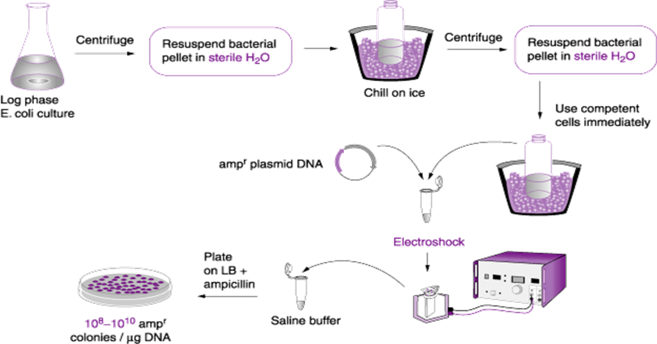

Figure 4: Transformation by electroformation.

Step 4: Screening for transformed cells:
To avoid the growth of the untransformed bacterial cells, plasmid vectors are engineered with selectable marker gene for resistance to the antibiotics (Table 1). The media in which the transformed bacterial cells are grown is supplied with that antibiotic whose resistance gene is present in the plasmid. Due to this only transformed cells show antibiotic resistance will grow in the media supplied with antibiotic and untransformed cells cannot grow as they do not carry antibiotic resistance gene. Transformed bacterial cells may contain either recombinant plasmid DNA (vector containing foreign DNA insert) or non-recombinant plasmid DNA (self ligated vector only). Both type of transformed bacterial cells will show antibiotic resistance and grow on the agar media plate.

Table 1: Some commonly used antibiotics and antibiotic resistance genes.
antibiotic | Mode of action | Resistance gene
Kanamycin | Inactivates translation by interfering with ribosome function | Neomycin or aminoglycoside phosphotransferase (neor) gene product inactivates kanamycin by phosphorylation
Ampicillin | Inhibits bacterial cell wall synthesis by disrupting peptidoglycan cross-linking | β-Lactamase (ampr) gene product is secreted and hydrolyzes ampicillin
Tetracycline | Inhibits binding of aminoacyl tRNA to the 30S ribosomal subunit | tetr gene product is membrane bound and prevents tetracycline accumulation by an efflux mechanism

Blue-white screening or “lac selection” (also called α-complementation) can be used to distinguish between recombinant transformants and non- recombinant transformants. Bacterial colonies are allowed to grow on selective media containing antibiotic and X-gal (5-bromo-4-chloro-indolyl-β-D-galactopyranoside), a colorless chromogenic compound. Not all plasmid vectors are engineered for “lac selection”; the plasmid that are engineered for blue-white screening carry a MCS site in between gene that encodes for amino acids for enzyme β-galactosidase which cleaves β-glycosidic bond in D- lactose. X-gal mimic D-lactose and β-galactosidase enzyme acts on X- gal and produces a blue color complex (Figure 5).
A successful ligation of the desired gene disrupts the lac Z gene, hence no functional β-galactosidase is produced resulting in white colonies. Hence successful recombinant transformed colonies can be easily identified by its white coloration from unsuccessful blue ones. pUC19, pBluescript, pGem-T are few example of cloning vectors used for this test and it also requires the use of specific E. coli host strains such as DH5α which carries the mutant lacZΔM15 genes.

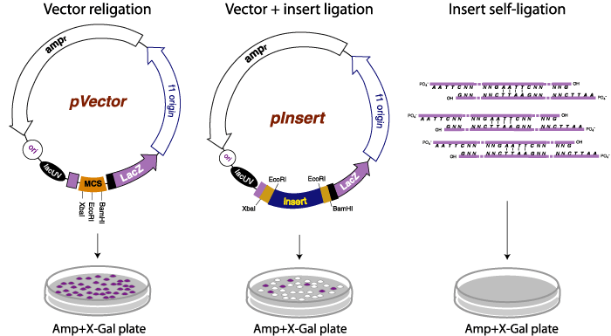

Figure 5: Growth on agar plates. Blue colonies represent Ampicillin-resistant bacteria that contain pVector and express a functional alpha fragment from an intact LacZ alpha coding sequence. White colonies represent Ampicillin-resistant bacteria that contain pInsert and do not produce LacZ alpha fragment.

Explanation of the colony selection: finding the rare bacterium with recombinant DNA
Only E. coli cells with resistant plasmids grow on antibiotic medium
Only plasmids with functional lacZ gene can grow on Xgal
lacZ(+) = blue colonies
lacZ functional = polylinker intact = nothing inserted, no clone
lacZ(-) = white colonies polylinker disrupted = successful insertion & recombination.

Step 5: Amplification and purification of recombinant plasmid DNA
The final step in DNA cloning is the isolation of the cloned recombinant DNA. A positive colony containing recombinant plasmid is identified and it is aseptically transferred to liquid medium and cell are allowed to grow exponentially overnight. A fully grown culture contains trillions of identical cells, which is harvested for the isolation of the plasmid DNA. The plasmid DNA is purified from harvested bacterial cell lysates. The purified plasmid DNA is dissolved in an appropriate buffer solution and can be used for further confirmation of the clone by restriction digestion and sequencing the plasmid DNA.

Additional information about The BLAST Sequence Analysis Tool
BLAST ( Basic Local Alignment Search Tool) is one of the most widely used bioinformatics programs for sequence searching. BLAST is an algorithm for comparing primary biological sequence information, such as the amino-acid sequences of proteins or the nucleotides of DNA sequences. A BLAST search enables a researcher to compare a query sequence with a library or database of sequences, and identify library sequences that resemble the query sequence above a certain threshold.
Different types of BLASTs are available according to the query sequences. For example, following the discovery of a previously unknown gene in the mouse, a scientist will typically perform a BLAST search of the human genome to see if humans carry a similar gene; BLAST will identify sequences in the human genome that resemble the mouse gene based on similarity of sequence. The BLAST algorithm and program were designed by Stephen Altschul, Warren Gish, Webb Miller, Eugene Myers, and David J. Lipman at the National Institutes of Health and was published in the Journal of Molecular Biology in 1990 .
If we sequence a DNA clone, the first bioinformatics analysis is a similarity search against a nucleotide database. The most widely used similarity search program accessible on the internet is BLAST, which will be described here and will be used by the students during the laboratory practice. The BLAST program is available online at several servers including the one at NCBI: http://blast.ncbi.nlm.nih.gov/Blast.cgi.

Note: NCBI ( National Center for Biotechnology Information) is part of the United States National Library of Medicine , a branch of the National Institutes of Health (NIH). The NCBI is located in Bethesda, Maryland and was founded in 1988 through legislation sponsored by Senator Claude Pepper.

