Remote Sensing Lab
LAB 9: Introduction to Satellite Meteorology
Purpose:

To learn the basic concepts of Satellite Meteorology.

Theory:

1. What is Satellite Meteorology?
Satellite Meteorology refers to the study of the earth's atmosphere and oceans using data obtained from remote sensing devices flown onboard satellites orbiting the earth. Observations and Measurements

Meteorology, like every other science, relies on careful and precise measurement of its subject. Meteorologists observe the atmosphere using two basic approaches.

Direct methods, also called in situ for "in place," measure the properties of the air that are in contact with the instrument being used.

Indirect methods, also referred to as remote sensing, obtain information without coming into physical contact with the region of the atmosphere being measured. Launching satellites into space equipped with remote sensing instruments allows us to continuously monitor planet Earth from a far.

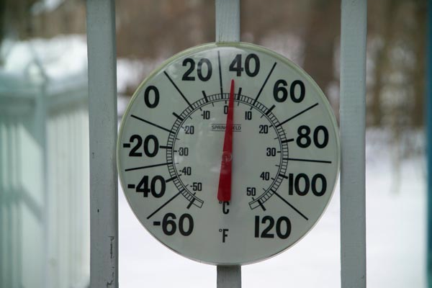
Direct method: A thermometer is in contact with the air around it and measures the temperature directly. | Indirect Method: Our eyes see (and remotely sense) the steam rising from the pan and the red, hot burner below.

2. Brief history of satellite meteorology

TIROS Satellites
- Satellites with meteorological instrumentation were first launched in the late 1950's.
- The first satellite completely dedicated to satellite meteorology was launched on 1 April 1960.
- It was called the TIROS (Television and Infrared Observational Satellite).
- The life span of this satellite was 79 days.
- The images, however, generated much excitement in the meteorological community.
- Nine additional TIROS satellites were subsequently launched through 1965.

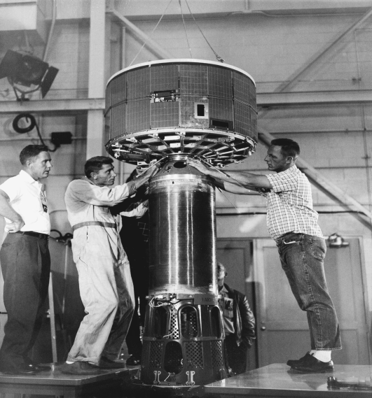 | 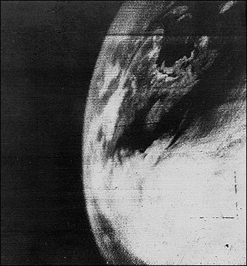
The first satellite. | The first picture of Earth from a weather satellite, taken by the TIROS-1 satellite on April 1, 1960. Although primitive in comparison with the images we now receive from satellites, this first picture was a major advance.

The Nimbus series
- Then came the Nimbus series, Nimbus 1 was launched on 28 August, 1964.
- The Nimbus satellites were the first three-axis stabilized meteorological satellites. This allowed the satellite sensors to continuously point towards the earth.
- They were also the first sun-synchronous satellites.
- Six more Nimbus satellites were subsequently launched and provided continuous coverage of the earth for the first time.
- This meant that tropical storms could be closely monitored for the first time.
- The last Nimbus satellite was launched in 1978.
- The current NOAA polar orbiting satellites are descendents of the original Nimbus satellites.

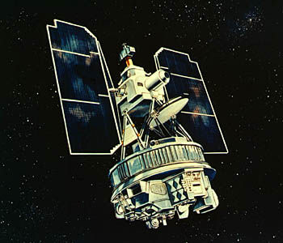

DMSP and ATS Satellites
- 16 September, 1966 marked the launch of the first DMSP (Defense Meteorological Satellite Program) satellite.
- The data from these satellites are very high quality.
- 7 December, 1966 marked the launch of the first Applications Technology Satellite (ATS 1).
- It was placed in geostationary orbit (similar to the current GOES E, W satellites) and produced high-temporal resolution imagery for the first time over the entire hemisphere.

GOES Satellite
- GOES 1 (Geostationary Operational Environmental Satellite) was launched on 16 October 1975.
- Currently, there are three GOES satellites in orbit, GOES 10 (W), 11, and 12 (E). All three are currently providing useable data.
- The first satellite dedicated to climate research was launched on 5 October 1984 from the Space Shuttle Challenger.
- The satellite is called the Earth Radiation Budget Satellite (ERBS)

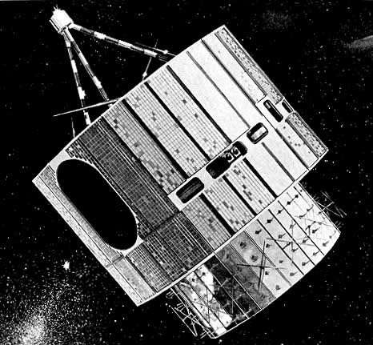

3. Types of satellites and their orbital coverage

Introduction to geostationary satellites

- GOES East and West are the two Geostationary satellites operated by the United States.
- They are relatively new and represent major improvements over previous GOES satellites.
- Satellite lifetime is about 5 years.
- Geostationary satellites orbit in the earth's equatorial plane at a height of 35,800 km. Note that the typical space shuttle orbit is only 225-250 km. At this height, the satellite's orbital period matches the rotation of the Earth, so the satellite seems to stay stationary over the same point on the equator.
- Geostationary satellites always view the same geographical area, day or night. For example, GOES East is always seeing the Eastern US.
- This is ideal for making regular sequential observations of cloud patterns over a region with visible and infrared radiometers
- High temporal resolution and constant viewing angles are the defining features of geostationary imagery.

Advantages and disadvantages of geostationary orbits
Advantages | Disadvantages
- Make repeated observations over a given area (constant view area).  - Get high temporal resolution data. GOES E and W can give you a temporal resolution of 1 minute!! Hence, GOES E and W can effectively monitor the severe weather environment and track severe storms and hurricanes in real time. | - Due to the high orbit, the spatial resolution of the data is not as great as for the polar orbiting satellite.  - Poor spatial resolution in the polar regions (parallax). We will talk more about this later.

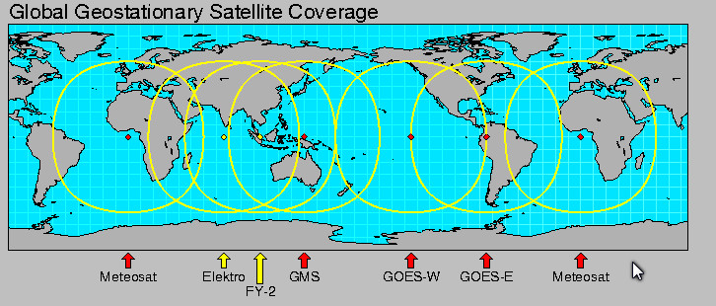

Polar Satellites
The primary mission of the polar orbiters is to provide daily global observations of weather patterns and environmental conditions in the form of quantitative data usable for numerical weather prediction.
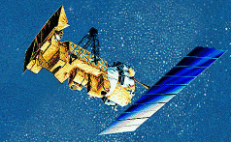

- Orbits are sun-synchronous circular orbits that almost pass over the poles.
- Altitudes of the orbits are much lower than for the Geostationary satellites. Altitudes are typically at 850 km.
- Orbital periods are about 98-102 minutes.
- Hence, each satellite will complete about 14 orbits in one day.

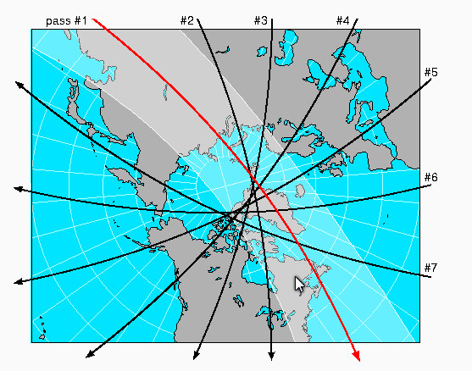

Advantages and disadvantages of polar orbits
Advantages | Disadvantages
- Since the orbit is lower than for the Geostationary satellites, the data resolution is higher.  - They provide global coverage, necessary for NWP models and climatic studies. | - Can not provide continuous viewing of one location

Methodology

Questions
- What year was the first satellite launched?
- What are the two main types of satellites? Which is closest to the Earth?
- Describe geostationary satellites orbit around the earth?
- Why the geostationary satellites are at an altitude of 35,800 km?
- What are the advantages and disadvantages of geostationary satellites?
- Describe the orbit of the polar orbiting satellites?
- At what altitude do polar orbiting satellites orbit the earth?
- What are the advantages and disadvantages of the polar orbiting satellites?
- Satellite technology is one of the biggest scientific breakthroughs of the 20th century, name at least 2 more and list your reasons for your choices?

