Remote Sensing Lab
LAB 11: Weather Satellite Images
Purpose:

To understand the weather satellite images to understand how to Interpreter weather satellite images.
.Theory:

I. Introduction
Instruments carried by weather satellites can record radiation of different wavelengths, including:
- ultraviolet radiation;
- visible light;
- near-infrared radiation;
- longwave infrared (IR) radiation; and
- microwave radiation.
Much as your eye does, visible images record visible light from the sun that is reflected by cloud tops, land surfaces, ocean surfaces, and snow/ice surfaces. Here's an example:
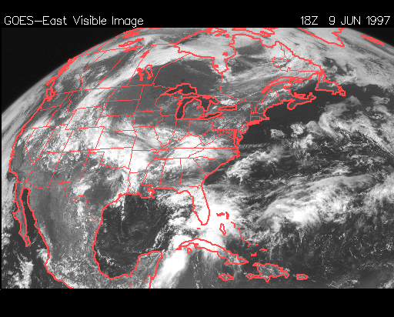
Invisible Image
Cloud tops, land surfaces, ocean surfaces, and snow/ice surfaces reflect some of the visible light that strikes them, but they emit mostly IR radiation. Wavelengths of this emitted IR radiation that lie in a portion of the electromagnetic spectrum called the atmospheric window pass unaffected through the atmosphere to the satellite, which records them in ordinary infrared (IR) images. Here are two examples, one in black-and-white and the other color enhanced:

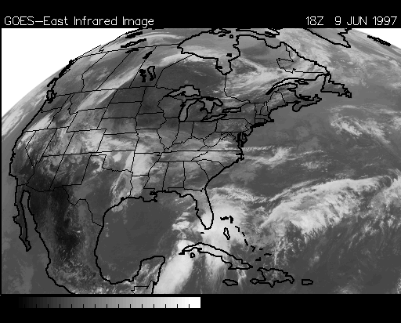
Infrared Image

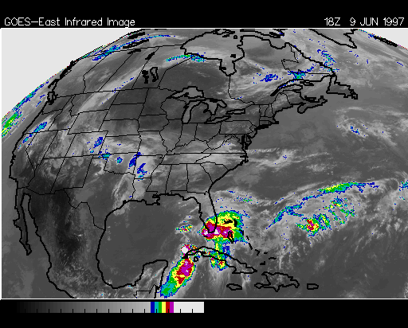
Color Enhanced Infrared Image

Note that visible and ordinary IR images tell us little about air itself, since both kinds of image record wavelengths to which air is transparent. However, water vapor, carbon dioxide, and other gases in the atmosphere both absorb and emit IR radiation with wavelengths lying outside of the atmospheric window. Images that record IR radiation emitted by water vapor, called water vapor images, and images that record IR radiation emitted by other gases, provide information about state of the atmosphere. Here's an example:
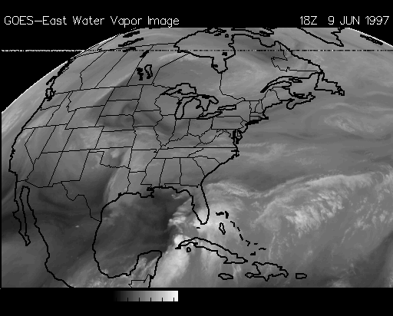
Water Vapor Image

Weather satellites record the "brightness" or intensity of the visible and IR radiation coming from different parts of the earth or atmosphere. Black-and-white satellite images such as the examples shown above display different intensities of radiation in different shades of gray.
On visible images, brighter (that is, whiter or lighter) areas represent greater intensities of visible radiation, and darker areas represent lower intensities of visible radiation, just as your eye would see.
On IR images, since our eyes can't see IR radiation of any intensity, we have to decide arbitrarily how to translate different intensities into different shades of gray on a black and white image (or different colors on a color-enhanced IR image). By convention, we usually translate low intensities of IR emission to lighter shades of gray, and greater intensities of IR emission to darker shades of gray. Since IR emission intensity tells us about temperature (the higher the emission intensity the higher the temperature), the different shades of gray (or different colors) therefore tell us about differences in temperature.

II. Background Questions
Q1. Suppose two patches of ground are identical, except that one has a high albedo and the other a low albedo. The sun shines on each equally. Which one, if either, looks brighter? Which one, if either, will become warmer? Why?
Ans:
The object wth higher albedo appears brighter.
The object with lower albedo becomes warmer than the higher-albedo object.

Q2. According to the basic laws of radiation, what determines the intensity with which an object emits radiative energy?
Ans:
The temperature of an object determines the intensity with which it emits radiative energy.

Q3. According to the basic laws of radiation, what is the relation between the temperature of an object and the wavelengths that it emits the most intensely?
Ans:
The warmer an object is, the shorter are the wavelengths at which it emits radiative energy the most intensely. The cooler the object is, the longer are the wavelengths at which it emits radiation the most intensely.

Q4. From the point of view of a satellite orbiting the earth, would you expect any visible light reaching you from the earth to be emitted from the earth or reflected by the earth? Why? What about longwave infrared radiation from the earth--reflected or emitted? Why?
Ans:
Essentially all of the visible light reaching a satellite from the earth is reflected light.
Essentially all of the longware infrared radiation reaching a satellite from the earth is emitted by the earth.

Q5: What two factors determine the intensity of visible light coming from features of the earth as viewed from an orbiting satellite?
Ans:
The intensity of visible light from the sun striking features of the earth; and the albedo of the features.

Q6: What one factor determines the intensity of longwave IR radiation coming from features of the earth as viewed from an orbiting satellite?
Ans:
The temperature of a feature on earth determines the intensity of longwave IR radiation the feature emits (according to the basic laws of radiation--see Question 2).

Q7: What creates contrast (that is, differences in shades of gray or differences in color) on IR satellite images?
Ans:
Differences in temperature produce differences in intensity of emission of longware IR radiation, which are translated by computers into different shades of gray or different colors on an IR satellite image. (See Question 2.)

Q8: What creates contrast on visible satellite images?
Ans:
Primarily, differences in albedo between features in an image cause contrast on a visible image.
Secondarily, differences in the intensity of visible light striking the earth. (Usually important only on images covering a relatively large portion of the earth.)

Q9: On a conventional black and white IR satellite image, what would a relatively dark shade of gray represent? What about a relatively light shade?
Ans:
Dark shades represent relatively warm temperatures on conventional black-and-white IR images. Lighter shades represent relatively cooler temperatures.

Q10: On a black and white visible satellite image, what would a relatively dark shade of gray represent? What about a relatively light shade?
Ans:
Dark shades on a visible images represent relatively low albedos (or sometimes relatively low intensity of visible light striking a feature). Lighter shades represent relatively higher albedos (or sometimes relatively higher intensity of light striking a feature).

Q11: On an IR image, which features (land surfaces, ocean surfaces, cloud tops, or snow/ice surfaces) tend to appear relatively dark and which relatively light, and under what conditions? (Consider time of year, time of day, latitude, and altitude.)
Ans:
Relatively dark features are relatively warm ones, including low clouds, land surfaces and ocean surfaces (compared to high clouds); land surfaces in the afternoon (compared to sunrise); tropical oceans (compared to higher-latitude oceans); low-altitude land surfaces (compared to high-altitude land surfaces); etc.
Relatively light features are relatively cold ones, including high clouds, high-latitude land surfaces in winter, etc.

Q12: Which of the four features typically distinguishable on visible images (land surfaces, ocean surfaces, cloud tops, and snow/ice surfaces) tend to appear relatively dark? Which tend to appear relatively light? Which one generally appears the darkest?
Ans:
For more or less equal intensity of visible light striking features in a visible image, relatively light features are relatively high-albedo ones, including clouds and snow/ice surfaces.
Relatively dark features are low-albedo ones, including land surfaces and, especially, ocean surfaces.

Q13: How is the time appearing on each satellite image (in Universal Time Coordinates, or UTC--formerly known as Greenwhich Mean Time, or GMT) converted to local time?
Ans:
For areas observing local standard time and lying west of Greenwich, England (0° longitude) and east of the international date line (approximately 180° longitude)--that is, in the Western Hemisphere--subtract the number of hours equal to the number of time zones between you and Greenwich, England from the time in UTC. For areas observing local daylight savings time, subtract one less than that.

Methodology

Answer the following MCQ
- This is the fraction of visible radiation that reflects off an object:
- Opaqueness
- Albedo
- Transmissivity
- Color

- Cloud shadowing is best seen on this type of satellite image:
- Visible
- Infrared
- Water Vapor

- This satellite imagery shows contrasting temperatures of cloud tops. Approximate cloud heights can be determined using this imagery:
- Visible
- Infrared
- Water Vapor

- If a colder surface is next to a warmer surface on conventional infrared imagery, which one will appear more white on the satellite image output?
- The colder surface
- The warmer surface

- On visible imagery, fog will cover unfrozen lakes and rivers while snow will not.
- True
- False

- Clouds on satellite imagery can be identified by their:
- Texture
- Brightness
- Temperature
- All of the above

- In this season visible imagery is most useful since the days are longer and the sun angle is higher:
- Summer
- Winter

- An advantage of infrared imagery over visible imagery is that:
- Infrared imagery is best at detecting thunderstorm texture
- Infrared imagery is best at detecting cloud thickness
- Infrared imagery can be used at night
- All of the above

- This imagery detects moisture or lack of moisture in the middle and upper layers of the troposphere:
- Visible
- Infrared
- Water vapor

- This imagery has the highest resolution of data:
- Visible
- Infrared
- Water vapor

- This is the best imagery for detecting low clouds when the earth's surface and the clouds have the same temperature:
- Visible
- Infrared
- Water vapor

- The wavelength of visible light is:
- 4 to 7 meters
- 4 to 7 centimeters
- 4 to 7 millimeters
- 0.4 to 0.7 micrometers

- When sunlight strikes a layer of fresh snow, most of the energy that makes up the sunlight will be:
- Reflected by the snow
- Absorbed by the snow
- Transmitted through the snow and into the ground

- The altitude of a GOES weather satellite is:
- 35 kilometers
- 350 kilometers
- 3.500 kilometers
- 35.000 kilometers
- 350.000 kilometers

