LECTURE -5
Blood and its Components
Blood is an essential fluid carries out the critical functions of transporting oxygen and nutrients to our cells and getting rid of carbon dioxide, ammonia, and other waste products. In addition, it plays a vital role in our immune system and in maintaining a relatively constant body temperature. Blood is a highly specialized tissue composed of more than 4,000 different kinds of components. Four of the most important ones are red cells, white cells, platelets, and plasma.
1-Red Cells
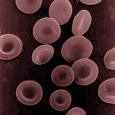
Human erythrocytes or "red cells"
(cell diameter about .0003 inches)
Red cells, or erythrocytes, are relatively large microscopic cells without nuclei. In this latter trait, they are similar to the primitive prokaryotic cells of bacteria. Red cells normally make up 40-50% of the total blood volume. They transport oxygen from the lungs to all of the living tissues of the body and carry away carbon dioxide. The red cells are produced continuously in our bone marrow from stem cells at a rate of about 2-3 million cells per second. Hemoglobin is the gas transporting protein molecule that makes up 95% of a red cell. Each red cell has about 270,000,000 iron-rich hemoglobin molecules. People who are anemic generally have a deficiency in red cells, and subsequently feel fatigued due to a shortage of oxygen. The red color of blood is primarily due to oxygenated red cells. Human fetal hemoglobin molecules differ from those produced by adults in the number of amino acid chains.
2-White Cells
White blood cells, or leukocytes, exist in variable numbers and types but make up a very small part of blood's volume--normally only about 1% in healthy people.

Leukocytes are not limited to blood. They occur elsewhere in the body as well, most notably in the spleen, liver, and lymphglands. Most are produced in our bone marrow from the same kind of stem cells that produce red blood cells. Others are produced in the thymus gland, which is at the base of the neck.
Some white cells are involved in defending the body against both infectious disease and foreign materials. There are several different types of white blood cells. They all have many things in common but are all distinct in form and function. A major distinguishing feature is the presence of granules; white blood cells are often characterized as granulocytes or a granulocytes.

A-Granulocytes
Granulocytes, also known as polymorphonuclear leukocytes are characterized by differently stained granules as viewed in their cytoplasm under light microscopy. These granules are membrane-bound enzymes that act primarily in the digestion of endocytosed particles. There are three types of granulocytes :

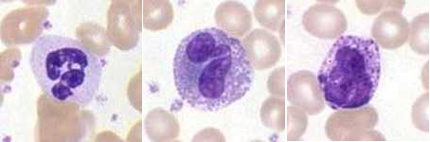

- Neutrophils defend against bacterial or fungal infection and other very small inflammatory processes. They are usually the first responders to microbial infection; their activity and death in large numbers forms pus.
-Eosinophils primarily deal with parasitic infections. They are also the predominant inflammatory cells in allergic reactions.

-Basophils are chiefly responsible for allergic and antigen response by releasing the chemical histamine, which causes dilation of the blood vessels.

B-Agranulocytes
Agranulocytes, or mononuclear leukocytes, are leukocytes characterized by absence of granules in their cytoplasm. Agranulocytes contain lysosomeswhich are small vesicles containing digestive enzymes that break down any foreign matter that is endocytosed by the cell. A granulocytes cells include:

1-Lymphocytes: come in three types :
- B-lymphocytes, which produce antibodies in thehumoral immune response.
- T-lymphocytes which participate in the cell-mediated immune response.
- The null group which contains natural killer cells; cytotoxiccells that participate in the innate immune response.

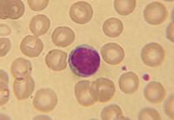
2-Monocytes present pieces of pathogens to T cells so that the pathogens may be recognized again and killed, or so that an antibody response may be mounted.
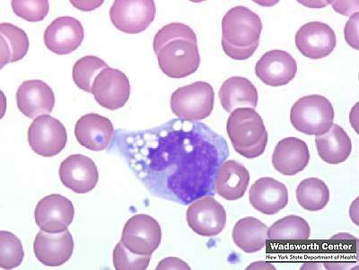

3- Macrophages are monocytes that have migrated out of the blood stream and into the body tissues. They take up and destroy necrotic cell debris and foreign material including viruses, bacteria, and tattoo ink.
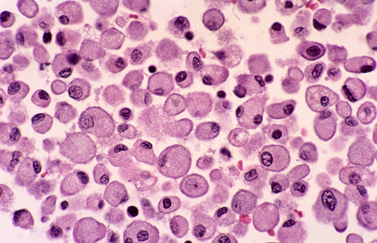
3-Platelets
Platelets , or thrombocytes , are cell fragments without nuclei that work with blood clotting chemicals at the site of wounds. They do this by adhering to the walls of blood vessels, thereby plugging the rupture in the vascular wall. They also can release coagulating chemicals which cause clots to form in the blood that can plug up narrowed blood vessels. Thirteen different blood clotting factors, in addition to platelets, need to interact for clotting to occur. They do so in a cascading manner, one factor triggering another. Hemophiliacs lack the ability to produce either blood factor 8 or 9.
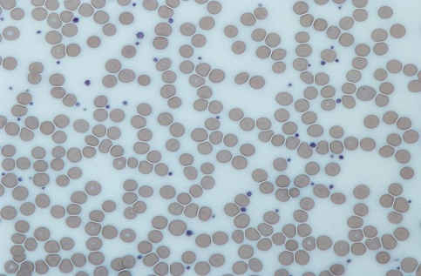
Platelets are not equally effective in clotting blood throughout the entire day. The body's circadian rhythm system (its internal biological clock) causes the peak of platelet activation in the morning. This is one of the main reasons that strokes and heart attacks are more common in the morning. Recent research has shown that platelets also help fight infections by releasing proteins that kill invading bacteria and some other microorganisms.

In addition, platelets stimulate the immune system. Individual platelets are about 1/3 the size of red cells. They have a lifespan of 9-10 days. Like the red and white blood cells, platelets are produced in bone marrow from stem cells.
4-Plasma
Plasma is the relatively clear, yellow tinted water (92%), sugar, fat, protein and salt solution which carries the red cells, white cells, and platelets. Normally, 55% of our blood's volume is made up of plasma. Plasma helps maintain blood pressure and regulates bodytemperature. plasma brings nourishment to them and removes the waste products ofmetabolism. It contains a complex mix of substances used by the body to perform important functions.These substances include minerals, salts, hormones and proteins.
Three important proteins found in plasma are:

a-albumin:
Serum albumin, often referred to simply as blood albumin, (a type of globular protein Albumin cleans the blood, carries substances around the body, and helps maintain the correct amount of fluid circulating in the body. without albumin, the high pressure in the blood vessels would force more fluids out into the tissues. It also acts as a plasma carrier by non-specifically binding several hydrophobic steroid hormones and as a transport protein for hemin and fatty acids. Too much or too little circulating serum albumin may be harmful. Human albumin solution can be used as a treatment to help people with severe burns, sepsis, liver disease or kidney disease.

b- Globulin
The globulins are a family of globular proteins that have higher molecular weights than albumins and are insoluble in pure water but soluble in dilute salt solutions. Some globulins are produced in the liver, while others are made by the immune system. The normal concentration of globulins in human blood is about 2.6-4.6 g/dL. Immunoglobulins are part of the immune system(the body's natural defence against infection and illness).

Immunoglobulins are antibodies that the body produces to fight a variety of infections. For example, they're used to fight health conditions such as: chickenpox, hepatitis, rabies .

c- Fibrinogen
Fibrinogen (factor I) is a glycoprotein in vertebrates that helps in the formation of blood clots. The fibrinogen molecule is a soluble, large, and complex plasma glycoprotein, that is converted by thrombininto fibrin during blood clot formation. The concentration of fibrinogen in the blood plasma is 200–400 mg/dL.
Hypoproteinemia is a decreased level of protein(s) in the blood. It occurs when protein is not properly absorbed during digestion (protein-losing gastroenteropathy). This can be caused by several gastrointestinal conditions, including impaired pancreatic function, bacterial overgrowth in the small intestine, gastrointestinal infection, parasite infestationsdiarrhea, Crohn's disease, or ulcerative colitis. In addition, individuals who have had part of the intestine removed surgically may experience hypoproteinemia. Low blood levels of proteins can also occur in other illnesses including kidney disease, liver disease, lymphoma, and AIDS. Certain drugs (neomycin, alcohol) may decrease protein absorption, thereby resulting in hypoproteinemia. Finally, a severe lack of protein in the diet (malnutrition) can also cause hypoproteinemia.
- plasma salts, the salts present in plasma include sodium, potassium, calcium, magnesium, chloride, and bicarbonate. These salts function in many important body processes. calcium functions in muscle contraction; sodium, chloride, and potassium function in nerve impulse transmission in nerve cells; and bicarbonate regulates pH. These salts are also called electrolytes. An imbalance of electrolytes, which can be caused by dehydration, can be a serious medical condition. Many gastrointestinal illnesses, such as cholera, cause a loss of electrolytes through severe diarrhea. When electrolytes are lost, they must be replaced with intravenous solutions of water and salts or by having the patient drink solutions of salts and water.

- plasma contains nutrients include amino acids, glucose, or sugars; and fatty acids and glycerol, the components of lipids (fats). In addition to nutrients, plasma also contains enzymes, or small proteins that function in chemical reactions, and hormones, which are transported from glands to body tissues. These waste products include creatinine, uric acid, and ammonium salts. Blood transports these waste products from the body tissues to the kidneys, where they are filtered from the blood and excreted in the urine.

Blood tests
A blood test is a laboratory analysis performed on a blood sample that is usually extracted from a vein in the arm using a needle, or viafingerprick. Multiple tests for specific blood components (such as a glucose test or a cholesterol test) are often grouped together into onetest panel called a blood panel or blood work. Blood testsare often used in health care to determine physiological and biochemical states, such as disease, mineral content, pharmaceutical drug effectiveness, and organ function. Typical clinical blood panels include abasic metabolic panel or a complete blood count. Blood tests are also used in drug tests to detect drug abuse.

Blood Specimen Collection and Processing
Venipuncture is useful as it is a minimally invasive way to obtain cells and extracellular fluid (plasma) from the body for analysis. Blood flows throughout the body, acting as a medium which provides oxygen and nutrients to tissues and carries waste products back to the excretory systems for disposal. The state of the bloods tream is affected by many medical conditions. For these reasons, blood tests are the most commonly performed medical tests.
If only a few drops of blood are needed, a fingerstick is performed instead of drawing blood from a vein.

Phlebotomists: a laboratory practitioners and nurses are those charged with patient blood extraction. However, in special circumstances, and emergency situations, paramedics and physicians sometimes extract blood. Also, respiratory therapists are trained to extract arterial blood to examine arterial blood gases.
1-Complete Blood Count
The complete blood count, or CBC, lists a number of many important values. Typically, it includes the following:
a-White Blood Count (WBC).
White blood cells are larger than red blood cells, but there are fewer of them in numbers. In infection, an increased number of white blood cells are sent from the bone marrow to attack the bacteria or virus that is causing the infection. An increased number of white blood cells may occur with mild infections, appendicitis, pregnancy, leukemia, hemmorrhage and hemolysis.
b-Red Blood Count (RBC).
Red blood cells are the most common type of cell in the blood ,body contains millionsupon millions of these disc-shaped cells.Red blood cells are produced by the bone marrowcontinuously in healthy adults. The cells contain hemoglobin which carries oxygen andcarbon dioxide throughout the body.The RBC determines if the number of red blood cells in the body is low (called anemia) or high (called polycythemia).
Common causes of an abnormal RBC include :
- iron deficiency (anemia) due to chronicblood loss (i.e. menstruation, small amounts of bleeding due to colon cancer), acute blood loss(i.e. acute bleeding ulcer, trauma), and hereditary disorders (i.e. sickle cell anemia). People with low hemoglobin levels have anemia and usually have a low red blood cell count and a low hematocrit. Signs and symptoms of anemia (paleness, shortness of breath, fatigue) will start to show when the hemoglobin is too low. In general, females have lower red blood counts and hemoglobin values than men.

- Polycythemia is relatively uncommon. Red blood cells contain hemoglobin, themolecules that carry oxygen and carbon dioxide in the blood. Measuring hemoglobin givesan exact picture of the ability of the blood to carry oxygen. The oxygen is used by the cellsto produce energy. The blood also brings carbon dioxide, the waste product of this energyproduction process, back to your lungs, where it is exhaled.
c-Hemoglobin Concentration (HGB).
The purpose of this test is to determine the ratio of plasma (clear liquid part of the blood)to red cells in the blood .
d-Hematocrit measurement
The hematocrit (Ht or HCT), British English spelling( haematocrit), also known as packed cell volume (PCV) or erythrocyte volume fraction (EVF), is the volume percentage (%) of red blood cells in blood. It is normally 45% for men and 40% for women. It is considered an integral part of a person's complete blood count results. Because the purpose of red blood cells is to transfer oxygen from the lungs to body tissues, a blood sample's hematocrit—the red blood cell volume percentage—can become a point of reference of its capability of delivering oxygen. Additionally, the measure of a subject's blood sample's hematocrit levels may expose possible diseases in the subject. Anemia refers to an abnormally low hematocrit, as opposed to polycythemia, which refers to an abnormally high hematocrit. For a condition such as anemia that goes unnoticed, one way it can be diagnosed is by measuring the hematocrit levels in the blood. Both are potentially life-threatening disorders.
e- MCV (Mean Cell Volume):
Measures the average size of red blood cells. In patients with anemia, it is the MCV measurement that allows classification as either a microcytic anemia (MCV below normal range), normocytic anemia (MCV within normal range) or macrocytic anemia (MCV above normal range). Normocytic anemia is usually deemed so because the bone marrow has not yet responded with a change in cell volume. It occurs occasionally in acute conditions, namely blood loss and hemolysis.

f- MCH (Mean Cell Hemoglobin):
Reflects the average weight of hemoglobin found in the red blood cell. ("normochromic") in macrocytic anemias (due to larger cell size, though the hemoglobin amount or MCH is high, the concentration remains normal).
g- MCHC (Mean Cell Hemoglobin Concentration):
macrocytic anemias (due to larger cell size, though the hemoglobin amount or MCH is high, the concentration remains normal). MCHC is elevated ("hyperchromic")

h-RDW (Red Cell Distribution Width):
RCD isa histogram (visual), which is a measure of the range of variation of red blood cell (RBC) volume.
i- MPV (Mean Platelet Volume):
Reflects the average volume of platelet. Platelets are the smallest type of cell found
in the blood. Platelets help stop bleeding after an injury by gathering around the injury site, plugging the hole in the bleeding vessel and helping the blood to clot more quickly.

j- Platelet count.
platelet counts are often done in bruising or in surgery.The platelet count may change with bleeding disorders, heart disease, diabetes, inflammatorydisorders, and anemias. People with a low WBC are more likely to catch colds or other infectious diseases. Low WBC counts may be seen in overwhelming infections like mumps, lupus, cirrohsis of the liver and cancer. In addition, radiation therapy and certain types of drug therapy tend to lower the WBC.

k- Erythrocyte Sedimentation Rate (ESR)
Also called an ESR or sedimentation rate test, measures the speed at which red blood cells settle to the bottom of an upright glass test tube. This measurement is important because when abnormal proteins are present in the blood, typically due to inflammation or infection, they cause red blood cells to clump together and sink

more quickly, which results in a high ESR value.The ESR is useful in detecting inflammation in the body that may be caused by infection, some cancers, and certain autoimmune diseases such as juvenile idiopathic arthritis, lupus, and Kawasaki disease. The ESR alone can't be used to diagnose any one specific disease, however.
2- Blood typing
Is a test that determines a person’s blood type. The test is essential in blood transfusion or in donate blood. Not all blood types are compatible, so it is important to blood group to ensure that in transfusion the body doesn’t make antibodies to attack the donor blood.

The Blood Types
The ABO blood typing system groups blood into one of four categories:
- O: type O individuals can donate blood to anyone, but can receive blood only from other type O individuals.
- A: type A individuals can donate to other type A individuals and type B individuals. Type A individuals can receive blood only from other type A individuals and type O individuals.
- B: type B individuals can donate blood to other B individuals and AB individuals. Type B individuals can receive blood only from type B individuals and type O individuals.
- AB: type AB individuals can give blood only to other AB individuals, but can receive blood of any type.
The Rh factor blood grouping system:
- Rh+: People with Rh-positive blood have Rh antigens on the surface of their red blood cells. People with Rh+ blood can receive Rh+ or Rh- blood.
- Rh-: People with Rh-negative blood do not have Rh antigens. People with Rh- blood can receive only blood that is also Rh-.
Together, the ABO and Rh grouping systems yield your complete blood type. There are eight possible types: O+, O-, A+, A-, B+, B-, AB+, and AB-.

