**Principle of Gel Electrophoresis**

Electrophoresis is the migration of charged particles or molecules in an electric field. This occurs when the substances are in aqueous solution. The speed of

migration is dependent on the applied electric field strength and the charges of the molecules. Thus, differently charged molecules will form individual zones while they migrate. In order to keep diffusion of the zones to a minimum, electrophoresis is carried out in an separation medium such as a viscous fluid or a gel matrix.

**Gel electrophoresis** is a basic biotechnology technique that separates macromolecules according to their size and charge. It is frequently used to analyze and manipulate samples of DNA, RNA, or proteins.

**Gel medium**

The gel medium prevents diffusion and thermal convection of the zones, and serves as a molecular sieve. Two gel types are employed: **agarose** and **polyacrylamide** gels. Agarose gels are used as thick layers in flatbed chambers mainly for preparative purposes, whereas polyacrylamide gels are applied in thin layers in vertical or cooled flatbed systems, mainly for high resolution techniques like sequencing and genotyping ( Table 1).

**Table 1**. Some media for electrophoresis (reprinted from; Van Holde, K. E.; Johnson, W. C.& Shing Ho, P.; 1998).

**Medium Conditions Principal Uses**

Starch Cast in tubes or slabs Proteins

Agarose gel Cast in tubes or slabs Very large proteins, nucleic

No cross-linking acids, nucleoproteins etc

Acrylamide gel Cast in tubes or slabs Proteins and nucleic acids

Cross-linking

**NOTE:** Chemically, agarose is a polysaccharide, whose monomeric unit is a disaccharide of D-galactose and 3,6-anhydro-L-galactopyranose which is shown in the diagram below.

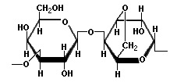

**NOTE:** Polyacrylamide, used mainly for SDS-PAGE, is a matrix formed from monomers of acrylamide and bis-acrylamide. The polymerisation reaction, shown in the diagram below, is a vinyl addition catalysed by free radicals. The reaction is initiated by TEMED, which induces free radical formation from ammonium persulphate (APS). The free radicals transfer electrons to the acrylamide/bisacrylamide monomers, radicalizing them and causing them to react with each other to form the polyacrylamide chain.

In the absence of bis-acrylamide, the acrylamide would polymerise into long strands, not a porous gel. But as the diagram shows, bis-acrylamide cross-links the acrylamide chains and this is what gives rise to the formation of the porous gel matrix. The amount of crosslinking, and therefore the pore size and consequent separation properties of the gel can be controlled by varying the ratio of acrylamide to bis-acrylamide.

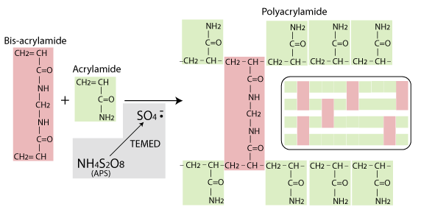

**Advantages and disadvantages of agarose gel electrophoresis:**

**Advantages** :

Nontoxic gel medium

Gels are quick and easy to cast

Good for separating large DNA molecules

Can recover samples by melting the gel,digesting with enzyme agarose or treating with chaotropic salts .

**Disadvantages :**

High cost of agarose

Fuzzy bands

Poor separation of low molecular weight samples .

**Agarose gel electrophoresis (AGE)**

Agarose gel electrophoresis is one of the traditional methods of separating and analyzing nucleic acid .In this method, a porous gel made from agarose acts as a separating medium. Agarose is a purified form of agar,a gelatinous substance extracted from red algae. Agarose is in powdered form, and is insoluble in water at room temperature. Firstly agarose gels are made by adding powdered agarose to liquid buffer and boiling the mixture until the agarose dissolves. This molten agarose is then cooled to about 55–60°C, poured into a gel mold called a casting tray, and allowed to solidify. Before solidification occurs, a comb is placed in the casting tray to create a row of wells into which samples are loaded once the comb is removed from the solidified gel.

The casting tray and solidified gel are then placed in an electrophoresis chamber that has wire electrodes at each end. The agarose gels are horizontally laid and are completely covered by an ioncontaining buffer, such as tris-borate-EDTA (TBE), that controls the pH of the system and conducts electricity. The comb is then carefully removed from the gel and samples are loaded into the resulting wells using a pipet. Samples for gel electrophoresis are mixed with a small amount of sucrose or glycerol to increase their density. This causes the samples to sink to the bottom of the well when loaded.

Once all the samples have been loaded into the wells, the chamber is connected

to a power supply and an electrical current (usually 50–150 V) is applied to the

gel. The chamber is designed with a positive electrode (anode) at one end and

a negative electrode (cathode) at the other end. Electrophoresis literally means “to carry with electricity;” once the electric field is established, charged molecules in the samples migrate through the pores of the gel toward their pole of attraction. Molecules with a net negative charge migrate toward the positive electrode and molecules with a net positive charge migrate toward the negative electrode. The overall charge of a molecule affects the speed at which it travels through the gel. Highly charged molecules migrate more quickly through the gel than weakly charged molecules.

The mobility of a molecule during gel electrophoresis also depends on its molecular size and shape. The small pores of the gel matrix act as a sieve that

provides great resolving power. Small molecules maneuver more easily through

the pores than larger molecules and therefore travel relatively quickly. Large

molecules encounter more resistance as they make their way through the tiny

pores and therefore travel at a slower rate.

Size and net charge are factors that together determine how quickly molecules

will travel through the gel, and thus what their migration distance will be.

Small size and strong charge increase a molecule’s migration rate through the

gel. Large size and weak charge decrease the migration rate. (Note: In electrophoresis of DNA, since all the samples have the same charge, their migration rate is based only on size).The size of the fragments can be determined by running standard DNA ladder run in parallel. Migration rate of the fragments also depends on the concentration of agarose used to prepare gel (Tab 2). Generally used agarose concentration is 0.7% to separate DNA fragments of range 2 -10 kb and 2% agarose for separation of small fragments such as 0.1-1 kb. Low percent gels are weak and high percent gels are often brittle. Standard 1% agarose gels are common for many applications, which can resolve DNA fragments from 0.5-30 kb in length.

**Table 2**. The suggested agarose concentrations for separation of different ranges of Linear DNA molecules (Lewis, 2011).

Agarose Concentration in Gel (% w/v) Range of Separation of Linear DNA Molecules

(kb)

0.3 5-60

0.6 1-20

0.7 0.8-10

0.9 0.5-7

1.2 0.4-6

1.5 0.2-3

2.0 0.1-2

**Staining of the bands**

Ethidium bromide (EtBr) is traditionally used as a dye that binds to DNA and fluoresces under ultraviolet light. EtBr causes mutation and must be handled as hazardous waste. Due to the hazardous nature of the EtBr, recently non-toxic dyes have been introduced in which the gels have to be stained first and then destained to visualize the bands. But, if you are using EtBr as a dye to visualize DNA bands you need to be more careful in handling as to prevent the hazardous effect of EtBr. The EtBr gels have to be disposed separately in hazard wastes disposal bags. While proteins separated on a polyacrylamide gel can be detected by various methods such as : Coomassie blue staining , Silver staining & Detection of radioactive proteins by autoradiography The autoradiography is a detection technique of radioactively labeled molecules that uses photographic emulsions sensitive to radioactive particles or light produced by an intermediate molecule. The emulsion containing silver is sensitive to particulate radiation

(alpha, beta) or electromagnetic radiation (gamma, light...), so that it precipitates as metallic silver. The emulsion will develop as dark precipitates in the region in which radioactive proteins are detected.

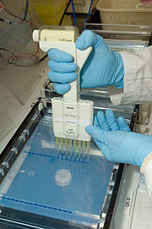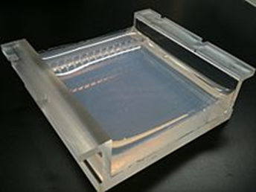

**1**

**2**

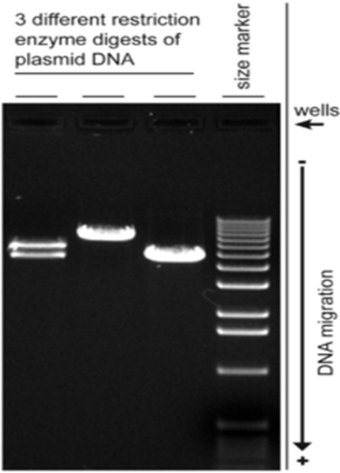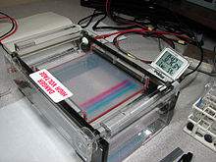

**3**

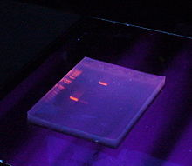

**5**

**4**

**Fig.1**: Agarose gel electrophoresis process.

**1:** An agarose gel cast in tray used for gel electrophoresis

**2:** Loading DNA samples into the wells of an agarose gel using a multi-channel pipette.

**3:** Agarose gel slab in electrophoresis tank with bands of dyes indicating progress of the electrophoresis. The DNA moves towards anode.

**4:** The gel with UV illumination: DNA stained with [ethidium bromide](https://en.wikipedia.org/wiki/Ethidium_bromide) appears as glowing orange bands.

**5:** Digital image of 3 plasmid restriction digests run on a 1% w/v agarose gel, 3 volt/cm, stained with ethidium bromide. The DNA size marker is a commercial 1 kbp ladder. The position of the wells and direction of DNA migration is noted.

Linear duplex DNA fragments travel through agarose gels at a rate which is

inversely proportional to the log of their molecular weight.

**Mr ∝ 1/ log (Mw)**

**Example 1**: Compare molecular mass vs. expected migration rate:

|  |  |  |  |
| --- | --- | --- | --- |
| **Molecular Mass**  **(kDa)** | **log (Molec. Mass)** | | **1/log (Molec. Mass)**  **i.e. relative Mr (Migration Rate)** |
| 20000 | | 4.3 | 0.23 |
| 15000 | | 4.1 | 0.24 |
| 10000 | | 4.0 | 0.25 |
| 5000 | | 3.7 | 0.27 |
| 1000 | | 3.0 | 0.33 |

Mr= Migration Rate

There is an inverse linear relationship between the logarithm of the electrophoretic mobility and gel concentration.

**Log (Mr)** ∝ **1/Gel %**

**Example 2**: Compare gel percentage vs. expected migration rate (Mr)

|  |  |  |
| --- | --- | --- |
| **Gel %** | **1/Gel %** | **inv log(1/Gel %)**  **(i.e. relative Mr)** |
| 2.0 | 0.5 | 3.2 |
| 1.5 | 0.66 | 4.6 |
| 1.0 | 1.0 | 10.0 |
| 0.5 | 2.0 | 100.0 |

The above explained relationship between migration rate and size of DNA is applicable only to linear DNA fragments. Generally DNA can exist in three forms: linear form, opencircular form and supercoiled form.

The linear DNA may be the product of PCR amplification or the restriction digestion product. But plasmid DNA is the one which are mostly studied. In in-vivo plasmids exist as highly supercoiled form to enable it to fit inside the cell. When the plasmid preparation is done plasmid DNA can exist in all the three conformations i.e. linear, opencircular and supercoiled forms (Fig. 2**)**.

**Supercoiled DNA** :Supercoiled DNA migrates faster than predicted in an agarose gel due to its conformation.  Supercoiled DNA is the desired species when isolating plasmid DNA.

**Nicked, Relaxed Circular Plasmid:**During replication, cellular topoisomerases nick one strand of the DNA helix and relax the superhelical tension, thus allowing polymerases to gain access to the DNA. Nicked circle DNA is the rubber band without any twists introduced.  This large floppy circle is the slowest migrating form in an agarose gel.

**Linear Plasmid:** Linearized DNA occurs when the DNA helix is cut in both strands at the same place.  Linear DNA generally migrates between the nicked circle and the supercoiled forms.  However, it may also migrate the same distance as nicked circle — it migrates as predicted by the length of the DNA (as compared to the MW markers).  You can identify the linear DNA form on an agarose gel by comparing uncut plasmid DNA with a sample of the plasmid that has been linearized using a restriction enzyme.  If you get linear DNA when you are hoping for supercoiled (e.g. after a plasmid prep) it is due to nuclease contamination or harsh treatment during purification.

**Circular, Single Stranded Plasmid :** During alkaline lysis plasmid preps, plasmids are denatured because the hydrogen bonds are disrupted by the alkaline conditions. But the covalently-closed circular strands remain intact and topologically constrained and when the pH is returned to neutral the hydrogen bonds reform and the supercoiled DNA is re-formed. However, if the [alkaline lysis](https://bitesizebio.com/articles/the-basics-how-alkaline-lysis-works/) step is overly harsh (e.g. it is incubated for too long) the DNA can become permanently denatured and give you useless single stranded closed circles that migrate ahead of all of the other forms of the plasmid in a gel.

Although DNA plasmid preps can return multiple forms of DNA, there is only one kind you want for successful cloning and transfection: supercoiled.

**Note:** Some times improper handling or storage of the isolated DNA may degrade, which can be detected as a smear when run on the agarose gel.

**Note:** supercoiled plasmid is only one kind you want for successful cloning and transfection.

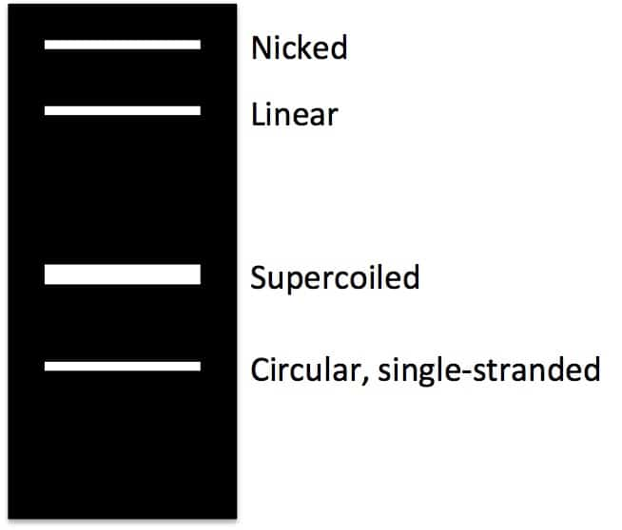

**Fig. 2:** Plasmid DNA checked on agarose gel showing all the three conformations.

**Recovery of DNA fragments from gels**

Several different procedures are used for the isolation of nucleic acids from agarose gels: electroelution, absorption to DEAE paper, absorption to glass powder or resins, digestion of agarose with enzymes.

**Pulsed field gel electrophoresis**

DNA fragments longer than about 20 kb cannot be resolved in conventional agarose gel electrophoresis because long DNA molecules align themselves as rods and migrate with a mobility that is independent of their length. In pulsed field gel electrophoresis (PFGE), the molecules are subjected to two alternating electrical fields that are applied on the gel at an angle between 110º and 180º. The DNA fragments must change their orientation with changes in the electric field: their helical structure is first compressed and then stretched. The ‘viscoelastic relaxation time’ is dependent on the size of the molecule. In addition, large molecules need more time to change their direction than small ones. Because of the longer time needed for stretching and reorientation, larger molecules have less time left for migration in the electric field.

In PFGE, the resulting electrophoretic mobilities depend on the pulse time: DNA molecules with fragment sizes up to about 10 megabases (Mb) can be resolved.

Pulse times of 1 s to 90 min are applied, depending on the length of the DNA molecules being analyzed. Large molecules are better separated with long pulse

times, small molecules need short pulse times. Separations can take several days. In order to prevent chromosome-size molecules breaking by shear forces during pipetting, sample preparation including cell disruption is carried out inside little agarose blocks. These agarose blocks are inserted into preformed sample wells of the separation gel.

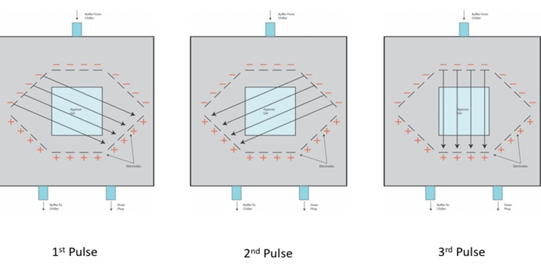

**Polyacrylamide gel electrophoresis (SDS-PAGE)**

Gel electrophoresis of proteins with a polyacrylamide matrix, commonly called

polyacrylamide gel electrophoresis (PAGE) is undoubtedly one of the most widely used techniques to characterize complex protein mixtures. It is a convenient, fast and inexpensive method because they require only the order of micrograms quantities of protein.

The proteins have a net electrical charge if they are in a medium having a pH different from their isoelectric point and therefore have the ability to move when subjected to an electric field. The migration velocity is proportional to the ratio between the charges of the protein and its mass. The higher charge per unit of mass the faster the migration.

Proteins do not have a predictable structure as nucleic acids, and thus their rates of migration are not similar to each other. They can even not migrate when applying an electromotive force (when they are in their isoelectric point). In these cases, the proteins are denatured by adding a detergent such as sodium dodecyl sulfate (SDS) to separate them exclusively according to molecular weight. This technique was firstly introduced by Shapiro *et al*. (1967). SDS is a reducing agent that breaks disulfide bonds, separating the protein into its sub-units and also gives a net negative charge which allows them to migrate through the gel in direct relation to their size. In addition, denaturation makes them lose their tertiary structure and therefore migration velocity is proportional to the size and not to tertiary structure.

**Two Dimensional Polyacrylamide Gel Electrophoresis (Two-dimensional gel electrophoresis)**

Two-dimensional gel electrophoresis (2-DE) is based on separating a mixture of proteins according to two molecular properties, one in each dimension. The most used is based on a first dimension separation by isoelectric focusing and second dimension according to molecular weight by SDS-PAGE .



**Fig. 3:** Staining of 2-D gels. A) 24 cm two dimensional polyacrylamide gel electrophoresis of

mouse colon protein stained by silver staining or (B) Deep purple flurophore dye.

Visualization of B image was done using a laser scanner (Magdeldin et al, 2010). C, D, and E

shows 2D-DIGE stained with cyDye (cy2, cy3 and cy5), respectively.