**Principles of blotting techniques**

**What is Blotting?**

Blots are techniques for transferring DNA , RNA and proteins onto a carrier so they can be separated, and often follows the use of a gel electrophoresis. The Southern blot is used for transferring DNA, the Northern blot for RNA and the western blot for protein.

Southern blotting is a method used to transfer DNA from an agarose gel to a membrane, where the DNA can be subsequently probed for a specific sequence. The technique was named after its inventor, **Edwin Mellor Southern**, who developed the technique in Edinburgh, Scotland in the 1975s. As a result subsequent blotting techniques have used similar nomenclature, for example Northern blotting, the transfer of RNA; Western blotting, the transfer of proteins; and Southwestern blotting, for the characterization of proteins that bind DNA.

**northern blotting**

**(RNA)**

**J.C. Alwine**

**western blotting**

**(Protein)**

**W. Neal Burnette Neal** Burnette

**eastern blotting**

**????**

**Southern blotting**

**(DNA)**

**Edwin M. Southern**



**Application of Southern blotting:**

Southern blot a technique developed for the detection of a specific DNA sequence (gene or other) in a large, complex sample of DNA (e.g. cellular DNA). For example, Southern blotting could be used to locate a particular gene within an entire genome. More of its applications are listed below:

1-Southern blotting technique is used to detect DNA in given sample.

2-DNA finger printing is an example of southern blotting.

3-Used for paternity testing, criminal identification, victim identification

4-To isolate and identify desire gene of interest.

5-Used in restriction fragment length polymorphism

6-To identify mutation or gene rearrangement in the sequence of DNA

7-Used in diagnosis of disease caused by genetic defects

8-Used to identify infectious agents.

**Principle of Southern blot:**

• This technique is based on the principle of separation of DNA fragments by gel electrophoresis and identified by labelled probe hybridization.

• Basically, the DNA fragments are separated on the basis of size and charge during electrophoresis. Separated DNA fragments after transferring on nylon membrane, the desired DNA is detected using specific DNA probe that is complementary to the desired DNA.

• Hybridization : Process of forming a double-stranded DNA molecule between a single-stranded DNA probe and a single-stranded target patient DNA.

• A hybridization probe is a short (100-500bp), single stranded DNA/or RNA. The probes are labeled with a marker so that they can be detected after hybridization.

## Procedure/ Steps

**Step 1**) Digest the DNA with an appropriate restriction enzyme.

**Step 2**) Run the digest on an agarose gel.

**Step 3**) After electrophoresis, denature the DNA (usually while it is still on the gel) by soaked the gel in alkali (NaOH) or acid (HCl) to denature the double stranded DNA fragments. DNA strands get separated. For example, soak it in about 0.5M NaOH, which would separate double-stranded DNA into single-stranded DNA. Only ssDNA can transfer.

A depurination step is optional. Fragments greater than 15 kb are hard to transfer to the blotting membrane. Depurination with HCl (about 0.2M HCl for 15 minutes) takes the purines out, cutting the DNA into smaller fragments. Be aware, however, that the procedure may also be hampered by fragments that are too small.

**Note**: Be sure to neutralize the acid after this step, or the base after the prior step if you don't depurinate.

**Step 4**) Transfer the denatured DNA to the membrane (Blotting). Traditionally, a nitrocellulose membrane is used, although nylon or a positively charged nylon membrane may be used. Nitrocellulose typically has a binding capacity of about 100µg/cm, while nylon has a binding capacity of about 500 µg/cm. Many scientists feel nylon is better since it binds more and is less fragile.

Nylon membranes cannot be damaged by handling and a single blot can be rehybridized up to ten times, this limit being due not to eventual breakage of the membrane but to the gradual loss of the blotted DNA during repeated hybridizations. The second advantage of nylon membranes is that under certain conditions (a positively charged membrane and an alkaline transfer buffer) the transferred DNA becomes covalently bound to the membrane during the transfer process. This is not the case with a nitrocellulose membrane, which initially binds DNA in a semipermanent manner, immobilization occurring only when the membrane is baked at 808C. Transfer onto a positively charged nylon membrane can therefore reduce the possible loss of DNA that might occur by

leaching through the membrane during the blotting process; it is also quicker, the transfer time being reduced from 18 h to 2 h. Finally, nylon membranes efficiently bind DNA fragments down to 50 bp in length, whereas nitrocellulose membranes are effective only with molecules longer than 500 bp. Nitrocellulose has not, however, been completely superseded because it has one significant

advantage compared with nylon membranes: a reduced amount of background hybridization, especially with probes that have been labelled with nonradioactive markers.

Transfer is usually done by capillary action, which takes several hours. Capillary action transfer draws the buffer up by capillary action through the gel an into the membrane, which will bind ssDNA.

You may use a vacuum blot apparatus instead of capillary action. In this procedure, a vacuum sucks SSC through the membrane. This works similarly to capillary action, except more SSC goes through the gel and membrane, so it is faster (about an hour). (SSC provides the high salt level that you need to transfer DNA.)

**Step 5**) Baking: After the DNA of interest bound on the membrane, it is baked by treating it with UV light. This cross links (via covalent bonds) the DNA to the membrane. (You can also bake nitrocellulose on autoclave at about 80C for a couple of hours to fix in the membrane, but be aware that it is very combustible.)

**Note**: For nylon membranes, the DNA is cross-linked to the membrane by the action of ultraviolet light; nitrocellulose membranes use heat to fix the DNA to the membrane.

**Step 6**) Blocking (Prehybridization): The membrane is then treated with casein or Bovine serum albumin (BSA) which saturates all the binding site of membrane.

**Note:** To prehybridize, add non-specific ssDNA. Somicated salmon sperm DNA is commonly used. You can use BSA( bovine serum albumen), a non-specific protein, SDS (sodium dodecyl sulfate), and formamide.

**Note**: A prehybridization step is required before hybridization to block non-specific sites, since you don't want your single-stranded probe binding just anywhere on the membrane.

**Step 7)** Hybridization with labelled probes: The DNA bound to membrane is then treated with labelled probe. The labelled probe contains the complementary sequences to the gene of interest . The probe bind with complementary DNA on the membrane since all other non-specific binding site on the membrane has been blocked by BSA or casein.

**Note**: Probing is often done with 32P labeled ATP, biotin/streptavidin or a bioluminescent probe.

**Note**: To hybridize, use the same buffer as for prehybridization, but add your specific probe.

**Step 8**) Visualization by Autoradiogram: The membrane bound DNA labelled with probe can be visualized under autoradiogram which give pattern of bands.

**Note**: If you used a radiolabeled 32P probe, then you would visualize by autoradiograph. Biotin/streptavidin detection is done by colorimetric methods, and bioluminescent visualization uses luminesence.

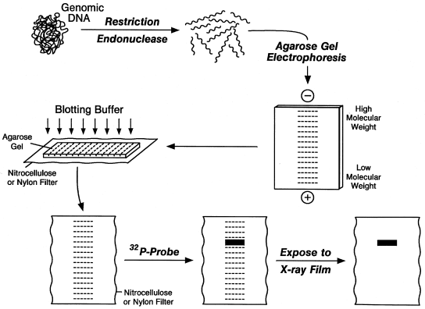

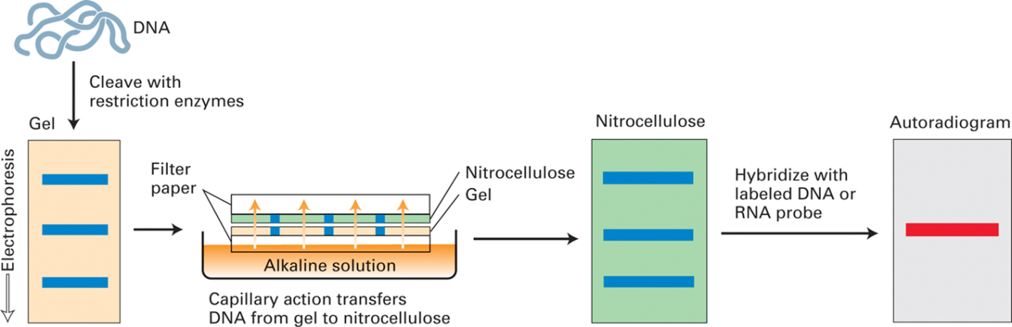



**Note**: Traditionally, a nitrocellulose membrane is used, although nylon or a positively charged nylon membrane may be used. Nitrocellulose typically has a binding capacity of about 100µg/cm, while nylon has a binding capacity of about 500 µg/cm. Many scientists feel nylon is better since it binds more and is less fragile. Transfer is usually done by capillary action, which takes several hours. Capillary action transfer draws the buffer up by capillary action through the gel an into the membrane, which will bind ssDNA.

**Note**: Probing is often done with 32P labeled ATP, biotin/streptavidin or a bioluminescent probe.

**Northern blotting**

Northern blotting was developed by James Alwine, George Stark and David Kemp (1977). Northern blotting drives its name because of its similarity to the first blotting technique, which is Southern blotting, named after the biologist Edwin Southern. The major difference is that RNA being analyzed rather than DNA in the northern blot.

Expression of a particular gene can be detected by estimating the corresponding mRNA by Northern blotting. Northern blotting is a technique where RNA fragments are separated by electrophoresis and immobilized on a paper sheet. Identification of a specific RNA is then done by hybridization using a labeled nucleic acid probe. It helps to study gene expression by detection of RNA (or isolated mRNA) in a sample.

In Northern blotting, probes formed of nucleic acids with a sequence which is complementary to the sequence or to a part of the RNA of interest. The probe can be DNA, RNA or chemically synthesized oligonucleotides of minimum 25 complementary bases to the target sequence.

**Western blotting**

Western blotting, also known as immunoblotting or protein blotting, is a technique used to detect the presence of a specific protein in a complex protein mixture. It is a core technique in cell biology, molecular biology, virology and others.

Western blots have become one of the most common analytical tools for the

Detection of viral proteins, characterization of monoclonal and Polyclonal antibody preparations and in determining the specificity of the immune response to viral antigens.

**Steps involved in western blotting :**

1.Sample preparation

2.Gel Electrophoresis

3.Blotting (or transfer)

4.Blocking

5.Antibody Probing

6.Detection

**Questions:**

## 1-what is the purpose of the Southern blot and hybridization technique?

### To detect a specific DNA molecule(s) among a complex mixture of DNA molecules

**2** -Why is it called Southern blot and hybridization?

### Because Edward Southern developed the technique.

### 

**3**-How do you denature double-stranded DNA?

### With heat (>95degC) or chemicals (eg. formamide or NaOH) .

**4**-How does renaturation of single-stranded DNA occur?

### by cooling or removal of chemicals .

**5**- What can the radioactively-labelled hybridization probe be?

### either DNA or RNA.

### 

**6**- What are the characterizations of the Southern blot?

### 1) Size-fractionation of a complex mixture of DNA molecules by agarose gel-electrophoresis. 2) Denaturation of the double-stranded DNA by NaOH (alkali) to break the hydrogen bond between bases 3) Transfer of the single-stranded DNA molecules to a rigid support, a nitrocellulose filter.

**7**- What are the steps for filter hybridization?

### - high molecular mass DNA to low molecular mass DNA fragments - single-stranded DNA becomes immoblized to the nitrocellulose filter - radioactively labelled hybridization probe anneals to target DNA - wash off probe not hybridized to the target DNA - overlay filter with X-ray film for autoradiography

**8**- What creates the photographic emulsion in autoradiogrphy?

### Silver halide (bromide, chloride, iodide) crystals suspended in gelatin on a plastic film.

### 

**9**- What is the chemical process of autoradiogrphy?

### Photons or radiation cause silver metallic speck to form. During development, entire crystal is converted into metallic silver that is visible on film .

**10**- What does autoradiography do?

### Allows radioactive emissions to activate silver grains in the film. Develops X-ray film .

**11**- How does the Southern blot and hybridization technique diagnosis sickle-cell anemia?

### It detects the Dde I fragments on a Southern blot by probing with beginning of beta-globin gene

**12**- What DNA probe is used to diagnosis Thalassemias?

### Globin genes.

### 

**13**- What DNA probe is used to diagnosis hemophilia?

### Factor VIII gene.

### 

**14**- What DNA probe is used to diagnosis dwarfism?

### Growth hormone gene .

**15**- What does a Northern blot measure?

A northern blot is a laboratory method used to detect specific RNA molecules among a mixture of RNA. Northern blotting can be used to analyze a sample of RNA from a particular tissue or cell type in order to measure the RNA expression of particular genes.

**16-** Show the differences between A , B , C

where : **A**:Southern blotting , **B**:Nothern blotting & **C**:Western blotting

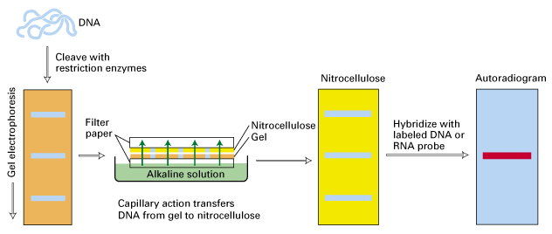

**A**



**B**

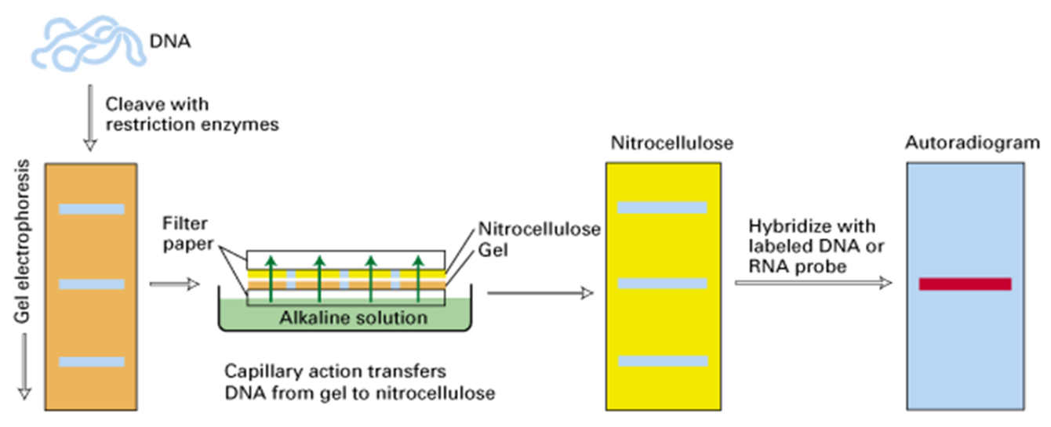

**C**