#### Microbial Fermentation by Yeast :

Anaerobic fermentation involves the breakdown of carbohydrates in the absence of oxygen , in biological process convert glucose , fructose and sucrose to ethanol & CO2 .

\***Uses of alcohol :**

 In pigments, pharmaceuticals, detergents and cosmetics can be used as fuel for cars.

If the rate of alcohol between ( 6-14%) the product called the wine. but if the alcohol concentration was ( 3-6%) the product called beer .

**\*\*Microorganisms:**

Saccharomyces *cerevisiae :* is the first choice in commercial production under anaerobic conditions , also the Saccharomyces *uvarum* is used because it is very soluble and this is easy to extract .

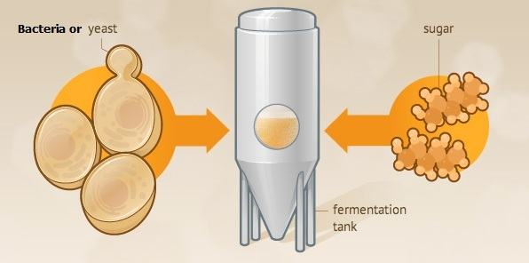

Alcohol was produced when the percentage of sugar in molasses ( waste of dates or vegetables ) should be between 10-25% . So the molasses are media for ethanol production.

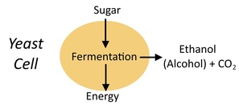 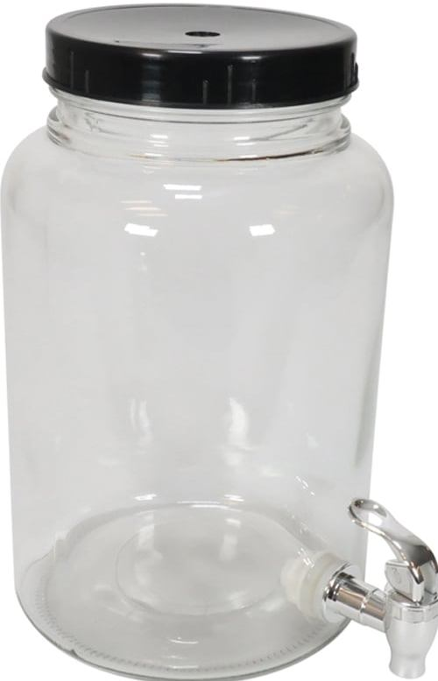

**\*\*\*Experimental fermentation method in lab :**

**Equipments and tools we need to**

**1- Glass fermentation vessels .**

**2- Condenser** :a glass condenser  is an apparatus used to [condense](https://en.wikipedia.org/wiki/Condensation) ([change the physical state](https://en.wikipedia.org/wiki/Change_of_state) of a substance from its gaseous (hot steam) to its liquid state by cooling in a process called [**distillation Process**](https://santafespirits.com/distillation-process).

**3- Refractometer:** A [refractometer](https://www.coleparmer.com/c/refractometers" \o " Buy Refractometers from Cole-Parmer) is a simple device it used for measuring concentrations of aqueous solutions. It requires only a few drops of liquid, and is used throughout the [food](https://www.coleparmer.com/industry/food-and-beverage), [agricultural](https://www.coleparmer.com/industry/agriculture), [chemical](https://www.coleparmer.com/industry/chemical-process), and manufacturing industries.

**4- Glass tools of measuring : beakers , pycnometer , round flask , cylinder et cetera.**

**\*\*\*\*Media components:**

**1- Source of sugar (sugar concentration about 15-25%), Dates, Date syrup (Dibbis), Sugar cane syrup, Molasses, Crystal sugar, Glucose …etc.**

**2- Distilled water.**

**3- Inoculum ( Yeast * *Saccharomyces cerevisie =* 0.25%).**

**4- salts ( Ammonium phosphate or Ammonium sulphate = 0.1% ) as source of nitrogen.**

**\*\*\*\*\*Fermentation conditions :**

**Anaerobic conditions ,temperature = 30 C , PH= 5 - 6**

**The first six hours of fermentation should be aerobic conditions to formation the biomass.**

**There are two experiments performed per week:**

**1- Total soluble solid (TSS %) : measured by refractometer,** **drop of solution is placed by pasteur pipette.**

**2- Ethanol concentration EOH % : performed by** [**distillation Process**](https://santafespirits.com/distillation-process).

Procedure:

1- put such as 50 ml from sample ( sugary solution) in distillation flask .

2- Connect the rest of glass tools with Flask for the completion the distillation process by boiling .

3- The resulting from the distillation process collected in pycnometer (its volume ranges between 15-25 ml) .

4- determine the specific gravity of ethanol concentration at every-time after distillation process of the sample, calculate the specific gravity by the following formula :

**Specific gravity = Weight of pycnometer plus distillate _ Weight of empty pycnometer.**

**Weight of pycnometer plus D.W _ Weight of empty pycnometer.**

**W= Weight of empty pycnometer.**

**W1= Weight of pycnometer plus D.W.**

**W2= Weight of pycnometer plus distillate.**

Specific gravity = W2 - W

W1 - W

5- compare the results of specific gravity each week in Lab. With the previous concentrations of sugary solution sample.

every week taking the sample and recording the readings.

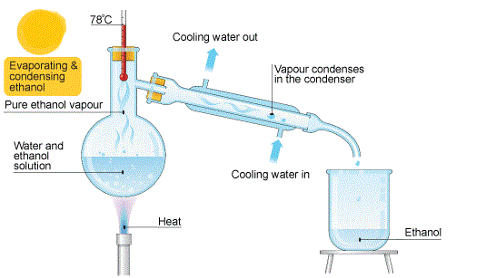

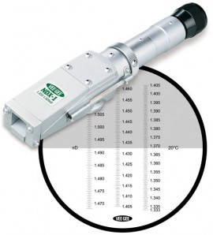 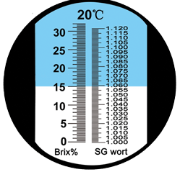

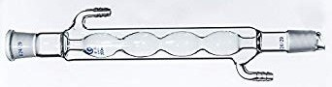

|  |  |  |
| --- | --- | --- |
| week | TSS% | EOH % |
| 0  1 Type of fermentation  2 …………………  3  4  5 Type of fermentation  6 ……………………. |  |  |