Lecture 2 Invertebrates
Locomotor organelles:
Flagella, cilia, pseudopodia
Cilia | Flagella
- short hair like appendages extending from the surface of living cell | - Long thread like appendages on the surface of living cell
- Rotational like a motor very fast moving | - Wave like undulating slow movement compared to cilia
- Many (hundreds) per cell | - Few (less than 10) per cell
- Eukaryotic cells | - Eukaryotic and prokaryotic cells

3. pseudopodia
The types of pseudopodia are
- Lobopodia ……Amoeba
- Filopodia ………..Euglypha
- Rhizopodia ……….or (Reticulopodia )………..Elphidium
- Axopodia …………Actinosphaerium

Reproduction in protozoa
I . A sexual reproduction
- Binary fission :
cell divided into two cells. DNA of the nucleus of a mature cell divided first and then the cell divided into two daughter cell of almost the same size, like Amoeba
- Multiple fission (sporulation)
one of cells enlarged and forms the sporangium. The nucleus divided many times and then the daughter nuclei are surrounded with protoplasm bits to form daughter cells called spores, spores are covered with a thick wall called the cyst, in maturation, the sporangium bursts and releases the spores

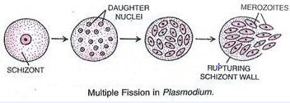
- Budding:
in which a new individual develops from some generative anatomical point of the parent organism. in some species buds, may be produced from almost any point of the body but in many cases budding is restricted to specialized areas.
- Plasmotomy:
A special type of fission in which a multinucleate protozoan divide into two or more multinucleate daughter individuals
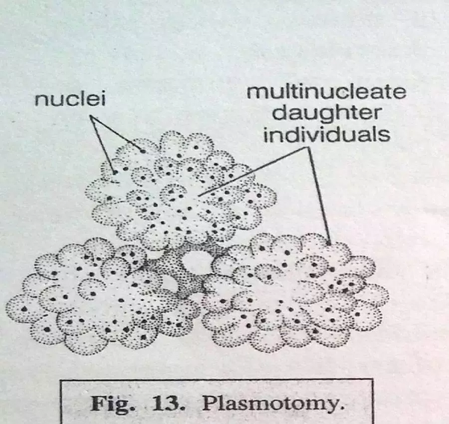

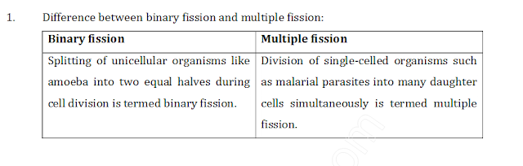
II . Sexual reproduction
- Syngamy :
Is the complete and permanent fusion of the two sex cells gametes to form a zygote, which gives rise to adult, and distinguished into following types
- Hologamy
- Paedogamy
- Isogamy
- Anisogamy
- Microgamy
- Macrogamy

- Conjugation
Sexual process in which two lower organisms of the same species such as protozoan exchange nuclear material during a temporary union, completely transfer one organism's contents to the other organism or fuse together to form one organism, the forms may or may not resemble each other in size, shape or motility, they differ in some physiological or genetic characteristic
- Plasmogamy :
Fusion of two or more cells or protoplast without fusion of nuclei, the purpose to kill the big size prey like paramecium
Note: It is not method or kind of reproduction

Euglena
- Biflagellate, unicell, spindle shape
- Most species have photosynthesizing chloroplast within the body of cell . Euglena chloroplasts contain pyrenoids, used in the synthesis of paramylon, a form of starch energy storage.
- All euglenoids have two flagella rooted in basal bodies located in a small reservoir at the front of the cell. one flagellum is very short, while the other is relatively long, and often easily visible with light microscopy .
- Euglena possess a red eyespot, an organelle composed of carotenoid pigment granules. The red spot itself is not thought to be photosensitive, aid in the detection of light , and have Photoreceptor or Paraflagellar body: this light sensitive region detects light and is located near the flagellum. It assists in phototaxis (movement toward or away from light).

- Euglena lacks a cell wall. Instead, it has a pellicle made up of a protein layer supported by a substructure of microtubules, arranged in strips spiraling around the cell, gives Euglena its exceptional flexibility and contractility. There is no cellulose.
- Species of Euglena are found in freshwater and salt water. They are often abundant in those
- Small and inconspicuous contractile vacuole is located to one side of the reservoir, into which it discharges, it function is osmoregulation.
- Euglena reproduce asexually through binary fission, a form of cell division, Euglena divide longitudinally, beginning at the front end of the cell, with the duplication of flagellar processes and stigma, a cleavage forms in the anterior, and a V-shaped, moves toward the posterior, until the two halves are entirely separated, sexual conjugation are rar
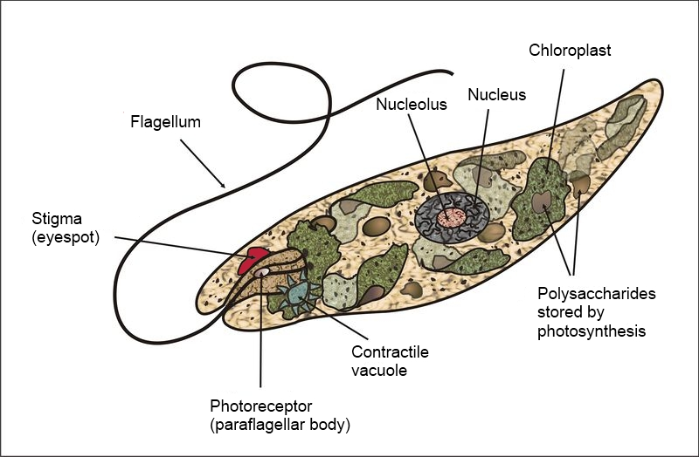
Euglena

Amoeba:
- They so tiny so need microscope to see them
- Living in water, including lakes ,ponds stream , river and puddles , some can live in the bodies of animals
- Move by pseudopodia and help amoeba to eat
- Reproduce by binary fission, it means that one amoeba can split in half and make two identical new Amoeba .
- Cytoplasm divided into two parts
Endoplasm and ectoplasm both enclosed with a flexible plasma membrane
- Cell contain single granular nucleus containing DNA.
- Contractile vacuole is used to maintain osmotic equilibrium by excreting excess water from the cell.
- An Amoeba obtains its food by phagocytosis and particles of organic matter or by pinocytosis taking in dissolved nutrients through vesicles formed within the cell membrane

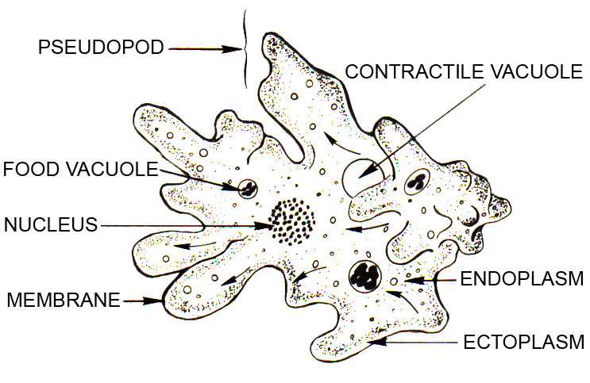
Amoeba

