Fungal physiology is the study of living fungi , their functions and activities to their environments.
The more understand their life and physiology, the better we can utilize them in agriculture , industry and medicine , and at the same time the greater will be our control over their harmful actives as pathogens of plants, animals and man , and as destroyers of timber , textiles food and feed.
Ultra structure of fungi
Most fungi grow as hyphae, which are cylindrical, threadlike
structures 2–10 μm in diameter and up to several centimeters in length.
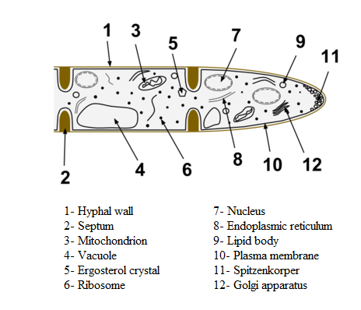
Hyphae
Hyphae grow at their tips. New hyphae are typically formed by emergence of new tips along existing hyphae by a process called branching, or occasionally growing hyphal tips bifurcate (fork) giving rise to two parallel growing hyphae.
The combination of apical growth and branching/forking leads to the development of a mycelium, an interconnected network of hyphae.
Hyphae can be either septate or coenocytic: septate hyphae are divided into compartments separated by cross walls (internal cell walls, called septa, that are formed at right angles to the cell wall giving the hypha its shape), with each compartment containing one or more nuclei; coenocytic hyphae are not compartmentalized.

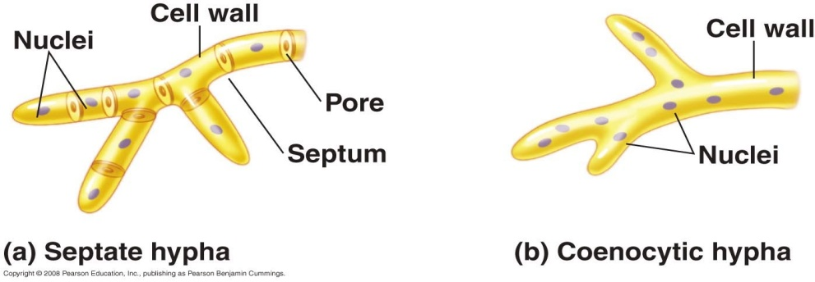

Septa have pores that allow cytoplasm, organelles, and sometimes nuclei to pass through; an example is the dolipore septum in the fungi of the phylum Basidiomycota.
Coenocytic hyphae are essentially multinucleate supercells.
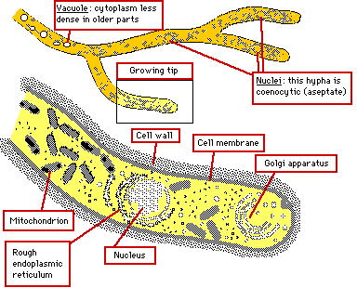

Cell structure | Description | Function
Cell wall | Freely permeable layer surrounding cell membrane | Supports and strengthens cell
Cell membrane | Selectively permeable double layer of lipid and protein molecules | Controls which substances can enter and leave the cell
Cytoplasm | Fluid enclosed by the cell membrane, containing organelles and ribosomes | Location of many chemical reactions
Mitochondria | Rod-shaped structures found in cytoplasm | Location where aerobic respiration occurs and most of the cell's ATP is produced
Ribosomes | Small complexes found in cytoplasm | Location where amino acids are connected together to produce proteins
Plasmids | Small circular DNA molecules | Contains genes that help cell to function, eg genes for antibiotic resistance
Nucleus | Compartment in cell where DNA is stored as chromosomes | Controls activities of cell
Fungal Cell Structure
Fungal cells are organized a little differently from animal and plant cells. Like plant cells, they have a cell wall; however, unlike plant cells, the cell wall lacks cellulose (in true fungi) and there are no chloroplasts.
The typical fungal structure is that of a colony of cells strung together in a filament called a Hypha (plural, hyphae). The cells in a hypha are separated by a cross-wall called a Septum. Hyphae tend to form a larger network of cells called a Mycelium. phs of mycelia, as needed.)
Cell Wall: This structure prevents the hyhae from bursting due to the processes of osmosis. The cell wall in mycelial fungi varies in thickness from about 50 nm (50 billionths of a metre) in the recently synthesized areas around the apex to 250 nanometres (250 billionths of a metre). The cell wall has four main biochemical constituents:

Chemical composition of the wall:
- POLYMERIC FIBRILS
  - chitin
  - cellulose (in the Oomycota)
- AMORPHOUS MATRIX COMPONENTS
  - glucans
  - proteins
  - lipids
  - heteropolymers (mixed polymers) of mannose, galactose, fucose and xylose
- The types and amounts of these various components vary amongst different groups of fungi and may even vary during the life cycle of a single species.
Functions The Fungal Wall
- PROTECTS the underlying protoplasm;
- determines and MAINTAINS THE SHAPE of the fungal cell or hypha; if you remove the wall the resulting protoplast will always assume a spherical shape;
- acts as an INTERFACE between the fungus and its environment;
- acts as a BINDING SITE for some enzymes;
- possesses ANTIGENIC properties - which allow interactions with other organisms.
Arrangement of the wall components:

- The diagram above represents a section through the mature lateral wall of hyphae of Neurospora crassa.
- In general, the inner part of the wall consists of POLYMERIC FIBRILS embedded in an AMORPHOUS MATRIX and this is covered by further layers of matrix material.
- At the HYPHAL TIP the wall is thinner and simpler in structure, consisting of only TWO LAYERS - an inner layer of fibrils embedded in protein and outer layer of mainly protein.
- EXTRA LAYERS of wall material are deposited in the lateral walls behind the extending apex - strengthening the wall as the hypha matures.
- In the oldest parts of the hyphae (and in many fungal spores) LIPIDS and PIGMENTS may be desposited in the wall:
  - LIPIDS serve as a nutrient reserve and help prevent desiccation
  - PIGMENTS, such as MELANIN, help protect the protoplast against the damaging effects of UV radiation.
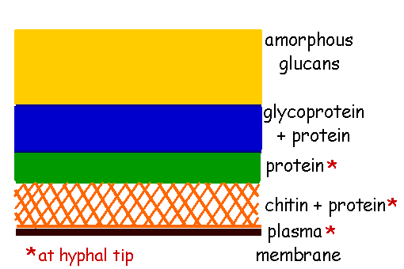
Table 1: Common wall constituents found in each division of fungi
Division | Fibrous | Gel-like Polymer
Basidiomycota | Chitin  β -(1-3), β-(1-6) Glucan | Xylomannoproteins  α (1-3) Glucan
Ascomycota | chitin  β -(1-3), β-(1-6) Glucan | Galactomannoproteins  α (1-3) Glucan
Zygomycota | Chitin  Chitosan | Polyglucuronic acid  Glucuronomannoproteins  Polyphosphate
Chytridiomycota | Chitin  Glucan | Glucan

