Cyanobacteria Population Dynamics and Toxin Biosynthesis in the Environment
Occurrence of toxic cyanobacterial blooms (cyanoblooms) is a serious global problem which affects the water quality due to the production and accumulation of different cyanotoxins and other malodorous compounds. These blooms may cause an increase of biological oxygen demand (BOD) and anoxia in the water bodies, and death of aquatic organismes. Nevertheless, cultural eutrophication from domestic, industrial, and agricultural wastes as well as global climate change can play a major role in the global expansion of harmful algal blooms and toxin production.
The anthropogenically (Human activities) led to change in the N/P ratio has frequently been interrelated to the appearance of cyanobacterial blooms .The phosphorus and nitrogen concentration was found as a primary regulating factor for increased cyanobacterial growth and changes of genotypes, these role of eutrophication in the occurrence of toxic blooms .
Global climate change followed by changes in air/water temperature gradients, as well as increased nutrient precipitation can affect the cyanobacterial bloom formation and production of different cyanotoxins
Warm and calm weather and low turbulence can enhance the formation of cyanobacterial blooms .Increased emission of ozone depleting substances (ODSs), due to huge burning of fossil-fuels and concomitant changes in air temperature, may promote the water cyanobacterial growth.
As a result of climate change, the frequent droughts in summer as well as flash-flooding may lead to abandoned nutrient discharges from urban areas to unloading water bodies such as ponds, lakes, ditches, and estuaries with the consequence of the increase of toxic blooms and the increase of the BOD of a water reservoir .
Nitrogen limitation under drought condition may cause a shift from non-N2-fixing to N2-fixing cyanobacteria leading to an increase in biologically available nitrogen and a subsequent production of cyanotoxins.
The increased salination due to summer droughts, rising sea levels, wind flow, and common practices of the use of freshwater for agricultural irrigation, all have led to the origin and existence of several salt tolerant freshwater toxic cyanobacteria as evidenced by an increased number of blooms in brackish waters .

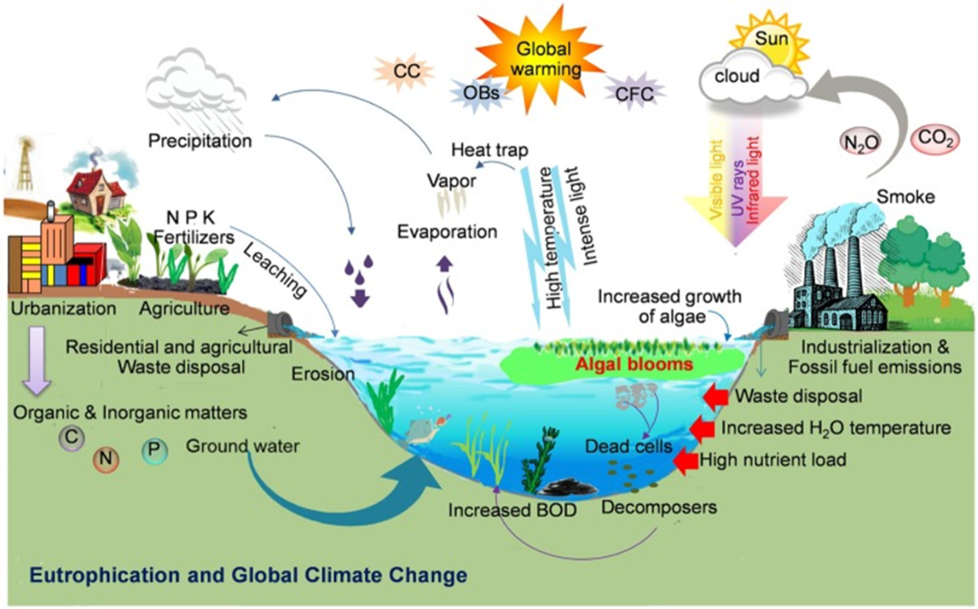
Formation of cyanobacterial blooms: Schematic illustration showing the key factors such as anthropogenic eutrophication, global climate change such as increased temperature and light or global warming due to an increase in ozone depleting substances (e.g., CO2, N2O, etc.), and other biotic and abiotic factors responsible for the worldwide bloom incidence (Illustration by R. P. Rastogi).

Source Water Condition: | When to take notice:
Excessive nutrients | Nitrogen and/or phosphorous are the primary nutrients of concern for cyanobacteria. Elevated nitrogen and/or phosphorous levels can lead to cyanobacteria proliferation. Different water bodies will have different levels of nutrients that can favor cyanobacteria proliferation.
Quiescence | Calm, stagnant waters (i.e., low flow or slope in rivers; low turnover or wind conditions in lakes/reservoirs; etc.).
Water temperature | Water temperatures above 25°C (or lower for some cyanobacteria species)
Light intensity and rainfall | Rainfall followed by prolonged periods of sunlight and dry conditions. Rain washes nutrients into the water body and subsequent sunny and dry conditions can lead to cyanobacteria proliferation.
Wind patterns | Wind conditions that concentrate surface blooms in warm, shallow parts of a water body in the vicinity of nutrient sources. Strong winds can also mix surface blooms downward toward intake depths.

Cyanobacteria Population Dynamics and Toxin Biosynthesis in the Environment
Cyanobacterial growth, species variations, and concentration in the environment are influenced by both abiotic and biotic environmental factors. Abiotic factors, such as wind and characteristics of water bodies (e.g., depth, stream flow, and tides), affect cyanobacterial accumulation and concentration, while light intensity, nutrients, temperature, and biotic factors influence toxin biosynthesis and cyanobacterial populations, species and strain variations.

1. Characteristics of Water Bodies and Wind Direction
Freshwater environments consist of two different habitats: benthic and planktonic habitats. The benthic habitat is the deepest region of freshwater environment, whereas the planktonic habitat is the upper region of the habitat. The benthic habitat is commonly inhabited by cyanobacteria lacking gas vacuoles, nontoxic Nodularia species (e.g., N. sphaerocarpa and N. harveyana), and a toxic benthic species, Phormidium favosum.
Meanwhile, the planktonic habitat is inhabited by cyanobacteria, consisting of gas vesicle organelles (enabling them to float). The planktonic cyanobacteria include Planktothrix, toxic Nodularia, Anabaena, Microcystis, Aphanizomenon, and Oscillatoria species. Therefore, samplings at different levels are important for accurate surveillance of toxic cyanobacteria. In addition, for selecting the sampling point, it is important to take wind, water stream flow, and tides into consideration, as the concentrations of cyanobacteria change within hours, depending on these factors. The wide range of cyanobacterial concentrations in sampling may provide inaccurate data on the potential toxic hazards of cyanobacteria for occasional swimmers and the amount of toxins, potentially entering drinking water.
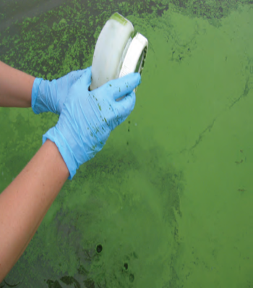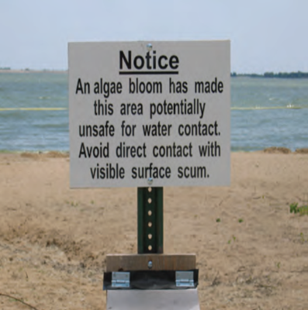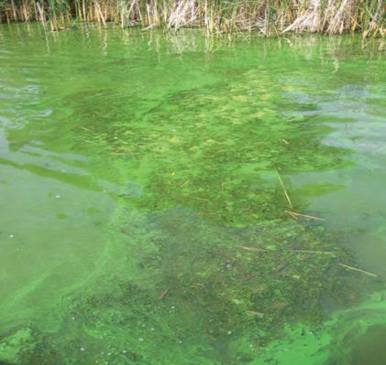
2. Light Intensity and Temperature
Many planktonic cyanobacteria regulate water buoyancy and position themselves for optimal light conditions by regulating the expression of genes. Alterations in buoyancy lead to cyanobacteria sinking during midday and floating at night. In addition to buoyancy regulation for optimal light conditions, specific cyanobacteria use phototaxis motility via gliding or twitching, as observed in Anabaena and Ocsillatoria species (gliding), as well as unicellular cyanobacteria, such as Synechocystis species (twitching).
Light intensity is also involved in toxin release and bioproduction. By using PCR, indicated that mcy gene cluster expression increases in Microcystis species during summer (abundant light intensity), but reduces during fall, differences in light intensity could change the transcription start sight of mcyA and this was not observed with various nitrogen concentrations, similar to CYN release into the environment by A. flos-aquae . Light intensity also influences the amount of toxins released by benthic cyanobacteria, as shown in benthic Oscillatoria species. Light intensity and toxin production are highly variable, partly due to the different intensities and strains tested. However, lowest toxin concentrations have generally been documented at low light intensities (2–20 μmol photons m−2 s−1), with highest levels between 20 and 142 μmol photons m−2 s−1 depending on the study. Also important is the relationship between iron uptake and light intensity. High light intensities increase cellular iron uptake which may ultimately be responsible for higher toxin production, In contrast, low concentrations of iron, implicated in slower cell growth, have led to higher microcystin concentrations.
That light was found to have more impact on MC production than nitrogen. In P. agardhii, increased light intensity altered the ratio between MC variants; production of microcystin-L was greater while the production of microcystin-R decreased with more light ~60 μmol m−2·s−1, among them microcystin-L was found to be more toxic than microcystin-R .
that UVB radiation supports the growth of MC producing cyanobacterial strains. They also indicated that non-MC producers are vulnerable to radiation when compared with MC producers .that light also plays an essential role in MC production.
Temperature raising prompts physiological mechanism for algal blooms ,Thus, temperature is one of the influential factors for the development of algal blooms For instance, that a temperature of 25°C could significantly increase CYN production versus 20°C, which is in contrast to the reduced anatoxin-a level produced by Anabaena and Aph- anizomenon species at high temperatures .
Factors affecting on Microcystin toxin production are light and temperature, with optimum temperatures from cyanobacteria ranging 20 to 25 C. These conditions suggest microcystins present in surface water supplies in warm and sunny climates.
Moreover, also observed different frequencies of species in different seasons, where nontoxic Planktothrix species were dominant during autumn, while both nontoxic and toxic Microcystis species were prevalent during hot summer. Therefore, surveillance of cyanotoxins and toxic cyanobacteria should be conducted constantly when light intensity and temperature are favorable for cyanobacterial toxin production to maximize identification.The effect of temperature on toxin levels is comparable in most cyanobacteria. Anatoxin-a production by Anabaena spp. and Aphanizomenon is highest at 20°C compared to 30°C or lower temperatures .Similarly, microcystin and nodularin concentrations, as studied in Anabaena, Microcystis and Nodularia, are highest between 18 and 25°C, with lower levels experienced at either higher or lower temperatures tested .Temperature effects on saxitoxin production in cyanobacteria have not been investigated, but their concentration in the dinoflagellate Alexandrium sp. is increased at low temperatures and phosphorus limitation .Different temperatures can also be correlated with different chemical forms of toxin produced . At temperatures below 25°C, Anabaena spp. produce microcystin-LR, instead of microcystin-RR which is preferentially synthesised at higher temperatures .
Nutrients
One of the most important factors contributing to the production of toxins, the frequent increment in HABs is related to the increase of nutrients loading. Among the most important anthropogenic impact for marine systems is the input of excessive nutrients, principally nitrogen and phosphorous that can cause eutrophication.
There is a strong relationship between nutrient loading to HABs, which shows the increase of HABs as nutrients loading increases. Increment of red tides in Hong Kong from 1976 to 1986 as nitrogen and phosphorous increased to 6- and 25fold respectively. Over the past several decades in the Gulf of Mexico it was also observed that raising nitrate loading, increased the concentration of potential toxic diatoms.
Algal species have different preference for nutrients as they have different physiological adaptations. Increasing Phosphorous that resulted in increasing the number of the toxin production of certain harmful dinoflagellate species
Nutrients, such as nitrogen and phosphorus are essential for cyanobacterial growth. Phosphorus is usually the limiting factor in lakes, and hence small changes in this nutrient may influence toxin production merely as a result of influencing growth. Generally, decreased amounts of microcystin (produced by Anabaena, Microcystis and Oscillatoria), anatoxin-a (produced by Aphanizomenon) and nodularin (produced by Nodularia) have been reported under the lowest phosphorus concentrations tested.
Cyanobacterial species and strain domination may be affected by different levels of nutrient use in different species. In this regard, observed Planktothrix agardhii domination in nutrient-rich water bodies, whereas P. rubescens was generally found in low nutrient lakes. Meanwhile, growth of toxic Microcystis species showed a positive correlation with phosphorus concentration and a negative correlation with nitrate concentration in the environment.Nutrient forms can influence toxin production. e.g. the production of the neurotoxin domoic acid (DA) by the diatom nitzschia species can be varied based on the nitrogen nutrient being used for their growth.
Cyanobacterial species and strain domination may be affected by different levels of nutrient use in different species. In this regard, observed Planktothrix agardhii domination in nutrient-rich water bodies, whereas P. rubescens was generally found in low nutrient lakes. Meanwhile, growth of toxic Microcystis species showed a positive correlation with phosphorus concentration and a negative correlation with nitrate concentration in the environment. In addition, the nutrient level affected toxin gene expression, as shown in mcy gene expression, which improves as nitrogen and phosphorus levels increase .In contrast, that phosphorus depletion could increase the concentration of anatoxin a, and presence of nitrogen increased the level of toxins. The authors associated this finding to the high nitrogen level, leading to phosphorus depletion and increased toxin biosynthesis.
the results contradicted previous research, which shows that nitrogen depletion increases the level of anatoxin-a biosynthesis in Anabaena and Aphanizomenon species . Meanwhile, previous studies have indicated that nitrate depletion increases saxitoxin production in the initial growth of heterocyst-forming A. flos-aquae. However, as the cells grow and are capable of fixing nitrogen from the environment, there are no significant differences in the production of saxitoxin between nitrate-depleted and nitrate-supplied media.
Generally, decreased amounts of microcystin (produced by Anabaena, Microcystis and Oscillatoria), anatoxin-a (produced by Aphanizomenon) and nodularin (produced by Nodularia) have been reported under the lowest phosphorus concentrations tested.
Trace metals such as iron, copper are essential for the growth of all phytoplankton and play critical roles in photosynthesis as well as in the assimilation of essential macronutrients, and for the toxicity of some HAB species .Indications regarding the role of iron are contradictory,. While studying the effect of trace metals on growth and on toxin content of Microcystis aeruginosa, that in batch cultures only zinc was required for both optimal growth and toxin production
Salt tolerance of CyanoHABs
Several common MC-producing genera (Anabaena, Anabaenopsis, Microcystis and Oscillatoria) may even display rapid growth rates in saline environments. For example, M. aeruginosa has one of the highest salt tolerances of all cyanophytes and can continue to both grow and produce MCs in saline environments.

Biotic Factors
Biotic factors also play an important role in cyanobacteria population and toxin production, that increased number of zooplanktons, as the main predators of cyanobacteria, increased the production of microcystins. They also found that microcystin producing cyanobacteria show better survival in combating zooplanktons. Research in this area has led to the theory that microcystin molecule expression is important to protect the cells against harsh conditions. Meanwhile, many bacteria and viruses have shown anticyanobacterial characteristics and seem to influence the bloom dynamics of cyanobacteria. In addition, both aquatic and terrestrial plants are known to produce allelochemicals, as secondary metabolites, which either positively or negatively affect the surrounding organisms, such as microbes.

