**Lab: 3**

**Order : Diptera**

**Sub order :Nematocera**

**Family : Simuliidae**

**Genus : Simulium**

**LIFE CYCLE**

The length of the life cycle varies with the species and environmental conditions. In temperate regions species may have one generation a year, while continuous breeding occurs in tropical species. The larval stage of *S. damnosum* can be completed in as little as 6 days, and the life cycle from egg to adult can be completed in less than 2 weeks.

**Eggs**:-  
The eggs are commonly laid in batches of 200-300, in a range of 30 to 800, on objects in or near running water or directly onto water or on the surface.

Eggs are 100 to 400 µm long and ovoid - triangular in shape. Their surface is comparatively smooth, lacking the patterned surface found in the eggs of *Culicoides* and culicids, and are covered with a gelatinous substance. Eggs may be laid in skeins like a string of beads, or in untidy masses. Freshly laid eggs are creamy-white, changing to dark brown or black within 24h.

**Larva** :-

brown, gray, or black with light brown head; body cylindrical, somewhat club-shaped; head with prominent pair of mouth brushes, cephalic (labral) fans used for filtering food from the water

posterior part of the abdomen are broader than the anterior segments of the abdomen.. The larva has a single anterior proleg, surmounted by a circlet of hooks and the The larva can change its location by drifting downstream on a silken thread, or by looping over the substrate surface using the posterior circlet and the hooks on the anterior proleg to retain a hold on secreted silk.

The mature last instar larva, recognised by the presence of a dark "gill spot" through which the developing gills of the pupa may be seen, on the lateral side of the thorax, is actually a pharate pupa within the larval skin (i.e. midway between loosening the larval skin and casting it off), and may move to a different site before pupating. In most species the pharate pupa spins a cocoon in which it pupates. This is usually slipper-shaped with the closed end directed upstream and the open end downstream .This alignment prevents the cocoon being torn off the substrate by the current. Construction of the cocoon takes about an hour and then the larval skin is shed.

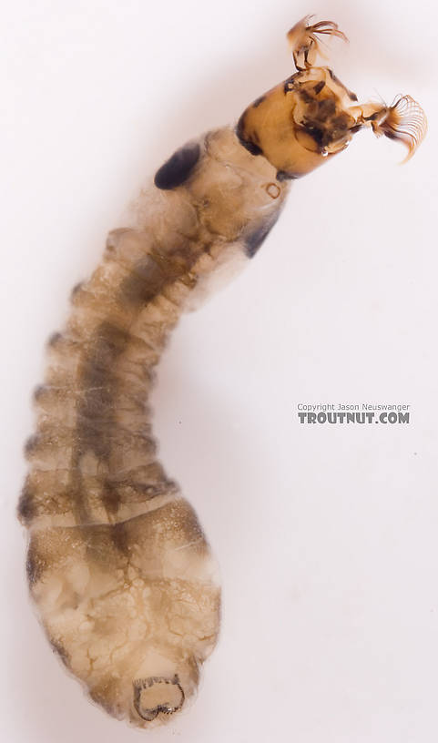

[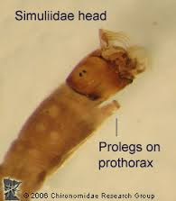](http://www.google.iq/url?sa=i&rct=j&q=&esrc=s&source=images&cd=&cad=rja&uact=8&ved=&url=http://midge.cfans.umn.edu/vsmivp/diptera/simuliidae/&ei=d_VLVO7CM4TjO7LPgcgK&psig=AFQjCNGOjLa0m8MdEYUQUjKocBTZhj7EMQ&ust=1414350584176617)

1. [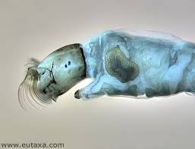](http://www.google.iq/url?sa=i&rct=j&q=&esrc=s&source=images&cd=&cad=rja&uact=8&ved=0CAcQjRw&url=http://www.eutaxa.com/S%20image%20r3b3.htm&ei=lidRVNuzA6au7gaYhICACw&psig=AFQjCNEbkhb1CHxodkoFjUdh_2vt-mQTdg&ust=1414690888896200)

Cephalic fan

Pro leg

Gill spot

**Pupa:-**   
The head and thorax of the pupa are combined into a single cephalothorax, and there is a segmented abdomen .The latter bears spines and hooks which engage with the threads of the cocoon and retain the pupa in place. Thecephalothorax bears a pair of elongate, branched pupal gills, which trail downstream of the cocoon. However, in some species the gills are short and barely extend beyond the lip of the cocoon. The gills are homologous with the respiratory horns of the Culicidae and Ceratopogonidae, but they do not have open spiracles. The tubular branches of the gill bear vertical struts which support a very thin, outer, minutely perforated, trilaminate epicuticle and an inner fine meshwork. The enclosed air-filled space around the struts functions as a plastron. The shapes of the cocoon and gills are important characters in the identification of species.

The pupa, which does not feed, becomes progressively darker as the adult develops within. At emergence, the pupal skin splits, and the adult floats up to the surface in a bubble of air and immediately takes flight, or the newly emerged adult crawls up some emergent object to reach the air.

1. [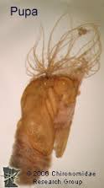](http://www.google.iq/url?sa=i&rct=j&q=&esrc=s&source=images&cd=&cad=rja&uact=8&ved=0CAcQjRw&url=http://midge.cfans.umn.edu/vsmivp/diptera/simuliidae/&ei=pPpLVM-FL8G5OPPjgdAE&psig=AFQjCNGOjLa0m8MdEYUQUjKocBTZhj7EMQ&ust=1414350584176617)

**Adult**

black to various shades of gray or yellow; thorax shiny, strongly convex, giving a humpbacked, gnat-like appearance; wings clear, broad, without hairs or scales; heavy veins near anterior wing margin, weak veins posteriorly; small head with large round eyes and short 11-segmented antennae; ocelli lacking

the female is dichoptic In the male the eyes are much larger and touch above the antennae (holoptic),