AGGLUTINATION REACTIONS
Lab. 7
When particulate antigen combines with its antibody in the presence of electrolytes at an optimal temperature and pH, resulting in visible clumping of particles.
- More sensitive than precipitation for the detection of antibodies.
- The agglutination reaction takes place better with IgM antibody.

There are 3 types of agglutination depends on the carrier that carry the antigens.
- Haem agglutination
- Bacterial agglutination
- Latex agglutination

Hemagglutination
- agglutination reactions that are performed on RBC’s - RBC’s mixed with antisera to the A or B blood-group antigens on a slide - if antigen is present on the cells, they agglutinate, forming a visible clump on slide.
Ex. ABO blood grouping

Bacterial Agglutination
- bacterial infection often elicits the production of serum antibodies specific for surface antigens on the bacterial cells - presence of such antibodies can be detected by bacterial agglutination reactions - serum antibody titer of a patient is defined as the reciprocal of the greatest serum dilution that elicits a positive agglutination reaction - agglutination titer of an antiserum can be used to diagnose a bacterial infection.
Ex. Widal test for diagnosis of enteric fever caused by salmonella.

Latex Agglutination
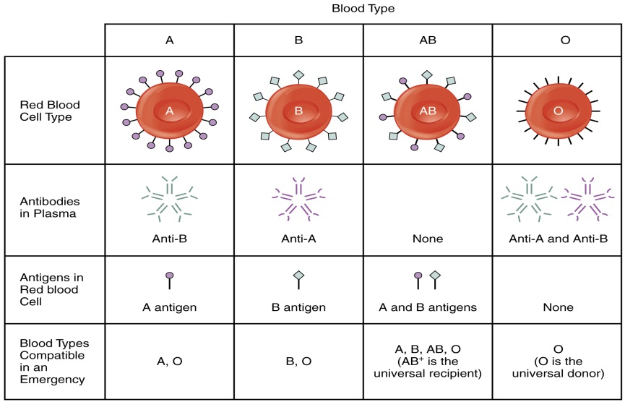
- Latex is inert Polystyrene latex particles (0.8 – 1 µm in diameter) are widely employed to dsorb several types of antigens . This test is convenient, rapid and specific Used for detection of hepatitis B antigen, ASO, CRP, RA factor, HCG and many other antigens Latex agglutination tile is used to perform this test.
The ABO Blood Group System
There are four major blood groups determined by the presence or absence of two antigens – A and B – on the surface of red blood cells:
- Group A – has only the A antigen on red cells (and B antibody in the plasma)
- Group B – has only the B antigen on red cells (and A antibody in the plasma)
- Group AB – has both A and B antigens on red cells (but neither A nor B antibody in the plasma)
- Group O – has neither A nor B antigens on red cells (but both A and B antibody are in the plasma)
Rh System
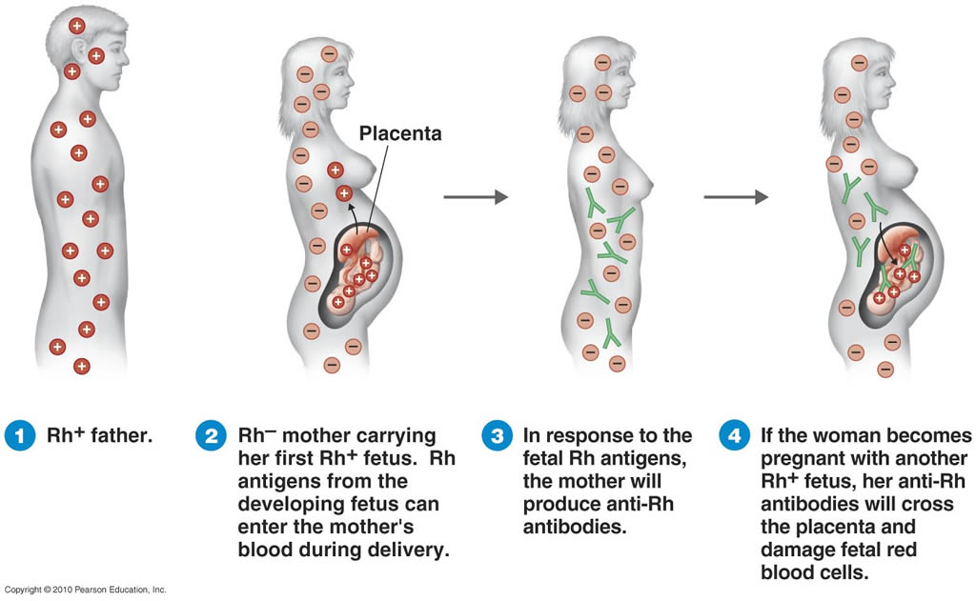
An individual either has, or does not have, the "Rh factor" on the surface of their red blood cells. This term strictly refers only to the most immunogenic D antigen of the Rh blood group system, or the Rh− blood group system. The status is usually indicated by Rh positive (Rh+ does have the D antigen) or Rh negative (Rh− does not have the D antigen) suffix to the ABO blood type. However, other antigens of this blood group system are also clinically relevant. These antigens are listed separately In contrast to the ABO blood group, immunization against Rh can generally only occur through blood transfusion or placental exposure during pregnancy in women. A mother who is Rh-negative may develop antibodies to an Rh-positive baby. If a small amount of the baby’s blood mixes with the mother's blood, which often happens in such situations, the mother's body may respond as if it were allergic to the baby. The mother's body may make antibodies to the Rh antigens in the baby’s blood. This means the mother has become sensitized and her antibodies may cross the placenta and attack the baby’s blood. Such an attack breaks down the fetus’s red blood cells, creating anemia (a low number of red blood cells). This condition is called hemolytic disease or hemolytic anemia. It can become severe enough to cause serious illness, brain damage, or even death in the fetus or newborn. Sensitization can occur any time the fetus’s blood mixes with the mother’s blood. It can occur if an Rh-negative woman has had a spontaneous or undetected miscarriage of a Rh positive fetus.

