Lab 2 Titration and Dilution
Serology and Vaccines
Dilution vs. Titration
In quantitative chemical analysis dilution and Titre are the two ways of describing the conditions, concentration or the percentage of particular particles, viruses, fats and many other things in a solution. Dilution is the term used for lowering the concentration of a particular solution. Dilution can be changed by adding more solvent or decreased by removing solvent. Titre is the threshold value of dilution at which it is required to carry out the reaction in case of chemical analysis and infection in case of viruses.
Dilution
When a solute is dissolved in a medium to prepare a solution it is done at different dilution levels. The proper composition is reached by proper dilution so that the solution can be used industrially or in household uses. If the proper dilution is not there it will imply that the composition of the solution will not be proper and the solution will not be of any use. The dilution can be decreased or increased by removing or adding of the medium in which solute is dissolved.
Titration
Is a common laboratory method of quantitative chemical analysis that is used to determine the unknown concentration of an identified analyte. Since volume measurements play a key role in titration, it is also known as volumetric analysis. A reagent, called the titrant is prepared as a standard solution. A known concentration and volume of titrant reacts with a solution of analyte to determine concentration. The volume of titrant reacted is called titre.
In brief:
Titration vs. Dilution
• Dilution is the chemical composition that can be changed easily but titre is the exact value and cannot be changed.
• Dilution is a simple process and can be done very easily but titre testing requires elaborate laboratory preparations.
• Dilution is a simple physical process and physical change occurs only when titre value is reached.
• Dilution cannot determine the chemical composition of the solution but titre testing is done to determine the composition of the solution.
• Dilution is a process that can by physical or chemical but titre is a particular value that is expressed by many units.

Type of Dilutions
- A two-fold dilution reduces the concentration of a solution by a factor of two that is reduces the original concentration by one half. A series of two-fold dilutions is described as two-fold serial dilutions.
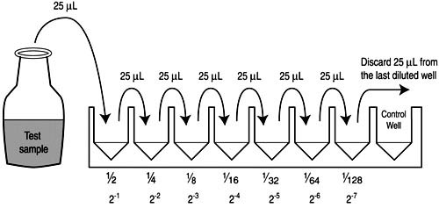

- A ten-fold dilution reduces the concentration of a solution or a suspension of virus by a factor of ten that is to one-tenth the original concentration. A series of ten-fold dilutions is described as ten-fold serial dilutions.
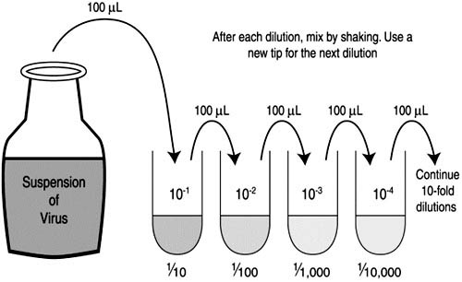

The dilution calculator equation
The dilution calculator is based on the following equation:

Concentration (start) x Volume (start) = Concentration (final) x Volume (final)

This equation is commonly abbreviated as: C1V1 = C2V2
An example of a dilution calculation using the dilution equation
Prepare 4 ml with 0.5 concentration from 0.8 diluted serum.
Using the equation C1V1 = C2V2, where
C1=0.8
C2=0.5
V2=4 ml
V1 is the unknown(?)
0.8 xV1= 0.5x4
V1= 2/ 0.8= 2.5 ml
4-2.5 = 1.5 ml is needed from (0.8 diluted serum)
NOTE: undiluted serum has a very fixed concentration (1).

