**Lec:1** **Diagnostic parasitology**

**Laboratory diagnosis**: is a basic step in the evaluation of the disease process, at times, confirming a presumptive diagnosis or providing evidence of an unsuspected agent of disease. However, failure to demonstrate or recover a parasite does not exclude the possibility of infection. Many of these parasites, especially the protozoa, can be identified only by microscopic examination. This requires considerable skill and apart from being time-consuming and labour-intensive the method has limitations. This also applies to most of the commonly used serological techniques.

**Direct identification**

**Direct methods** (e.g, microscopy, cultivation of specific nucleid acids, detection of specific antigens) = highly specific and unambigously recommendable, however, in some cases: either low sensitivity (microscopy) or expensive, but important - the possibility of testing the sensitivity to ATB

Parasitic infections are usually diagnosed from samples of faeces, urine, blood and tissue.

**Faeces:** Evidence of intestinal parasitism, apart from the general clinical signs, are obtained from faecal or post-mortem examination. There is no "general" technique,nor is there an "ideal" technique for the microscopic examination of faeces. In fact, a reliable diagnosis can usually be made only by using a combination of several techniques such as:

***- Direct saline smear:*** This procedure provides only an indication of the parasites present and cannot be used quantitatively. To prepare a direct faecal smear a drop of saline is placed in the centre of a microscope slide and a 2 mg faecal sample is suspended in this drop without spreading it. This is then covered with a coverslip and examined.

***- Stained smears:*** This type of smear is essential for accurate diagnostic detail and is also suitable for long-term storage for record purposes. The two stains generally used are haematoxylin and trichrome.

***— Parasite concentration in faeces by flotation:*** This is used for the identification of oocysts of coccidia and helminth eggs .One drawback of this technique is that there is not always a direct relationship between the number of eggs in faeces and the number of parasites present.

**Urine:** Examination of urine sediment is used mainly for the identification of ***Schistosoma*** eggs .

**Blood:** Testing is used to identify the various stages of blood parasites and is routinely applied to diagnose malaria, , babesiosis, trypanosomiasis and most types of filariasis. Trypanosoma can also be diagnosed with wet smears. Depending on the application and purpose, two types of blood films are used.

***Thin blood films*** :are useful for studying morphological changes of blood cells and blood parasites. The main disadvantage is that sample volume is small,making the detection of low parasitaemia and carrier animals difficult.

***Thick blood films***:contain 6 to 20 times as much blood per unit area as thin films. The thick film is suited for rapid diagnosis of parasitaemia that is too low to be detected with thin films. This method is not suitable for detailed morphological studies of parasites.

**Tissue:** Recovery of protozoa or helminths from biopsy material is often an important aid to diagnosis. Lymph node, spleen, liver, lung, bone marrow or spinal fluid biopsies are frequently used to diagnose a variety of diseases.

**Post-mortem:** Post-mortem examination is currently the most effective way to accurately diagnose helminth infection. Brain-cortex smears are examined for babesiosis (***Babesia bovis),*** cysticercosis

**Indirect identification**

All methods for the direct identification of parasites fail if the parasite density in the specimen is below the sensitivity of the method employed, or if the parasite cannot be directly demonstrated due to the life cycle in the host (e.g. toxoplasmosis,echinococcosis and cysticercosis). In such cases indirect methods must be used.

Ideally, serology should allow:

1. Differentiation between recent and latent infections
2. Should be able to demonstrate whether an animal is a carrier
3. As well as the elimination of the parasite after therapeutic measures have been applied.

**Commercially available tests** present problems in

Reliability and interpretation of results. Costly, specialised apparatus is often needed to perform the tests. With the majority of tests, specificity is not satisfactory and cross-reaction seldom allows distinction between closely related organisms. However, monoclonal antibodies may overcome this problem and enable the identification of highly specific antigen sites.

Tests commonly in use include the :

**complement fixation test (CFT),**

**immunodiffusion (ID),**

**indirect haemagglutination (IHA),**

**indirect immunofluorescent antibody test (IFA),**

**enzyme-linked immunosorbent assay (ELISA)**

**radioimmunoassay (RIA)** .

**Note**: Less frequently used **tests include latex agglutination**, **capillary agglutination and card agglutination** .

**Principle** :Most of these tests are based on the reaction of antibodies with antigenic parasite components (whole or soluble) resulting in antigen-antibody complexes. These complexes are detected by the addition of antiglobulins coupled to **fluorescein and rhodamine dyes, radioisotopes or enzymes**.

**Because antibodies can persist for a long time after elimination of the parasites, another drawback of serology is that the demonstration of a specific antibody does not indicate the present parasitological status of the host**. The results of a serologicaltest are therefore retrospective. Serodiagnosis of helminth infections is even more difficult because cross-reactivity is more the rule than the exception. Only highly purified, defined antigens allow serodiagnosis to the genus level; species-specific serodiagnosis is unusual . Antigen-capturing ELISA can be used for demonstrating infection with trypanosomes .

**Antigen**

The application and reliability of serology is in many cases dependent on the availability of sufficient amounts of high quality antigen. The inability to culture many parasites ***in vitro*** and the lack of suitable animal models often hamper antigen preparation.

**REPORTING ORGANISMS**

-**ORGANISM NAMES**: List all names using genus/species/stage (trophozoites, cysts, oocysts, spores, eggs, larvae, etc-.)

◻**quantitation**: Very few parasites are quantitated: *Blastocystis* spp*.*, some helminth eggs (*Trichuris trichiura*), helminth eggs (*Schistosoma* spp.) facts seen in the o&p exam (rare, few, mod, many)

◻**non pathogens**: These organisms must also be reported (same infecting route)

**antibody detection Limited Information: Patient History and Clinical Symptoms Critical**.

**1-Recent travel to an endemic are**a

–Positive = recent infection

2-**Resident of endemic area**

–Positive = infection unrelated to current clinical status

Protozoa specific; Helminths = cross reactivity Amebiasis, babesiosis, malaria, Chagas’, *Toxoplasma*, trypanosomiasis, *, Ascaris*, cysticercosis, echinococcosis, paragonimiasis, fascioliasis, filariasis, toxocariasis, trichinosis, strongyloidiasis, schistosomiasis, *Baylisascaris*; PCR (blood parasites)

Antibodies may/may not decline with time/therapy –6 months to years

**Examination of exact sample (dependence on clinical symptoms and signs!!!) isolated:**

•• From exact site;

•• at the exact time interval;

•• transport to laboratory examination under adequate conditions (standards)

•• examined by adequate methods (standards)

**1) DIRECT** – macroscopically or microscopically

**A**- **Culture**: specilized culture media or tissue cultures under controlled laboratory conditions

**B**- **non-concentration methods**: native fresh mounts ,stained smears

**C-** **concentration methods**: flotation- sedimentation-filtration

• **specific methods**: detection of DNA, circulating antigens

**Detection of the parasite DNA**: limited use

**Material:** e.g. in blood, stool, urine(fresh, frozen, fixed in pure **100% alcohol**)

.**2) INDIRECT** – using specific methods, detection of specific **antibodies in the serum,**: e.g., ELISA, IHA, IFAT

**MACROSCOPICAL** examination of samples





**Diagnosis methods**

1-Microscopy

For many years, microscopy has been the only tool available for the detection of parasites through inspection of blood smears, tissue specimens, feces, lymph node aspirates], bone marrow and even cerebrospinal fluid. However, sample preparation for direct observation is time-consuming, labour intensive, and proper diagnosis depends on qualified laboratory technicians.. In reality, all major intestinal helminth infections are still solely dependent on microscopy for diagnosis. As for other parasite infections, many are confirmed by the use of microscopy in conjunction to other methods of diagnosis including serology-based assays and more recently molecular-based assays.

**STOOL FIXATIVES**

-**Formalin**: 5%-10%

- sodium acetate-acetic acid-formalin SAF: significantly higher sensitivity for parasitic protozoa Mixture  used  to  fix  fecal  specimens for subsequent concentration and staining of smears.

**Merthiolate-Iodine-Formaldehyde (MIF)**: is a solution used in biomedical laboratories for concentration of [stool samples](https://en.wikipedia.org/wiki/Stool_sample) prior to [microscopic investigation](https://en.wikipedia.org/wiki/Microscopy) for [parasites](https://en.wikipedia.org/wiki/Parasite). Concentration of stool is necessary in order to raise sensitivity of microscopy, as in non-concentrated samples the likelihood of finding equivalents of actually present parasites is too low. MIF enables separation of different strata of stool matter, and sedimentation of stool particles that contain parasites (usually parasite eggs). After application of MIF, usually [centrifugation](https://en.wikipedia.org/wiki/Centrifuge) is used for acceleration of sedimentation.

As prepared commercially, 1 liter (0.22 imp gal; 0.26 U.S. gal) of MIF-solution contains:

* [Ethanolamine](https://en.wikipedia.org/wiki/Ethanolamine) 1,000 mg (15 gr)
* [Ethylenediamine](https://en.wikipedia.org/wiki/Ethylenediamine) 280 mg (4.3 gr)
* [Sodium chloride](https://en.wikipedia.org/wiki/Sodium_chloride) 8,000 mg (120 gr)
* [Disodium-Tetraborate-Decahydrate](https://en.wikipedia.org/wiki/Borax) 2,650 mg (40.9 gr)
* [Distilled water](https://en.wikipedia.org/wiki/Distilled_water) 1,000 ml (35 imp fl oz; 34 US fl oz)

If Thiomersal is needed for preservation of the sample, add:Thiomersal 1,000 mg (15 gr)

-**Fixative with Polyvinyl Alcohol PVA (glue)** : Polyvinyl alcohol (PVA) containing the fixative mercuric chloride is considered the “gold standard” for the fixation of ova and parasites in the preparation of permanently stained smears of stool specimens.

-**Mercury-based fixatives**:f ixatives with a mercuric chloride (HgCl2) base have been used to preserve stool specimens for the recovery and identification of intestinal parasites

-**Zinc-based fixatives:** copper-based generally poor.Both Schaudinn's and polyvinyl alcohol (PVA) fixatives with a mercuric chloride (HgCl2) base have been used to preserve stool specimens for the recovery and identification of parasites, primarily the intestinal protozoa PVA is a plastic powder that is dissolved in the Schaudinn's fixative; this plastic powder serves as an adhesive to help glue the stool onto the glass slide when the fecal smears are prepared, while the actual fixation occurs with the Schaudinn's solution. Stool specimens can be examined fresh or preserved.

**Examination of fresh specimens** permits the observation of motile trophozoites, but this must be carried out without delay. Liquid (diarrheic) specimens (which are more likely to contain trophozoites) should be examined within 30 minutes of passage (not within 30 minutes of arrival in the laboratory!), and soft specimens (which may contain both trophozoites and cysts) should be examined within one hour of passage. If delays cannot be avoided, the specimen should be preserved to avoid disintegration of the trophozoites. Formed specimens (less likely to contain trophozoites) can be kept for up to one day, with overnight refrigeration if needed, prior to examination.

The flow chart on the right shows how specimens preserved in formalin and PVA are processed and tested at CDC.

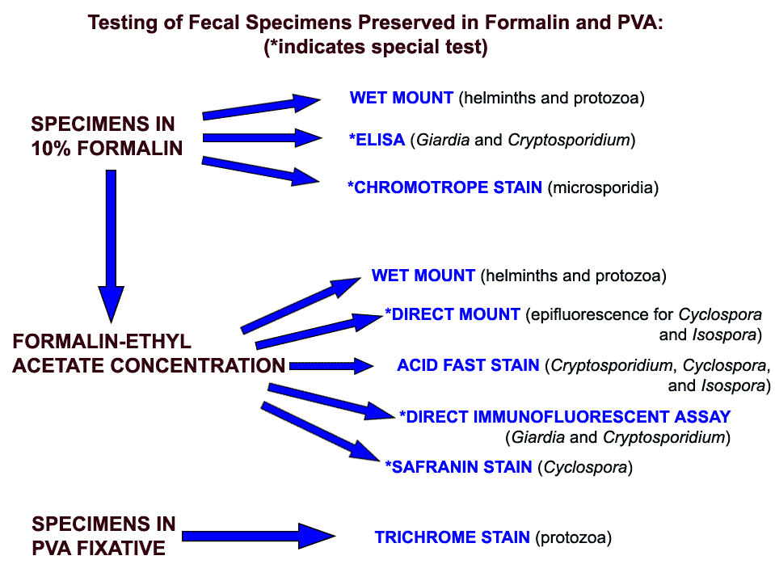

**Specimens preserved in formalin** can be tested directly (wet mount, immunoassay, chromotrope stain, UV fluorescence) or can be concentrated prior to further testing.

**Concentration procedure** separate parasites from fecal debris and increase the chances of detecting parasitic organisms when these are in small numbers. They are divided into flotation techniques and sedimentation techniques.

**Flotation techniques** :(most frequently used: zinc sulfate or Sheather's sugar) use solutions which have higher specific gravity than the organisms to be floated so that the organisms rise to the top and the debris sinks to the bottom. The main advantage of this technique is to produce a cleaner material than the sedimentation technique. The disadvantages of most flotation techniques are that the walls of eggs and cysts will often collapse, thus hindering identification. Also, some parasite eggs do not float.

**Sedimentation techniques**: use solutions of lower specific gravity than the parasitic organisms, thus concentrating the latter in the sediment. Sedimentation techniques are recommended for general diagnostic laboratories because they are easier to perform and less prone to technical errors. The sedimentation technique used at CDC is the formalin-ethyl acetate technique, a diphasic sedimentation technique that avoids the problems of flammability of ether, and which can be used with specimens preserved in formalin, MIF or SAF.

##### **Formalin-Ethyl Acetate Sedimentation Concentration**

1. Mix the specimen well.
2. Strain 5ml of the fecal suspension (more or less depending on its consistency) through wetted cheesecloth-type gauze placed over a disposable paper funnel into a 15 ml conical centrifuge tube. (Conical paper cups with the tips cut off are sufficient).
3. Add 0.85% saline or 10% formalin through the debris on the gauze to bring the volume in the centrifuge tube to 15 ml. Distilled water may be used; however, Blastocystis hominis may be deformed or destroyed.
4. Centrifuge at 500 × g for 10 minutes.
5. Decant supernatant. Add 10 ml of 10% formalin to the sediment and mix thoroughly with wooden applicator sticks.
6. Add 4 ml of ethyl acetate, stopper the tube, and shake vigorously in an inverted position for 30 seconds. Carefully remove the stopper.
7. Centrifuge at 500 × g for 10 minutes.
8. Free the plug of debris from the top of the tube by ringing the sides with an applicator stick. Decant the top layers of supernatant.
9. Use a cotton-tipped applicator to remove debris from sides of the centrifuge tube.
10. Add several drops of 10% formalin to resuspend the concentrated specimen. Proceed with applicable testing.

*Commercial fecal concentration tubes are available that decrease processing time and supplies needed for concentrating specimens (e.g., Fecal Parasite Concentrator, Evergreen Scientific).

**Specimens preserved in PVA** are mostly used for permanent staining with trichrome. Prior to staining, they are processed as follows:

1. Insure that the specimen is well mixed.
2. Prepare a smear using 2 to 3 drops of the specimen depending on density.
3. Heat fix on slide warmer set at 60°C for 5 minutes or air dry completely at room temperature.

Slides may be trichrome stained or kept for several months in a protective slide tray or box for future staining.

**Eleven (11) Ways to Make a Better Slide**

**1-**The single most important step in the preparation of a well stained fecal smear is good fixation.

**2**- Touch the end of the slide to a paper towel for two seconds to

remove excess fluid before proceeding to the next step.

3-Incomplete removal of mercuric chloride (liquid Schaudinn’s fixative with PVA) may cause smear to contain highly refractive crystals or granules, which may prevent detection or identification of any organisms present. The 70% ethanol-iodine solution removes the mercury from the slide; the subsequent alcohol rinses then remove the iodine (should be a strong tea color). Thus, when the slide is ready for trichrome staining, both the mercury and iodinehave been removed.

4-When using non-mercury based fixatives, the iodine-alcohol step (used for the removal of mercury) and the subsequent alcohol rinses

can be eliminated from the procedure. The smears for staining can be pre-rinsed with 70% alcohol and placed in the trichrome stain, or they can be placed directly into the trichrome stain as the first step in the staining protocol.

5-Smears that are predominantly green may be due to the inadequate

removal of iodine by the 70% ethanol (steps 3 and 4). Lengthening the time of these steps or more frequent hanging of the 70% ethanol will help.

6- To restore weakenedtrichrome stain, remove the cap and allow the ethanol (carried over on the staining rack from a previous dish) to evaporate. After a few hours, fresh stock stain may be added to restore lost volume. Older, more concentrated stain produces more intense colors and may require slightly longer destaining times (an extradip). Remember that PVA smears usually require a slightly longer staining time.

7-Although the trichrome stain is used essentially as a “progressive” stain (no destaining is necessary), the best results are obtained by using the stain “regressively”(destaining the smears briefly in acidified alcohol).

8-It is essential to rinse the smears free of acid to prevent continued

destaining. Since 90% alcohol will continue to leach trichrome stain from the smears, it is recommended that after the acid-alcohol is used, the slides be quickly rinsed in 100% alcohol and dehydrated through two additional changes of 100% alcohol.

9-In the final stages of dehydration (steps 9 to 11), the 100% ethanol

and the xylene (or xylene substitute) should be kept as free from water as possible.Coplin jars must have tight fittingcaps to prevent both evaporation of reagents and absorption of moisture. If the xylene becomes cloudy after addition of slides from the 100% ethanol, return the slides to fresh 100% ethanol and replace the xylene with fresh stock.

10-If the smears peel or flake off, the specimen might have been inadequately dried on the slide (for PVA-fixed specimens), the smear may have been too thick, or the slide may have been greasy(fingerprints). However, slides generally do not have to becleaned with alcohol prior to use.

11-If the stain appears unsatisfactory upon examination and it is not

possible to obtain another slide to stain, the slide may be restained. Place the slide in xylene to remove the coverslip and reverse the dehydration steps. Add 50% ethanol as the last step. Destain the slide in 10% acetic acid for several hours and wash it thoroughly first in the water; and then in 50% and 70% ethanol. Place the slide in the trichrome stain for 8 minutes and complete the staining procedure.

**Note: Mayer’s Albumin Used to adhere fecal specimens to glass**

**slides in the modified iron hematoxylin/ trichrome staining process.**