Environmental management technique
تقنية المعالجة البيئية
Lab.3
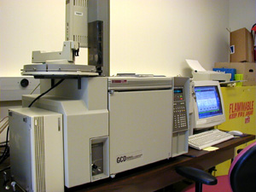
GC-MS System
Gas Chromatography-Mass Spectroscopy
Background
Gas chromatography-mass spectroscopy (GC-MS) is one of the so-called hyphenated analytical techniques. As the name implies, it is actually two techniques that are combined to form a single method of analyzing mixtures of chemicals. Gas chromatography separates the components of a mixture and mass spectroscopy characterizes each of the components individually. By combining the two techniques, an analytical chemist can both qualitatively and quantitatively evaluate a solution containing a number of chemicals.
The uses for GC-MS are numerous. They are used extensively in the medical, pharmacological, environmental, and law enforcement fields. This laboratory exercise will look at evaluate samples containing the pollutants called PAHs.
Gas Chromatography
In general, chromatography is used to separate mixtures of chemicals into individual components. Once isolated, the components can be evaluated individually.
In all chromatography, separation occurs when the sample mixture is introduced (injected) into a mobile phase. In liquid chromatography (LC), the mobile phase is a solvent. In gas chromatography (GC), the mobile phase is an inert gas such as helium.
The mobile phase carries the sample mixture through what is referred to as a stationary phase. The stationary phase is a usually chemical that can selectively attract components in a sample mixture. The stationary phase is usually contained in a tube of some sort. This tube is referred to as a column. Columns can be glass or stainless steel of various dimensions.
The mixture of compounds in the mobile phase interacts with the stationary phase. Each compound in the mixture interacts at a different rate. Those that interact the fastest will exit (elute from) the column first. Those that interact slowest will exit the column last. By changing characteristics of the mobile phase and the stationary phase, different mixtures of chemicals can be separated. Further refinements to this separation process can be made by changing the temperature of the stationary phase or the pressure of the mobile phase.
The GC has a long, thin column containing a thin interior coating of a solid stationary phase (5% phenyl-, 95% dimethylsiloxane polymer). This 0.25 mm diameter column is referred to as a capillary column. This particular column is used for semivolatile, non-polar organic compounds such as the PAHs we will look at. The compounds must be in an organic solvent.
The capillary column is held in an oven that can be programmed to increase the temperature gradually (or in GC terms, ramped). This helps the separation. As the temperature increases, those compounds that have low boiling points elute from the column sooner than those that have higher boiling points. Therefore, there are actually two distinct separating forces, temperature and stationary phase interactions mentioned previously.
As the compounds are separated, they elute from the column and enter a detector. The detector is capable of creating an electronic signal whenever the presence of a compound is detected. The greater the concentration in the sample, the bigger the signal. The signal is then processed by a computer. The time from when the injection is made (time zero) to when elution occurs is referred to as the retention time(RT).
While the instrument runs, the computer generates a graph from the signal. (See figure 1). This graph is called a chromatogram. Each of the peaks in the chromatogram represents the signal created when a compound elutes from the GC column into the detector. The x-axis shows the RT, and the y-axis shows the intensity (abundence) of the signal. In Figure 1, there are several peaks labeled with their RTs. Each peak represents an individual compound that was separated from a sample mixture. The peak at 4.97 minutes is from dodecane, the peak at 6.36 minutes is from biphenyl, the peak at 7.64 minutes is from chlorobiphenyl, and the peak at 9.41 minutes is from hexadecanoic acid methyl ester.
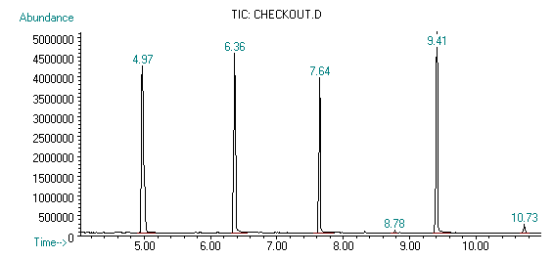
Figure 1: Chromatogram generated by a GC.
If the GC conditions (oven temperature ramp, column type, etc.) are the same, a given compound will always exit (elute) from the column at nearly the same RT. By knowing the RT for a given compound, we can make some assumptions about the identity of the compound. However, compounds that have similar properties often have the same retention times. Therefore, more information is usually required before a student can make an analytical for identification of a compound in a sample containing unknown components.
Mass Spectroscopy
As the individual compounds elute from the GC column, they enter the electron ionization (mass spec) detector. There, they are bombarded with a stream of electrons causing them to break apart into fragments. These fragments can be large or small pieces of the original molecules.
The fragments are actually charged ions with a certain mass. The mass of the fragment divided by the charge is called the mass to charge ratio (M/Z). Since most fragments have a charge of +1, the M/Z usually represents the molecular weight of the fragment.
A group of 4 electromagnets (called a quadrapole, focuses each of the fragments through a slit and into the detector. The quadropoles are programmed by the computer to direct only certain M/Z fragments through the slit. The rest bounce away. The computer has the quadrapoles cycle through different M/Z's one at a time until a range of M/Z's are covered. This occurs many times per second. Each cycle of ranges is referred to as a scan.
The computer records a graph for each scan. The x-axis represents the M/Z ratios. The y-axis represents the signal intensity (abundance) for each of the fragments detected during the scan. This graph is referred to as a mass spectrum (see Figure 2).
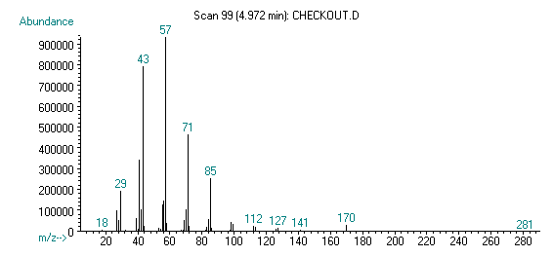
Figure 2: Mass-spectrum generated by an MS.
The mass spectrum produced by a given chemical compound is essentially the same every time. Therefore, the mass spectrum is essentially a fingerprint for the molecule. This fingerprint can be used to identify the compound. The mass spectrum in Figure 2 was produced by dodecane. The computer on our GC-MS has a library of spectra that can be used to identify an unknown chemical in the sample mixture. The library compares the mass spectrum from a sample component and compares it to mass spectra in the library. It reports a list of likely identifications along with the statistical probability of the match.

GC-MS
When GC is combined with MS, a powerful analytical tool is created. A researcher can take an organic solution, inject it into the instrument, separate the individual components, and identify each of them. Furthermore, the researcher can determine the quantities (concentrations) of each of the components.

GC–MS full-scan of the light fractions of saturated compounds and aromatic compounds isolated from crude oil

Compounds of petroleum hydrocarbons identified by GC-MS.
No. Compound
1 1-Methyl-4-(1-methylethy-lidene)-cyclohexane
2 cis,cis-1,6-Dimethylspiro[4,5]decane
3 Bicyclo[2,2,1]heptane,2,2,3-trimethyl
4 1-Pentadecyne
5 1-Methylbicyclo[3,2,1]octane
6 (+)-(2)-Longipinane
7 1,2,3,6b,7,8,9,10,10a,10b-Decahydro-fluoranthene
8 4-(4-Ethylcyclohexyl)-1-pentyl-cyclohexene
9 Octacosahydro-9,9_-biphenathrene
10 3-Methyl-6,7-benzoisoquinoline
11 1,4-Dimethyl-anthracene
12 Decahydro-1,6-dimethyl-4(1-methylenthyl)-naphthalene
13 5-Butyl-6-hexyloctahydro-1H-indene
14 2-Butyl-5-hexyloctahydro-1H-indene
15 1,2,3,4,7,12-Hexahydro-benz[a]anthracene
16 9-1-Butyl-anthracene
17 9-Butyltetradecahydro-anthracene
18 (5,Alpha,13,alpha)-d-homoandrostane
19 5,Alpha-cholest-22-ene
20 Benz[a]anthracene
21 Triphenylene
22 Chrysene
23 Androstane
24 Baccharane
25 1,3-Dimethyl-pyrene
26 Cholestane
27 Perylene
28 23,28-Bisnor-17,alpha,(H)-hopane
29 4-Iodo-N-[2,4,6-trimethyl-phenyl]-benzamide
30 28-Nor-17,beta,(H)-hopane
31 2-(4-Chlorophenyl)benzothiazole

