**2METEOROLOGY AND AIR POLLUTION**

**2.1. Learning objective**

After the completion of this chapter, the student will be able to:

1. Describe the importance of metrology regarding to air pollution

2. Identify the importance of environmental and adiabatic laps rate

3. State the role of inversion on the concentration of air pollutants

4. Analyze plumes behavior in different environmental conditions

**Introduction to the chapter**

Meteorology specifies what happen to puff or plume of pollutants from the time it is emitted to the time it is detected at some other location. The motion of the air causes a dilution of air pollutant concentration and we would like to calculate how much dilution occurs as a function of the meteorology or atmospheric condition.

Air pollutants emitted from anthropogenic sources must first be transported and diluted in the atmosphere before these undergo various physical and photochemical transformations and ultimately reach their receptors. Otherwise, the pollutant concentrations reach dangerous level near the source of emission. Hence, it is important that we understand the natural processes that are responsible for their dispersion. The degree of stability of the atmosphere in turn depends on the rate of change of ambient temperature with altitude.

**I. VERTICAL DISPERSION OF POLLUTANTS**

As a parcel of air in the atmosphere rises, it experience s decreasing pressure and thus expands. This expansion lowers the temperature of the air parcel, and therefore the air-cools as it rises. The rate at which dry air-cools as it rises is called the dry adiabatic lapse rate and is independent of the ambient air temperature. The term adiabatic means that there is no heat exchange between the rising parcel of air under consideration and the surrounding air. The dry adiabatic lapse rate can be calculated from the first law of thermodynamics (1°C per 100m).

As the air parcel expands, it does work on the surroundings. Since the process is usually rapid, there is no heat transfer between the air parcel and the surrounding air. **Saturated adiabatic lapse rate, (**Γ**s)**

Unlike the dry adiabatic lapse rate, saturated adiabatic lapse rate is not a constant, since the amount of moisture that the air can hold before condensation begins is a function of temperature.

A reasonable average value of the moist adiabatic lapse rate in the troposphere is about 6°C/Km.

**Example**

An air craft flying at an altitude of 9 km draws in fresh air at - 40°C for cabin ventilation. If that fresh air is compressed to the pressure at sea level, would the air need to be heated or cooled if it is to be delivered to the cabin at 20°C.

**Solution**

As the air is compressed, it warms up it is even easier for the air to hold whatever moisture it may have, had .so there is no condensation to worry about and the dry adiabatic lapse rate can be used, At 10°C per km, compression will raise the air temperature by

10x9=90°C making it -40+90°c=50°C It needs to be the air conditioned

The air in motion is called **wind,** air that is rushing from an area of high pressure towards an area of low pressure. When the weatherman reports the wind to us, he uses a measuring system worked out in 1805 by Adoniral Beaufort.

For example, a “moderate breeze” is a wind of 13 to 18 miles an

Hour (see annex 2). Obviously, air quality at a given site varies tremendously from day to day, even though the emissions remain relatively constant. The determining factors have to do the weather :how strong the winds are, what direction they are blowing ,the temperature profile , how much sun light available to power photochemical reactions, and how long it has been since the last strong winds or precipitation were able to clear the air. Air quality is dependent on the dynamics of the atmosphere, the study of which is called *meteorology*

**2.3. Temperature lapse rate and stability**

The ease with which pollutants can disperse vertically into the atmosphere is largely determined by the rate of change of air temperature with altitude. For some temperature profiles, the air is stable, that is, air at a given altitude has physical forces acting on it that make it want to remain at that elevation. Stable air discourages the dispersion and dilution of pollutants. For other temperature profiles, the air is unstable. In this case, rapid vertical mixing takes place that encourages pollutant dispersal and increase air quality. Obviously, vertical stability of the atmosphere is an important factor that helps determine the ability of the atmosphere to dilute emissions; hence, it is crucial to air quality. Let us investigate the relationship between atmospheric stability and temperature. It is useful to imagine a “parcel” of air being made up of a number of air molecules with an imaginary boundary around them. If this parcel of air moves upward in the atmosphere, it will experience less pressure, causing it to expand and cool. On the other hand, if it moves dawn ward, more pressure will compress the air and its temperature will increase.

As a starting point, we need a relationship that expires an air parcel’s change of temperature as it moves up or down in the atmosphere. As it moves, we can imagine its temperature, pressure and volume changing, and we might imagine its surrounding adding or subtracting energy from the parcel. If we make small changes in these quantities, and apply both the ideal gas law and the first law of thermodynamics, it is relatively straightforward to drive the following expression.

dQ=Cp dt –vdp…………………….. (2.1)

Where:

dQ = heat added to the parcel per unit mass (J/kg)

Cp = Specific heat at a constant pressure (1005J/Kg - oC)

dt= Incremental temperature change(oC)

v = volume per unit mass (m3/kg)

dp = Incremental pressure change in the parcel (Pa)

Let us make the quite accurate assumption that as the parcel moves, there is no heat transferred across its boundary, that is, that this process is *adiabatic*. This means that dQ = 0; so we can rearrange (2.1) as

dP/ dT = Cp / V−−−−−−−−−−−−−−−−−−(2.2)

The above equation gives us an indication of how atmospheric temperature would change with air pressure, but what are really interested in is how it changes with altitude .To do that we need to know how pressure and altitude are related. Consider a static column of air with a cross section A, as shown in figure 2.1 .A horizontal slice of air in that column of thickness dZ and density ρ will have mass ρAdZ. If the pressure at the top of the slice due to the weight of air above it is P(Z+dZ), then the pressure at the bottom of the slice ,P(Z) will be P(z+dz) plus the added weight per unit area of the slice itself:

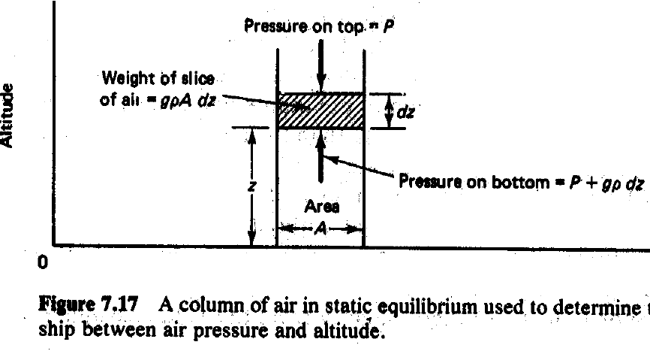

*(P z) =P (z+ dz)= gρAdz* /A − − − − − − − − − − − − − − − − − (2.3)

Where:

g is the gravitational constant. We can write the incremental pressure

dP for incremental change in elevation, dz as

dP = p(z + dz) –p(z) = -g ρ dz ……………………(2.4)

Expressing the rate of change in temperature with altitude as a product, and substituting in (2.2) and (2.3) gives:

dP/ dT = Cp / V 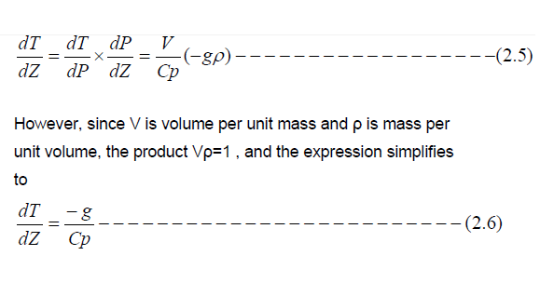

The negative sign indicates that temperature decreases with increasing altitude. Substituting the constant g =9.806m/s2, and the constant –volume specific heat of dry air at room temperature, Cp 1005J/kg. 0C in (2.6) yields

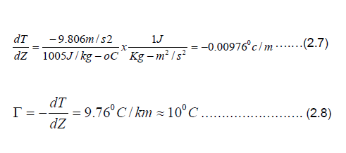

**ATMOSPHERIC STABILITY**

The ability of the atmosphere to disperse the pollutants emitted in to it depends to a large extent on the degree of stability. A comparison of the adiabatic lapse rate with the environmental lapse rate gives an idea of stability of the atmosphere. When the environmental lapse rate and the dry adiabatic lapse rate are exactly the same, a raising parcel of air will have the same pressure and temperature and the density of the surroundings and would experience no buoyant force.

Such atmosphere is said to be neutrally stable where a displaced mass of air neither tends to return to its original position nor tends to continue its displacement

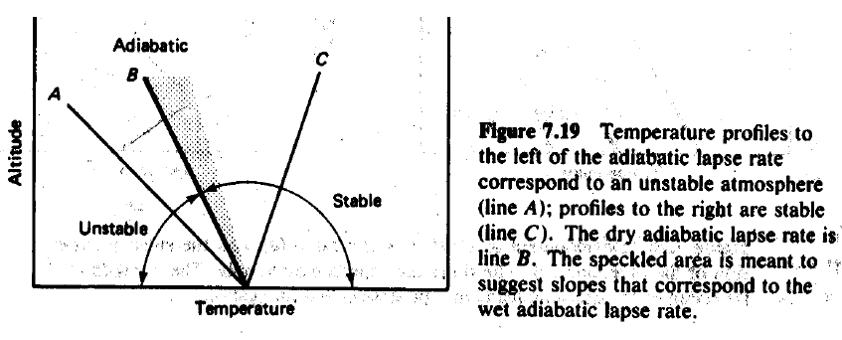

When the environmental lapse rate (-dT/dz.)Env is greater than the dry adiabatic lapse rate,Γ the atmosphere is said to be super adiabatic. Hence a raising parcel of air, cooling at the adiabatic rate, will be warmer and less dense than the surrounding environment. As a result, it becomes more buoyant and tends to continue it’s up ward motion. Since vertical motion is enhanced by buoyancy, such an atmosphere is called unstable. In the unstable atmosphere the air from different altitudes mixes thoroughly. This is very desirable from the point of view of preventing pollution, since the effluents will be rapidly dispersed throughout atmosphere. On the other hand, when the environmental lapse rate is less than the dry adiabatic lapse rate, a rising air parcel becomes cooler and denser than its surroundings and tends to fall back to its original position. Such an atmospheric condition is called stable and the lapse rate is said to be sub adiabatic. Under stable condition there is very little vertical mixing and pollutants can only disperse very slowly. As result, their levels can build up very rapidly in the environment. When the ambient lapse rate and the dry adiabatic lapse rate are exactly the same, the atmosphere has neutral stability. Super adiabatic condition prevails when the air temperature drops more than 1°C /100m; sub adiabatic condition prevail when the air temperature drops at the rate less than 1°c/100m.

**Inversion**

Atmospheric inversion influences the dispersion of pollutants by [restricting](تقييد) vertical mixing. There are several ways by which inversion layers can be formed. One of the most common types is the [**elevated** **subsidence inversion**](ارتداد%20الانقلاب%20المرتفع), This is usually associated with the sub-tropical anti cyclone where the air is warmed by compression as it descends in a high pressure system and [achieves](يحرز%20او%20يحصل) temperature higher than that of the air under Neath. If the temperature increase is sufficient, an inversion will result

• It lasts for months on end

• Occur at higher elevation

• More common in summer than winter

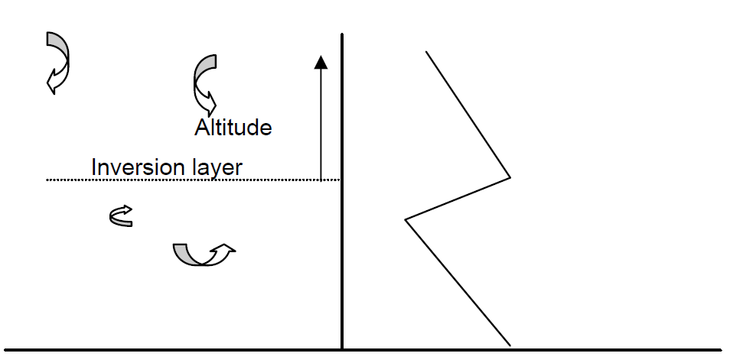

The subsidence is caused by air flowing down to replace air, which has flowed out of the high-pressure region.

**Radiation Inversion**

The surface of the earth cools down at night by radiating energy toward space. On cloudy night, the earth’s radiation tends to be absorbed by water vapor, which in turn reradiates some of that energy back to the ground. On the clear night, however, the surface more readily radiate energy to space, and thus ground cooling occurs much more rapidly. As the ground cools, the temperature of the air in contact with the ground also drops. [As is often the case on clear winter nights, the temperature of this air just above the ground becomes colder than the air above it,](كما%20هو%20الحال%20في%20الليالي%20الشتوية%20تصبح%20درجة%20حرارة%20الهواء%20فوق%20الارض%20ابرد%20من%20الهواء%20فوقه) creating an inversion. Radiation inversions begins to form at dusk .

As the evening progresses, the inversion extends to a higher and higher elevation, reaching perhaps a few hundred meters before the morning sun warms the ground again, breaking up the inversion. Radiation inversion occurs close to the ground, mostly during the winter, and last for only a matter of hours. They often begin at about the time traffic builds up in the early evening, which traps auto exhaust at ground level and causes elevated concentration of pollution for commuters. Without sunlight, photochemical reactions cannot takes place, so the biggest problem is usually accumulation of carbon monoxide (CO). In the morning, as the sun warms the ground and the inversion begins to the break up, pollutants that have been [trapped](محصورة%20او%20محجوزة) in the stable air mass are suddenly brought back to earth in a process known as fumigation. Fumigation can cause short lived high concentrations of pollution at ground level. Radiation inversions are important in another context besides air pollution. Fruit growers in places like California have long known that their crops are in greatest danger of frost damage on winter nights when the skies are clear and a radiation inversion sets in. Since the air even a few meters up is warmer than the air at crop level, one way to help protect sensitive crops on such nights is simply to mix the air with large motor driven fans.

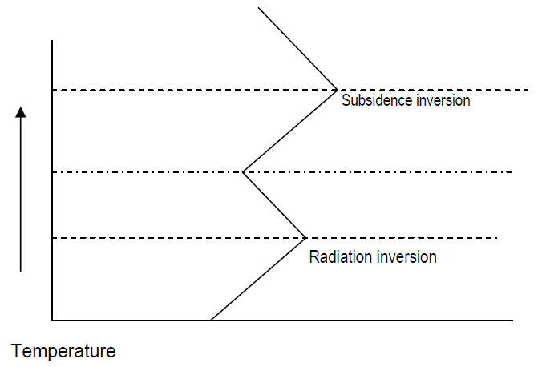

The third type of inversion, known as [**advective inversion**](الانقرب%20بالاتجاه%20الافقي) is formed when warm air moves over a cold surface or cold air. The inversion can be a ground based in the former case, or elevated in the latter case. An example of an elevated advective inversion occurs when a hill range forces a warm land breeze to follow at high levels and cool sea breathes flows at low level in the opposite direction.

TOPOGRAPHICAL EFFECTS

In large bodies of water the thermal inertia of the water causes a slower temperature change than the nearby land. For example, along an ocean coastline and during periods of high solar input, the daytime air temperature over the ocean is lower than over the land. The relative warm air over the land rises and replaced by cooler ocean air. The system is usually limited to altitudes of several hundred meters, which of course, is where pollutants are emitted. The breeze develops during the day and strongest in midafternoon. At night the opposite may occur, although, usually not with such large velocities. At night the ocean is relatively warm and the breeze is from the cooler land the warmer ocean. The on shore breeze is most likely in the summer months, while the off-shore land breeze more likely occur in winter months. A second common wind system caused by topographical effect is the mountain - valley wind. In this case the air tends to flow down the valley at night Valleys are cooler at higher elevation and the driving force for the airflow result from the differential cooling. Similarly, cool air drains off the mountain at night and flows in to the valley. During the day light hours an opposite flow may occur as the heated air adjacent to the sun warmed ground begins to rise and flow both up the valley and up the mountain slopes. However, thermal turbulence may mask the daytime up- slope flow so that it is not as strong as the nighttime down - slope flow. Both the sea breeze and the mountain valley wind are important in meteorology of air pollution. Large power stations are often located on ocean costs or adjacent to large lakes. In this case the stack effluent will tend to drift over the land during the day and may be subjected to fumigation.

**2.4. Wind velocity and turbulence**

The wind velocity profile is influenced by the surface roughness and time of the day. During the day, solar heating causes **thermal turbulence** or eddies set up convective currents so that turbulent mixing is increased. This results in a more flat velocity profile in the day than that at night.

The second type of turbulence is the **mechanical turbulence**, which is produced by shearing stress generated by air movement over the earth’s surface. The greater the surface roughness, the greater the turbulence . The mean wind speed variation with altitude is the planetary boundary layer can be represented by a simple empirical power.

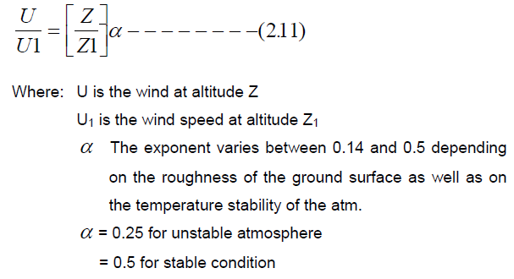

**Table 2.1: Wind velocity in different topography**

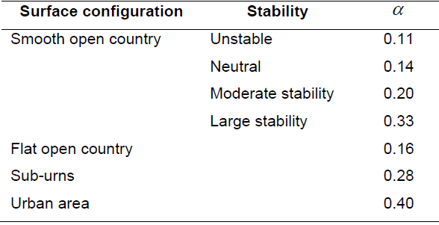

Atmospheric turbulence is characterized by different sizes of eddies. These eddies are primarily responsible for diluting and transporting the pollutants injected in to the atmosphere. If the size of the eddies is larger than the size of the plume or a puff, then the plume or the puff will be transported downwind by the eddy with little dilution. Molecular diffusion will ultimately dissipate the plume or the puff. If the eddy is smaller than the plume or the puff, the plume or the puff will be disperse uniformly as the eddy entrains fresh air at its boundary.

**Plume behavior**

The behavior of a plume emitted from an elevated source such as a tall stack depends on the degree of instability of the atmosphere and the prevailing wind turbulence.

**Classification of plume behavior**

1. **Looping:**

It occurs under super adiabatic conditions, with light to moderate wind speeds on a hot summer after noon when large scale thermal eddies are present. The eddies carry portion of a plume to the ground level for short time periods, causing momentary high surface concentration of pollutants near the stack. Thus the plume moves about vertically in a spastic fashion and the exhaust gases disperse rapidly

1. **Conning:**

It occurs under cloudy skies both during day and night, when the lapse rate is essentially neutral. The plume shape is vertically symmetrical about the plume line and the major part of the pollutant concentration is carried down -wind fairly far before reaching the ground level.

1. **Fanning:**

Occurs when the plume is dispersed in the presence of very light winds as a result of strong atmospheric inversions. The stable lapse rate suppresses the vertical mixing, but not the horizontal mixing entirely. For high stacks, fanning is considered a favorable meteorological condition because the plume does not contribute to ground pollution.

1. **Fumigation**

Here, a stable layer of air lies a short distance above the release point of the plume, and the unstable air layer lies below the plume .This unstable layer of air causes the pollutant to mix down - wind toward the ground in large lumps, but fortunately this condition is usually of short duration lasting for about 30 minutes Fumigation is favored by clear skies and light winds, and it is more common in the summer seasons.

1. **Lofting**

The condition for lofting plume are the inverse of those for fumigation, when the pollutants are emitted above the inverse layer , they are dispersed vigorously on the upward direction since the top of the inversion layer acts as a barrier to the movement of the pollutants towards the ground .

1. **Trapping:**

Occurs when the plume effluent is caught between two inversion layers. The diffusion of the effluent is severely restricted to the unstable layer between the two unstable layers.

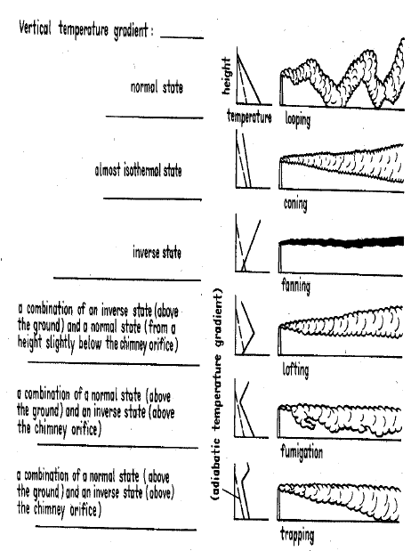

**Stack Plume Dispersion:**

**In the stable atmosphere case** (producing a fanning plume), there is horizontal dispersion at a right angle to the wind due to turbulence and diffusion. In the vertical, dispersion is suppressed by the stability of the atmosphere, so pollution does not spread toward the ground. This results in very low pollution concentrations at the ground.

**In unstable air**, the plume will whip up and down as the atmosphere mixes around (whenever an air parcel goes up, there must be air going down someplace else to maintain continuity, and the plume follows these air currents). This gives the plume the appearance that it is looping around.

**An inversion** aloft will trap pollutants underneath it, since the stable inversion prevents vertical dispersion. Pollution released underneath the inversion layer will fumigate the mixed layer. Note that if the smokestack was high enough to release the pollution within the inversion layer, the plume would fan because the plume occurs within stable air.

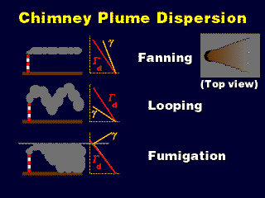

**More on Chimney Plume Dispersion**

**In the neutral atmosphere case**, the horizontal dispersion at a right angle to the wind is due to turbulence and diffusion, which occurs at the same rate as the vertical dispersion, which is not being opposed nor encouraged by the stability (or lack of it) in the atmosphere. So, the plume spreads equally in the vertical and horizontal as it propagates downstream, forming a coning plume.

In the lofting case, pollution dilutes upward. This produces much lower pollution concentrations at the ground at a distance downstream than the straight stable case (fanning plume), because molecular diffusion and some turbulence allow smoke to reach the ground eventually, and the fanning plume does not have the upward dispersion that the lofting plume has.

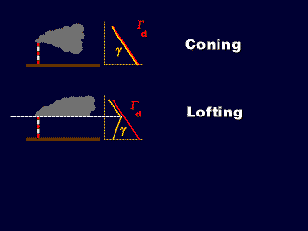

**Enhancing Dispersion: Flow Obstructions**

* Turbulent wake behind a building helps mix pollutants to the ground that might not have been there normally, in a stable atmosphere.
* Downwash is especially bad when there are pollution sources on the top of the building.
* It is important to get the pollution emitted high enough above the building so that it does not get caught in the downwash and get carried down to the ground

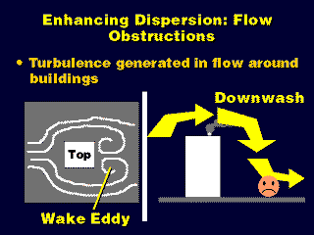

**Enhancing Dispersion with Smokestacks**

Pollution emitted from a taller stack has to travel a longer distance to get to the ground, so it will become more dilute.

[Also, it may be possible for taller stacks to get above low-level inversions....](http://apollo.lsc.vsc.edu/classes/met130/notes/chapter18/graphics/inversion.gif)

|  |
| --- |
|  |
|  |
| http://apollo.lsc.vsc.edu/classes/met130/notes/chapter18/graphics/inversion.gif |

**Tall and Short Smoke Stacks**

* With a tall enough smokestack, pollution is emitted within the inversion aloft, forming a fanning plume that does not pollute the area near the smokestack. If it's not tall enough, it will fumigate the countryside.
* Switching the layers so that the inversion is at the ground, we need the smokestack tall enough to be above the ground inversion, so   that a lofting plume is formed. Architects will need to know the average depth of the nocturnal radiation inversion in order to know how tall to build the smokestack.

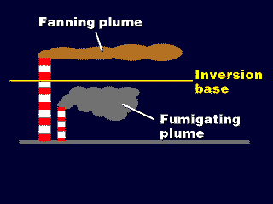

**Exit Velocity**

The faster the smoke gushes out, the more momentum it has, and the higher it will fly before it levels out and disperses toward the ground.

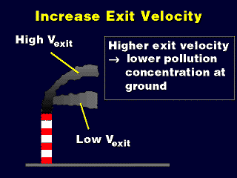

**Methods for Increasing Exit Velocity**

* Narrowing the smokestack's opening forces the smoke out as a faster streaming, narrower jet.
* Backpressure from the smaller opening may reduce the efficiency of the flow of smoke out of the chimney, however, partially offsetting the increasing in plume momentum.

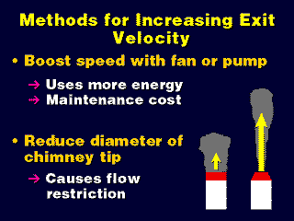

Exit Temperature

* The higher the temperature, the greater the positive buoyancy in smoke streaming out of the smokestack.
* The smoke has to rise higher before it has adiabatically cooled to a neutral buoyancy temperature

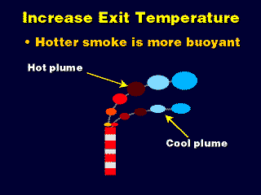

**Methods for Increasing Exit Temperature**

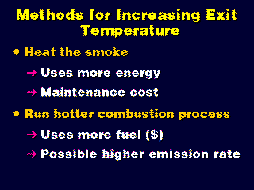

**PLUME DISPERSION**

Dispersion is the process by which contaminants move through the air and a plume spreads over a large area, thus reducing the concentration of pollutants it contains. The plume spreads both horizontally and vertically. If it is gaseous, the motion of the molecules follows the low of gaseous diffusion. The most commonly used model for the dispersion of gaseous air pollutants is the Gaussian, developed by Pasquill, in which gases dispersed in the atmosphere are assumed to exhibit idea gas behavior.

**2.6. The Gaussian plume model**

The present tendency is to interpret dispersion data in terms of the Gaussian model. The standard deviations are related to the eddy diffusivities

**Gaussian Model**

For a description of pollutant dispersion in the atmosphere we use in several cases models which assume that the pollutant concentration after their release from the source have a canonical distribution (Gaussian distribution) as examined in the previous paragraphs. These models are called Gaussian models. The Gaussian models are extensively used since they describe realistically, based on comparison with field data, the pollutant dispersion at a local level for a stationary atmosphere. In a Cartesian orthogonal coordination system with origin at the bottom of the point source, with direction xx0 the wind direction, yy0 the direction vertical to the wind direction at the surface and zz0 the vertical one, the concentration of pollutants at the position (x,y,z) can be described from the equation (Seinfeld and Pandis 2006):

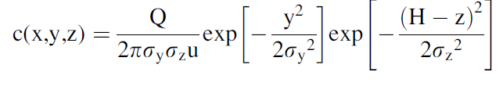

where, c(x,y,z) is the concentration of pollutant at point (x,y,z), expressed in σx mg/m3, Q the emission rate expressed in mg/s, u, the wind velocity (m/s),σy and σz the typical pollutant distribution deviations, at axis yy**؍** and zz**؍**, respectively and H the effective height of plume emission .The conditions which have to obtain in order to apply a Gaussian model to give realistic results are the following:

1. The pollutant emissions are continuous or at least the emissions occur for a time interval which is larger than the travel time of the pollutant from the source to the receptor point which the concentration has to be derived.
2. The pollutants are not reacting chemically in the atmosphere since the Gaussian model is not including chemical reactions.
3. At the wind direction the transport process is dominant to the turbulent dispersion.
4. The aerosol diameter to be smaller than 20 mm in order for their residence time in the atmosphere to be larger than the time intervals which are studied with the Gaussian models.
5. The atmosphere, to be in a stationary condition in relation to the meteorological parameters, for the time interval of transport from the pollution source to the receptors. This condition, is satisfied in most cases. For example if there is transport of pollutants to distances smaller than 10 km and the wind velocity is 5 m/s, then the transport time is close to 35 minutes and for these time intervals the meteorological conditions are usually stable.

With the Gaussian model are calculated average pollutant concentrations at several points around the emission source. There is a difference in the pollutant concentration distribution between average and instant values. The average concentration has a Gaussian distribution at the cross direction and to a lesser extent in the vertical direction. The question which arises is how large the time interval has to be at which the average concentration values have to be obtained in order for the average concentrations to have a canonical distribution. In the majority of cases average values of hourly concentrations are calculated. However, there are indications that the Gaussian distribution is observed also in cases where the average values are calculated for time intervals of tens of minutes. From the equation which describes the Gaussian plume it can be seen that the model cannot be applied in case the wind velocity tends to zero. In cases of very low wind velocity, it is set equal to 0.5 or 1 m/s based on the model being used.

**Limitations of the Gaussian Model**

1. Conditions of Intense Instability:

When there are very unstable conditions in the atmosphere the air flux inside the boundary layer is turbulent and upward and downward air movements are present. This has as a result the pollutants emitted from a source to be transported quickly to the upper layers of the boundary layer or close to the surface. The upward movements have higher velocity than the downward transport and cover smaller area. Therefore the pollutants have higher probability to be located in a downward air movement with a final result the main axis of the plume to move to the surface. In total the plume moves to the surface or to the base of the boundary layer. This fact is not considered in the Gaussian model and requires caution in application of the models in very unstable conditions.

1. Emissions Close to the Surface: When the emissions occur close to the surface, then difficulties arise in the application of Gaussian models due to the variation of wind velocity and the turbulence structure. More precisely the wind velocity close to the surface changes to logarithmic versus height and is difficult to use a characteristic velocity for the whole boundary layer. Furthermore the turbulent flux is not homogeneous in the vertical direction and deviates from the Gaussian distribution. The cross sectional distribution of emissions close to the surface continues to be canonical.

**Calculation of the** σ**y and** σ**z Coefficients. Stability Methodology**

The dispersion coefficients (σ) are determined from field measurements. The dispersion coefficients are dependent on the topography of the area of interest,

the atmospheric stability and the distance and time from the start of the dispersion

(Schnelle and Dey 1999).

The values in the scientific literature for the functions ),σy and σz versus distance from the source and stability conditions have been calculated during field experiments from the period between 1950 and 1960 (Hanna et al. 1981). The area of the experiment was homogeneous, the emissions were performed close to the surface and the measurements were done at distances smaller than 1 km from the source. These field experiments resulted in 1961 in the Pasquill curves (Fig. 6.1). The semi continuous lines are due to the fact that the experiments were performed at a distance of 1 km away and the continuation of the lines is valid in ideal conditions. Probably the actual curves deviate from these ideal lines since the conditions in the atmosphere are almost never ideal.

Analytical expressions for the functions σy and σz (dispersion coefficients for the directions x and y) have been presented in the scientific literature. One of the first mathematical expressions was given during 1967 by Smith who showed hourly measurements at distances up to 10 km from a source with height of 108 meters. According to Smith’s measurements the following expressions for σy and σz are given:

σy = a χ b and σz = c χ d

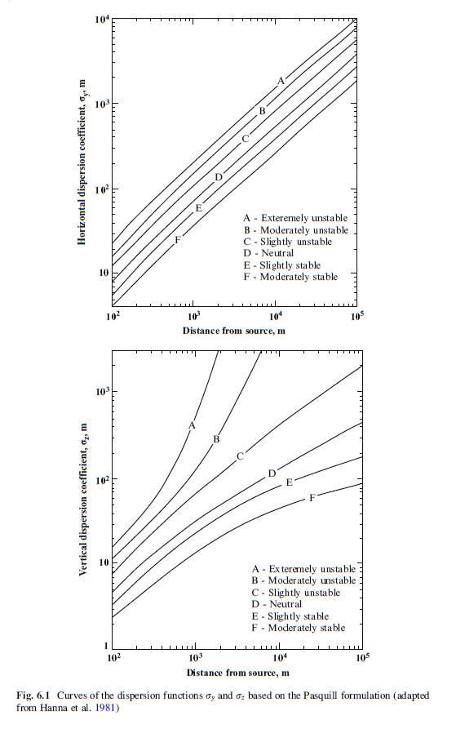

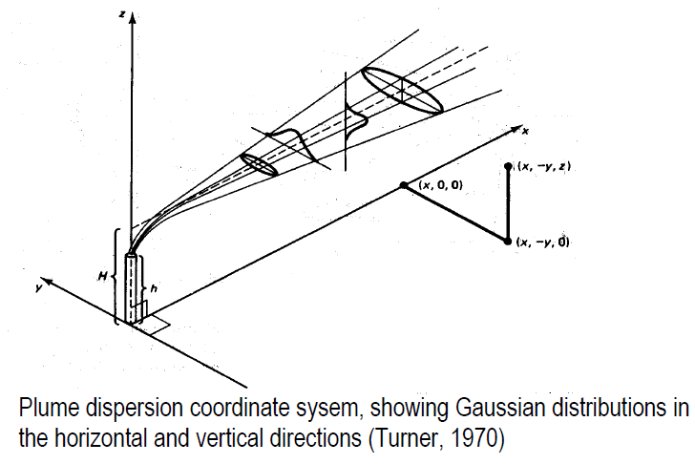

**Plume Rise**

When the emissions from a stack have a higher temperature than the temperature of the environment, then the plume is rising due to thermal motion. In addition plume rise is also occurring if the emissions exit the stack with high velocity. Some plumes rise also due to different characteristics of the pollutants (density and composition). These gaseous species have positive upward transport (buoyant plume) if they are thinner than the air and a downward transport if they are heavier than the air. The rising of warm gaseous plumes can be described in the following stages (Fig. 6.3):

1. Thermal stage, which is characterized by:

– Mixing due to initial turbulence,

– Moderate ascending and planar shape,

– Application of a linear thermal model and finally

– Description of the phenomenon by the Briggs methodology which assumes that the plume reaches its maximum height at this stage.

1. Intermediate stage, which is characterized by:

– Dominance of the atmospheric turbulence,

– Breaking of the plume into small compartments and

– A stepwise increase of the plume diameter.

1. Diffusion stage, which is characterized by:

– Dominance of the atmospheric turbulence diffusion

– Plume formation– even larger diffusion and

– Relatively slow development.

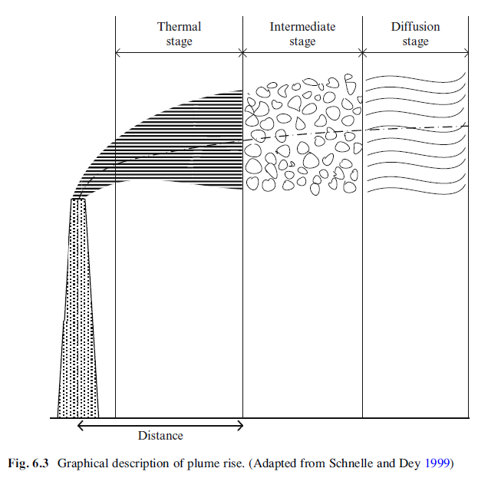



**Major emission sources:**

1. Transportation;

2. Industrial and domestic fuel burning;

3. Industrial processes.

**Receptors:**

1. Humans;

2. Animals;

3. Plans;

4. Materials.

**Atmosphere**

acts as a medium for transport and dispersion,

physical and chemical transformations

**2. Air pollution classification.**

**according to chemical composition:**

1- Sulfur-containing compounds.

2- Nitrogen-containing compounds.

3- Carbon-containing compounds.

4- Halogen-containing compounds.

5-Toxic substances (any of about).

6- Radiative compounds.

**according to physical state:**

1. Gaseous.

2. Liquid (aqueous).

3. Solid.

**according to the manner in which they reach the atmosphere:**

1. Primary pollutants (those emitted directly from the sources).

2. Secondary pollutants (those formed in the atmosphere by chemical interactions among primary pollutants and

normal atmospheric conditions).

**according to the space scales of their effects:**

1. Local (or indoor).

2. Regional.

3. Global.

􀁺 Criteria air pollutants are six major pollutants defined by EPA (Environmental Protection Agency) for which ambient air standards have been set to protect human health and welfare.

Criteria pollutants (defined by EPA):

1. Ozone, O3.

2. Carbon monoxide, CO.

3. Sulfur dioxide, SO2.

4. Nitrogen oxides, NOx.

5. Lead, Pb.

6. Particulates, PM10

**3. Major air pollutants**

**Ozone as a pollutant.**

Ozone, O3, is a gas.

􀁺 At ground level, ozone is a hazard (‘bad’ ozone) - it is a major constituent of photochemical smog. However, in the stratosphere, it serves to absorb some of the potentially harmful UV radiation from the sun, which is believed to cause skin cancer, among other things (‘good’ ozone). Sources: ozone is not emitted into the atmosphere; ozone is formed from the ozone precursors, VOCs, and nitrogen oxides (will be discussed in several Lectures).

"Bad" ozone effects:

􀁺 diverse effects on human health

􀁺 ecological effects: damage vegetable and trees,

**Major sulfur-containing compounds :**

Sulfur dioxide, SO2, is a colorless gas with a sharp odor, primary pollutant, has anthropogenic (man-made) and natural sources.

Anthropogenic sources: industries burning sulfur-containing fossil fuels, ore smelters, oil refineries.

􀁺 Sulfur is present in many fuels (e.g., coal, crude oils) over a wide range of concentrations. Combustion causes its oxidation to sulfur dioxide.