Introduction to Microbiology
The Microbial World and You
Microorganisms / Microbes:
-typically unicellular
-too small to see with unaided eye
-include:
bacteria & archaea fungi
protozoa algae viruses
-located almost everywhere
-only a small % are pathogens
-most involved in environmental / ecosystem balance:
*breakdown waste
*ﬁx nitrogen
*photosynthesis –foundation of food chain
*digestion in animals
*vitamin production
Organism Nomenclature
-Established by Carolus Linnaeus (1735)
-latinized
-each organism has unique two part genus & species name:
e.g. Escherichia coli
-written in italics or underlined
-genus with capital ﬁrst letter
-species/speciﬁc epithet all lowercase
-after ﬁrst use in documents can abbreviate genus: E. coli
-name often describes organism: shape, habitat, name of discoverer, etc.

Microbial Groups
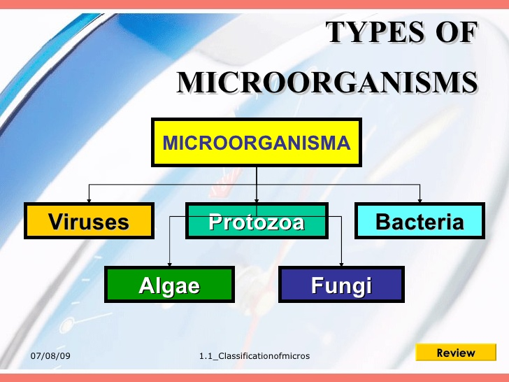

Brief History of Microbiology
1665 Robert Hooke
-Developed ﬁrst microscope
-Observed smallest units of life, calls them cells
-Proposed cell theory:
All living things are composed of cells
Prevailing thoughts:
Spontaneous Generation Theory: some forms of life could arise spontaneously from nonliving matter

1673-1723 van Leeuwenhoek
-Enhanced microscope magniﬁcation
-Published observations of tiny live moving objects: called them “animalcules”
Scientists now interested in microbes: Where do they come from?

1858 Virchow
-Theory of Biogenesis: living cells can only arise from living cells
Great debates & Experiments to prove both sides continue
1861 Louis Pasteur
-Demonstrates microbes in air can contaminate sterile solutions but air cannot give rise to microbes: no spontaneous generation

-Microbes present on all non-living matter
-Microbes can be killed by heat
-Methods can block access of microbes to sterilized medium:
aseptic technique

-Establishes link between activity of a microbe and speciﬁc change in organic material.
-Invented Pasteurization: kill contamination
-Applied ‘microbes cause change in organics’ logic to disease
Germ Theory of Disease: microbes cause disease
(prevailing thought: disease = punishment for misdeeds
1860s Joseph Lister
-Knew physicians transmitted infections
-Knew phenol (carbonic acid) killed bacteria
-Treated surgical wounds and implements, reduced incidence of infection
1876 Robert Koch
-Proves Germ Theory of Disease:
*Anthrax-kills livestock
*isolated Bacillus anthracis from sick animals
*grows B. anthracis in culture
*injects culture into healthy animal
*animal sick with Anthrax, dies, same B. anthracis in blood
-Koch’s Postulates: experimental steps to prove a particular bacteria causes a particular disease.
1857-1914 Golden Age of Microbiology
-Establishment of Microbiology as a science
-Discovery of disease agents
-Discovery of role of immunity
-Development of vaccines
-Development of Chemotherapy
- Vaccination:

1796 Jenner lister
-Observed milkmaids who got cowpox never got smallpox
-Injected cowpox into child, child mildly ill
-Child never contracted cowpox or smallpox
1880 Pasteur
-Observed bacteria grown in lab became avirulent but could produce immunity
-Coined the term vaccine (vacca is Latin for cow)
Chemotherapy = treatment of disease using chemicals
Antibiotics = chemicals produced by one microbe to kill another
Synthetic drug = chemicals synthesized in lab to treat infections and disease
1910 Ehrlich
-First chemotherapy for infection
-Salvarsan (arsenic) for syphilis
-First antibiotic
-Penicillin for Staphylococcus infections

Early microbiology topics now divided into speciﬁc ﬁelds:
Bacteriology : study of bacteria
Mycology : study of fungi
Phycology: study of algae
Parasitology: study of protozoa
and parasitic worms
Virology: study of viruses
Immunology: host immunity & vaccines
Recombinant DNA Technology: insertion of genes into microbes to produce therapeutics

Microbes and Human Welfare (Good)
-Recycling vital elements (decomposition, photosynthesis, & nitrogen ﬁxation return C, N, O, S, and P back to food chain)
-Sewage treatment
-Bioremediation
-Insect pest control
-Food production
-Commercial applications
-Biotechnology & Genetic Engineering:
*vaccines, *therapeutics, *gene therapy and *agriculture

Microbes and Human Disease
-Normal Microbiota = microbes that live in or on you always
sometimes good, sometimes bad
*prevent pathogen colonization
*produce vitamins in gut
*can cause disease in new location or immuno-compromised host
-Resistance = ability to ward off disease
-Infectious Disease
Pathogens = microbes that have part of life cycle in human host causing illness
*reemerging and increasing
*increasing drug resistance Emerging Infectious Diseases (EIDs) =
diseases that are new or changing and increasing
*genetic changes in organisms
*spread to new regions

