Biotechnology for the second year

Lecture 7: Plant biotechnology

Plant tissue culture: is the growth of explant (any plant part) or plant cells in vitro (in the laboratory culture media).

- Plant cell culture is based on the unique property of the cell-totipotency.
- Cell-totipotency is the ability of the plant cell to regenerate into whole plant. This property of the plant cells has been exploited to regenerate plant cells under the laboratory conditions using artificial nutrient mediums.
- Gottlieb Haberlandt, the german botanist is regarded as the father of plant tissue culture.
Stages of plant tissue culture
There are four stages of plant tissue culture:
- Initiation stage. A piece of plant tissue (called an explant) is (a) cut from the plant, (b) disinfested (removal of surface contaminants), and (c) placed on a medium. A medium typically contains mineral salts, vitamins, sucrose, antibiotics (optional), and a solidifying agent such as agar. The objective of this stage is to achieve an aseptic culture. An aseptic culture is one without contaminating bacteria or fungi.
- Multiplication stage. A growing explant can be induced to produce vegetative shoots by including a cytokinin in the medium. A cytokinin is a plant growth regulator that promotes shoot formation from growing plant cells.
- Rooting or preplant stage. Growing shoots can be induced to produce adventitious roots by including an auxin in the medium. Auxins are plant growth regulators that promote root formation.
- Acclimatization. A growing, rooted shoot can be removed from tissue culture and placed in soil. When this is done, the humidity must be gradually reduced over time because tissue-cultured plants are extremely susceptible to wilting.
Types of cultures
- Organ Culture
- Explant culture
- Callus culture
- Cell suspension cultures
- Protoplast culture
- Embryo culture
- Anther and Pollen Culture

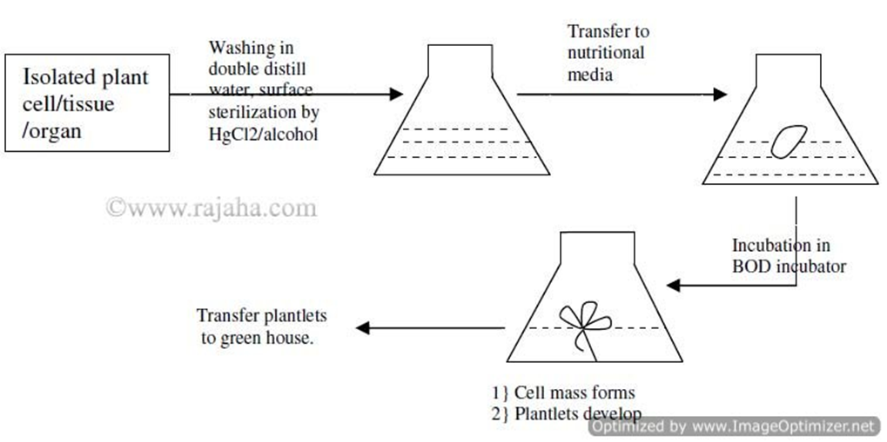
Stages of plant tissue culture

Some Applications of Cell and Tissue Culture

- Micropropagation /Clonal Propagation
- Clonal propagation is the process of asexual reproduction by multiplication of genetically identical copies of individual plants.
- Micropropagation is the tissue culture methods of plant propagation.
- The micropropagation is rapid and has been adopted for commercialization of important plants such as banana, apple, and other plants.

- Production of virus free plants
It has become possible to produce virus free plants through tissue culture at the commercial level. Among the culture techniques, meristem-tip culture is the most reliable method for virus and other pathogen elimination.
3. Production of synthetic seeds
In synthetic seeds, the somatic embryos are encapsulated in a suitable matrix (e.g. sodium alginate), along with substances like mycorrhizae, insecticides, fungicides and herbicides.

4. Production of secondary metabolites
The most important chemicals produced using cell culture are secondary metabolites. These secondary metabolites include alkaloids, glycosides (steroids and phenolics), terpenoids, latex, tannins etc.
Product | Plant source | Uses
Artemisin | Artemisia spp. | Antimalarial
Berberine | Coptis japonica | Antibacterial, anti-inflammatory
Capsaicin | Capsicum annum | Cures Rheumatic pain
Morphine | Papaver somniferum | Analgesic, sedative
Taxol | Taxus spp. | Anticarcinogenic
Transgenic plants with beneficial traits
- Transgenic plants or transgenic crops are the plants, in which a functional foreign gene has been incorporated by any biotechnological methods that generally are not present in the plant.
- Transgenic plants have many beneficial traits like insect resistance, herbicide tolerance, delayed fruit ripening, improved oil quality, weed control etc, but the main goal of producing transgenic plants is to increase the productivity.
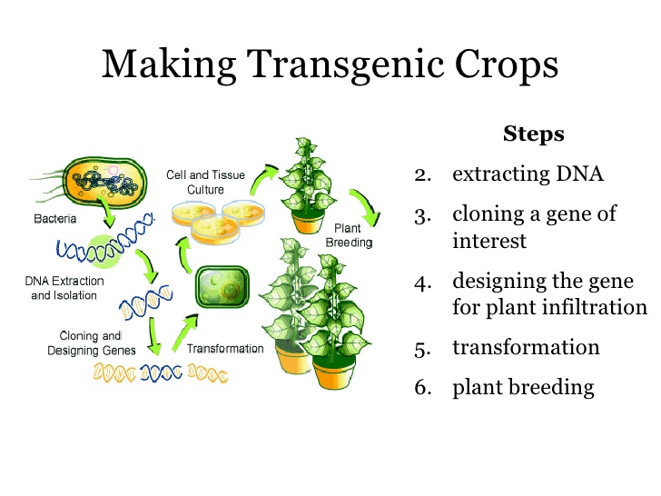
Some of the traits introduced in these transgenic plants are as follows:

Stress tolerance
Biotechnology strategies are being developed to overcome problems caused due to biotic stresses (viral, bacterial infections, pests and weeds) and abiotic stresses (physical actors such as temperature, humidity, salinity etc).
Abiotic stress tolerance
The plants show their abiotic stress response reactions by the production of stress related osmolytes like sugars, sugar alcohols, amino acids and certain proteins (e.g. antifreeze proteins).Transgenic plants have been produced which over express the genes for one or more of the above mentioned compounds. Such plants show increased tolerance to environmental stresses. Resistance to abiotic stresses includes stress induced by herbicides, temperature, drought, salinity, ozone and intense light.
Herbicide tolerance
Several biotechnological strategies for weed control are being used e.g. the over-production of herbicide target enzyme (usually in the chloroplast) in the plant which makes the plant insensitive to the herbicide.
Insect resistance
The transgenic technology uses an innovative and eco-friendly method to improve pest control management.
The first genes available for genetic engineering of crop plants for pest resistance were Cry genes (popularly known as Bt genes) from a bacterium Bacillus thuringiensis. These are specific to particular group of insect pests, and are not harmful to other useful insects like butter flies and silk worms.
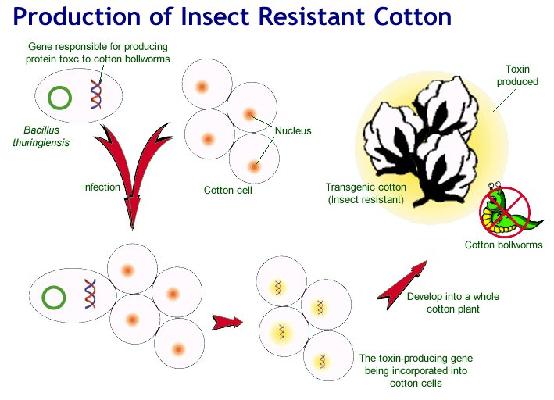
Virus resistance
There are several strategies for engineering plants for viral resistance, and these utilizes the genes from virus itself. The virus coat protein-mediated approach is the most successful one to provide virus resistance to plants.
Delayed fruit ripening
The gas hormone, ethylene regulates the ripening of fruits, therefore, ripening can be slowed down by blocking or reducing ethylene production. This can be achieved by introducing ethylene forming gene(s) in a way that will suppress its own expression in the crop plant.

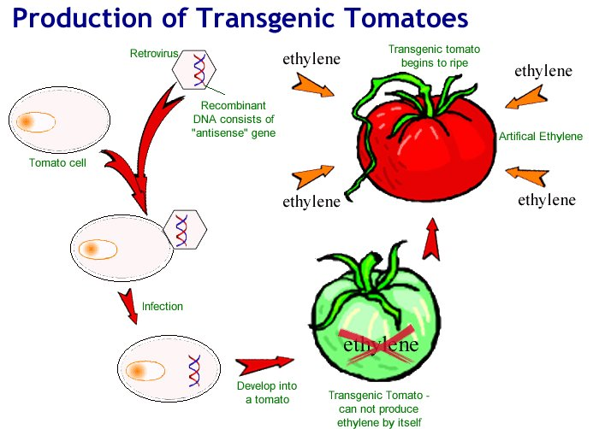

Transgenic plants as bioreactors (molecular farming)
Plants can serve as bioreactors to modified or new compounds. The transgenic plants as bioreactors have some advantages such as:
- The cost of production is low
- There is an unlimited supply
- Safe and environmental friendly
- There is no scare of spread of animal borne diseases
Tobacco is the most preferred plant as a transgenic bioreactor because it can be easily transformed and engineered.
Some of the uses of transgenic plants are:
- Improvement of Nutrient quality
- Improvement of seed protein quality
- Diagnostic and therapeutic proteins
- Edible vaccines
- Biodegradable plastics
Bioethics in Plant genetic Engineering
The major concerns about GM crops and GM foods are:
- Effect of GM crops on biodiversity and environment.
- The risk of transfer of transgene from GM crops to pathogenic microbes.
- The transfer of genes from animals into GM crops for molecular farming may change the fundamental vegetable nature of plants.
- The GM crops may bring about changes in evolutionary patterns.
- There is a risk of transferring allergens (usually glycoproteins) from GM food to human and animals.
- There is a risk of “gene pollution” i.e. transfer of transgene of GM crop through pollen grains to related plant species and development of super weeds.
- There is a need to study thoroughly as to how the genetically engineered plants will affect the ecological balance, once they are released in the environment.

