Biotechnology for the second year

Lecture 8: Nanotechnology
Nanotechnology is the manipulation of matter with at least one dimension sized from 1 to 100nm.
- One nanometer (nm) is one billionth, or 10⁻⁹, of a meter. To put that scale in another context, the comparative size of a nanometer to a meter is the same as that of a marble to the size of the earth.
- The term "nano-technology" was first used by Norio Taniguchi in 1974, though it was not widely known.
- The concepts that seeded nanotechnology were first discussed in 1959 by renowned physicist Richard Feynman.
Because of quantum size effects and large surface area to volume ratio, nanomaterials have unique and different properties compared with their larger counterparts, enabling unique applications. For instance;
- Opaque substances can become transparent (copper).
- Stable materials can turn combustible (aluminium).
- Insoluble materials may become soluble (gold).
- A material such as gold, which is chemically inert at normal scales, can serve as a potent chemical catalyst at nanoscales.
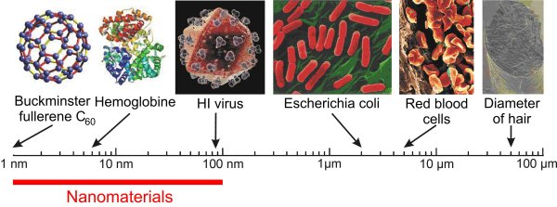
Comparison of Nanomaterials Sizes
Nanoparticles can be divided into:
- Combustion-derived nanoparticles (like diesel soot).
- Manufactured nanoparticles like carbon nanotubes.
- Naturally occurring nanoparticles from volcanic eruptions, atmospheric chemistry etc.
Synthesis processes of nanomaterials:
Two main approaches are used;
- Bottom-up; in this approach, materials and devices are built from molecular components which assemble themselves chemically by principles of molecular recognition.
- Top-down; in this approach, nano-objects are constructed from larger entities without atomic-level control.
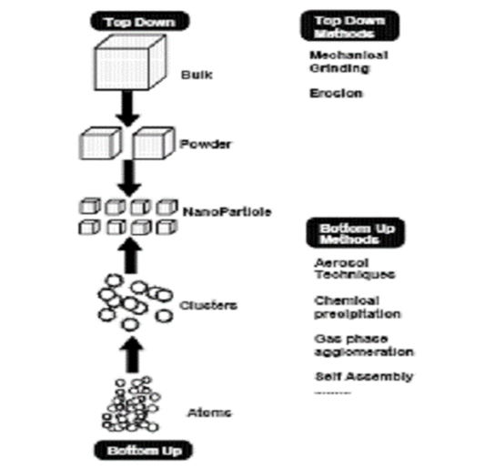
Schematic representation of the ‘bottom up’ and top down’ synthesis
processes of nanomaterials with the popular techniques that are used

Nanotoxicology
It is the study of the toxicity of nanomaterials. It addresses the toxicology of nanoparticles which appear to have toxicity effects that are unusual and not seen with larger particles. Nanotoxicological studies are intended to determine whether and to what extent these properties may pose a threat to the environment and to human beings. Typical nanoparticles that have been studied are titanium dioxide, alumina, zinc oxide, carbon black, and carbon nanotubes, and "nano-C₆₀".

Properties of nanomaterials that influence toxicity include:
- Size
- Chemical composition
- Shape
- Surface structure
- Surface charge
- Aggregation and solubility
- The presence or absence of functional groups of other chemicals
Nanopollution is a generic name for all waste generated by nanodevices or during the nanomaterials manufacturing process. This kind of waste may be very dangerous because of its size. It can float in the air and might easily penetrate animal and plant cells causing unknown effects. Most human-made nanoparticles do not appear in nature, so living organisms may not have appropriate means to deal with nanowaste.
Examples of toxicity effects of nanoparticles:
- Certain nanoparticles may move easily into sensitive lung tissues after inhalation, and cause damage that can lead to chronic breathing problems.
- Some nanoparticles seem to be able to translocate from their site of deposition to distant sites such as the blood and the brain.
- Lab mice consuming nano-titanium dioxide showed DNA and chromosome damage to a degree "linked to all the big killers of man, namely cancer, heart disease, neurological disease and aging.
- The greater chemical reactivity of nanomaterials can result in increased production of reactive oxygen species (ROS), including free radicals. It may result in oxidative stress, inflammation, and consequent damage to proteins, membranes and DNA.

Some applications of nanotechnology
- Medical and biological applications
Nanobiotechnology (sometimes referred to as nanobiology) is defined as a field that applies the nanoscale principles and techniques to understand and transform biosystems and uses biological principles and materials to create new devices and systems integrated from the nanoscale.
Nanomedicine is the medical application of nanotechnology. The approaches to nanomedicine range from the medical use of nanomaterials to nanoelectronic biosensors. Nanomedicine seeks to deliver a valuable set of research tools and clinically helpful devices in the near future. The National Nanotechnology Initiative expects new commercial applications in the pharmaceutical industry that may include advanced drug delivery systems, new therapies, and in vivo imaging.
Some nanomaterials are being investigated for use in nanomedicine; Nanoparticales, Liposomes and Dendrimers.
The size of nanomaterials is similar to that of most biological molecules and structures; therefore, nanomaterials can be useful for both in vivo and in vitro biomedical research and applications. Thus far, the integration of nanomaterials with biology has led to the development of diagnostic devices, contrast agents, analytical tools, physical therapy applications, and drug delivery vehicles.
- Environmental applications
Green nanotechnology refers to the use of nanotechnology to enhance the environmental sustainability of processes producing negative externalities. It also refers to the use of the products of nanotechnology to enhance sustainability. It includes making green nano-products and using nano-products in support of sustainability.
Green nanotechnology has two goals:
  - Producing nanomaterials and products without harming the environment or human health.
  - Producing nano-products that provide solutions to environmental problems.
- Food industry applications
Bacteria identification and food quality monitoring using biosensors; intelligent, active, and smart food packaging systems; nanoencapsulation of bioactive food compounds are few examples of emerging applications of nanotechnology for the food industry. Nanotechnology can be applied in the production, processing, safety and packaging of food. A nanocomposite coating process could improve food packaging by placing anti-microbial agents directly on the surface of the coated film.
New foods called nano-foods are among the nanotechnology-created consumer products coming onto the market, there are more than 609 known or claimed nano-products.
Examples of nano- foods:
- A brand of canola cooking oil called Canola Active Oil, contains an additive called "nanodrops" designed to carry vitamins, minerals and phytochemicals through the digestive system and urea.
- A chocolate diet shake called Nanoceuticals Slim Shake Chocolate, uses cocoa infused "NanoClusters" to enhance the taste and health benefits of cocoa without the need for extra sugar.
- A tea called Nanotea.

