**Biotechnology for the second year**

**Lecture 9: Biosensors**

A biosensor is an analytical device for the detection of ananalytethat combines a biological component with a physicochemical detector component.

**Biosensor consists of 3 parts:**

* The ''sensitive biological element'' (biological material (eg. tissue, microorganisms, organelles, cell receptors, enzymes, [antibodies](http://www.news-medical.net/health/Antibody-What-is-an-Antibody.aspx), nucleic acids, etc), a biologically derived material or biomimic).The sensitive elements can be created by biological engineering.
* The ''transducer'' or the ''detector element'' (works in a physicochemical way; optical, piezoelectric, electrochemical, etc.) that transforms the signal resulting from the interaction of the analyte with the biological element into another signal (i.e., transducers) that can be more easily measured and quantified.
* Associated electronics or signal processors that are primarily responsible for the display of the results in a user-friendly way.

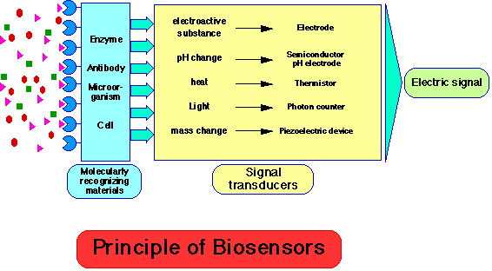



**Schematic diagram showing the main components of a biosensor. The biocatalyst (a) converts the substrate to product. This reaction is determined by the transducer (b) which converts it to an electrical signal. The output from the transducer is amplified (c), processed (d) and displayed (e)**

**Classes of biosensors**

1. **Catalytic biosensors:**kinetic devices that measure steady-state concentration of a transducer-detectable species formed/ lost due to a biocatalytic reaction.

**Monitored quantities:**

* Rate of product formation
* Disappearance of a reactant
* Inhibition of a reaction

**Biocatalysts used:**

* Enzymes,most common; ex., glucose oxidase, urease (catalyzes urea hydrolysis), alcohol oxidase, etc.
* Microorganisms
* Organelles
* Tissue samples

**Three potential measurement routes:**

1. pH change (acid production)

2. O2consumption (fluorophore monitor)

3. H2O2production (electrochemical)

Commercially Available Biosensors:glucose, lactate, alcohol, sucrose, galactose, uric acid, alpha amylase, choline, L-lysine—all amperometric based (O2/H2O2)

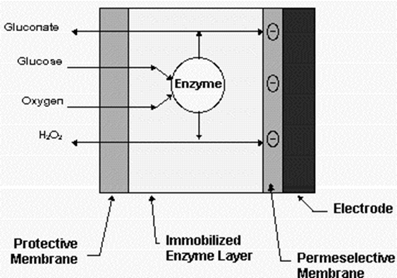

**Overall structure of glucose biosensor**



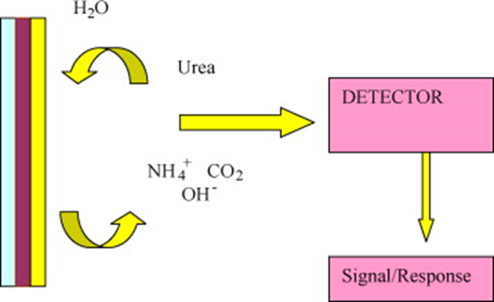

**Schematic of a typical urea biosensor**

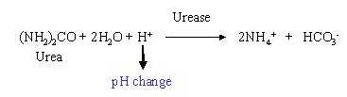

1. **Affinity biosensors**: devices in which receptor molecules bind analyte molecules “irreversibly”, causing a physicochemical change that is detected by a transducer; ex.,DNA chip.

**Receptor molecules:**

* Antibodies
* Nucleic acids
* Hormone receptors

Antibodies and nucleic acid fragments are most common.

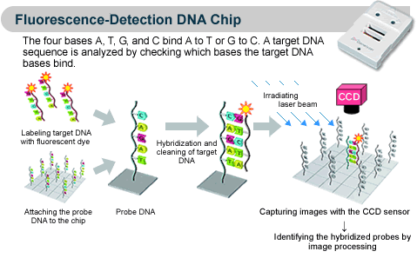

**Transducers**

**1) Electrochemical**:translate a chemical event toan electrical event by measuring current passed, potential changebetween electrodes, or may change conductivity between two electrodes and therefore the corresponding transduction device has been described as:Amperometric(most common), Potentiometric, andConductimetric transducers.

Example: Glucose sensor (most commercial devices).

**2) Photochemical (Optical)**: translate chemical event to a photochemical event, measure light intensity and wavelength (λ)and therefore the corresponding transduction device has been described as:Colorimetric, Fluorescence, and Reflectancetransducers.

A popular example is a biosensor, which makes use of luciferase enzyme for detection of bacteria in food.

**3) Piezoelectric**: translate a mass change from a chemical adsorption event to electrical signal.These are affinity biosensors. This technology is available for many years and is cheap.

Example: Quartz Crystal Microbalance

**Ideal Biosensor Characteristics**

1. Sensitivity
2. Simple calibration(with standards)
3. Linear Response
4. Background Signal:low noise, with ability for correction
5. No hysteresis—signalindependent of prior history of measurements
6. Selectivity—response only to changes in target analyte concentration
7. Long-termStability—not subject to fouling, poisoning, or oxide formation that interferes with signal; prolonged stability of biological molecule
8. Dynamic Response—rapid response to variation in analyte concentration
9. Biocompatibility—minimize clotting, platelet interactions, activation of complement when in direct contact with bloodstream

**Uses of biosensors**

* Quality assurance in agriculture, food and pharmaceutical industries
* Monitoring environmental pollutants and biological warfare agents
* Medical diagnostics
* Biological assays