Hypothalamus:

The hypothalamus is located near the center of the brain, above the brainstem and below the cerebrum composed of many small nuclei with diverse functions. Located above the midbrain and below the thalamus, the hypothalamus makes up the ventral diencephalon. The diencephalon is an embryologic region of the vertebrate neural tube that gives rise to posterior forebrain structures. By synthesizing and secreting neurohormones, the nuclei of the hypothalamus act as a conduit between the nervous and endocrine systems via the pituitary gland (hypophysis), regulating homeostatic functions such as hunger, thirst, body temperature, heart rate, blood pressure, and contractions of the urinary bladder.



**This diagram shows the hypothalamus and pituitary glands. The pituitary is attached to the underside of the brain at the hypothalamus by a thin stalk. The anterior pituitary receives blood that contains controlling factors directly from the hypothalamus. These factors either stimulate or inhibit the release of pituitary hormones. The posterior pituitary is controlled by nerves from the hypothalamus**.

**Hormones that are released by the hypothalamus**

Special neurons in the hypothalamus synthesize and secrete the ***hypothalamic releasing***and ***inhibitory hormones*** that control secretion of the anterior pituitary hormones. These neurons originate in various parts of the hypothalamus and send their nerve fibers to the ***median eminence*** and ***tuber cinereum****,* an extension of hypothalamic tissue into the pituitary stalk.  
The endings of these fibers are different from most endings in the central nervous system, in that their function is not to transmit signals from one neuron to another but rather to secrete the hypothalamic releasing and inhibitory hormones into the tissue fluids.  
These hormones are immediately absorbed into the hypothalamic-hypophysial portal system and carried directly to the sinuses of the anterior pituitary gland.

**The major Hypothalamic Releasing and Inhibitory Hormones Control Anterior Pituitary Secretion.**

1. ***Thyrotropin-releasing hormone* (TRH),** which causes release of thyroid-stimulating hormone.  
   ***2.*** ***Corticotropin-releasing hormone* (CRH)**, which causes release of adrenocorticotropin.  
   ***3.*** ***Growth hormone–releasing hormone* (GHRH),** which causes release of growth hormone, and ***growth hormone inhibitory hormone* (GHIH),** also called ***somatostatin,***which inhibits release of growth hormone.  
   ***4.*** ***Gonadotropin-releasing hormone* (GnRH),** which causes release of the two gonadotropic hormones, luteinizing hormone and follicle-stimulating hormone  
   ***5. Prolactin inhibitory hormone* (PIH),** which causes inhibition of prolactin secretion.

There are some additional hypothalamic hormones, including one that stimulates prolactin secretion and perhaps others that inhibit release of the anterior pituitary hormones.

**the pituitary gland**:

is attached to the underside of the brain by a slender stalk. The pituitary gland, also called the **hypophysis,** itsits in a pocket of bone called the ***sella turcica*** which is located directly above the palate of the mouth and behind the bridge of the nose. It arises from two different tissue sources:

**Posterior pituitary** is nervous tissue (**neurohypophysis**) and **Anterior pituitary** is glandular (**adenohypophysis**).

**Posterior pituitary**: is the neural portion derived from an extension of the hypothalamus (median eminence) which remains connected throughout life by a stalk, called the infundibulum.

**Anterior pituitary:** is the glandular portion derived from the mouth epithelium (Rathke’s pouch) .It forms a cuff (pars tuberalis) around the infundibulum.

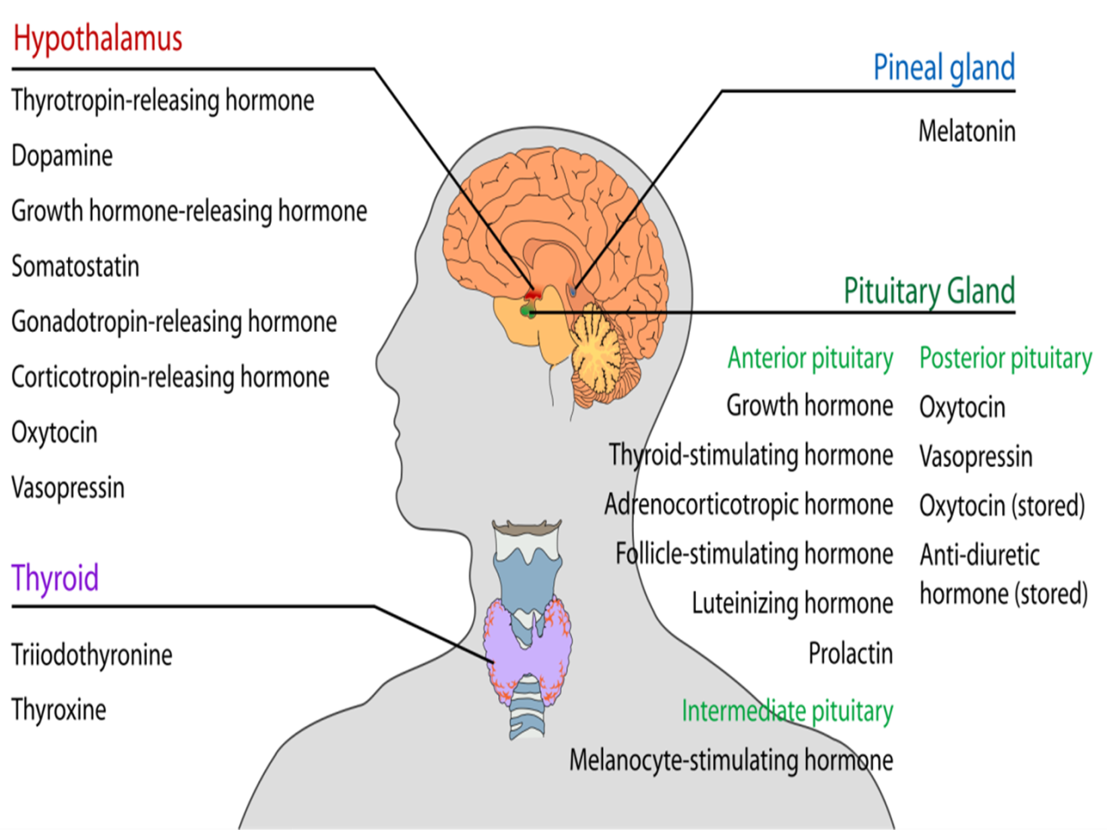

**The Anterior Pituitary Gland Contains Several**

**Different Cell Types That Synthesize and Secrete**

**Hormones.**

Usually, there is one cell type for each major hormone formed in the anterior pituitary gland. With special stains attached to high-affinity antibodies that bind with the distinctive hormones, at least five cell typescan be differentiated (Figure 76-3). Table 76-1 provides a summary of these cell types, the hormones they produce, and their physiological actions. These five cell types are:

1. Somatotropes—human growth hormone (hGH)

2. Corticotropes—adrenocorticotropin (ACTH)

3. Thyrotropes—thyroid-stimulating hormone (TSH)

4. Gonadotropes—gonadotropic hormones, which

include both luteinizing hormone (LH) and folliclestimulating

hormone (FSH)

5. Lactotropes—prolactin (PRL)

About 30 to 40 percent of the anterior pituitary cells are somatotropes that secrete growth hormone, and about 20 percent are corticotropes that secrete ACTH. Each of the other cell types accounts for only 3 to 5 percent of the total; nevertheless, they secrete powerful hormones for controlling thyroid function, sexual functions, and milk secretion by the breasts. Somatotropes stain strongly with acid dyes and are therefore called acidophils. Thus, pituitary tumors that secrete large quantities of human growth hormone are called acidophilic tumors.

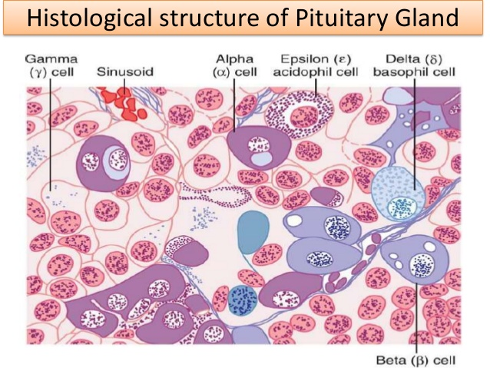

**Figure 76-3. Cellular structure of the anterior pituitary gland. *(Modified from Guyton AC: Physiology of the Human Body, 6th ed.* *Philadelphia: Saunders College Publishing, 1984.)***

**The following hormones are released by the anterior pituitary:**

1. **Growth Hormone** stimulates bone and muscle cells to grow.
2. **Prolactin** causes the mammary glands to produce milk.
3. **Follicle Stimulating Hormone (FSH)** and **Luteinizing** **Hormone (LH),** known collectively as **gonadotropins,** stimulate hormone and gamete production by the **gonads (testes and ovaries).**
4. **Thyroid Stimulating Hormone (TSH)** causes the thyroid to produce thyroid hormone.
5. **Adrenocorticotropic Hormone (ACTH)** stimulates the adrenal cortex to produce corticosteroids, especially during periods of stress.
6. **Melanocyte Stimulating Hormone (MSH)** may have a role in fat metabolism.
7. **Endorphins,** which are also produced by the brain, reduce the perception of pain.

|  |  |  |  |
| --- | --- | --- | --- |
| **Cell** | **Hormone** | **Chemistry** | **Physiological Action** |
| **Somatotropes** | **Growth hormone**  **(GH) (somatotropin** | **Single chain of 191 amino acids** | **Stimulates body growth; stimulates secretion**  **of insulin-like growth factor-1; stimulates**  **lipolysis; inhibits actions of insulin on**  **carbohydrate and lipid metabolism** |
| **Corticotropes** | **Adrenocorticotropic**  **hormone (ACTH)**  **(corticotropin)** | **Single chain of 39 amino acids** | **Stimulates production of glucocorticoids and**  **androgens by the adrenal cortex; maintains**  **size of zona fasciculata and zona reticularis**  **of cortex** |
| **Thyrotropes** | **Thyroid-stimulating**  **hormone (TSH)**  **(thyrotropin)** | **Glycoprotein of two subunits,**  **α (89 amino acids) and**  **β (112 amino acids)** | **Stimulates production of thyroid hormones by**  **thyroid follicular cells; maintains size of**  **follicular cells** |
| **Gonadotropes** | **Follicle-stimulating**  **hormone (FSH)**  **Luteinizing (LH)**  **hormone** | **Glycoprotein of two subunits,**  **α (89 amino acids) and**  **β (112 amino acids)**  **Glycoprotein of two subunits,**  **α (89 amino acids) and**  **β (115 amino acids** | **Stimulates development of ovarian follicles;**  **regulates spermatogenesis in the testis**  **Causes ovulation and formation of the corpus luteum in the ovary; stimulates production of estrogen and progesterone by the ovary; stimulates testosterone production by the testis** |
| **Lactotropes-**  **Mammotropes** | **Prolactin (PRL)** | **Single chain of 198 amino acids** | **Stimulates milk secretion and production** |

**The posterior pituitary**

is an extension of the brain. It releases two hormones—**oxytocin** and **antidiuretic hormone (ADH)**—that are made in specialized cells in the **hypothalamus**. The hormones are transported down nerve cells into the pituitary, where they are stored. The hypothalamus signals for their release by direct nerve signals to allow for quicker secretion. **Oxytocin** stimulates the uterus to contract during labor and stimulates the breast to start releasing milk when a baby nurses. **Antidiuretic hormone** reduces urine output by acting on the collecting ducts of the kidney.

**Factors That Stimulate or Inhibit Secretion of Growth Hormone**

**Inhibit Growth Hormone Secretion**

**Stimulate Growth Hormone Secretion**

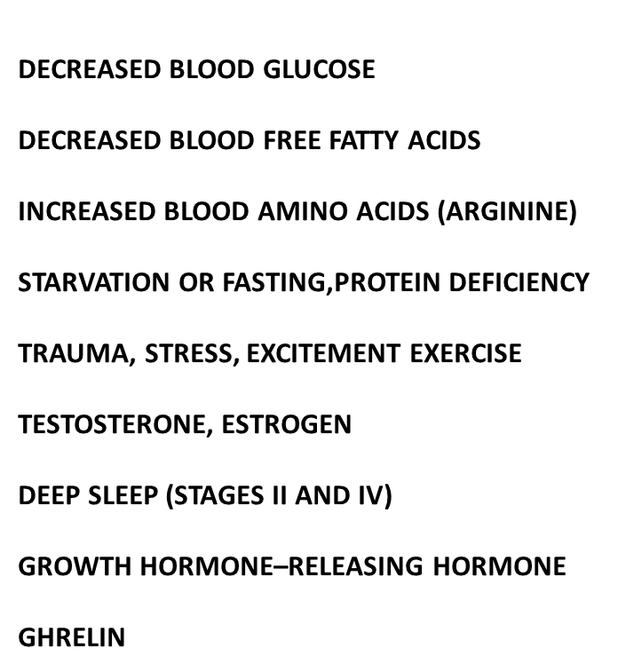

**Increased blood glucose**

**Increased blood free fatty acids**

**Aging**

**Obesity**

**Growth hormone inhibitory hormone (somatostatin)**

**Growth hormone (exogenous)**

**Somatomedins (insulin-like growth factors)**

