Fungi growth : Growth may be defined as an irreversible increase in the volume of an organism, usually accompanied by an increase in biomass.

Laboratory methods for measuring the growth rate of fungi:
To measure the rate of fungal growth on solid media use measure the diameter of the colony While on liquid media we use the method of dry weight.

- Measure the diameter of the colony:
It is one of the most common ways are made through pollination mid dishes containing Media PDA by regular discs from fungal culture modern age between the ages (7-14 days) and then incubated at a temperature of 25 ° C or in an atmosphere lab for a week, taking into account taking measure the diameter colony at regular intervals and that the work of the two lines perpendicular to the base plate and measure both of them and take the average.
The downside of this method is that it ignores the thickness of the developing mycelium in the dish. Some fungi may not expand in growth horizontally as much as it expands vertically.

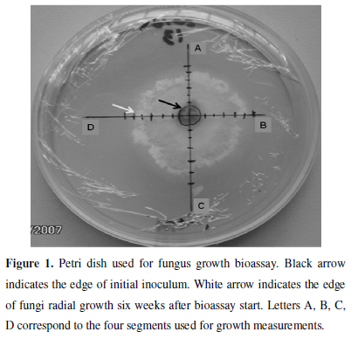

- The method of measuring dry weight and wet weight:
This method is considered one of the best ways and the most accurate and which weighed mycelium and that first filtration of media components with the fungal growth and should be considered wash mycelium and to get rid of the remnants sticking with the media , weighed mat fungal wet and then dried mycelium in special oven at a temperature of 80 ° C until constancy weight and weighed mycelium after drying on a sensitive balance and sufficient weight to approximate the nearest mg. This method is used with the liquid media.
The problem of this method is that the weight may reflect the accumulation of multiple sugars or other materials .

- Turbidity method
This method for estimating private growth unicellular fungi, such as yeast, can be made a count by using a hemacytometer slide,also spectrophotometer device used to estimate the number of cells through the turbid measure where the turbid turn into a number of cells through use of standard curve. The problem with this method is that it is estimated the living and the dead cells together.

- Measure the concentration of the cell components
Some of the cell components such as chitin, glucosamine, is considered as a standard for growth.
It is a useful way to measure the growth of pathogenic fungi for the plant, after the hydrolysis of the infected tissue is released glucose- amin, which is separated chromatography, separated quantity commensurate with the dry weight, which can determine the severity of the infection in the plant tissue. The membrane lipid ergosterol is found almost exclusively in fungi, and is frequently used by environmental microbiologists as an indicator of living fungal biomass.

- Metabolism measurement
Metabolic activities are used as a measure of growth, such as the production of co2, to estimate the growth of some fungi in the fermentation (Brewers)

