Introduction and overview

**Sensing:** Using instruments/devices to measure parameters.

Two categories of sensing devices:

1. **In-situ sensing**: measuring devices are in contact with the medium or object they are sensing like Thermometers measure temperature and Barometer measure pressure .

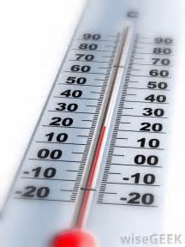 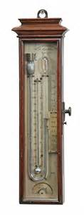

1. **Remote sensing**: measurement devices are not in direct contact with the objects they sense like Satellite and Radar.

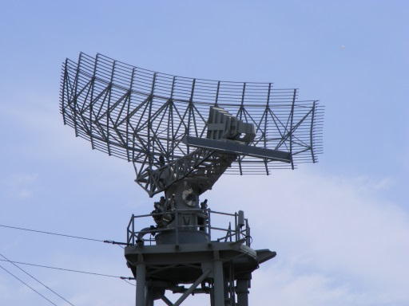 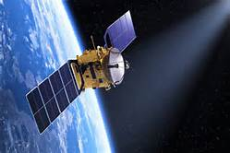

**Why Remote Sensing?**

**In-situ ‘observing’ network of stations have gaps spatially and temporally.

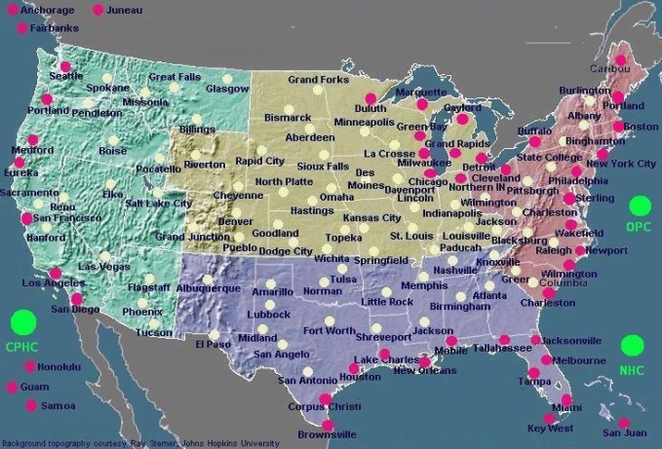

**Remotely sensed data (satellite and radar) are vital to operational weather forecasters because they fill in the spatial and temporal gaps left by the observing network



***Remote Sensing Platforms***

**To enable a sensor to collect and record electromagnetic radiation from an object, the sensor must reside on a stable platform away from the object. Platforms for remote sensors may be located on the ground, on an aircraft, or on a satellite outside the earth's atmosphere. There are many types of Platforms for Remote Sensing:**

**• *Ground-based sensors* such as weather radars are those located on the ground. These sensors are used to record information of an object near the surface of the earth. Restricted by their fixed location, the coverage of these ground-based sensors is usually limited to the vicinity of the sensor.**

**• *Spaceborne sensors* are located outside the earth. One example of spaceborne sensors is meteorological satellite. Since satellite circles the earth continuously, the coverage of a satellite is larger than that of ground-based sensors.**

* ***Airborne remote sensing* are mounted on an aircraft to obtain images of the earth's surface. Analog aerial photography, videography, and digital photography are commonly used in airborne remote sensing. Synthetic Aperture Radar imaging is also carried out on airborne platforms. An advantage of airborne remote sensing, compared to satellite remote sensing, is the capability of offering very high spatial resolution images (20 cm or less). The disadvantages are low coverage area and high cost per unit area of ground coverage*.***

**Aircraft** **Satellite**



**Mobile Radar Doppler Radar**



**Wind Profiler**

**Who uses Remote Sensing and why?**

* The meteorologist, who looks for changes in weather systems for use in weather forecasting.
* The geographer, who looks for changes on the Earth's surface that need to be mapped.
* The forester, who needs information about what type of trees are growing and if they have been affected by disease, fire or pollution.
* The environmentalist, who wants to detect, identify and follow the movement of pollutants such as oil slicks on the ocean.
* The geologist, who is interested in finding valuable minerals;
* the farmer, who wants to keep an eye on how his crops are growing and if they've been affected by drought, floods, disease or pests.
* The ship captain, who needs to find the best route through the northern ice packs.
* The firefighter, who sends out his crews based on information about the size and movement of a forest fire.

And there are many more ways to use remote sensing.

***Application of Remote Sensing***

Satellites have played a huge role in development of many technologies such as world mapping, GPS, etc. However, their applications are not limited Following are some major areas in which remote sensing is useful:

* Weather
* Agriculture
* Forestry
* Military surveillance
* Hydrology
* Geology of Earth’s surface
* Biodiversity
* Discovering ancient archaeological sites
* Improving air traffic control
* Marine life
* Environmental preservation
* Monitoring oil reserves
* Observing climate changes

**Remote Sensing Methods**

Remote sensing refers to the activities of obtaining information about an object by a sensor without being direct contact with object.

Remote sensors can be classified into active and passive type in accordance with the source of electromagnetic radiation.

Some sensors rely on the radiation emitted or reflected from the object. This type of sensors is called ***passive sensor.*** other type of sensor shines electromagnetic radiation onto the object and receives the reflected radiation. They are called ***active sensor***.

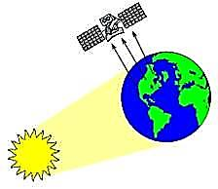

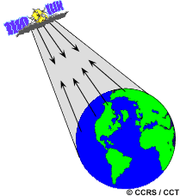

Active sensor Passive sensor

**Active Sensors**

The majority of active sensors operate in the microwave portion of the electromagnetic spectrum, which makes them able to penetrate the atmosphere under most conditions. An active technique views the target from either end of a baseline of known length. The change in apparent view direction (parallax) is related to the absolute distance between the instrument and target.

* [**Laser altimeter**](https://earthdata.nasa.gov/user-resources/remote-sensors#altlidarradar)—An instrument that uses a lidar to measure the height of the platform (spacecraft or aircraft) above the surface. The height of the platform with respect to the mean Earth’s surface is used to determine the topography of the underlying surface.
* [**Lidar**](https://earthdata.nasa.gov/user-resources/remote-sensors#altlidarradar)—A light detection and ranging sensor that uses a laser (light amplification by stimulated emission of radiation) radar to transmit a light pulse and a receiver with sensitive detectors to measure the backscattered or reflected light. Distance to the object is determined by recording the time between transmitted and backscattered pulses and by using the speed of light to calculate the distance traveled.
* [**Radar**](https://earthdata.nasa.gov/user-resources/remote-sensors#altlidarradar)—An active radio detection and ranging sensor that provides its own source of electromagnetic energy. An active radar sensor, whether airborne or spaceborne, emits microwave radiation in a series of pulses from an antenna. When the energy reaches the target, some of the energy is reflected back toward the sensor. This backscattered microwave radiation is detected, measured, and timed. The time required for the energy to travel to the target and return back to the sensor determines the distance or range to the target. By recording the range and magnitude of the energy reflected from all targets as the system passes by, a two-dimensional image of the surface can be produced.
* [**Ranging Instrument**](https://earthdata.nasa.gov/user-resources/remote-sensors#ranging)—A device that measures the distance between the instrument and a target object. Radars and altimeters work by determining the time a transmitted pulse (microwaves or light) takes to reflect from a target and return to the instrument. Another technique employs identical microwave instruments on a pair of platforms. Signals are transmitted from each instrument to the other, with the distance between the two determined from the difference between the received signal phase and transmitted (reference) phase. These are examples of active techniques. An active technique views the target from either end of a baseline of known length. The change in apparent view direction (parallax) is related to the absolute distance between the instrument and target.
* [**Scatterometer**](https://earthdata.nasa.gov/user-resources/remote-sensors#scatterometers)—A high-frequency microwave radar designed specifically to measure backscattered radiation. Over ocean surfaces, measurements of backscattered radiation in the microwave spectral region can be used to derive maps of surface wind speed and direction.
* [**Sounder**](https://earthdata.nasa.gov/user-resources/remote-sensors#sounder)—An instrument that measures vertical distribution of precipitation and other atmospheric characteristics such as temperature, humidity, and cloud composition.

**Passive Sensors**

Passive sensors include different types of radiometers and spectrometers. Most passive systems used in remote sensing applications operate in the visible, infrared, thermal infrared, and microwave portions of the electromagnetic spectrum. Passive remote sensors include the following:

* [**Accelerometer**](https://earthdata.nasa.gov/user-resources/remote-sensors#ranging)—An instrument that measures acceleration (change in velocity per unit time). There are two general types of accelerometers. One measures translational accelerations (changes in linear motions in one or more dimensions), and the other measures angular accelerations (changes in rotation rate per unit time).
* [**Hyperspectral radiometer**](https://earthdata.nasa.gov/user-resources/remote-sensors#hyperspectral)—An advanced multispectral sensor that detects hundreds of very narrow spectral bands throughout the visible, near-infrared, and mid-infrared portions of the electromagnetic spectrum. This sensor’s very high spectral resolution facilitates fine discrimination between different targets based on their spectral response in each of the narrow bands.
* [**Imaging radiometer**](https://earthdata.nasa.gov/user-resources/remote-sensors#multispectral)—A radiometer that has a scanning capability to provide a two-dimensional array of pixels from which an image may be produced. Scanning can be performed mechanically or electronically by using an array of detectors.
* [**Radiometer**](https://earthdata.nasa.gov/user-resources/remote-sensors#multispectral)—An instrument that quantitatively measures the intensity of electromagnetic radiation in some bands within the spectrum. Usually, a radiometer is further identified by the portion of the spectrum it covers; for example, visible, infrared, or microwave.
* [**Sounder**](https://earthdata.nasa.gov/user-resources/remote-sensors#sounder)—An instrument that measures vertical distributions of atmospheric parameters such as temperature, pressure, and composition from multispectral information.
* [**Spectrometer**](https://earthdata.nasa.gov/user-resources/remote-sensors#spectrometer)—A device that is designed to detect, measure, and analyze the spectral content of incident electromagnetic radiation. Conventional imaging spectrometers use gratings or prisms to disperse the radiation for spectral discrimination.
* [**Spectroradiometer**](https://earthdata.nasa.gov/user-resources/remote-sensors#multispectral)—A radiometer that measures the intensity of radiation in multiple wavelength bands (i.e., multispectral). Many times the bands are of high-spectral resolution, designed for remotely sensing specific geophysical parameters

**Satellite visible sensors:** visible imagery is available only during daylight hours since sunlight is reflected only during that period.



**Satellite IR sensors**: Infrared energy is emitted 24 hours a day from the earth’s surface and the atmosphere and is sensed by satellites continuously.



**Active** instruments provide their own energy (electromagnetic radiation) to illuminate the object or scene they observe. They **send a pulse of energy** from the sensor to the object and then receive the radiation that is reflected or backscattered from that object. Scientists use many different types of active remote sensors.

