**Adrenal GLANDs**  
 The adrenal glands are **small**, **yellowish** organs that rest on the upper poles of the kidneys in the **Gerota fascia**. The right adrenal gland is pyramidal, whereas the left one is more crescentic, extending toward the hilum of the kidney. At age **1** year, each adrenal gland weighs approximately **1** g, and this increases with age to a final weight of **4-5** g.   
**The arterial blood supply** comes from **3** sources, with branches arising from the **inferior phrenic artery**, the **renal artery**, and the **aorta**.   
**Venous drainage** flows directly into the inferior vena cava on the right side and into the left renal vein on the left side.  
 **Lymphatics drain** medially to the aortic nodes.  
**Each adrenal gland is composed of** **two** **distinct parts**: **the adrenal cortex** and **the adrenal medulla**. The cortex is divided into **three** zones. From exterior to interior, these are the **zona glomerulosa**, the **zona fasciculata**, and the **zona reticularis**.



The **zona glomerulosa**, immediately inside the capsule and comprising about **15%** of the cortex, consists of closely packed, rounded or arched cords of columnar or pyramidal cells with many capillaries. The steroids made by these cells are called **mineralocorticoids** because they affect uptake of **Na+**, **K+**, and **water** by cells of renal tubules. The principal product is **aldosterone**, the major regulator of salt balance, which acts to stimulate **Na+** reabsorption in the distal convoluted tubules. **Aldosterone** secretion is stimulated primarily by **angiotensin II** and also by an increase in plasma **K+** concentration, but only weakly by **ACTH**.

The middle **zona fasciculata**, occupies **65%** to **80%** of the cortex and consists of long cords of large polyhedral cells, one or two cells thick, separated by fenestrated sinusoidal capillaries.

The cells are filled with lipid droplets and appear vacuolated in routine histologic preparations. These cells secrete **glucocorticoids**, especially **cortisol**, which affect carbohydrate metabolism by stimulating gluconeogenesis in many cells and glycogen synthesis in the liver. Cortisol also suppresses many immune functions and can induce fat mobilization and muscle proteolysis. Secretion is controlled by **ACTH** with negative feedback proportional to the concentration of circulating glucocorticoids. Small amounts of weak androgens are also produced here.

The innermost **zona reticularis** comprises about **10%** of the cortex and consists of smaller cells in a network of irregular cords interspersed with wide capillaries . The cells are usually more heavily stained than those of the other zones because they contain fewer lipid droplets and more lipofuscin pigment. Cells of the **zona reticularis** also produce **cortisol** but primarily secrete the **weak androgens**, including **dehydroepiandrosterone (DHEA)** that is converted to testosterone in both men and women. Secretion by these cells is also stimulated by **ACTH** with regulatory feedback.

The **adrenal medulla** is composed of large, pale-staining polyhedral cells arranged in cords or clumps and supported by a reticular fiber network . A profuse supply of sinusoidal capillaries intervenes between adjacent cords and a few parasympathetic ganglion cells are present. Medullary parenchymal cells, known as **chromaffin cells**, arise from neural crest cells, as do the postganglionic neurons of sympathetic and parasympathetic ganglia. **Chromaffin cells** can be considered modified sympathetic postganglionic neurons, lacking axons and dendrites and specialized as secretory cells.

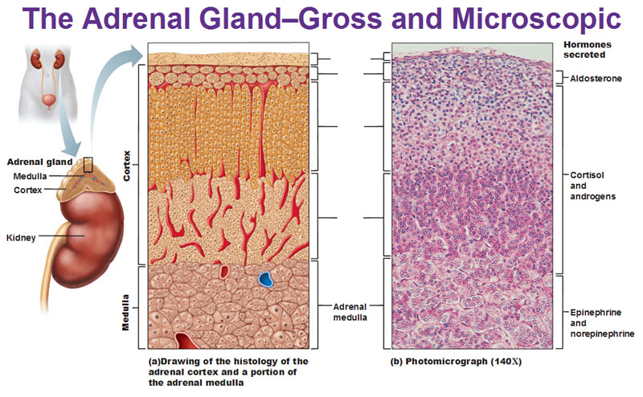

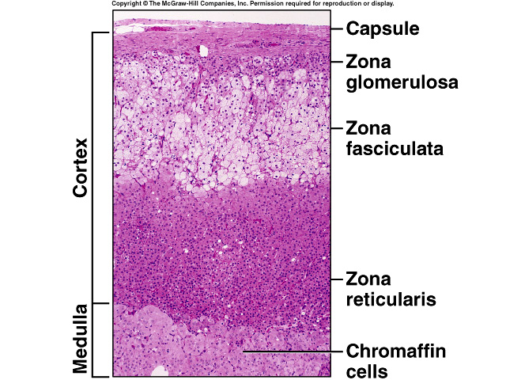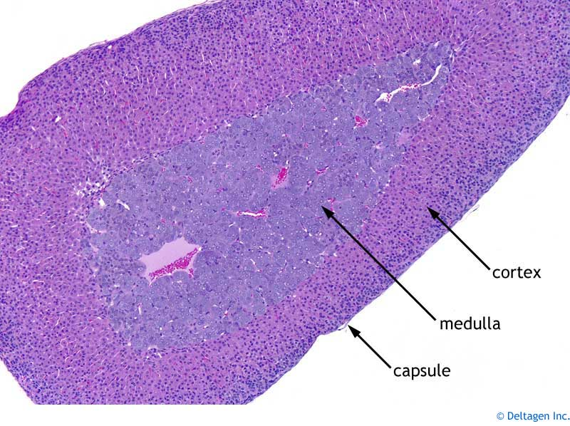

**Embryology**

First detected at **6** weeks' gestation, the adrenal cortex is derived from the mesoderm of the posterior abdominal wall. Steroid secretion from the fetal cortex begins shortly there after. Adult-type **zona glomerulosa** and **fasciculata** are detected in fetal life but make up only a small proportion of the gland, and the **zona reticularis** is not present at all. The fetal cortex predominates throughout fetal life. The adrenal medulla is of ectodermal origin, arising from neural crest cells that migrate to the medial aspect of the developing cortex.

The fetal adrenal gland is relatively large. At **4** months' gestation, it is **four** times the size of the kidney; however, at birth, it is a **third** of the size of the kidney. This occurs because of the **rapid regression** of the fetal cortex at birth. It disappears almost completely by age **1** year; by age **4-5** years, the permanent adult-type adrenal cortex has fully developed.

Anatomic anomalies of the adrenal gland may occur, because the development of the adrenals is closely associated with that of the kidneys, agenesis of an adrenal gland is usually associated with ipsilateral agenesis of the kidney, and fused adrenal glands (whereby the two glands join across the midline posterior to the aorta) are also associated with a fused kidney.

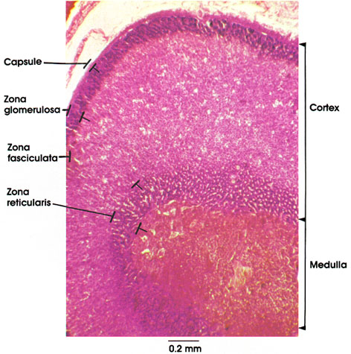

**Corticosteroids Mineralocorticoids, Glucocorticoids, and Androgens.**   
Two major types of adrenocortical hormones, the ***mineralocorticoids***and the ***glucocorticoids****,* are secreted by the adrenal cortex. In addition to these, small amounts of sex hormones are secreted, especially ***androgenic hormones****,* which exhibit about the same effects in the body as the male sex hormone testosterone.   
They are normally of only slight importance, although in certain abnormalities of the adrenal cortices, extreme quantities can be secreted and can result in masculinizing effects.  
 The ***mineralocorticoids*** have gained this name because they especially affect the electrolytes (the “minerals”) of the extracellular fluids-sodium and potassium, in particular.   
The ***glucocorticoids*** have gained their name because they exhibit important effects that increase blood glucose concentration. They have additional effects on both protein and fat metabolism that are equally as important to body function as their effects on carbohydrate metabolism.  
More than 30 steroids have been isolated from the adrenal cortex, but two are of exceptional importance to the normal endocrine function of the human body: *aldosterone,* which is the principal ***mineralocorticoid, and cortisol****,* which is the ***principal glucocorticoid.***

**Synthesis and Secretion of Adrenocortical Hormones The Adrenal Cortex Has Three Distinct Layers.**  
**the adrenal cortex is composed of three relatively distinct layers:**

**1.** The ***zona glomerulosa****,* a thin layer of cells that lies just underneath the capsule, constitutes about **15** per cent of the adrenal cortex. These cells are the only ones in the adrenal gland capable of secreting significant amounts of ***aldosterone***because they contain the enzyme ***aldosterone synthase****,* which is necessary for synthesis of aldosterone.   
The secretion of these cells is controlled mainly by the extracellular fluid concentrations of ***angiotensin II*** and ***potassium****,* both of which stimulate aldosterone secretion.

**2.** The ***zona fasciculata****,* the middle and widest layer, constitutes about **75** per cent of the adrenal cortex and secretes the glucocorticoids ***cortisol***and ***corticosterone,***as well as small amounts of *adrenal androgens* and *estrogens.*   
The secretion of these cells is controlled in large part by the hypothalamic-pituitary axis via ***adrenocorticotropic hormone (ACTH).***

**3.** The ***zona reticularis,*** the deep layer of the cortex, secretes the adrenal androgens ***dehydroepiandrosterone (DHEA)*** and ***androstenedione,***as well as small amounts of estrogens and some glucocorticoids .

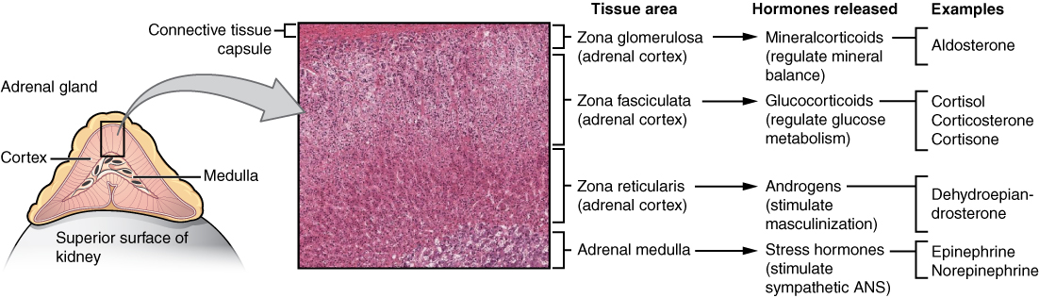

**Gland/Tissue Adrenal cortex**

**1.Hormones:** Cortisol

**Major Functions:** Has multiple metabolic functions for **controlling metabolism** of **proteins**, **carbohydrates**, and **fats**; also has anti-inflammatory effects.

**Chemical Structure:** Steroid

**2. Hormones:** Aldosterone

**Major Functions:** Increases **renal sodium reabsorption**, **potassium secretion**, and **hydrogen ion secretion**

**Chemical Structure:** Steroid

**Gland/Tissue Adrenal medulla**

**1.Hormones:** Norepinephrine, epinephrine.

**Major Functions:** Same effects as sympathetic stimulation.

**Epinephrine** and **norepinephrine** are released to the blood in large quantities during intense emotional reactions, such as fright, and produce vasoconstriction, increased blood pressure, changes in heart rate, and elevated blood glucose levels.

These effects facilitate various defensive reactions (the fight-or-flight response). During normal activity, the adrenal medulla continuously secretes small quantities of the hormones.

**Chemical Structure:** Amine

