Lec.4 Bioseparation Technique
Isolation and Purification of Biological Products by Precipitation
PRECIPITATION
Precipitation may be conducted at various stages of the product recovery process in order to concentrate the biological products and purify them from various impurities by lowering the solubility of the solute. It is a particularly useful process as it allows enrichment and concentration in one step. The ways to precipitate out the biological product can vary from simple pH and temperature variation to chemical reactions involving metal ions.
It is possible to obtain some products (or to remove certain impurities) directly from the broth by precipitation.

Typical agents used in precipitation of interest insoluble biological products include:
1. Acids and bases to change the pH of a solution until the isoelectric point (pI) of the compound is reached and pH equals pI, when there is then no overall charge on the molecule and its solubility is decreased( Isoelectric point: The pH at which the net charge on the proteins zero).
2. Salts such as ammonium and sodium sulfate are used for the recovery and fractionation of proteins. The salt removes water from the surface of the protein revealing hydrophobic patches, which come together, causing the protein to precipitate. The most hydrophobic proteins will precipitate first, thus allowing fractionation to take place. This technique is also termed “salting out.”
3. Organic solvents: Dextrans can be precipitated out of a broth by the addition of methanol, chilled ethanol and acetone can be used in the precipitation of proteins mainly due to changes in the dielectric properties of the solution.
4. Nonionic polymers such as polyethylene glycol (PEG) can be used in the precipitation of proteins and are similar in behavior to organic solvents.
5. Polyelectrolytes can be used in the precipitation of a range of compounds, in addition to their use in cell aggregation.
6. Protein binding dyes (triazine dyes) bind to and precipitate certain classes of protein.
7. Affinity precipitants are an area of much current interest in that they are able to bind to, and precipitate, compounds selectively.
8. Heat treatment as a selective precipitation and purification step for various thermostable products and in the deactivation of cell proteases.
Factors utilized for precipitation:
1. Temperature
The solubility of proteins in aqueous solutions depends on the temperature. Quite clearly the solubility of proteins is more sensitive to the lowering of temperature of the solution to the point where proteins is precipitated; cooling on its own is rarely used for precipitation.

2. pH adjustment
The solubility of a protein depends on the solution pH, the minimum solubility being observed at its isoelectric point (zero net charge). pH adjustment on its own is rarely used for protein separation since once again the solubility differences are not large enough. However, the pH-solubility effect can be utilized in salt based protein precipitation processes for optimization of operating conditions.

3. Addition of organic solvents
Solvents such as ethanol and acetone precipitate proteins by decreasing the dielectric constant of the solution causing the solubility to decrease. The dielectric constant of water is 78.3 while that of ethanol is 24.3 suggest that a protein would have a lower solubility in an ethanol-water mixture than in water itself. Organic solvents usually bind to specific locations on the protein molecules and thus disrupt the hydrophobic interactions which hold the protein structure in place. Acetone, methanol, ethanol, propanol and butanol are mainly used for protein precipitation. Hence organic solvent based protein precipitation processes are usually carried out at low temperatures in order to minimize denaturation. Organic solvents are also widely used for DNA and RNA precipitation.
4. Addition of anti-chaotropic agent
Anti-chaotropic agent is a molecule in an aqueous solution that will increase the hydrophobic effects within the solution. Anti-chaotropic salts such as ammonium sulphate and sodium sulphate can be used in protein purification processes, to remove undesired proteins from solution by removing the highly structured water layer which usually covers these patches in solution. As a result hydrophobic residues on a protein molecule can interact with those on another and this eventually leads to aggregation and precipitate formation. Salts can also reduce the solubility of proteins by shielding charged groups which normally keep proteins apart in solution. When the electrostatic charge on protein molecules are shielded, the molecules can easily interact, form aggregates and eventually precipitate.
At low ammonium sulphate concentrations, results in increase in protein solubility, this is referred to as the salting-in effect. This could be explained by the: salt molecules stabilize protein molecules by decreasing the electrostatic energy between the protein molecules which increase the solubility of proteins.
At higher ammonium sulphate concentrations, the solubility of proteins decreases very significantly with increase in salt concentration; this is referred to as the salting-out effect. The most hydrophobic proteins will precipitate first, thus allowing fractionation to take place, this technique is also termed “salting out.”
At higher salt concentrations, the electrostatic double-layers become diffuse and at such conditions, the salts can actually shield the electrostatic charges present on the proteins. This reduces the protein-protein electrostatic repulsion forces leading to protein aggregation and hence reduction in solubility. However, the main reason for the reduced protein solubility at higher salt concentrations is the increase in protein-protein hydrophobic interaction. Also the association of large amounts of water molecules with the salt molecules results in less water molecules being available for dissolving proteins.

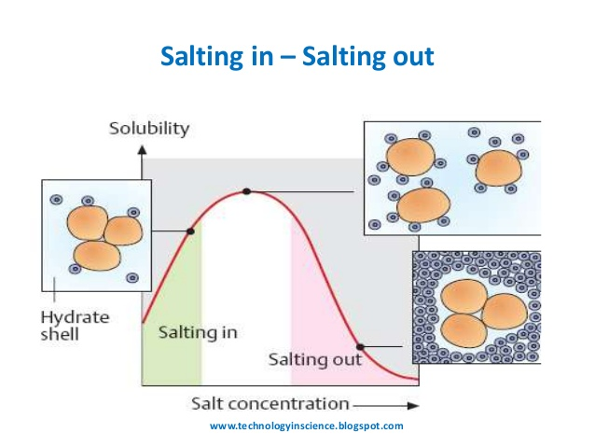

When using ammonium sulphate as a precipitating agent, two operational approaches could be used:
1. Direct addition of solid ammonium sulphate crystals to the sample.
2. Addition of a saturated ammonium sulphate solution to the sample.
The first approach is preferred in small scale applications; however, this approach suffers from the unevenness of ammonium sulphate concentration in the precipitating medium caused due to the salt dissolution process. In most protein precipitation processes, the second approach is preferred.
In many purification processes, differential ammonium sulphate concentration are commonly used, i.e. the supernatant from one precipitation step is subjected to further ammonium sulphate precipitation. For example, in a 30-50% ammonium sulfate, the sample is first subjected to precipitation using 30% salt saturation. The supernatant thus obtained in then subjected to precipitation using 50% salt saturation.

5. Addition of urea and guanidine hydrochloride.

Chaotropic salts such as urea and guanidine hydrochloride precipitate proteins by denaturing them. These salts act by disrupting intra-molecular hydrogen bonds and hydrophobic interactions in proteins, chaotropic salts are used also in DNA and RNA purification.

6- Addition of heavy metals salts
Heavy metal salts usually contain Hg⁺², Pb⁺², Ag⁺¹, Cd⁺² and other metals with high atomic weights. Since salts are ionic they disrupt salt bridges in proteins. The reaction of a heavy metal salt with a protein usually leads to an insoluble metal protein salt.
7. Addition of biospecific reagents as in immunoprecipitation.
Immunoprecipitation relies on antigen-antibody recognition and binding. This in its simplest form can be carried out by treating an antigen containing solution with an antibody.
When multivalent antigens react with antibodies in solution they form large molecular networks by cross-linking. These large complexes which eventually precipitate are called precipitins and these can easily be removed from solutions by standard solid-liquid separation techniques.

